Article
Collagen-Coated Poly(lactide-co-glycolide)/Hydroxyapatite Scaffold Incorporated with DGEA Peptide for Synergistic Repair of Skull Defect
Ming Bi ¹, Hui Han ², Shujun Dong ³, Ying Zhang ^{4,}*, Weiguo Xu ⁵, Bitao Zhu ⁵, Jingyun Wang ¹, Yanmin Zhou ^{1,}* and Jianxun Ding ^{5,}*
¹ Department of General Dentistry, School and Hospital of Stomatology, Jilin University, Changchun 130021, P. R. China; biming11@mails.jlu.edu.cn (M.B.); jlccjingyun@sina.com (J.W.)
² Department of Thyroid Surgery, The First Hospital of Jilin University, Changchun 130021, P. R. China; hh198404@hotmail.com (H.H.)
³ VIP Integrated Department, Stomatological Hospital, Jilin University, Changchun 130021, P. R. China; dsj@jlu.edu.cn (S.D.)
⁴ Department of Orthopedics, Zhongshan Hospital Affiliated to Xiamen University, Xiamin 361004, People's Republic of China
⁵ Key Laboratory of Polymer Ecomaterials, Changchun Institute of Applied Chemistry, Chinese Academy of Sciences, Changchun 130022, P. R. China; wgxu@ciac.ac.cn (W.X.); btzhu@ciac.ac.cn (B.Z.)
*Correspondence: jxding@ciac.ac.cn (J.D.); zhouym62@126.com (Y.Z.); xmzhangying@163.com (Y.Z.)

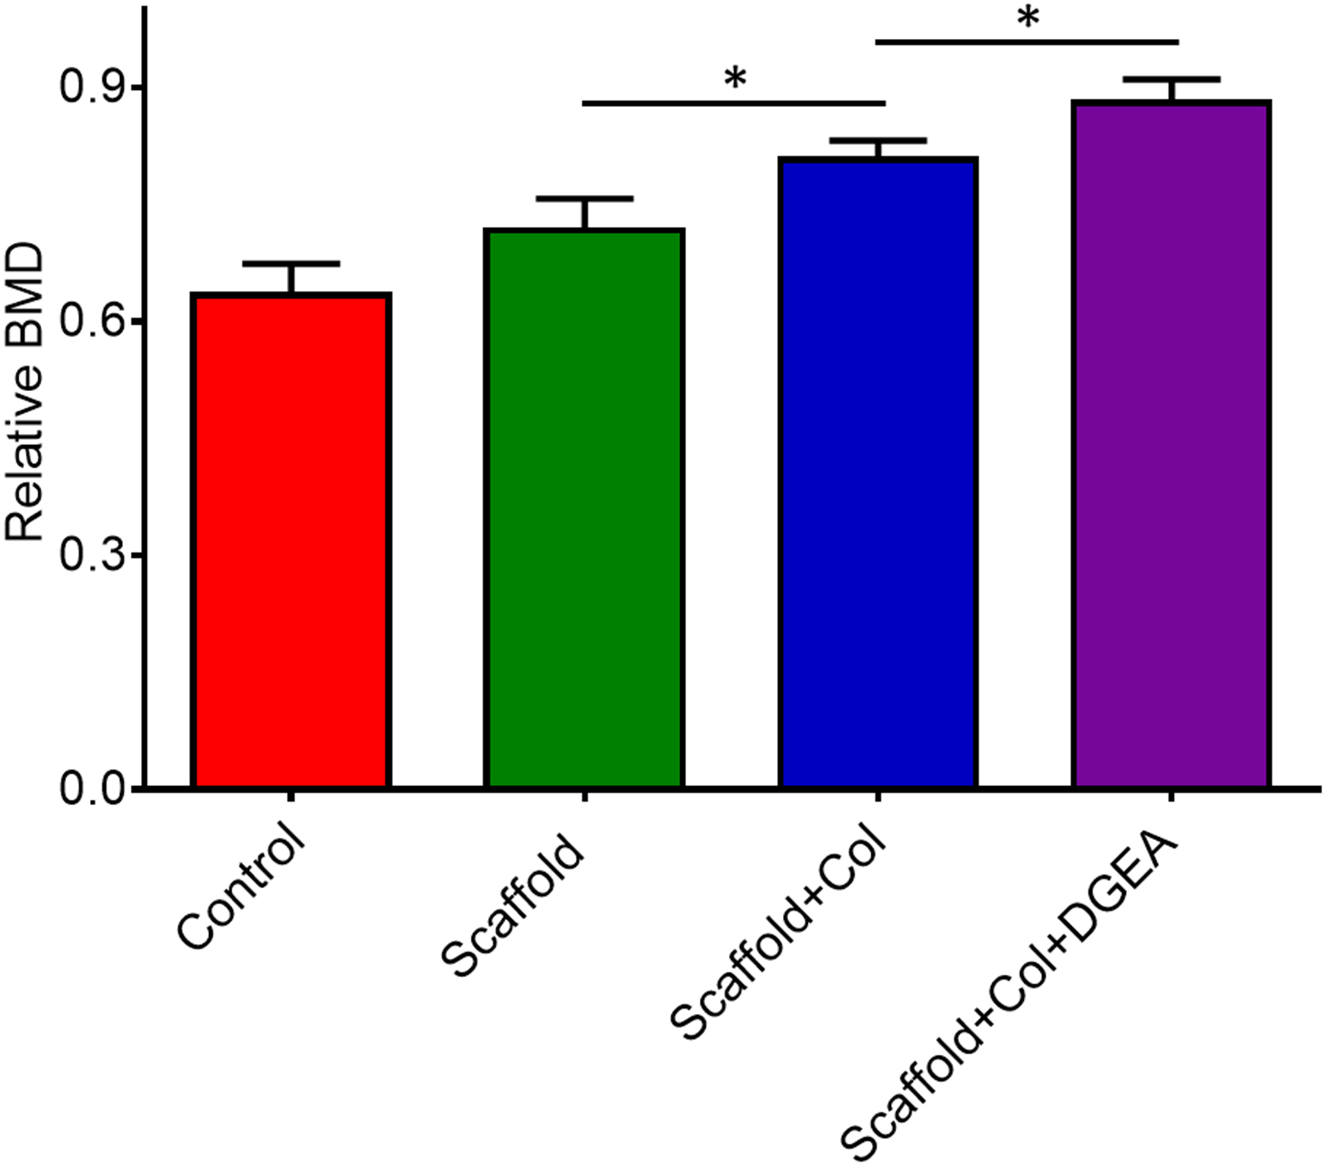
Figure S1. Bone mineral density (BMD) of new born tissue in defect region.
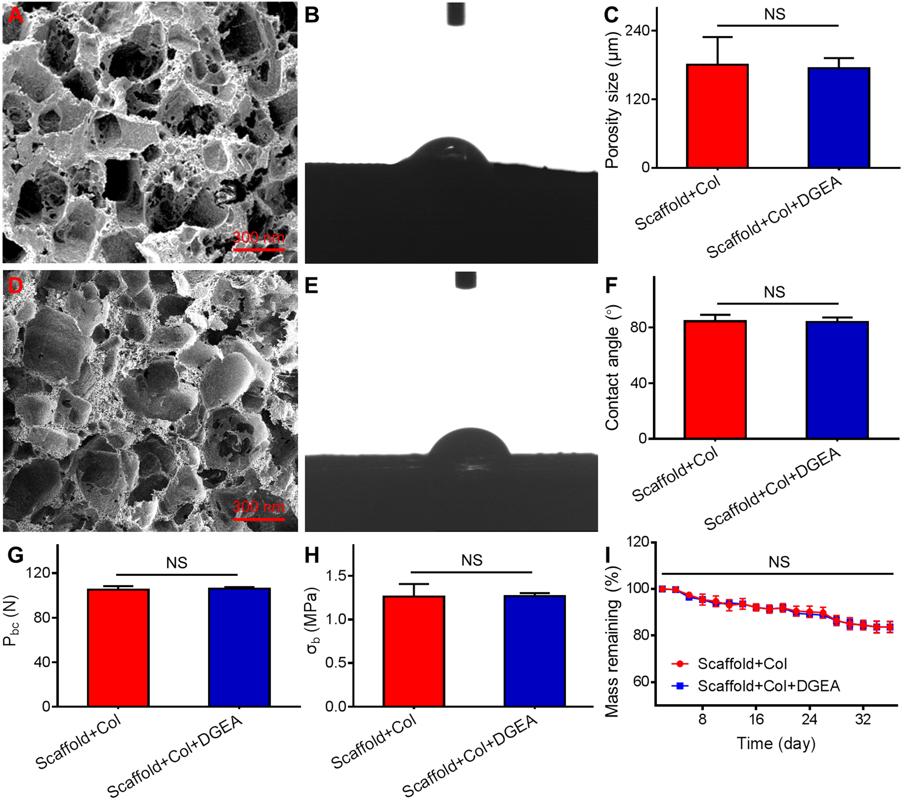
Figure S2. Morphologies, mechanical strength, and degradation. (A, D) Morphologies, (B, E) morphologies of contact angle measurement, (C) porosity sizes, and (F) contact angle of collagen-coated scaffold and the DGEA-collagen-coated scaffold. (G) Compressive load, (H) compressive tests, and (I) degradation rate of collagen-coated scaffold and DGEA-collagen-coated scaffold (n = 3, P = no statistical difference (NS)).

