Submitted to Molecules

Dual Monitoring of Cracking and Healing in Self-healing Coatings using Microcapsules Loaded with Two Fluorescent Dyes

Young Kyu Song¹, Tae Hee Lee^{1,2}, Jin Chul Kim¹, Kyu Cheol Lee¹, Sang Ho Lee¹,
Seung Man Noh¹, Young Il Park^{1*}

¹Research Center for Green Fine Chemicals Korea Research Institute of Chemical Technology Ulsan 44412, Republic of Korea
²Department of Chemical Engineering Ulsan National Institute of Science and Technology Ulsan 44919, Republic of Korea

* Corresponding authors: Dr. Young Il Park (ypark@krict.re.kr)
- Experimental
  - Materials
Urea, an aqueous formaldehyde solution (37 wt%), poly(ethylene-alt-maleic anhydride) (EMA), resorcinol, benzoin isobutyl ether (BIE), styrene, 1-octanol, 4-(Dicyanomethylene)-2-methyl-6-(4-dimethylaminostyryl)-4H-pyran (DCM) were purchased from Sigma-Aldrich. Methacryloxypropyl-terminated polydimethylsiloxane (MAT-PDMS) (molecular weight 380–550 g/mol, viscosity 4–6 cSt) was acquired from Gelest. Ammonium chloride was supplied from Duksan Pharmaceutical. The coatings were applied using an epoxy polymeric resin (YD-114) based on bisphenol-A diluted with aliphatic glycidyl ether and a cycloaliphatic amine-modified curing agent (KH-816) for the epoxy resin that had been kindly donated by Kukdo Chemicals. An epoxy paint as top coating containing gray pigment was kindly donated by Samjoong Inc. All chemicals and organic solvents were used with purification, with the exception of styrene, which was passed over a basic alumina column to remove any inhibitors.

  - Instruments
Proton nuclear magnetic resonance (¹H NMR) spectra were taken on a Bruker Ultrasheild 300 MHz spectrometer in deuteriochloroform (CDCl₃). IR spectra were recorded on a Fourier transform infrared (FT-IR) spectrophotometer (Nicolet 6700, Thermo Scientific). UV-Vis spectroscopy was conducted using a Lambda 25 UV-Vis spectrometer (Perkin-Elmer). Fluorescence spectra were collected using a Varian Cary Eclipse fluorescence spectrometer. Rheological experiments during photocuring were carried out by connecting a rotational rheometer (MARS III, Haake, Thermo Scientific) with and Omni Cure Series 2000 UV-vis mercury lamp curing system (Lumen Dynamics). Photo-irradiation for fluorescence detection and UV curing was conducted using an exposure system (EXECURE 4000, HOYA) equipped with a mercury lamp. A mechanical stirrer (EUROSTAR 20, IKA) was used for the microencapsulation. A microscope (BX-53, Olympus) was used to take pictures of the damaged surface, healed surface, and microcapsules. The microcapsule size was analyzed using the microscope equipped with a CCD camera (DP73, Olympus) and image analysis software (cellSens Entry, Olympus). The mean diameter was determined from a data set of at least 300 individual diameter measurements. A scanning electron microscope (SEM) (SNE-3000M, SEC) was used to examine the morphology, microcapsule shape, and coating surface.

  - Synthesis of dye-loaded microcapsule
A 2.5 wt% aqueous solution of EMA (5 mL) was added to distilled water (20 mL), to which urea (0.504 g), resorcinol (0.050 g), and ammonium chloride (0.050 g) were then added with stirring. The pH of the resultant solution was adjusted to 3.5 using a 10% NaOH solution. One drop of 1-octanol was then added to this solution to eliminate surface bubbles. The resultant mixture was agitated at 1200 rpm, and to the stirred solution was added 10 mL of the core material, which consisted of MAT-PDMS, styrene, BIE, and 4-(dicyanomethylene)-2-methyl-6-(4-dimethylaminostyryl)-4H-pyran (DCM), (1,1,2,2,-tetrakis(4-(diphenylamino)phenyl)ethane (4-TPAE) as AIE luminogen (the content of the core material is shown in Table 1). 4-TPAE was synthesized according to the method report in the literature. ^{[1]}. To the agitated emulsion was added a 37 wt% formaldehyde (1.456 g, 0.0179 mol) solution, and the temperature of the resulting mixture was raised to 60°C, and the solution was heated at that temperature for 5.5 h. The reaction mixture was cooled to room temperature, and the microcapsules were separated using vacuum filtration. The microcapsules were washed with water and acetone and then air-dried. The yields of the microcapsule were approximately 80%. Microcapsules without TPE were synthesized using the same process as in the above-mentioned procedure with TPE. The microcapsule and a filter paper were placed between two glass slides and pressed together. The cured material was extracted from the squeezed microcapsule. The broken shell materials were washed with chloroform and then dried in an oven at 60℃. The extracted core and dried shell material were together mixed with KBr to form a pellet from which IR spectra were acquired.

  - Preparation of self-healing coating
The DCM dye containing healing agent (D-HA) loaded microcapsule, 4-TPAE containing healing agent (T-HA) loaded microcapsule and (DCM and 4-TPAE containing healing agent) DT-HA loaded microcapsule were added to the epoxy resin in an amount of 25 wt%, respectively, to form a self-healing coating. A control coating was prepared the epoxy resin without the microcapsule. The coating was applied to the surface of a glass slide and dried for 2 h at 60℃. The resultant coatings were covered with and grey pigment epoxy coating to block UV light. The microcapsule containing layer was 400 ㎛ thick, and the top coating layer was 200 ㎛ thick.

- Reference
[1] Lifang Zhao, Yiliu Lin, Tong Liu, Hongxiang Li, Yu Xiong, Wang Zhang Yuan, Herman H.-Y. Sung, Ian D. Williams, Yongming Zhang and Ben Zhong Tang, “Rational bridging affording luminogen with AIE features and high field effect mobility”, J. Mater. Chem C, 2015, 3, 4903-4909.
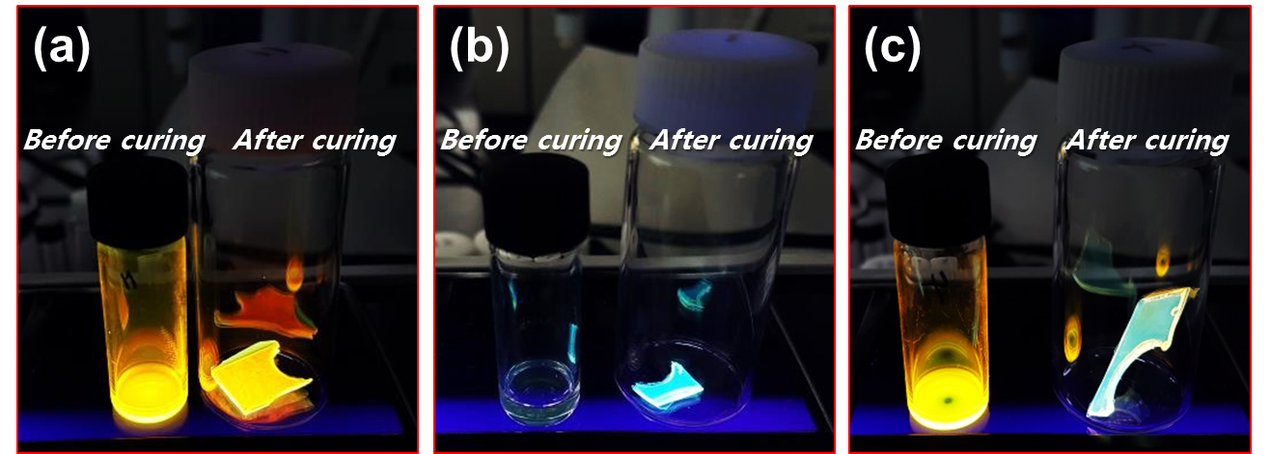
Figure S1. Photographs of (a) normal FL-dye (DCM) (b) AIE-dye (4-TPAE) and (c) mixture of DCM and 4-TPAE in healing agent before and after photo-curing.

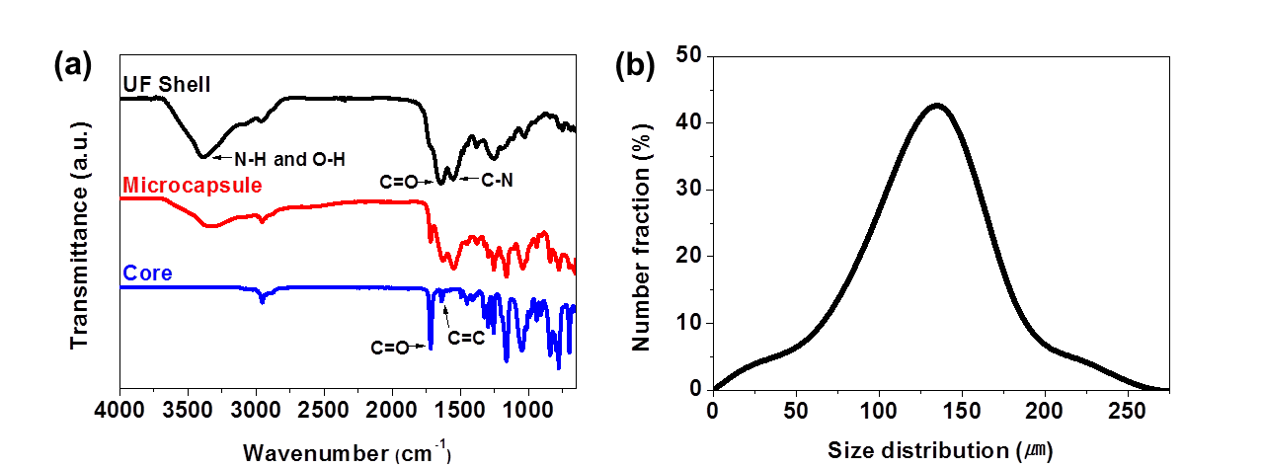
Figure S2. (a) Confirmation of microencapsulation via FT-IR spectral. (b) Size distribution of microcapsule.

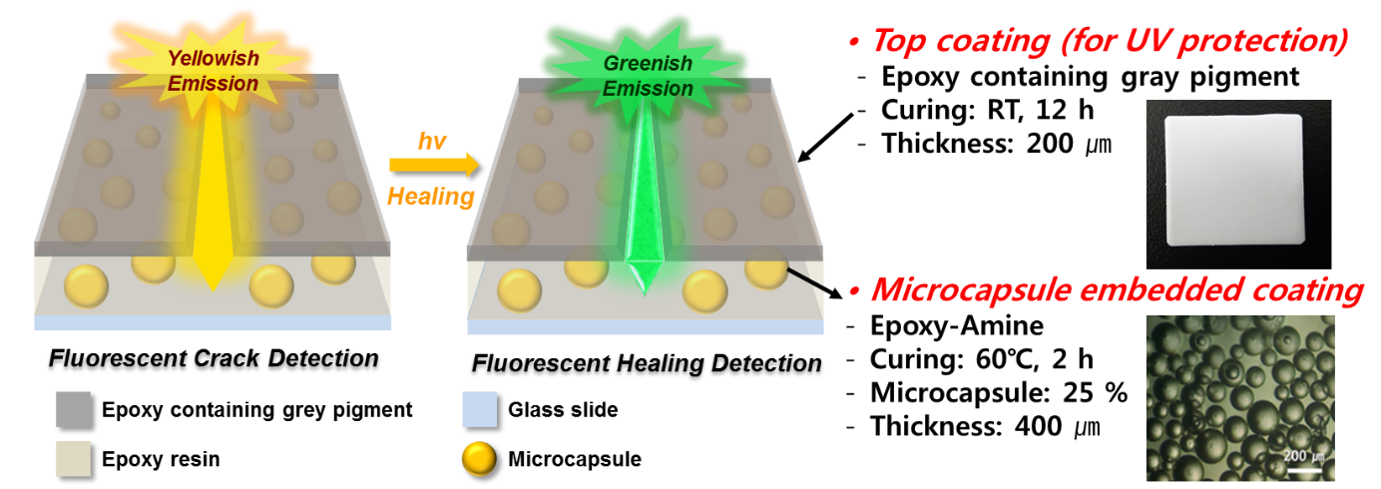
Figure S3. Schematic diagram of self-healing coating system with dye-loaded encapsulate and Figure of top-coating and microcapsule.

