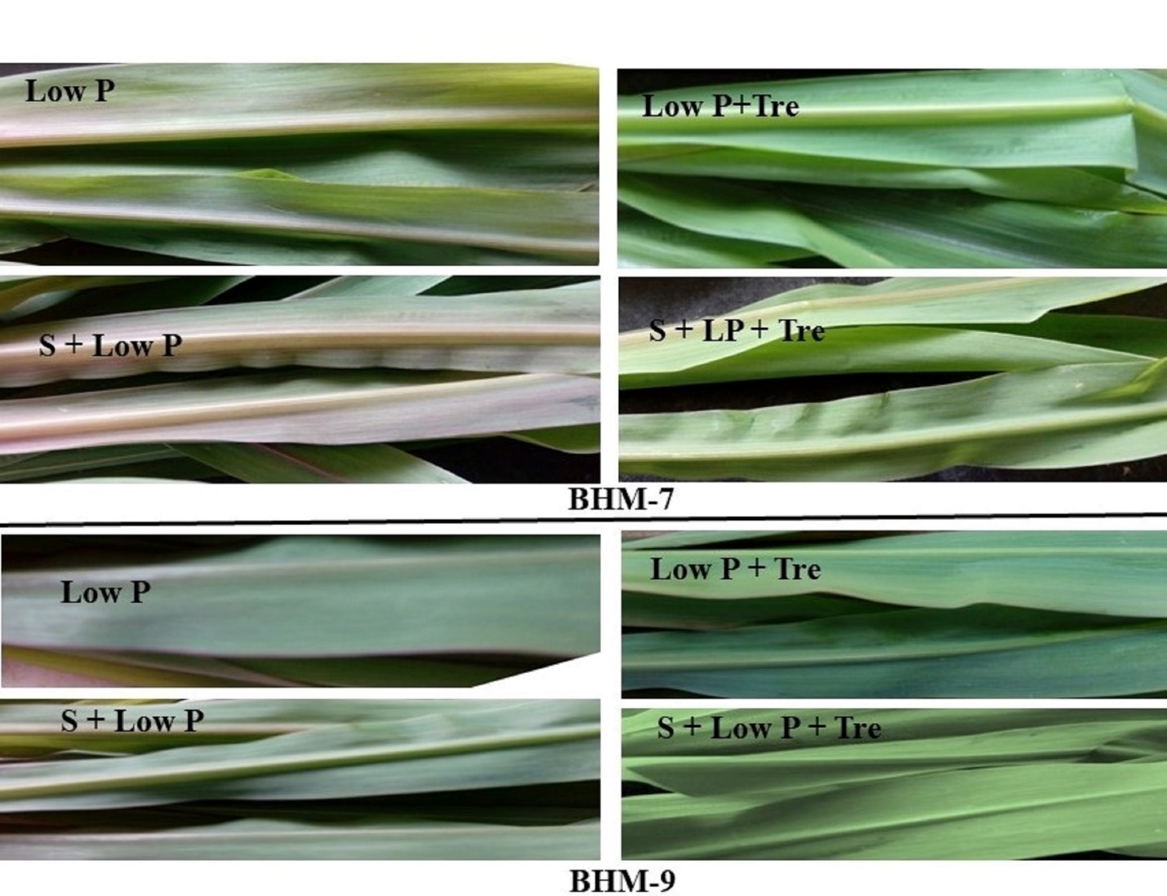
Supplementary Fig. 1. Effect Trehalose (Tre, 10 mM) on P deficiency symptom in maize seedlings of BHM-7 and BHM-9 under salinity (S, 150 mM) and low P (5 µM KH₂PO₄) stress. Seedlings were imposed stress for fifteen days

