**Supporting Data**

**Remodeling the forces in the universe using the combined effects of gravitational repulsion and attraction forces on gaseous molecules**

C.K. Gamini Piyadasa*

**File 1.** File Type: MS Excel. Note: Original empirical data given in the British Imperial System of Units have been converted to SI Units for the calculations.

**File 2.** File Type:PDF**.** Program text written inWolfram Mathematica 11.2 to calculate parameters *x, GR, GA, FR* and *FA* with respect to *T* and *y*.

**File 3**. File type: Wolfram Mathematica 11.2 note book file

**Note:** Double click on the documents .xlsx, .PDF and .nb to open

**Fig. A -** Graphical representation of tf (in Table I) through a metal tube of water droplets of masses 4 and 9 mg against temperature.

**Fig. B -** *FR* vs. *T* - Extrapolation of graph *FR* vs. *T* crosses (0,0) when y ≈ 0.5

**Fig. C -** *FA* vs. *T* - Negative *FA* tends to become positive as *T* approaches 0 K when y ≈ 0.5

**File 1.** File Type: MS Excel. Note: Original empirical data given in British Imperial Units have been converted to SI Units for the calculations.



**File 2.** File Type: PDF. Program text written in Wolfram Mathematica 11.2 to calculate parameters *x*, *GR*, *GA*, *FR* and *FA* with respect to *T* and *y*.



**File 3**. File type: Wolfram Mathematica 11.2 note book file



**Fig. A.** Time of fall (*tf*) of water droplets of 4 and 9 mg in air at temperatures 10, 30 and 60⁰C

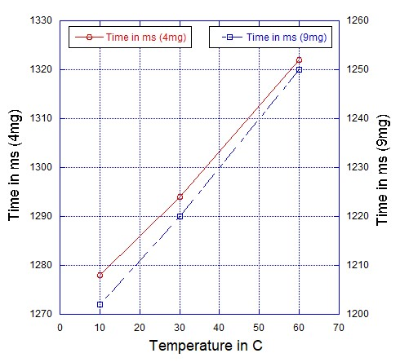

Investigating the time of fall (*tf*) of water droplets under varying droplet temperatures:

A water-droplet of mass 4 mg and temperature 10⁰C was dropped through a metal tube of height 5.913 m, and the time of fall (*tf*) was measured. Drop was repeated 25 times, and the readings were averaged. The experiment was repeated for droplets at temperatures 30 and 60⁰C.

The entire experiment was repeated with water droplets of mass 9 mg.

Results are given in TABLE I, and graphically presented in Fig. A.



For further details please refer [2].

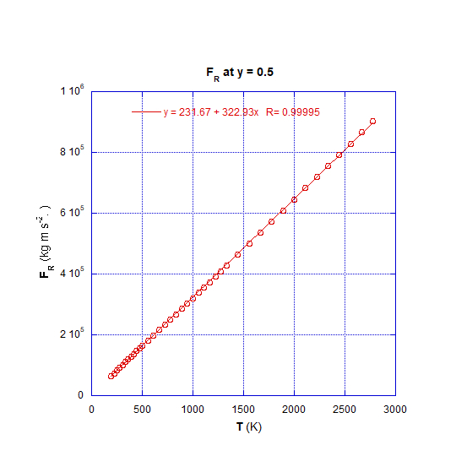



**Fig. B.** *FR* vs. *T; w*hen extrapolated crosses (0,0) when *y* ≈ 0.5

*FR* is linearly proportionate to *T* at any given value of *y* (Fig. 7(d)); thus, vindicating the mathematical model Eq. 5.

A significant finding is that, in the linear relationship *FR* vs. *T* extrapolated graph intercept ≈ 0 when *y*≈ 0.5, while intercept > 0 when *y*< 0.5, and intercept < 0 when *y*> 0.5.

Significantly, this result confirms the findings presented in a previous paper [2] of the series of publications emanating from this research program (See Fig. A)

**Fig. C.** *FA* vs. *T*; *FA* tends to become positive as *T* approaches 0 K when *y* ≈ 0.5

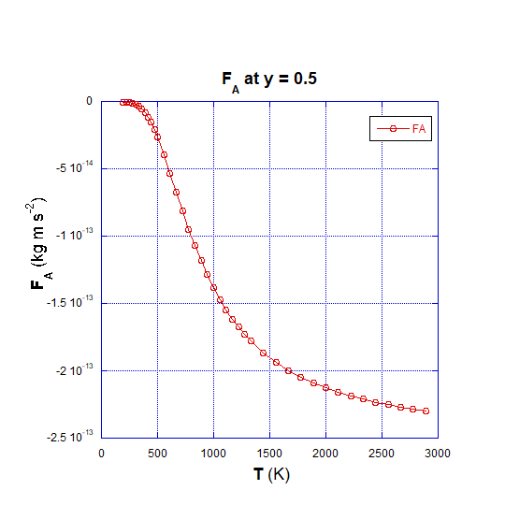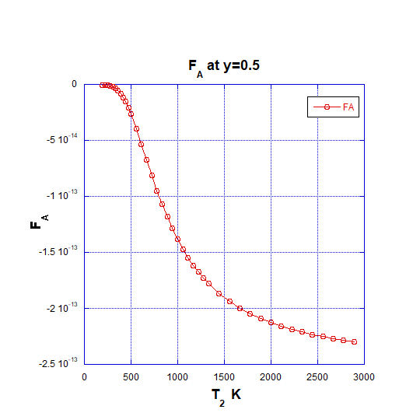

Applying empirical data to Eq. 24 has unearthed that *FA*, (the attraction force among gas molecules) is negative at elevated temperatures, implying that it acts as a repulsive force together with *FR*. This negative *FA* tends to becomes positive at lower temperatures where gases are expected to condense.