Supplementary File
Hub module | Genes
Brown  module（GSE19804）  （n=185） | CTHRC1 ARHGAP31 CST1 SUGCT SORD PCLAF TNS1 TNPO1 PAICS CDCA7 LAMP3 MDK SFXN1 COMP TFAP2A SULF1 IGSF9 GJB2 P3H4 UHRF1 CST2 CTTN MMP12 ATOH8 DNAH14 NMU PGM2L1 SLC39A8 AQP4 GPX3 CDCA3 SLC46A2 PEBP4 MS4A15 SOX4 GREM1 KLF9 HSPB8 JPT1 ANP32E TENM4 SRPX2 RUNX2 CST4 CPB2 SCG5 E2F8 CENPU ACACB VEPH1 SLC2A1 LRRC15 PCDH7 FIGNL1 MXRA5 MND1 THY1 ADAM12 ADGRD1 FAM199X CCDC34 SHCBP1 MKI67 MFAP2 TRIM59 LRRK2 IQGAP3 FHL2 CILP2 DEPDC1 ABCA3 LAMP5 FAP SLC2A5 PLAU PCP4 PLPP4 SFTA1P IGF2BP3 DIO2 KNL1 GPX8 FNDC1 CACNA2D2 DEPDC1B DEPDC7 PRR11 VCAN PLLP CYP4B1 HOXB7 HLF WISP1 HOXA10 HSD17B6 FUT9 GPR87 CILP CEMIP SUSD2 SCGB3A2 CDK1 BUB1 CCNB1 CCNB2 MAD2L1 CDC20 TOP2A CCNA2 KIF11 BUB1B DLGAP5 KIF2C KIF20A AURKA NDC80 CENPF NUSAP1 BIRC5 NCAPG PRC1 TPX2 UBE2C NUF2 TTK ZWINT RRM2 MELK CDKN3 PTTG1 CENPK CHEK1 NEK2 MCM4 ASPM MCM2 PBK KIF4A CEP55 FOXM1 KIF15 COL1A1 ANLN COL1A2 COL10A1 COL11A1 COL3A1 COL5A2 COL5A1 COL8A2 PLOD2 TYMS KIF14 ORC6 HMMR KIF26B GMNN FEN1 MMP1 FBXO32 GINS1 GINS2 GTSE1 ZBTB16 RMI2 UBE2T ITGA11 BRIP1 EZH2 CCNE2 PSAT1 PAFAH1B3 MMP11 THBS2 NME1 STIL PSPH FANCI MMP13 ADAMTS12 ECT2 IGFBP3 SFTPD PLA2G1B SFTPB
Turquoise module （GSE30219）  (n=413) | GPD1 BTNL9 SCARA5 PLAC9 GDF10 HSPB6 FHL1 DAPK2 TNPO1 FAM189A2 PGR ANKRD29 DLC1 EMCN ABCA8 PDE2A CSRNP1 ARHGAP6 LOC100506990 PSMD6-AS2 FHL5 PGM5 NOSTRIN FILIP1 LTBP4 SPATA13 STARD13 RUFY2 TNS2 PREX2 CFAP70 SYNPO2 GPX3 IFT57 PCLAF JCAD VEPH1 ATAD2 CX3CR1 PALMD ADIRF RBP4 PLPP3 HBB VAPA CDCA3 FRY ATOH8 TGFBR3 SELENOI VSIG2 CTHRC1 FAM199X SRD5A1 HIGD1B CAB39L CDH19 IL33 HMGB3 NR4A1 DIXDC1 NR4A3 MAGI2-AS3 ARHGAP44 PLSCR4 ATP5S COX7A1 UHRF1 SHC3 HLF 2-Mar DEPDC1 RNF125 CDO1 HMGB3P1 CKAP2 MMP12 SPARCL1 NDRG2 FAM13C NETO2 AUNIP NTN4 KNSTRN MKI67 DNAH14 PSAT1 THY1 E2F8 KNL1 DSP SPAG5 CRIM1 SIX4 PRICKLE2 FIGNL1 RAI2 CCDC34 C1orf112 PIMREG WFDC1 TMPO CENPU CDCA2 DEPDC1B SPP1 METTL7A HELLS CDCA7 FAM162B ECE2 CNRIP1 SAMD4A HYAL1 ESRP1 NEBL AFF3 PDK1 GRAMD2A DONSON SGO2 IQGAP3 MYRF CACNA2D2 RAB11FIP1 CYS1 CKAP2L PARPBP ADAM12 PRR11 PDK4 KL ABCA3 MLLT11 COCH NDC1 DUXAP10 MT1M PPP1R3C EPB41L5 SULF1 RERG TRIM59 MDK CGNL1 ARNTL2 ZNF367 NEIL3 RNASE4 8-Sep GGH ADGRD1 KCNE1 SLC12A8 IGSF9 TMEM125 SLC7A5 NEGR1 CPB2 NR4A2 ID4 IGF2BP3 SLC2A5 CA2 FAXDC2 CAMK2N1 PFN2 WASF1 LOXL2 RPL39L CTSV PID1 MEST CABYR MTFR2 BCL11A CDK5R1 CDHR3 C12orf56 MACROD2 CHRNA5 FAM83D CRABP2 WISP1 NR3C2 HOXA10 ADAMDEC1 PI15 APOD SLC22A3 PRAME WDR72 TMEM158 FAP ZIC2 APOBEC3B FNDC1 DNALI1 HOXD10 ATP8A1 DLX6 MLPH CNTNAP2 MAGEA6 CAPN8 HOXC6 DLX5 HES6 HORMAD1 AQP3 MAGEA12 MAGEA1 TSPAN8 MS4A8 LGSN CALB1 CDK1 CCNB1 CCNB2 BUB1 CDC20 MAD2L1 PLK1 AURKB CCNA2 CENPE CDCA8 KIF2C BUB1B NDC80 TOP2A BIRC5 KIF11 CENPF KIF18A CENPL CENPH CENPN CENPI CENPK KIF20A NUF2 ESPL1 DLGAP5 KIF23 AURKA ZWINT CDCA5 ZWILCH KNTC1 SPC25 SKA1 PRC1 UBE2C CHEK1 NCAPG TPX2 HIST1H2BD HIST1H2BH RACGAP1 TTK MCM4 NUSAP1 CDC45 CDC6 MCM2 RFC4 RRM2 POLE2 PTTG1 CDKN3 ASPM KIF4A MELK SMC2 CDT1 FOXM1 ORC6 SMC4 NEK2 KIF15 MCM8 CDC25A SKP2 PBK CEP55 MCM10 RAD51 ANLN PIK3R1 HJURP OIP5 CENPW KIF18B GMNN KIF26B DBF4 TYMS NCAPG2 EXO1 CCNE1 ITGA1 NUP155 KIF14 RMI2 FEN1 NCAPH BRIP1 CDC25C AGTR1 HMMR TIMELESS COL1A1 CKS1B UBE2S MYBL2 COL1A2 CKS2 COL5A2 PLOD2 LMO7 ADRB2 ZBTB16 ARRB1 GINS2 CCNE2 RAD51AP1 RNF144B EZH2 FOS NR3C1 LMNB1 COL3A1 CBX2 COL10A1 COL11A1 FBXO5 MMP1 NMU CTTN DTL EPAS1 GINS1 ECT2 GTSE1 AR SYT1 SSTR1 GAL UBE2T MND1 P2RY14 CITED2 LPL SERPINA1 VIPR1 RAMP2 NME1 RAP1A CLU AOX1 MYH11 KPNA2 DUSP1 SORBS1 FANCI CBX7 CERS6 ASF1B NME5 SHCBP1 ALDH2 E2F7 SGMS2 TRIP13 MAOB TFAP2A MMP9 MAOA SCNN1B FXYD1 LRRFIP1 SHANK3 GRIA1 ATP1A2 PAICS PPAT PRKCE PAFAH1B3 SUV39H2 FGFR4 GATA2 SCN4B TPD52 PLA2G1B ADAMTSL3 TSC22D3 MMP11 TK1 GREM1 RAD54B RNASEH2A LMNB2 SLC2A1 IGFBP3 DSCC1 STIL PGF THBS2 EGLN3 BMP2 CDKN2A HMGA2
Yellow module (GSE32863)  (n=79) | CACNA2D2 UHRF1 UBE2T Pfs2 C9orf140 CDC45L PGC MGC24665 C17orf53 ECT2 C1QTNF6 SLPI CDCA7 SUSD2 WDR51A A2M HES6 PGCP PTTG3 HDC LEPREL1 FLRT3 TBX2 NMU SCG5 RPL39L SELENBP1 ZNF533 SCGB3A2 RNASE1 VSIG2 TRIP13 FOLR1 ANG KCNK12 C4BPA IGJ PCP4 TUBB2B AGR3 SCGB3A1 TOP2A CCNB2 CDC20 AURKB AURKA CDCA8 UBE2C KIF20A TPX2 BIRC5 PRC1 NUSAP1 CENPF PTTG1 MCM2 NEK2 CDCA5 TYMS MCM4 MELK ASPM NUP155 TUBG1 FEN1 TIMELESS CCNF KIFC1 KIF1A STIL TK1 H2AFX KIAA0101 ALDH2 E2F2 SFTPD CCNE1 MAOA SFTPB
Yellow module (GSE63459)  (n=160) | ADRB2 MARCKSL1 CES1 IDH2 CSTF2 PSAT1 C6orf125 NOSTRIN KIAA0859 ST6GALNAC6 STOM PLA2G4F WFS1 MAL XPO5 SAP18 TNFSF12 MTA3 MGC13170 NARF SLC2A1 C17orf53 CALM1 GSN CDC45L MOCS1 ALG8 TSPAN4 C1orf112 TLE4 EDNRA C6orf129 IFT57 WDR51A CIRBP AHCY TMEM132A C20orf20 MGC24665 MS4A2 GDDR TPSAB1 HMGA1 BOLA2 ECRG4 FLJ40629 HCAP-G CABYR PCCB NUDT1 GPR116 PLOD1 C9orf140 SUSD2 NCALD SLPI C20orf24 ABCA3 VSIG2 PTTG3 KLF2 DLG7 TROAP PGCP TMEM106C CPA3 SFTPD MSN DLC1 DKFZp762E1312 SELENBP1 CDC2 NR3C2 HES6 C16orf60 RAFTLIN C18orf56 C1orf116 RPS6KA2 HLA-DRB6 CTSH RNASE1 IGF2BP3 FOXA2 BUB1 CCNB2 CCNA2 CDC20 AURKB TOP2A CDCA8 AURKA KIF11 CENPF KIF2C KIF20A TPX2 BIRC5 PRC1 CHEK1 NUSAP1 UBE2C CENPM MCM3 MCM4 MCM2 RFC4 KNTC1 CDCA5 SPC24 PTTG1 RCC2 TTK CDKN3 NEK2 PLK4 MCM7 MELK CEP55 FOXM1 ASPM TYMS MCM6 E2F3 FEN1 HMMR TIMELESS MCM10 ANLN CDK4 E2F2 EXO1 TUBG1 CKS1B CCNE1 CCNF EZH2 RAB3IP KIAA0101 RAD51AP1 POLQ OIP5 SHMT2 UBE2T TK1 STIL CBX2 ALDH2 PAICS CCT3 GAPDH APOA1BP MRPL12 CD59 RPL34 MRPS17 RPL39L TRIP13 MAOA FOLR1
Table S1. Genes in key modules.

Figure S1. Expression of CENPF, ERβ, ERβ2 and ERβ5 are associated with T stage in LUAD patients. (A) Tissue microarray (TMA) was used to analyze the expression of CENPF in benign lung lesions and different TNM staging tissues of LUAD. The magnification of each slice is 40×, 100×, 200× in order. (B-D) Analysis of the relationship between the expression of CENPF, ERβ, ERβ1, ERβ2 and ERβ5 and the TNM staging or T stage or N stage of LUAD. The corresponding P value is marked above the picture.
Figure S2. WGCNA analysis and determination of the CENPF gene. (A, D, G) Dendrogram of all differentially expressed genes clustered based on a dissimilarity measure (1-TOM) (GSE30219, GSE32863, GSE63459). (B, E, H) Heat maps and distribution of differential genes for different modules related to NSCLC staging (GSE30219) and LUAD staging (GSE32863, GSE63459). (C, F, I) Analysis of the scale-free fit index for various soft-thresholding power (β) and Analysis of the mean connectivity for various soft-thresholding power (GSE30219, GSE32863, GSE63459).
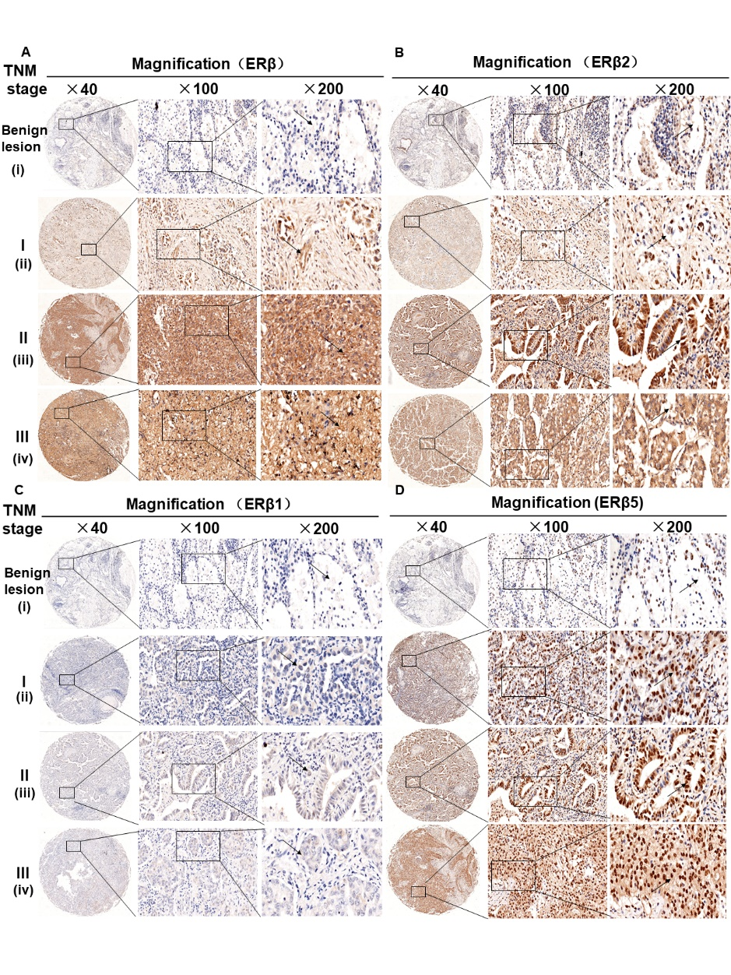
Figure S3. (A-D) Expression of ERβ, ERβ1, ERβ2 and ERβ5 in benign lung lesions (i) and different TNM staging of LUAD (ii=I stage, iii=II stage, iv=III stage). The magnification of each slice is 40×, 100×, 200× in order.
Figure S4. Knockdown of CENPF inhibits the biological effects of LUAD cells and the growth of LUAD in vivo. (A) Protein expression of CENPF in different cell lines. *P < 0.05 vs other cells. (B) mRNA expression of CENPF in different cell lines. *P < 0.05 vs other cells. (C) Representative cellular immunofluorescence images after transfection of CENPF (200×). Green stands for CENPF and blue stands for DAPI. (D) Representative Ki67 staining (green) shows cell proliferation of LUAD cells after CENPF-NC or KD treatment (200x). The nuclei were counterstained with DAPI (blue). (E, F) Migration and invasion pictures of A549 and H1299 cells, and corresponding quantified histograms. (G, H) Corresponding gray value analysis of N-cadherin, E-cadherin and MMP2 in A549 and H1299 cells. (I) Representative scratched pictures of A549 and H1299 cells. (J-L) Percentage of CENPF-deficient cells H1299 at different stages of the cell cycle (G1, S and G2/M) and corresponding quantified histograms of A549 and H1299. (M) Corresponding gray value analysis of protein CCND1, CDK2 and CDK4 in A549 and H1299. (N) Representative TUNEL staining (green) shows (200x). (O, P) Immunohistochemical analysis of CENPF, ERβ, ERβ2 and ERβ5 expression in nude mice tumor tissues and corresponding quantitative histograms. *P < 0.05.
Figure S5. Knockdown of CENPF inhibits proliferation, invasion and migration of LUAD cells via the ERβ pathway. (A) Migration and invasion pictures of A549 and H1299 cells. (B-D) Corresponding quantified histograms of MMP2, N-cadherin and E-cadherin in A549 and H1299 cells. (E) Representative scratched images of A549 and H1299 cells. (F, G) Percentage of the H1299 cells at different stages of the cell cycle (G1, S and G2/M) and corresponding quantified histograms. (H) Corresponding quantified histograms of CCND1, CDK2 and CDK4 in A549 and H1299. *P < 0.05.
Figure S6. Knockdown of CENPF can inhibit the expression of ERβ2/5 in vitro and in vivo. (A, B) Corresponding gray value analysis of CENPF, ERβ, ERβ1, ERβ2 and ERβ5 in vitro and in vivo experiment. (C, D) Corresponding gray value analysis of CENPF, ERβ, ERβ1, ERβ2 and ERβ5 in vitro and in vivo experiment after treated with E2 and Ful treatment. (E) Pictures of nude mice sacrificed at 45 days. *P < 0.05.

