Supplementary Materials
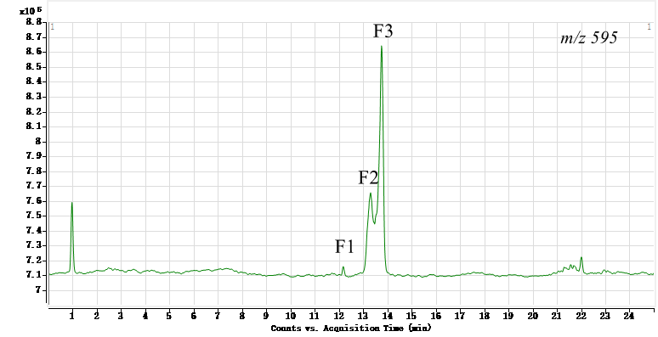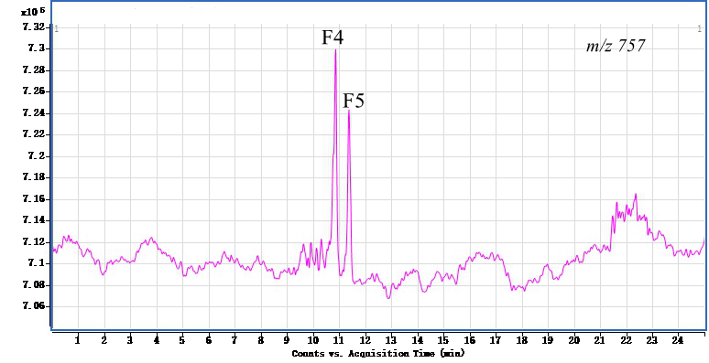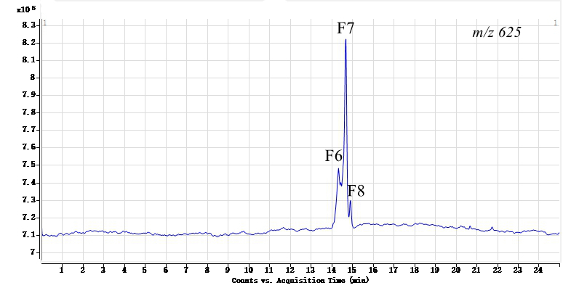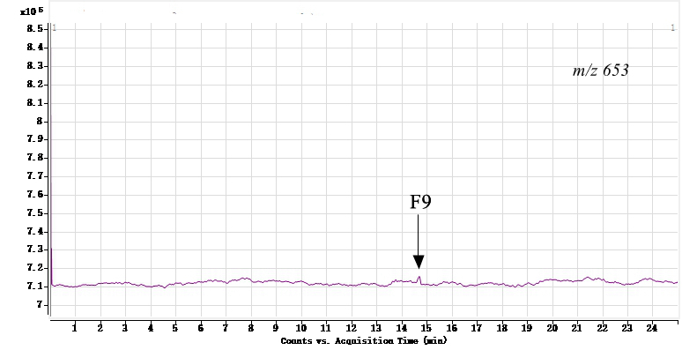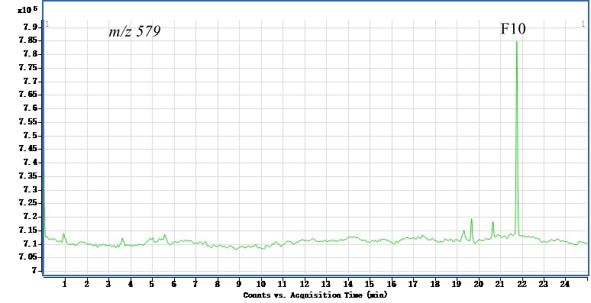

Figure S1. LC-MS analysis of the crude extract from leaves of Actinidia arguta in positive ion mode. Selected ion chromatograms of m/z 595,757,625,653,579 respectively, with the retention time of corresponding constitutions

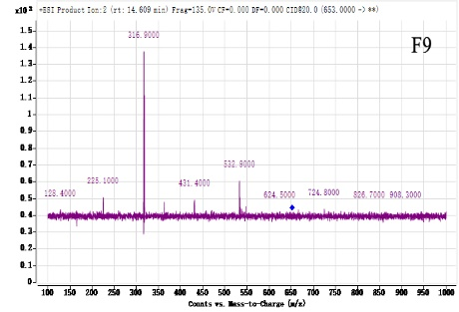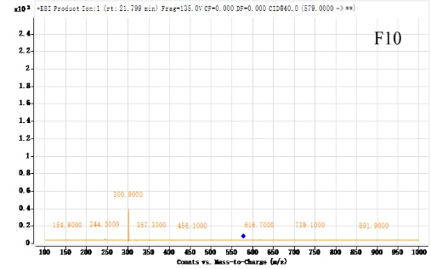

Figure S2. LC-MS² spectra of [M+H]⁺ ion for the ten constituents

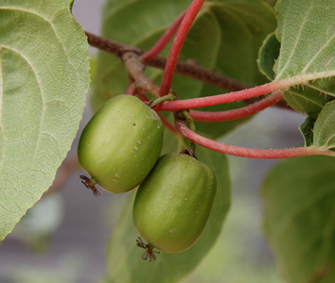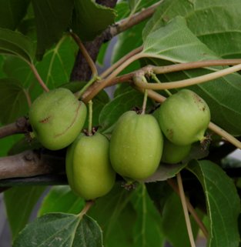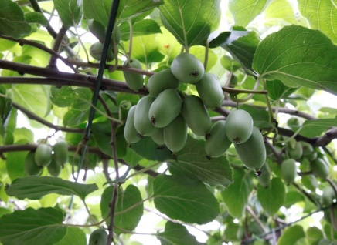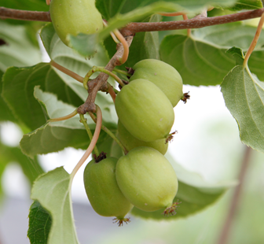
b
c
d
e
f
a
g
h
Figure S3. Fruits (female) or flowers (male) of eight accessions in Actinidia arguta. a; CJ-1; b: HY-1; c: CBS-3; d: CBS-11; e: CBS-6; f: CBS-8; g: BYS-13; h: BYS-5.

