†Electronic Supplementary Information (ESI)

Nucleation points: The forgotten parameter in the synthesis of hydrogel-coated gold nanoparticles

Adolfo Sepúlveda,^{a,c} Audrey Picard-Lafond,^{b,c} André Marette^{d} and Denis Boudreau^{b,c*}

ªDépartement de biochimie, de microbiologie et de bio-informatique, Université Laval, Québec, Québec G1V 0A6, Canada.
^{b}Département de chimie, Université Laval, Québec, Québec G1V 0A6, Canada.
^{c}Centre d’optique, photonique et laser (COPL), Université Laval, Québec, Québec G1V 0A6, Canada.
^{d}Département de médecine, Faculté de médecine, Institut universitaire de cardiologie et de pneumologie de Québec (IUCPQ) et Institut sur la nutrition et les aliments fonctionnels (INAF), Université Laval, Québec G1V 0A6, Canada.
*E-mail: Denis.Boudreau@chm.ulaval.ca

Functionalization of gold nanoparticles:

Table S1 : Volume of 1-mM SDS and 1.4-mM B-en-A solutions used depending on diameter of starting gold cores.
Gold core diameter  (nm) | SDS  (mL) | B-en-A  (mL)
15 | 3.00 | 1.64
35 | 4.72 | 2.58
50 | 6.00 | 3.26

TEM and size distribution of Au@pNIPAM nanoparticles:

S1: 50-nm AuNPs@pNIPAM

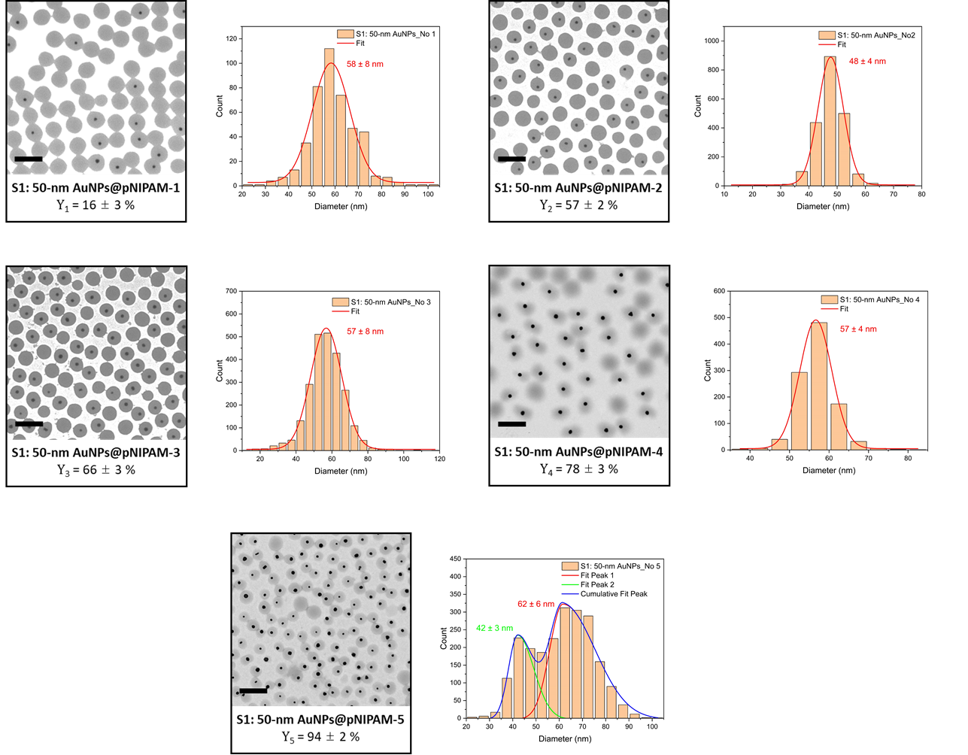
Figure S1 : Transmission electron micrographs of S1 polymerization series and corresponding size distribution histograms of gold cores. Y_{x} is average diameter of Au@pNIPAM particles, as determined from TEM images. Scale bars are 500 nm.

S2: 35-nm AuNPs@pNIPAM

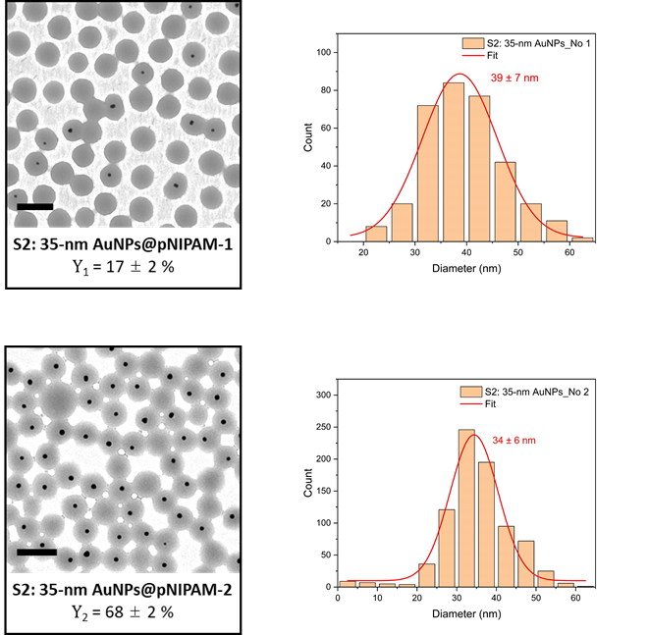
Figure S2 : Transmission electron micrographs of the S2 polymerization series and their corresponding size distribution histogram of the gold cores. Scale bars are 500 nm.

S3: 15-nm AuNPs@pNIPAM

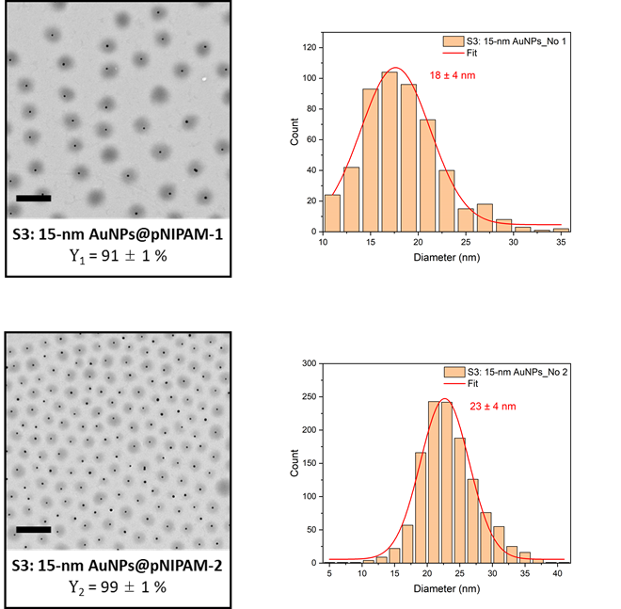
Figure S3 : Transmission electron micrographs of the S3 polymerization series and their corresponding size distribution histogram of the gold cores. Scale bars are 500 nm.

Bimodal samples - S4: 50/65-nm AuNPs@pNIPAM and S5: 25/65-nm AuNPs@pNIPAM

Table S2 : Number of functionalized gold nanoparticles utilized in both bimodal samples S4 and S5.
Sample | Number of 25-nm AuNPs (x10¹²) | Number of 50-nm AuNPs (x10¹²) | Number of 65-nm AuNPs (x10¹²)
S4: 50/65-nm AuNPs@pNIPAM | - | 4.4 ± 0.1 | 1.7 ± 0.1
S5: 25/65-nm AuNPs@pNIPAM | 8.0 ± 0.3 | - | 6.6 ± 0.4
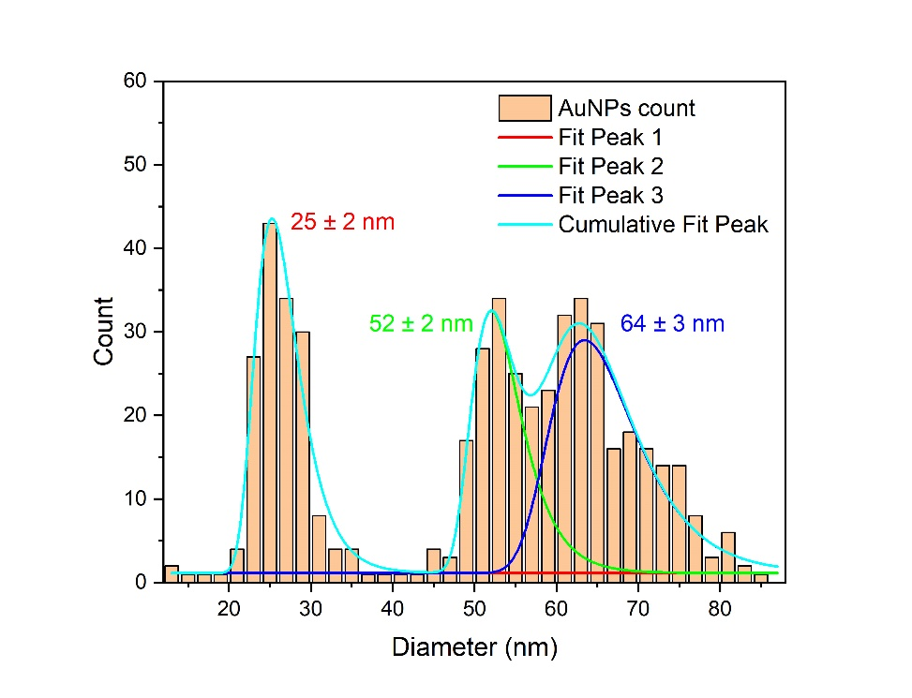
Figure S4 : Size distribution histogram of the gold cores employed in both bimodal samples S4 and S5.

Preparation of pNIPAM microgels without metallic cores
Spherical microgels of pNIPAM were synthesized following the previously explained precipitation polymerization protocol but omitting the step of adding the functionalized gold nanoparticles. Hence, 57 mg of NIPAM and 12 mg of BIS were dissolved in 25 mL of nanopure water at room temperature and under continuous stirring (600 rpm). After complete dissolution, the mixture was heated to 70 °C and purged with nitrogen to remove oxygen. The polymerization was initiated after 20 min by the rapid addition of 1 mL of an aqueous KPS solution (1.85 mM) and allowed to proceed for 2 h. Afterward, the solution was cooled down to room temperature and purified by three consecutive centrifugations at 6000 rcf until obtaining a clear supernatant. The resulting pNIPAM microgels were redispersed in 5 mL of nanopure water and stored at 4 °C.

Overall particle surface and encapsulation yield
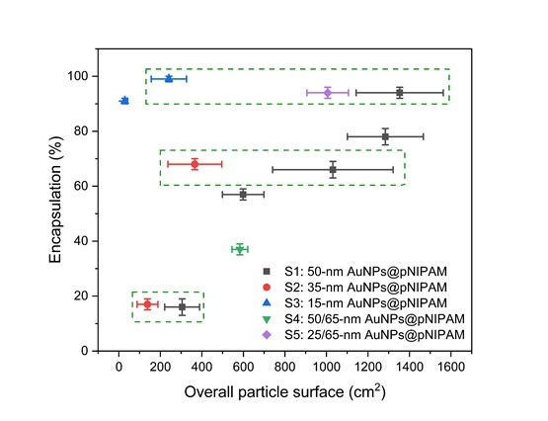
Figure S5 : Resulting yield as a function of the overall particle surface calculated for each sample.

Polydispersity index (PDI)

Table S3 : Summary of the particle hydrodynamic diameters and their polydispersity indices measured by DLS. ‡
Samples | T = 15 °C |  | T = 50 °C
 | D_{H} (nm) | PDI | D_{H} (nm) | PDI
S1: 50-nm AuNPs@pNIPAM-1 | 501 ± 6 | 0.015 ± 0.001 | 339 ± 5 | 0.049 ± 0.037
S1: 50-nm AuNPs@pNIPAM-2 | 370 ± 3 | 0.007 ± 0.007 | 255 ± 1 | 0.009 ± 0.008
S1: 50-nm AuNPs@pNIPAM-3 | 391 ± 7 | 0.046 ± 0.055 | 264 ± 8 | 0.020 ± 0.009
S1: 50-nm AuNPs@pNIPAM-4 | 345 ± 1 | 0.005 ± 0.005 | 230 ± 3 | 0.024 ± 0.006
S1: 50-nm AuNPs@pNIPAM-5 | 231 ± 4 | 0.012 ± 0.011 | 146 ± 3 | 0.074 ± 0.023
S2: 35-nm AuNPs@pNIPAM-1 | 378 ± 2 | 0.011 ± 0.005 | 254 ± 6 | 0.024 ± 0.013
S2: 35-nm AuNPs@pNIPAM-2 | 372 ± 3 | 0.029 ± 0.018 | 253 ± 4 | 0.017 ± 0.004
S3: 15-nm AuNPs@pNIPAM-1 | 305 ± 5 | 0.008 ± 0.006 | 204 ± 3 | 0.014 ± 0.011
S3: 15-nm AuNPs@pNIPAM-2 | 188 ± 4 | 0.039 ± 0.019 | 120 ± 1 | 0.055 ± 0.009
pNIPAM microgels | 331 ± 6 | 0.027 ± 0.024 | 243 ± 5 | 0.011 ± 0.004
‡The uncertainties correspond to the standard deviation of the mean values measured by DLS (N=3).
Shrinking ratio
The shrinkage capacity for each sample was calculated using the following equation [1]:

$$Shrinking ratio= {\left(\frac{R_{shrunken}}{R_{swollen}}\right)}^{3}×100\% (1)$$

Here, $R_{shrunken}$ corresponds to the mean hydrodynamic radius of the gold-pNIPAM core-shell nanoparticle measured at the shrunken state (50 °C). $R_{swollen}$ is the mean hydrodynamic radius measured at the swollen state (15 °C).

[1] Hellweg T, Kratz K, Pouget S, Eimer W. Internal dynamics in colloidal PNIPAM microgel particles immobilised in mesoscopic crystals. vol. 202. 2002.

