Supplementary Information for

Evaluation of ((La_{0.60}Sr_{0.40})_{0.95}Co_{0.20}Fe_{0.80}O_{3-x})-Ag composite anode for direct ammonia solid oxide fuel cells and effect of Pd impregnation on the electrochemical performance
Shambhu Singh Rathoreª, Aniruddha P. Kulkarniª*, Daniel Finiª, Sarbjit Giddeyª, Aaron Seeber^{b}
a: CSIRO Energy, Private Bag 10, Clayton South 3169, Victoria, Australia|
b: CSIRO Manufacturing, Private Bag 31, Clayton South 3169, Victoria, Australia
*Corresponding author email: Aniruddha.Kulkarni@csiro.au

Supporting Figure
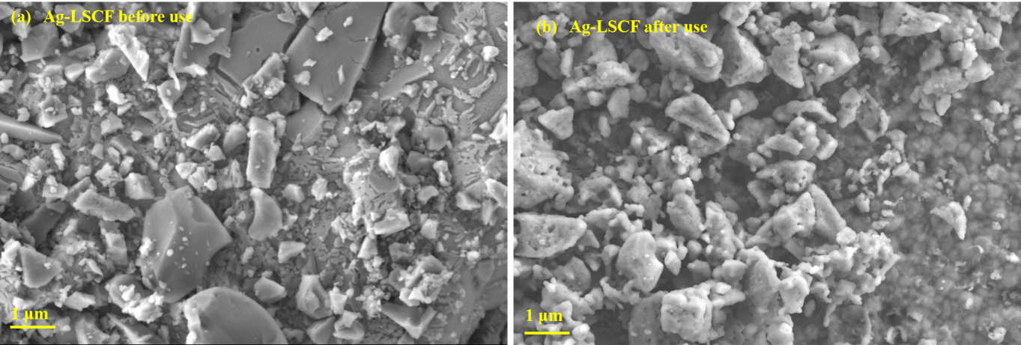
Figure S1. SEM image of Ag-LSCF anode surface as prepared (a) and after cell operation (b).

