The Effect of Freeze-drying and its Implications
for Botanical Medicine: A Review
Kathy Abascal
1
*, Lisa Ganora
1
and Eric Yarnell
2
The Effect of Freeze-drying and its Implications
for Botanical Medicine: A Review
Kathy Abascal
1
*, Lisa Ganora
1
and Eric Yarnell
2
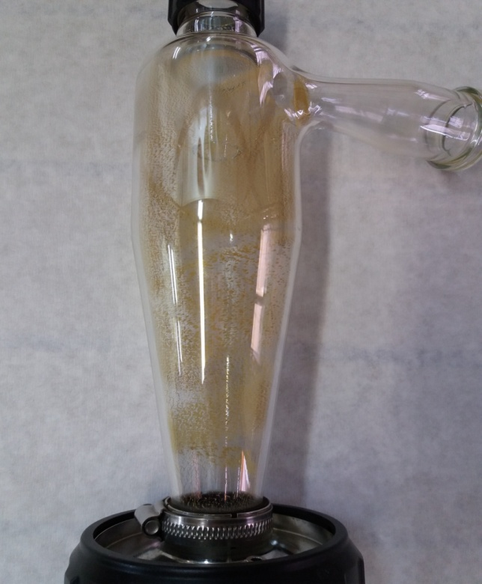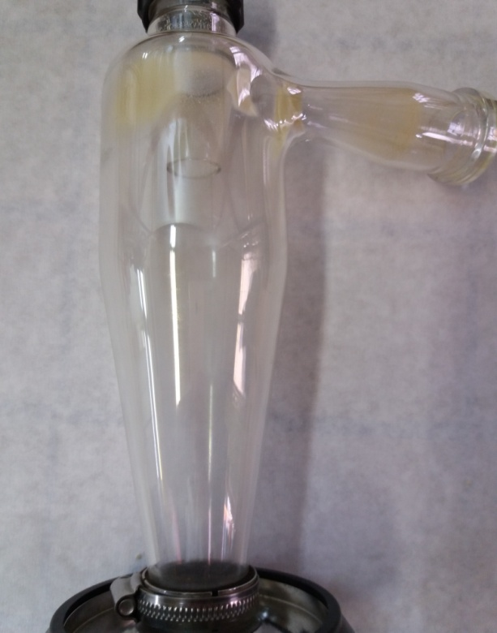
A
B
Supplement 1. Cyclone of spray dryer device after drying of (A) pure wild thyme extract and (B) gelatin encapsulated extract.
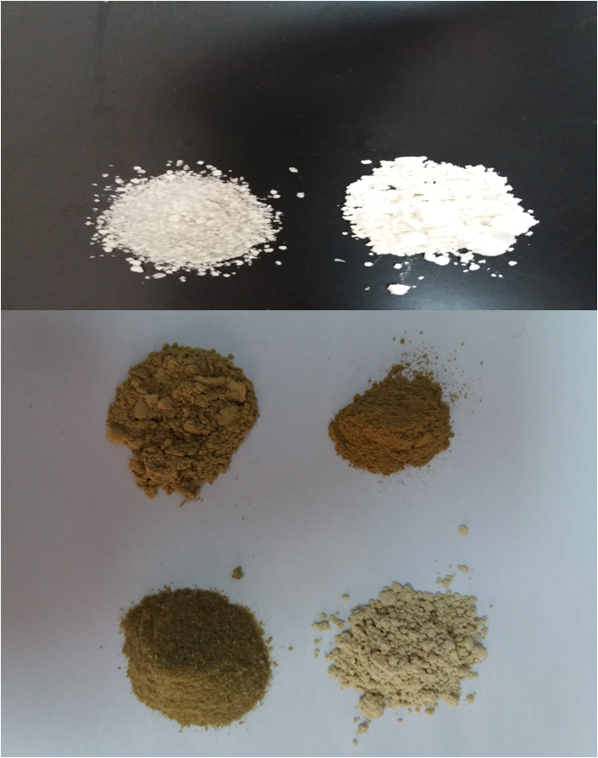
C
B
A
A
Supplement 2. Macroscopic view of lyophilized and spray dried (A) gelatin, (B) wild thyme extract and (C) gelatin encapsulated wild thyme extract obtained in heat-assisted extraction.
II
I
Supplement 3. Thermograms of lyophilized (I) and spray dried samples (II) (a) gelatin, wild thyme extracts obtained by (b) high temperature and (c) microwaves, and gelatin encapsulated extract obtained by (d) high temperature and (e) microwaves; differential scanning calorimetry.

