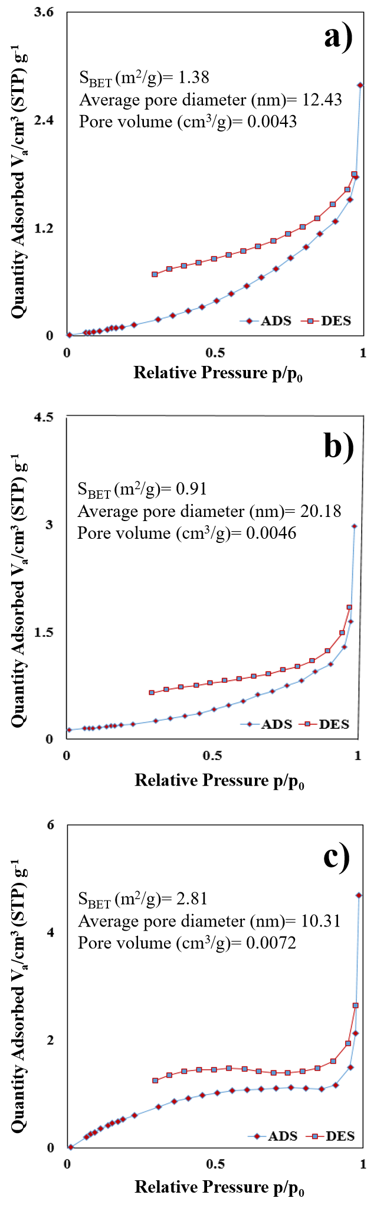
Fig. S1. N₂ adsorption–desorption isotherms for (a) OP, (b) NOP and c) SNOP.
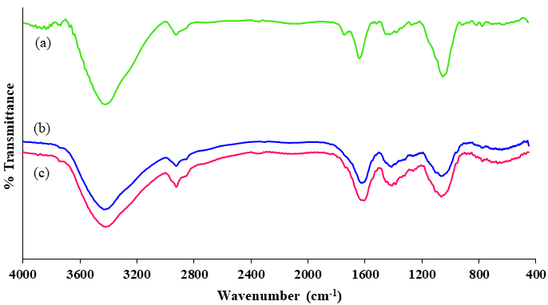
Fig. S2. FTIR spectra of (a) OP, (b) SNOP and (c) NOP.

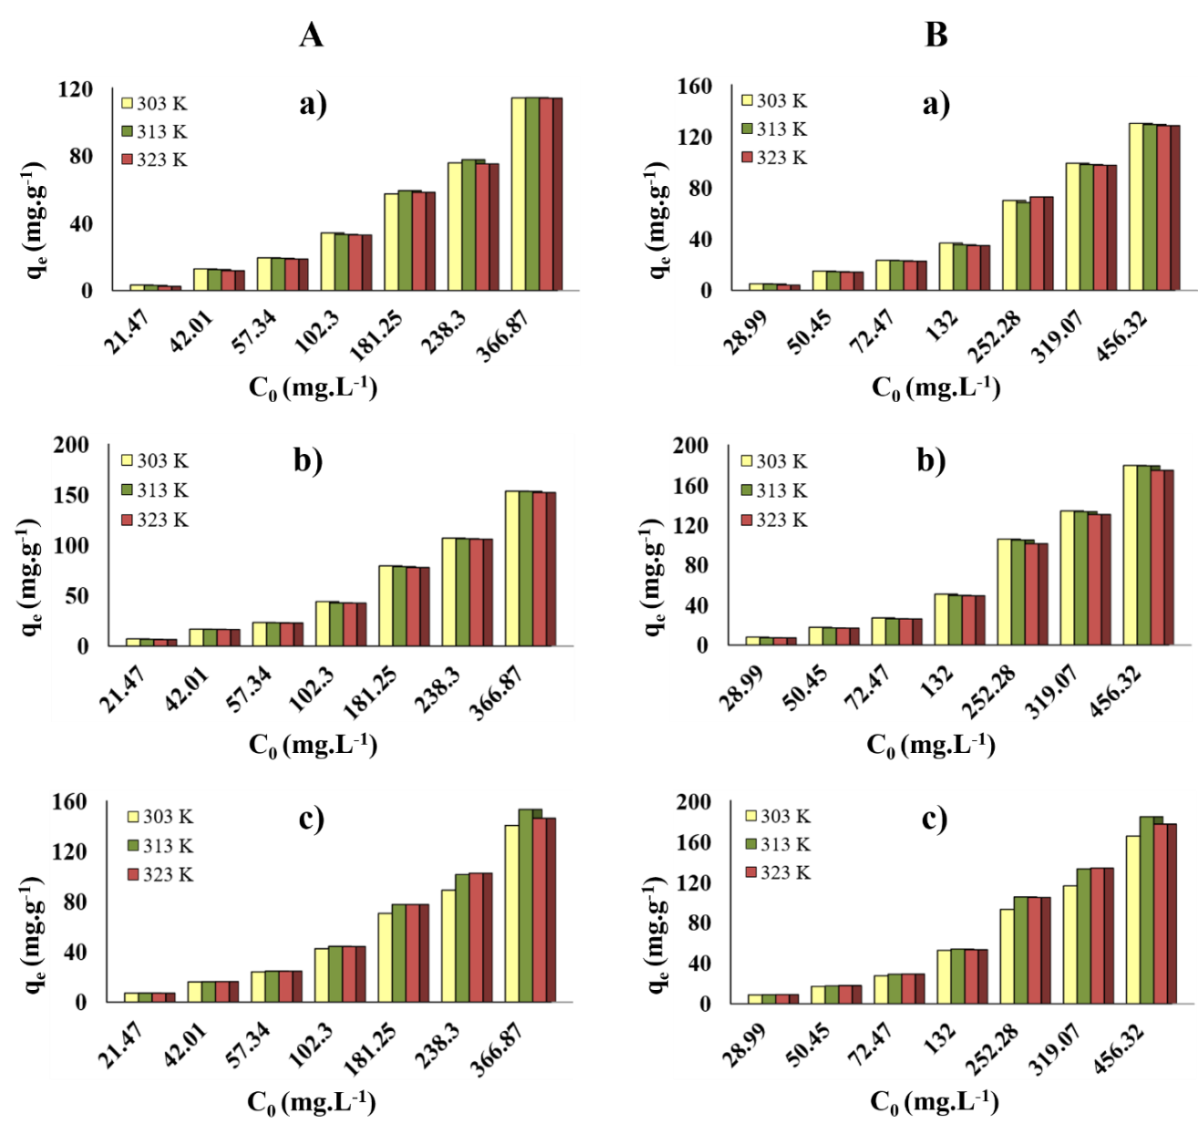
FigS3. Effect of temperature on the multi-component adsorption of A) MB and B) CV at different initial concentrations onto a) OP, b) NOP and c) SNOP.

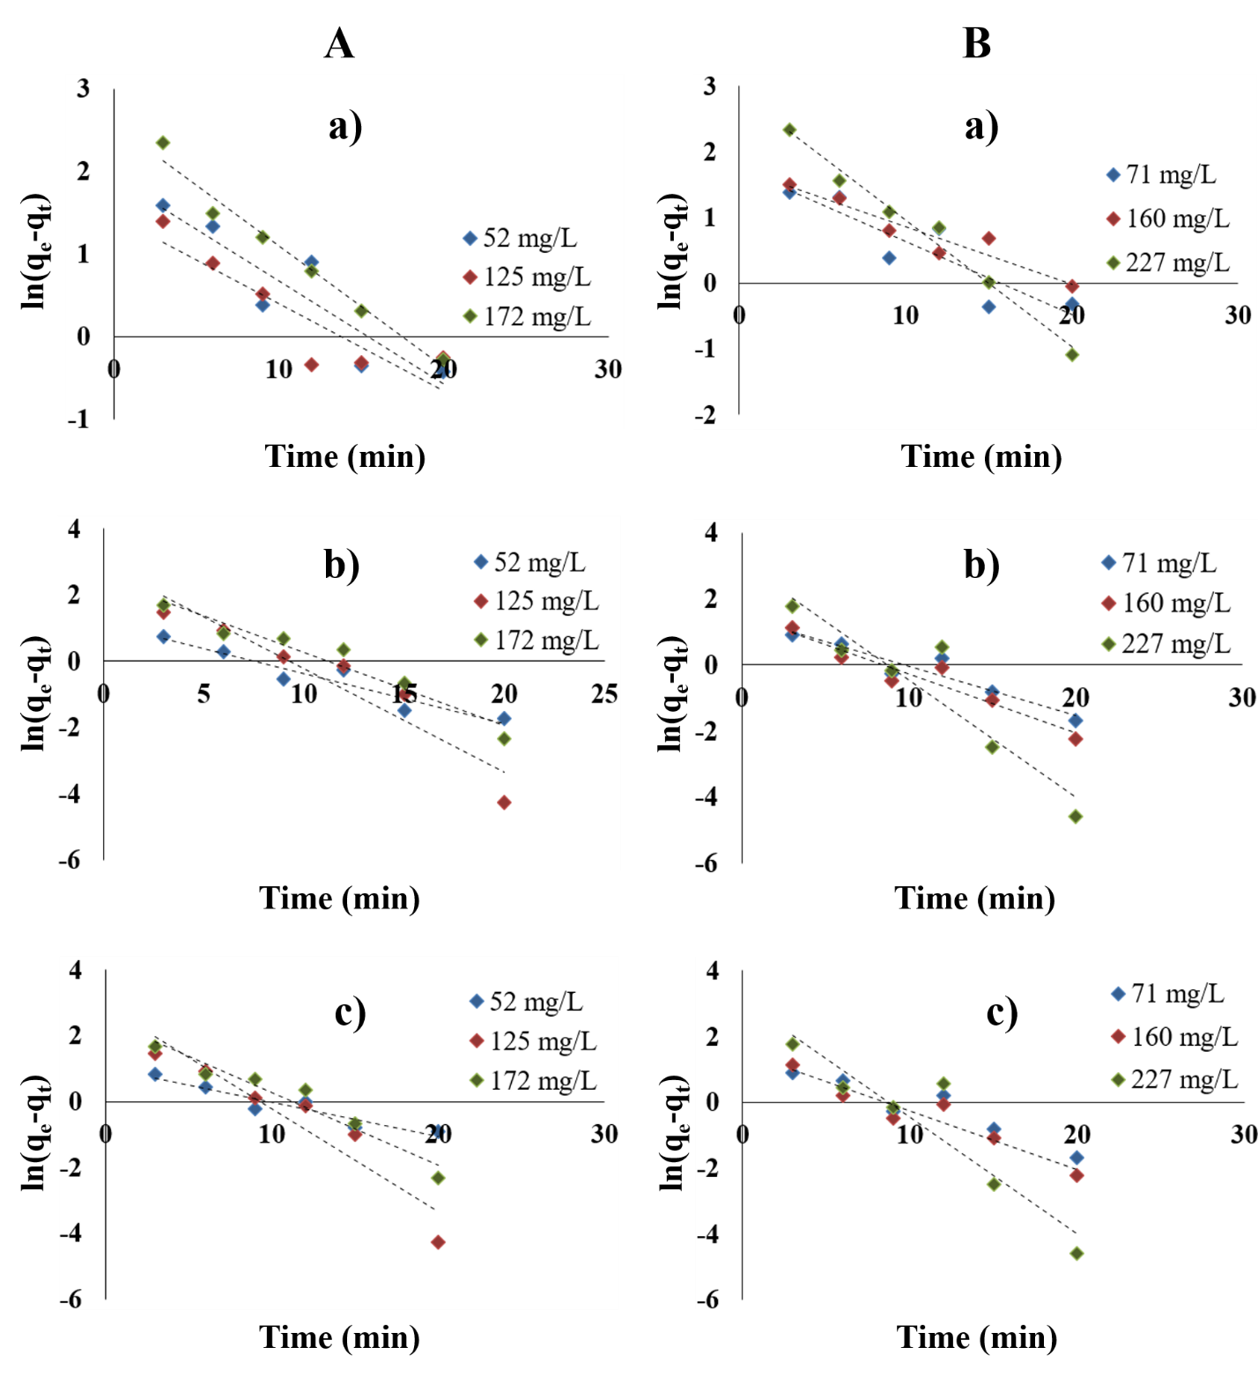
FigS4. Pseudo-first-order kinetic model for binary adsorption of A) MB and B)
CV onto a) OP, b) NOP and c) SNOP.

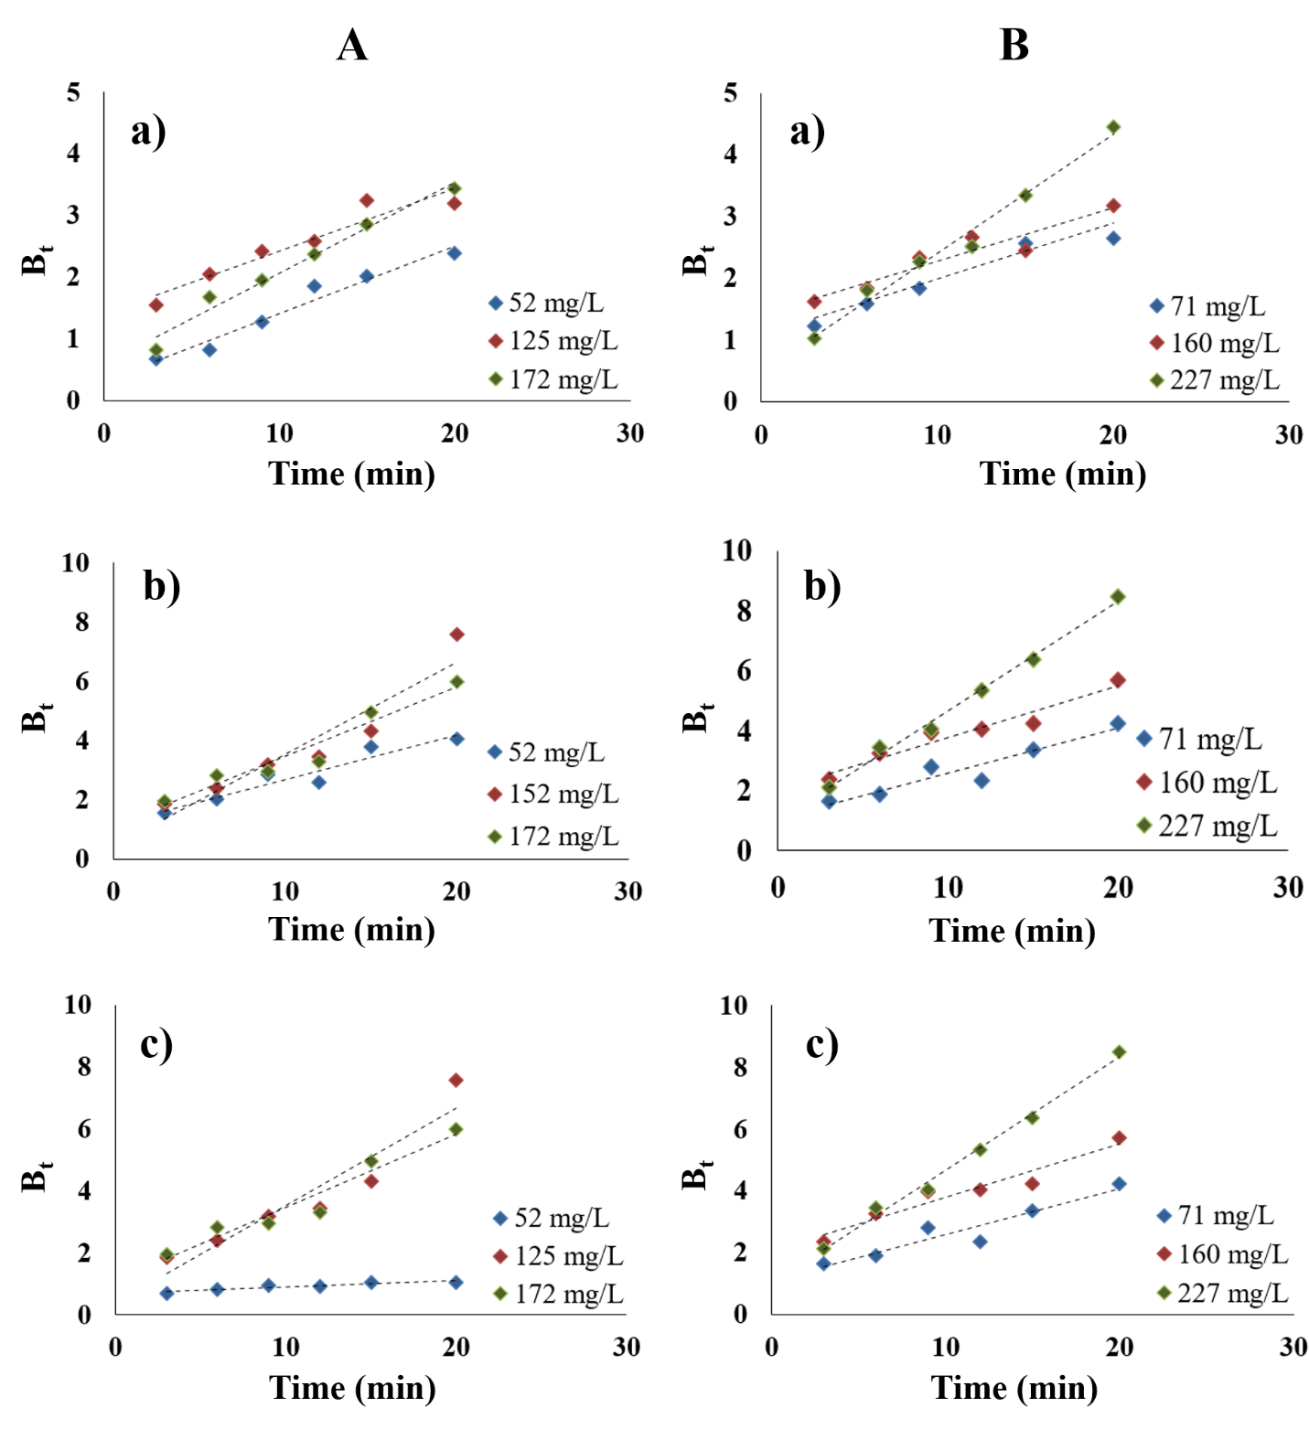
FigS5. Plots of B_{t} vs time for different initial concentrations of mixed solutions of A) MB and B) CV onto a) OP, b) NOP and c) SNOP.

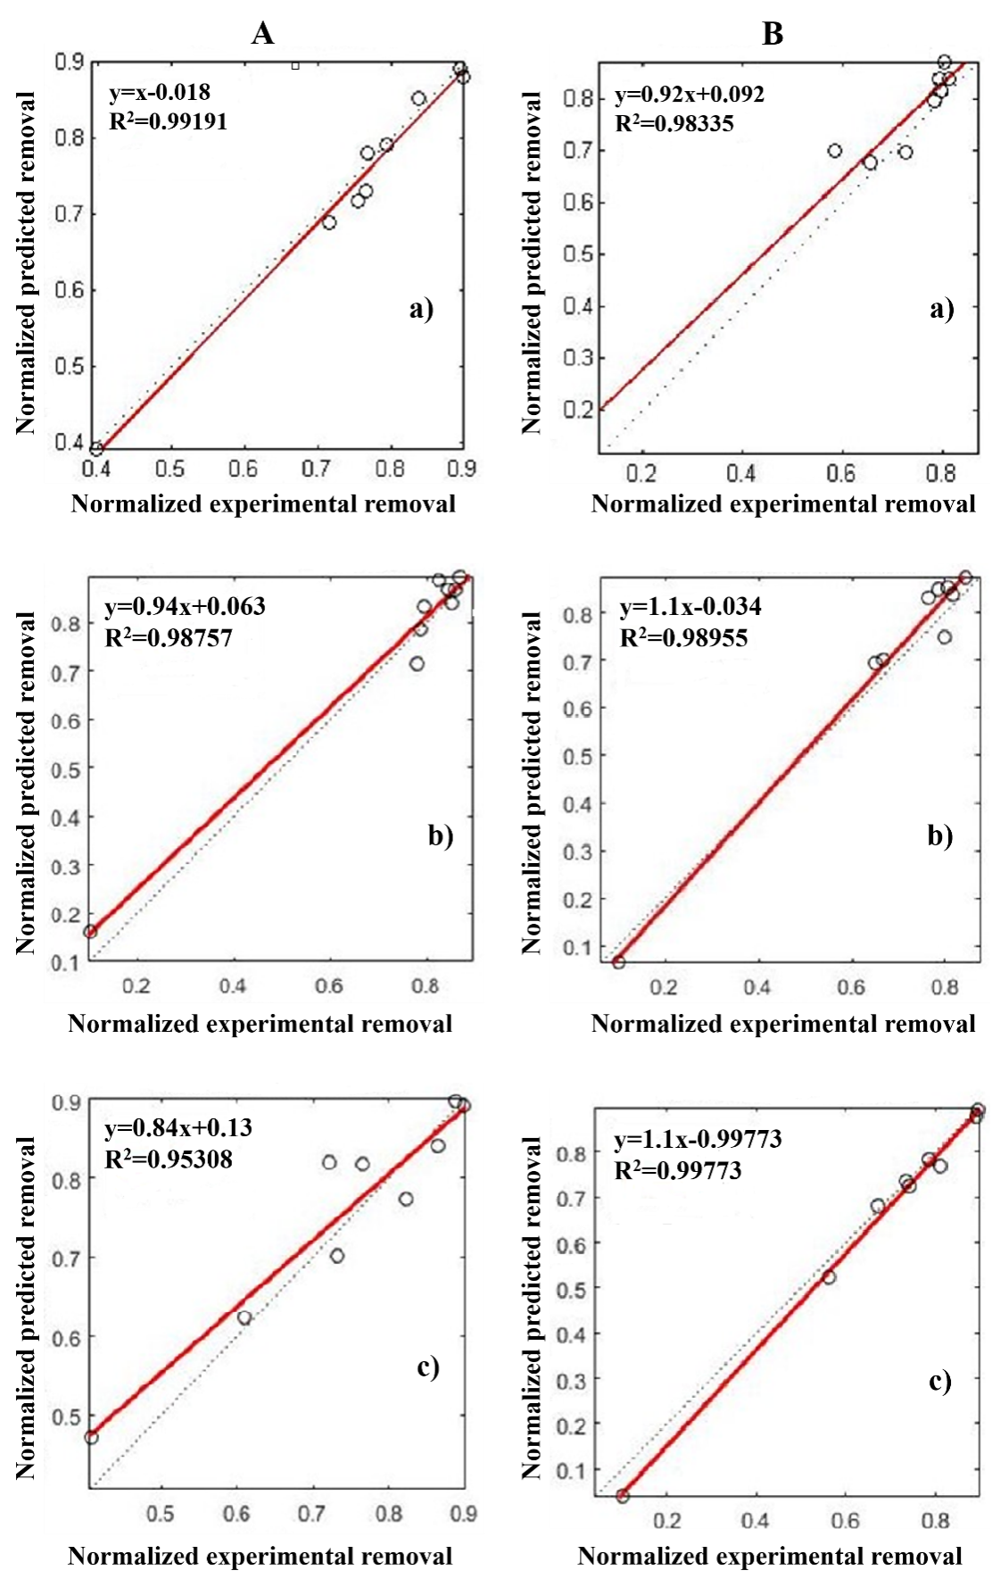
FigS6. Predicted normalized results vs. experimental normalized results for the test data setsfor multi-component adsorption of A) MB and B) CV onto a) OP, b) NOP and c) SNOP for the optimum number of hidden layer.

