Appendix
Table-1. Mean concentration ± standard deviation of elements that were found as below detection limit (Bdl) at one or more than one sector of the Chilika lagoon.
Seasons | Elements | Pre-COVID |  |  | Post-COVID
 |  | Sectors |  |  | Sectors
 |  | Northern | Central | Southern | Northern | Central | Southern
Pre-Monsoon | Be | Bdl | 0.15 ± 0.12 | 0.30 ± 0.0 | 0.01± 0.0 | 0.13 ± 0.06 | 0.08 ± 0.0
 | Cd | Bdl | 0.40 ± 0.14 | Bdl | Bdl | 0.26 ± 0.19 | Bdl
 | Co | Bdl | 1.10 ± 0.42 | Bdl | 0.65 ±0.35 | 1.07 ± 0.49 | Bdl
 | Ni | Bdl | 1.08 ± 0.45 | Bdl | 1.25± 0.07 | 0.93 ± 0.15 | Bdl
 | Pb | Bdl | 2.26 ± 1.69 | Bdl | 2.45± 0.79 | 3.17 ± 0.94 | 2.25± 1.20
Monsoon | Be | 0.15 ± 0.06 | 0.11 ± 0.07 | 0.10 ± 0.0 | Bdl | Bdl | 0.10 ± 0.13
 | Cd | Bdl | 0.69 ± 0.62 | Bdl | Bdl | Bdl | 0.11 ± 0.30
 | Co | 0.31 ± 0.04 | 0.45 ± 0.30 | 0.50 ± 0.34 | Bdl | 0.52 ± 0.40 | 0.36 ± 0.31
 | Ni | Bdl | 1.35 ± 0.41 | Bdl | 0.40 ± 0.74 | 1.25 ± 3.32 | 0.71 ± 1.08
 | Pb | 1.12 ± 1.77 | 2.90 ± 0.77 | 2.04 ± 1.12 | Bdl | Bdl | Bdl
Post-Monsoon | Be | Bdl | 0.10 ± 0 | Bdl | Bdl | 0.11 ± 0.06 | Bdl
 | Cd | Bdl | 0.74 ± 1.49 | 0.20 ±0.08 | 0.40 ± 0.14 | 0.82 ± 1.11 | 0.15 ± 0.10
 | Co | 0.37 ± 0.05 | 0.37 ± 0.08 | 0.36 ±0.05 | 0.31 ± 0.07 | 0.34 ± 0.09 | Bdl
 | Ni | 0.70 ± 0.99 | 5.55 ± 6.29 | 0.95 ± .34 | 1.60 ± 1.27 | 1.60 ± 1.84 | 1.24 ± 0.10
 | Pb | Bdl | Bdl | 0.70 ± 0.99 | 2.74 ± 3.62 | 6.27 ± 5.72 | Bdl

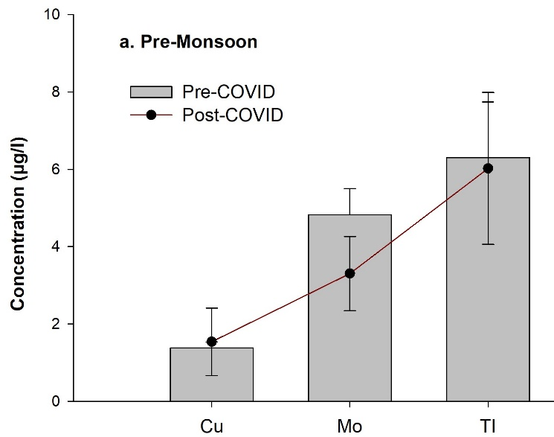 | 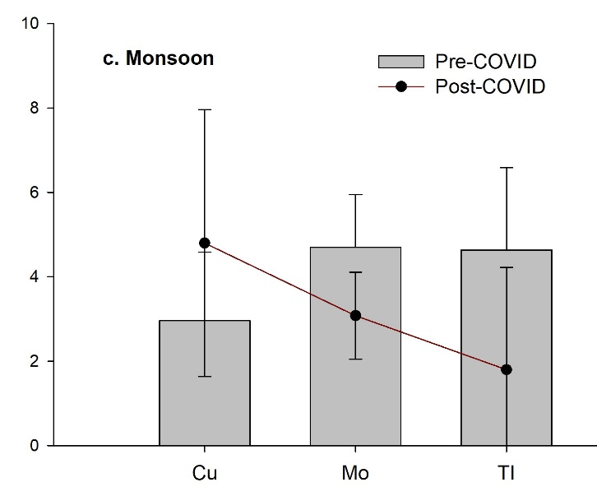 | 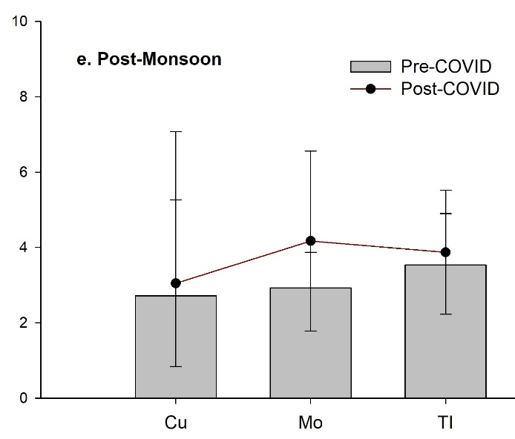
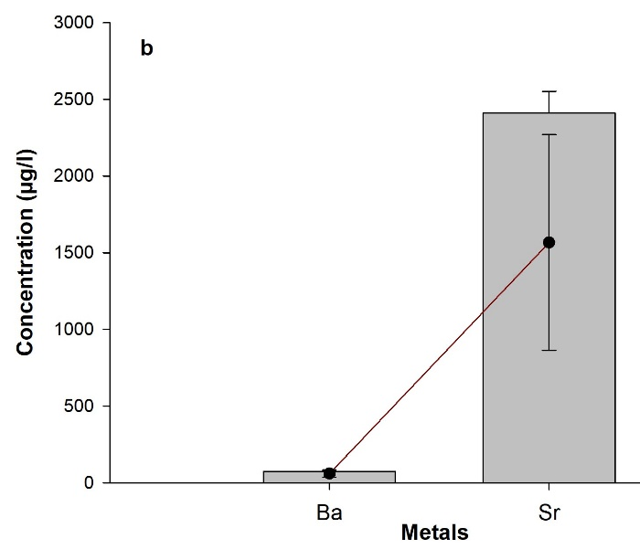 | 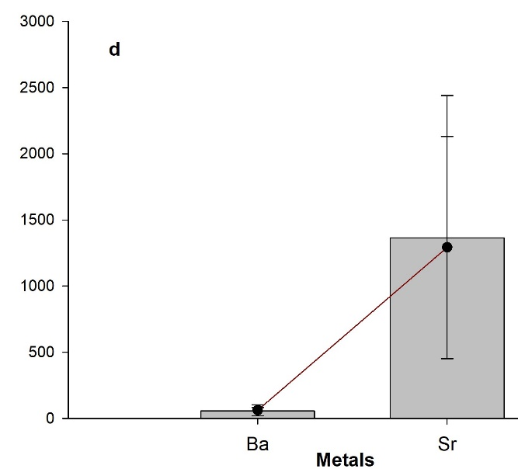 | 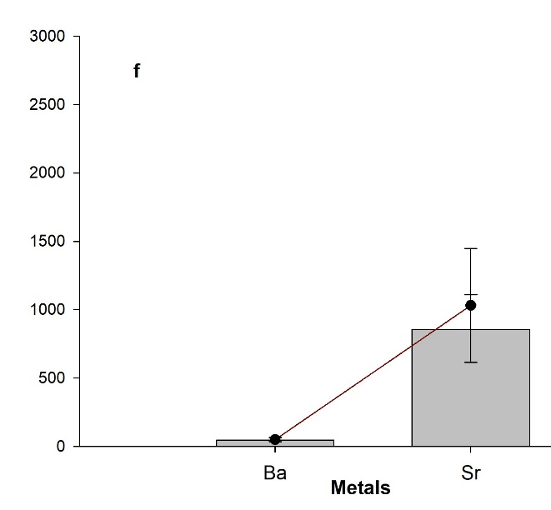
Fig.1. Fig.4 Mean concentration ± standard deviation of statistically not-significant elements (Ba, Cu, Mo, Tl and Sr) in post-COVID scenarios between sectors and seasons are plotted against pre-COVID scenarios. Elements such as Ba and Sr are separated due to their high concentration than other elements for better representation. Pre-monsoon (a and b), monsoon (c and d) and post-monsoon (e and f).

