Supporting information

**Surface Activity of Humic Acid and Its Sub-fractions from Forest Soil**

**Shijie Tian1, Weiqiang Tan1*, Xinyuan Wang1, Tingting Li2, Fanhao Song2, Nannan Huang2**

1School of Environmental and Municipal Engineering, Qingdao University of Technology, Qingdao 266033, China.

2State Key Laboratory of Environmental Criteria and Risk Assessment, Chinese Research Academy of Environmental Sciences, Beijing 100012, China.

* Correspondence: Weiqiang Tan, tanweiqiang@qut.edu.cn

Figure captions

**Figure S1.** Relationships between CMC and percentage of alkyl C, O-alkyl C, aromatic C and carbonyl C base on 13C NMR of HA and its sub-fractions: CMC vs. alkyl C (┄), CMC vs. O-alkyl C (┄), CMC vs. aromatic C (┄), CMC vs. carbonyl C (┄).

**Figure S2.** Effect of concentration on Zeta potential for HA.

**Figure S3.** Intensity-base PSDs of HA and its sub-fractions (a. HA1; b. HA2; c. HA3; d. HA4; e. HA5; f. HA6; g. HA).

**Figure S4.** Volume-base PSDs of HA and its sub-fractions (a. HA1; b. HA2; c. HA3; d. HA4; e. HA5; f. HA6; g. HA).

Figure S5. Gaussian peak distribution of Number PSDs for six HA sub-fractions at concentrations of 2000 mg·L-1, pH = 6.86 (■ HA1; ■ HA2; ■ HA3; ■ HA4; ■ HA5; ■ HA6).

Table captions

**Table S1.** Multiple linear equations obtained by previous researchers.



**Figure S1.** Relationships between CMC and percentage of alkyl C, O-alkyl C, aromatic C and carbonyl C base on 13C NMR of HA and its sub-fractions: CMC vs. alkyl C (┄), CMC vs. O-alkyl C (┄), CMC vs. aromatic C (┄), CMC vs. carbonyl C (┄).



**Figure S2.** Effect of concentration on Zeta potential for HA.

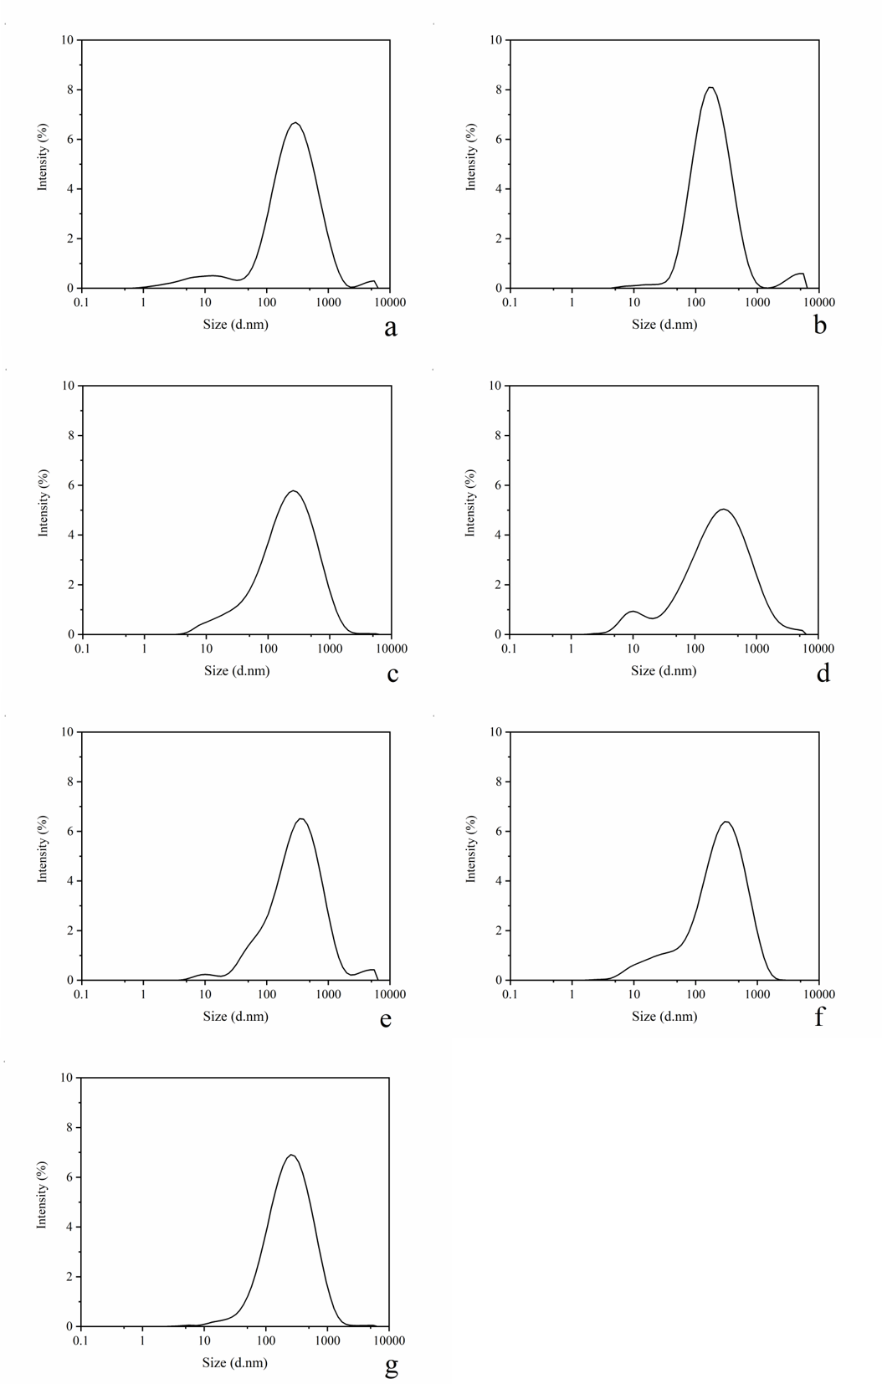

**Figure S3.** Intensity-base PSDs of HA and its sub-fractions (a. HA1; b. HA2; c. HA3; d. HA4; e. HA5; f. HA6; g. HA).

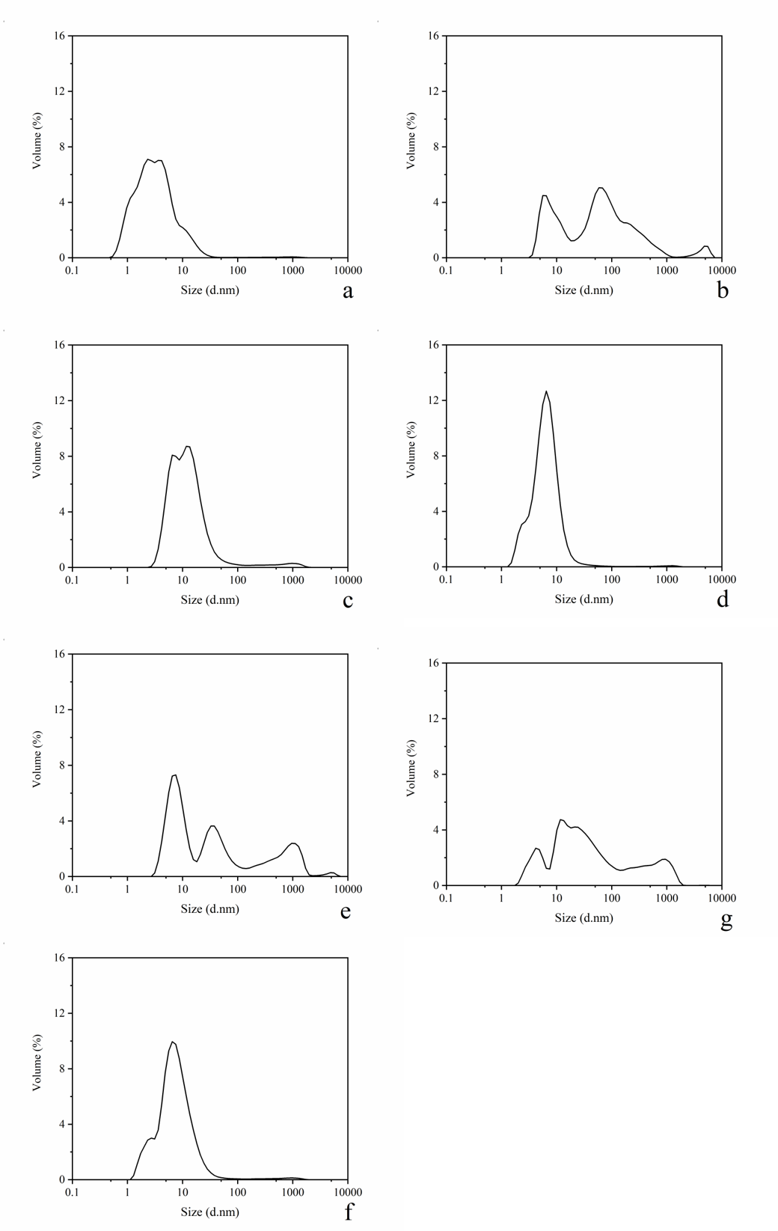

**Figure S4.** Volume-base PSDs of HA and its sub-fractions (a. HA1; b. HA2; c. HA3; d. HA4; e. HA5; f. HA6; g. HA).



Figure S5. Gaussian peak distribution of Number PSDs for six HA sub-fractions at concentrations of 2000 mg·L-1, pH = 6.86 (■ HA1; ■ HA2; ■ HA3; ■ HA4; ■ HA5; ■ HA6).

**Table S1.** Multiple linear equations obtained by previous researchers

|  |  |  |  |  |  |
| --- | --- | --- | --- | --- | --- |
|  | Equation | n | R2 | *p* | ref |
| S1 | CMC = 24.6–0.189×alkyl-C–2.64(N+S) | 6 | 0.770 | <0.1 | Quadri, et al. [1] |
| S2 | CMC = 12,246–56.19×alkyl-C–0.532×MW | 7 | 0.900 | <0.05 | Adani, et al. [2] |
| S3 | CMC = 8565–(22.1×H)–(146×alkyl-C)–(176×aromatic-C)+1877×HB/HI | 13 | 0.878 | <0.0001 | Salati, et al. [3] |

References

1. Quadri, G.; Chen, X.; Jawitz, J. W.; Tambone, F.; Genevini, P.; Faoro, F.; Adani, F., Biobased surfactant-like molecules from organic wastes: the effect of waste composition and composting process on surfactant properties and on the ability to solubilize tetrachloroethene (PCE). *Environmental Science & Technology* **2008,** *42*, (7), 2618-2623. https://doi.org/10.1021/es702144t.

2. Adani, F.; Tambone, F.; Davoli, E.; Scaglia, B., Surfactant properties and tetrachloroethene (PCE) solubilisation ability of humic acid-like substances extracted from maize plant and from organic wastes: A comparative study. *Chemosphere* **2010,** *78*, (8), 1017-1022. https://doi.org/10.1016/j.chemosphere.2009.11.039.

3. Salati, S.; Papa, G.; Adani, F., Perspective on the use of humic acids from biomass as natural surfactants for industrial applications. *Biotechnology Advances* **2011,** *29*, (6), 913-22. https://doi.org/10.1016/j.biotechadv.2011.07.012.