Supplementary information 1. General circulation models used in ecological niche model projections in RCP 4.5 and RCP 8.5 for 2050.
General circulation model acronym | Institution
bnu_esm | Beijing Normal University Earth System Model
cesm1_bcg | National Center for Atmospheric Research – The University of Arizona
cesm1_cam5 | National Center for Atmospheric Research – The University of Arizona – NSF-DOE-NCAR
csiro_access1_3 | Commonwealth Scientific and Industrial Research Organization (CSIRO) and Bureau of Meteorology (BOM), Australia
csiro_access1 | Commonwealth Scientific and Industrial Research Organization (CSIRO) and Bureau of Meteorology (BOM), Australia
gfdl_cm3 | NOAA Geophysical Fluid Dynamics Laboratory
gfdl_esm2g | NOAA Geophysical Fluid Dynamics Laboratory
gfdl_esm2m | NOAA Geophysical Fluid Dynamics Laboratory
giss_e2_r | NASA Goddard Institute for Space Studies USA
giss_e2_h | NASA Goddard Institute for Space Studies USA
inm_cm4 | Russian Institute for Numerical Mathematics
miroc_esm | University of Tokyo, National Institute for Environmental Studies, and Japan Agency for Marine-Earth Science and Technology
miroc_esm_chem | University of Tokyo, National Institute for Environmental Studies, and Japan Agency for Marine-Earth Science and Technology
miroc_miroc5 | University of Tokyo, National Institute for Environmental Studies, and Japan Agency for Marine-Earth Science and Technology
mohc_hadgem2_cc | UK Met Office Hadley Centre
mohc_hadgem2_es | UK Met Office Hadley Centre
mri_cgcm3 | Meteorological Research Institute
ncar_ccsm4 | US National Centre for Atmospheric Research
ncc_noresm1_m | Norwegian Climate Centre
nimr_hadgem2_ao | UK Met Office Hadley Centre
cccma_canesm2 | Canadian Centre for Climate Modelling and Analysis  Canada
mpi_esm_lr | Max Planck Institute for Meteorology, Germany

Supplementary information figure 1. Known distribution areas of Lycoriella agraria. Occurrences used for calibration and evaluation of the model. Below is shown the accessible area (M): 50 km buffer around to all occurrences.
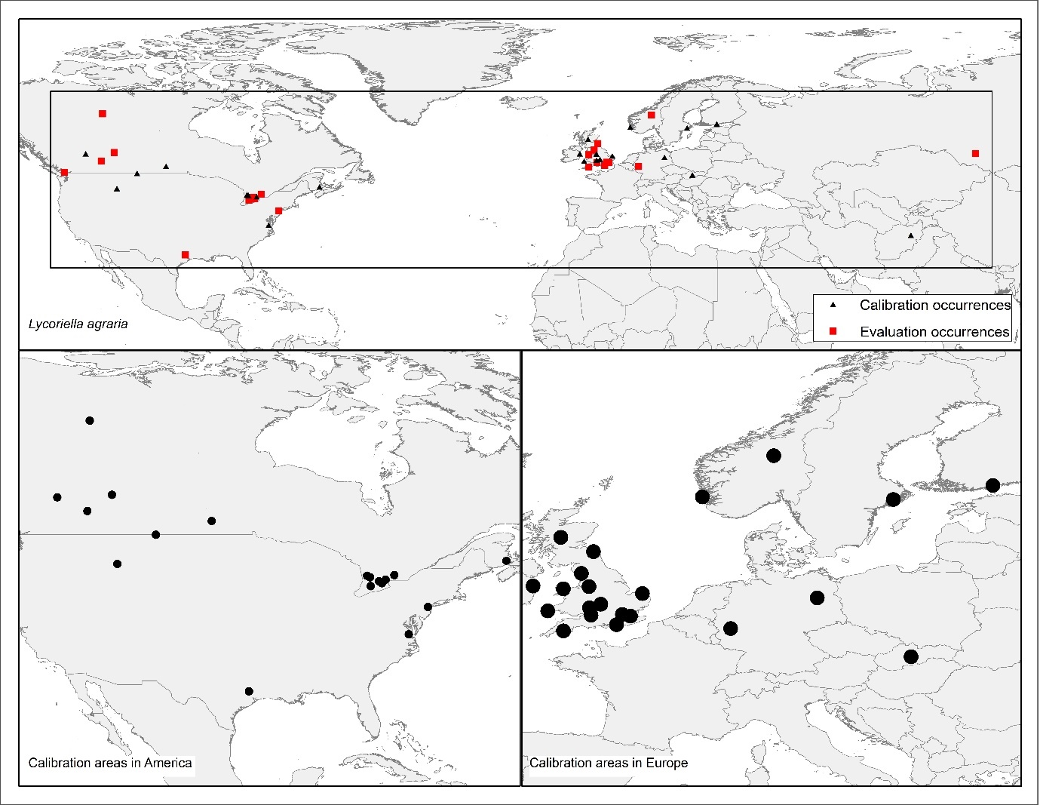

Supplementary information figure 2. Known distribution areas of Lycoriella ingenua: Occurrences used for calibration and evaluation of the model. Below is shown the accessible area (M): 50 km buffer around to all occurrences.

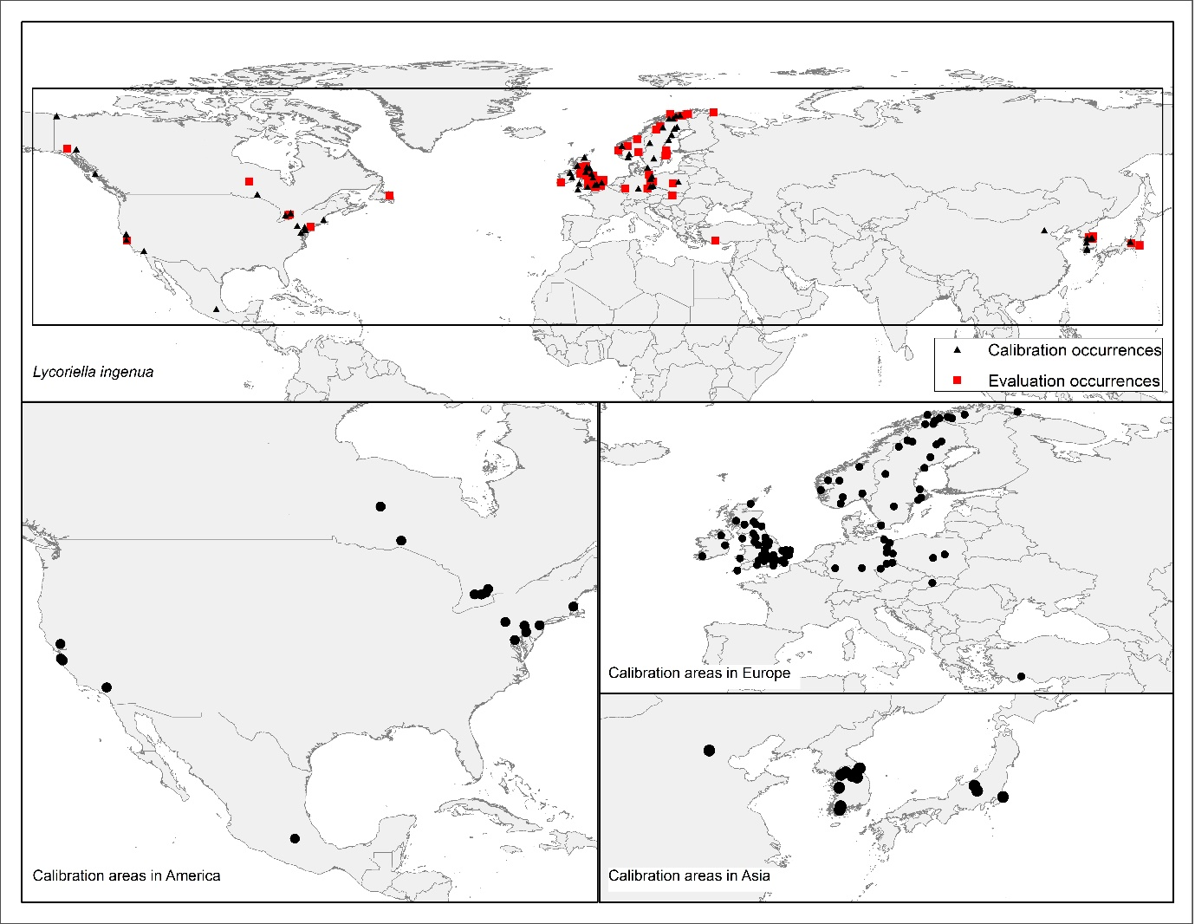

Supplementary information figure 3. Known distribution areas of Lycoriella sativae: Occurrences used for calibration and evaluation of the model. Below is shown the accessible area (M): 50 km buffer around to all occurrences.
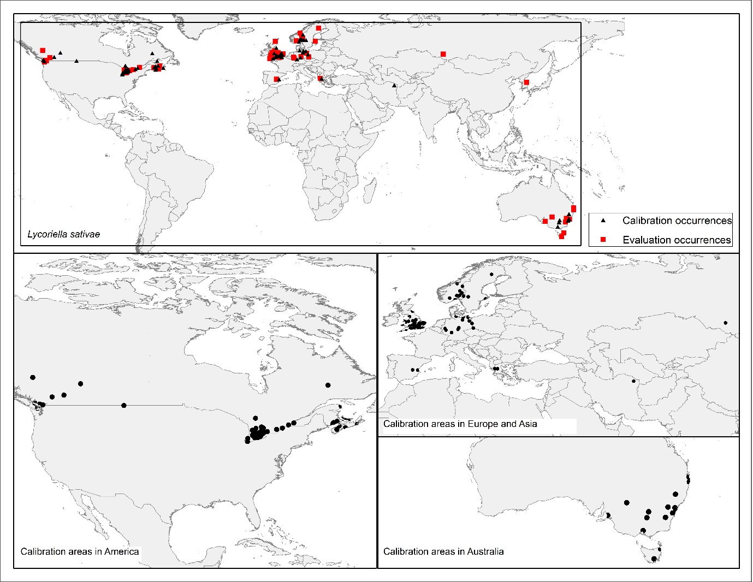

Supplementary information figure 4. Projections of environmental suitability for Lycoriella agraria in current and future scenarios (RCP 4.5 and RCP 8.5) for 2050 in low extrapolation risk areas.
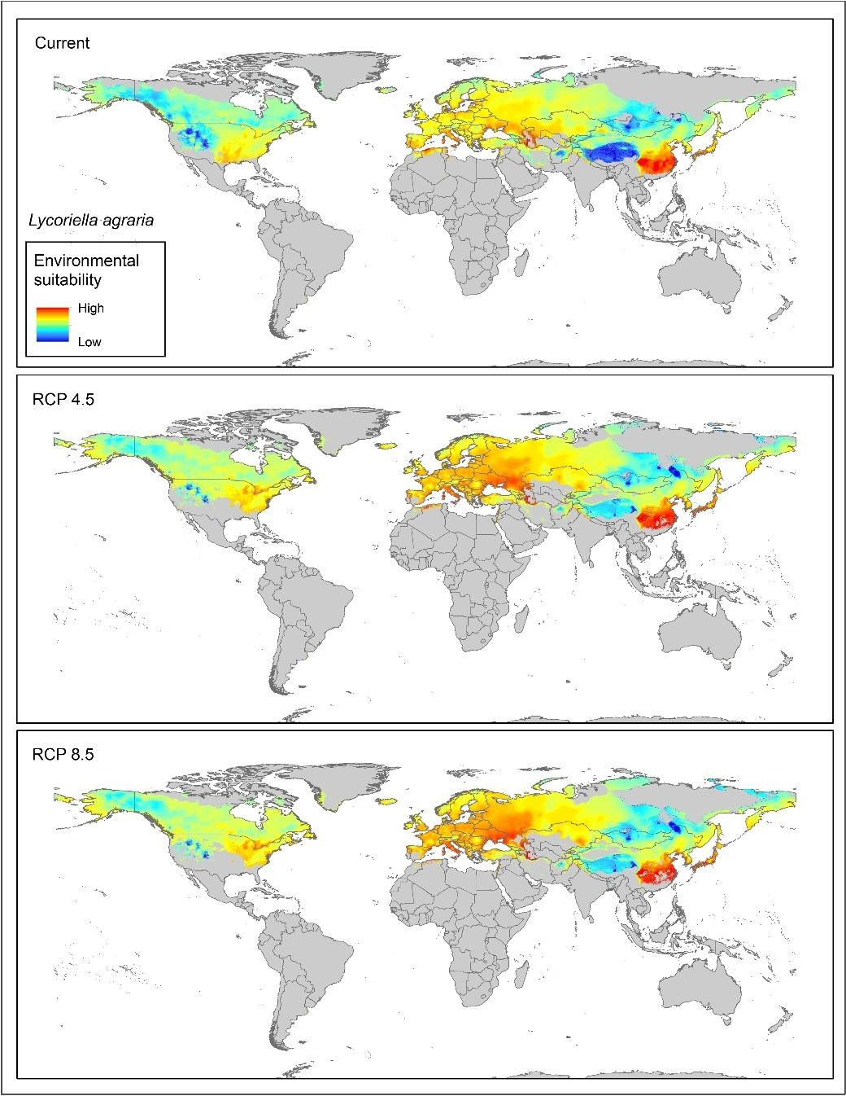

Supplementary information figure 5. Projections of environmental suitability for Lycoriella ingenua in current and future scenarios (RCP 4.5 and RCP 8.5) for 2050 in low extrapolation risk areas.
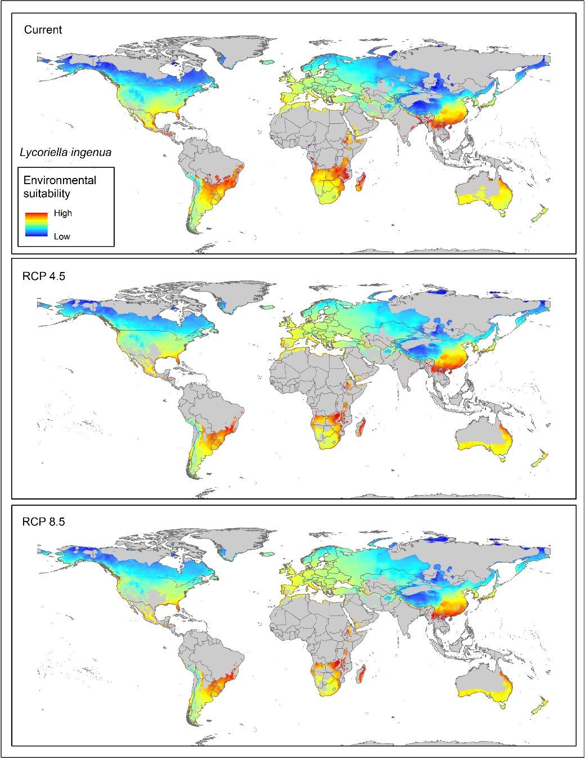

Supplementary information figure 6. Projections of environmental suitability for Lycoriella sativae in current and future scenarios (RCP 4.5 and RCP 8.5) for 2050 in low extrapolation risk areas.
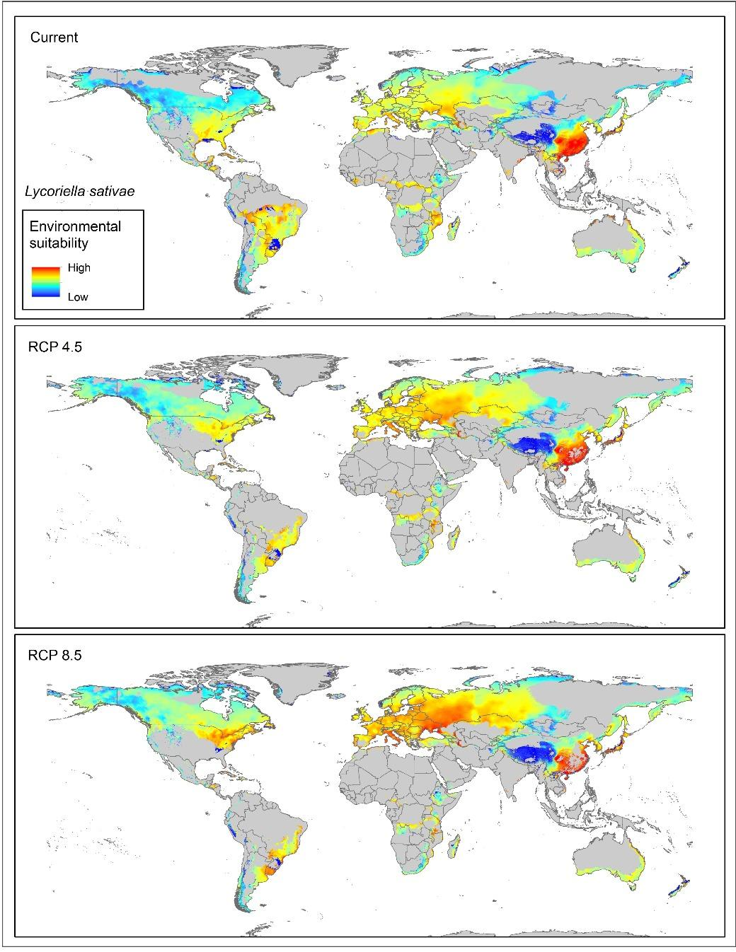

Supplementary information figure 7. MOP analysis of extrapolation risk from the calibration area under projection current and future conditions for Lycoriella agraria. Red areas represent strict extrapolation. Blue areas represent similarity between the calibration area (M) and the RCPs scenarios of projections.
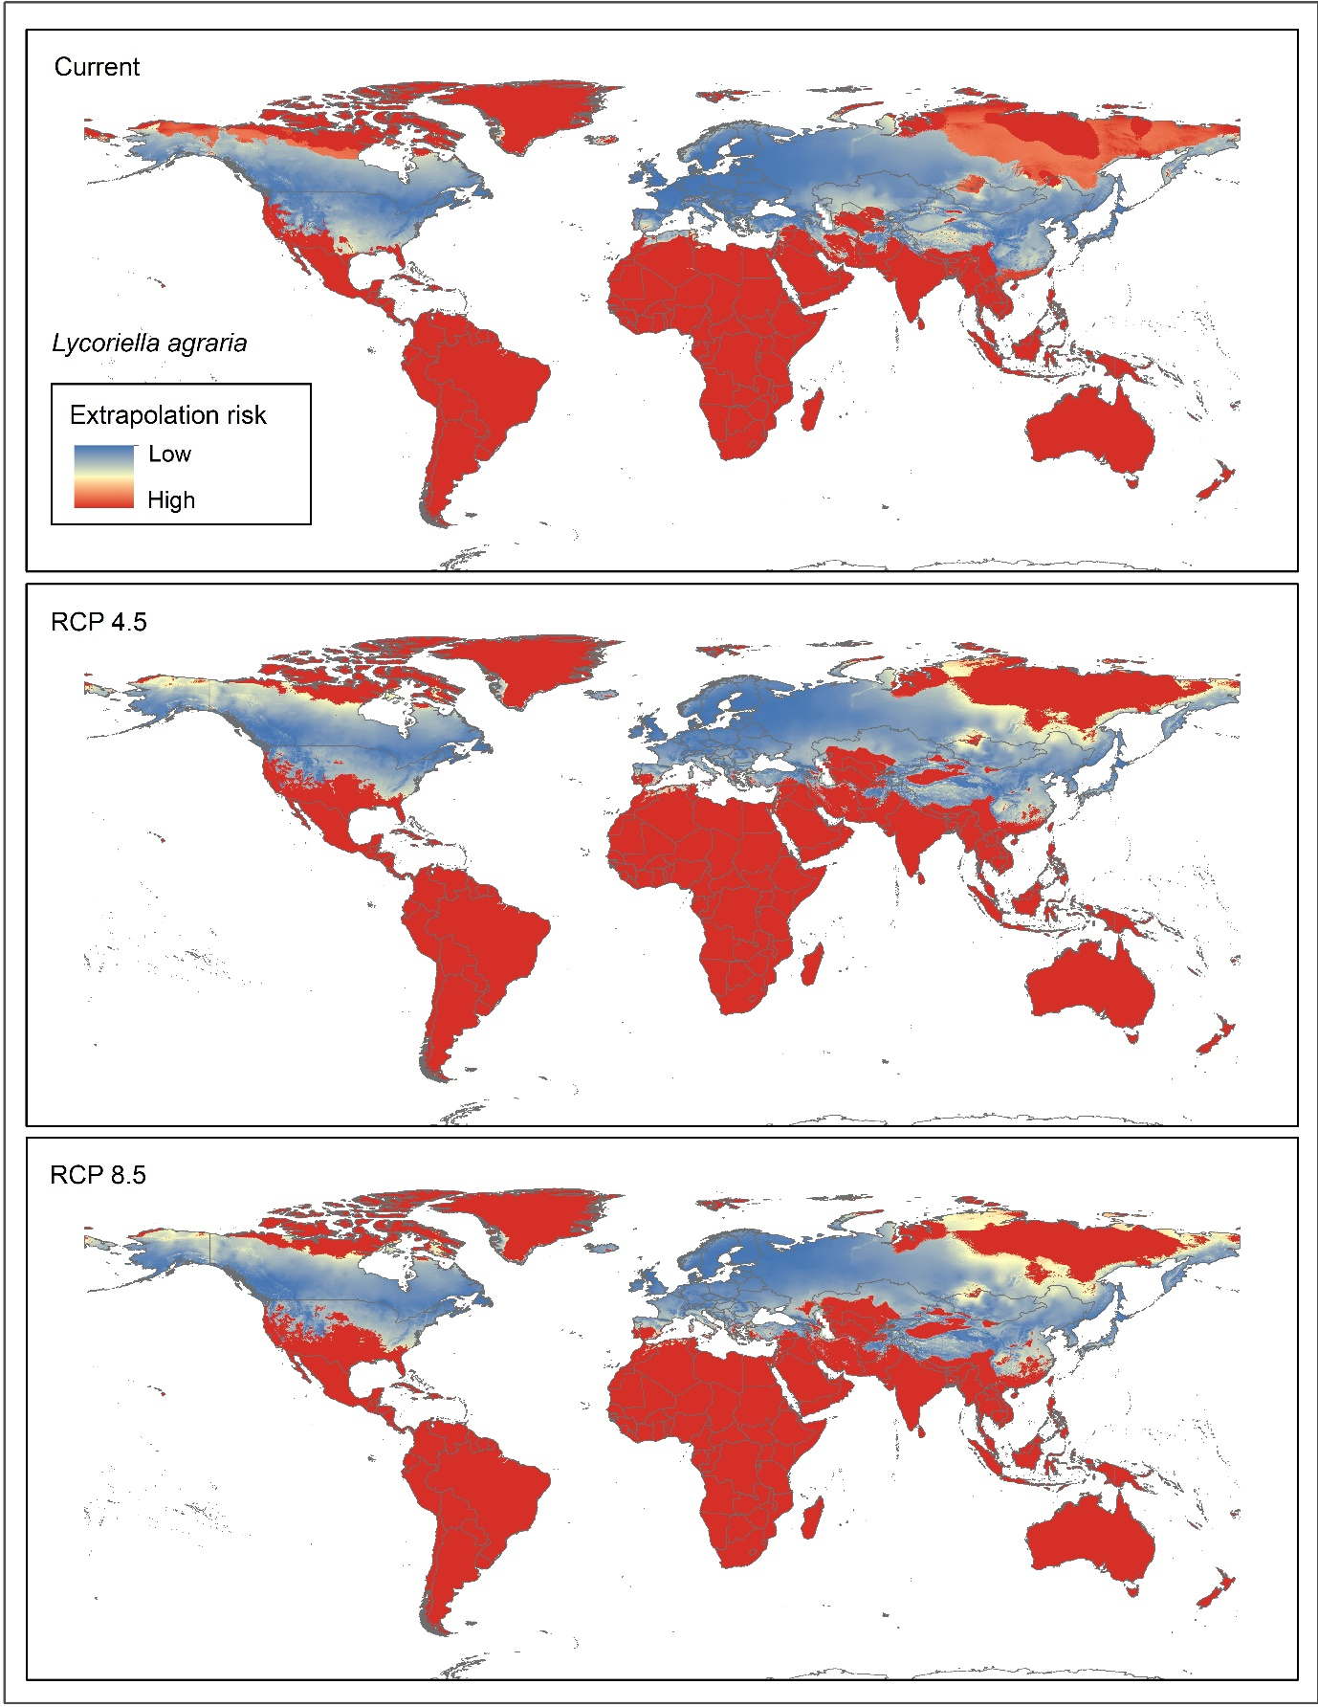

Supplementary information figure 8. MOP analysis of extrapolation risk from the calibration area under projection current and future conditions for Lycoriella ingenua. Red areas represent strict extrapolation. Blue areas represent similarity between the calibration area (M) and the RCPs scenarios of projections.

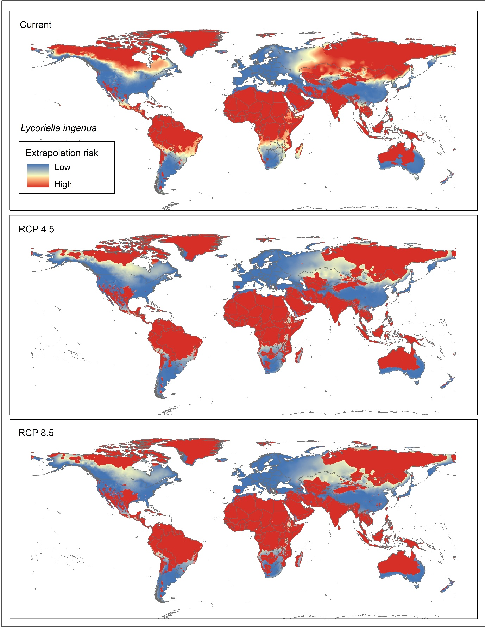

Supplementary information figure 9. MOP analysis of extrapolation risk from the calibration area under projection current and future conditions for Lycoriella sativae. Red areas represent strict extrapolation. Blue areas represent similarity between the calibration area (M) and the RCPs scenarios of projections.
