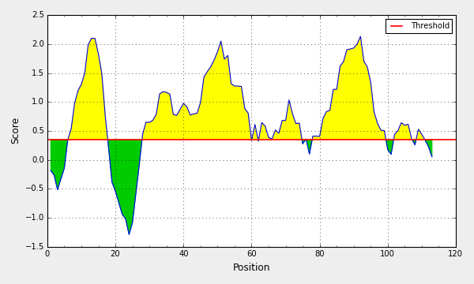

TiLV ORF10

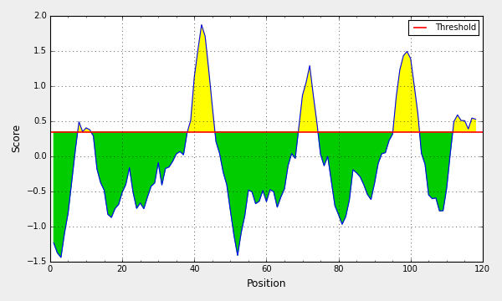

TiLV ORF9

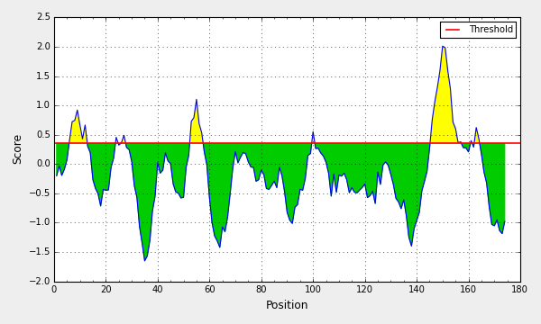

TiLV ORF8

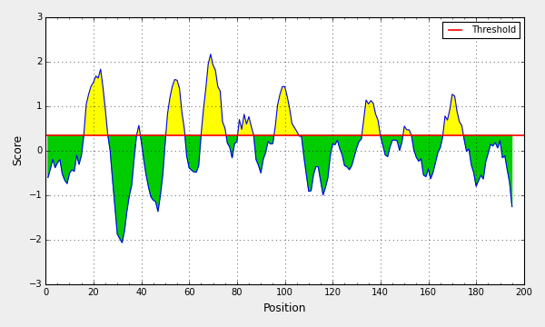

TiLV ORF7

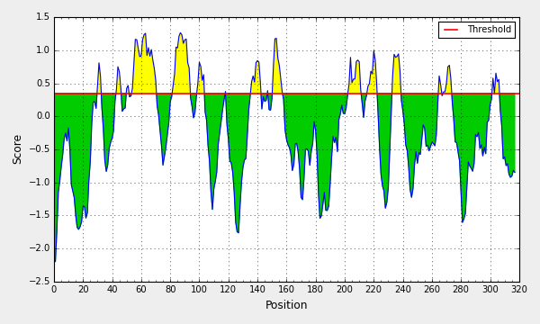

TiLV ORF6

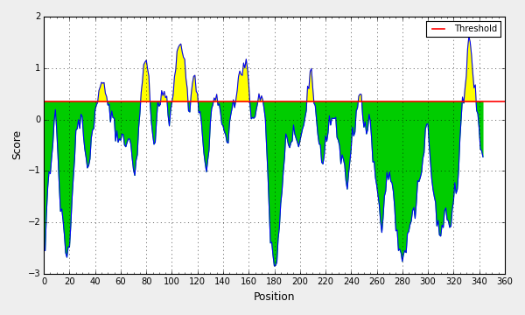

TiLV ORF5

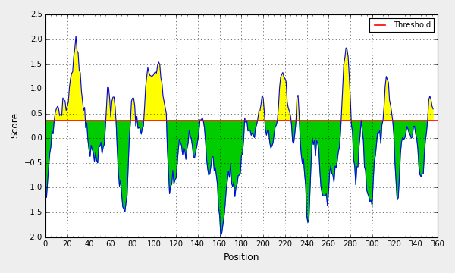

TiLV ORF4

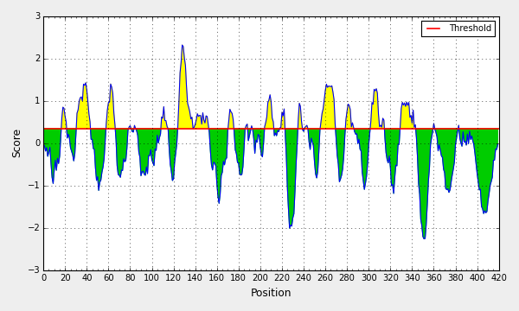

TiLV ORF3

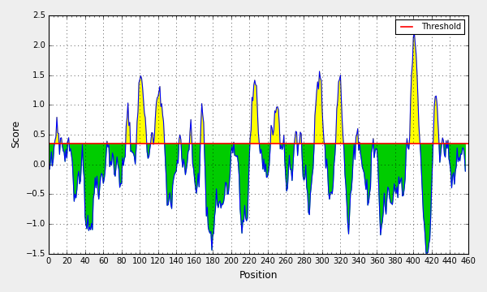

TiLV ORF2

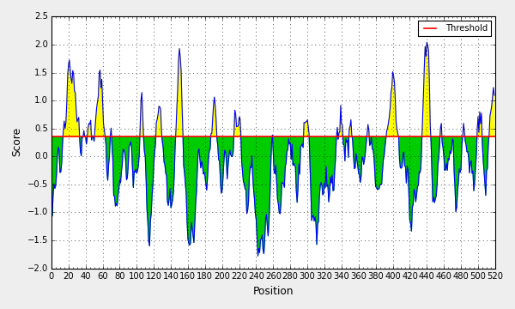

TiLV ORF1

**Supplementary Fig. 1** The antibody epitope prediction of 10 putative proteins encoded by TiLV. The antibody epitope prediction of 10 putative proteins encoded by TiLV segment 1~10 using the Bepipred Linear Epitope Prediction (IEDB analysis resource) at <http://tools.immuneepitope.org/bcell/>.