Clinical relevance of elevated soluble ST2, HSP27 and 20S proteasome in patients with COVID-19
Ralph Wendt¹ *, Marie-Therese Lingitz^{2,3}*, Maria Laggner², Michael Mildner^{2,4} Denise Traxler^{2,5}, Alexandra Graf⁶, Pavla Krotka⁶, Bernhard Moser^{2,7,}, Konrad Hoetzenecker⁷, Sven Kalbitz¹, Christoph Lübbert^{1,8}, Joachim Beige^{1,9}, Hendrik Jan Ankersmit^{2,7}
* contributed equally
1 Department of Infectious Diseases, Tropical Medicine, Nephrology and Rheumatology, St. Georg Hospital, Delitzscher Str. 141, D-04129 Leipzig, Germany
2 Laboratory for Cardiac and Thoracic Diagnosis, Department of Surgery, Regeneration and Applied Immunology, Medical University of Vienna, Research Laboratories Vienna General Hospital, Waehringer Guertel 18-20, 1090 Vienna, Austria
3 Department of Anaesthesia, Intensive Care Medicine and Pain Medicine, Medical University of Vienna, Waehringer Guertel 18-20, 1090 Vienna, Austria
4 Department of Dermatology, Medical University of Vienna, Waehringer Guertel 18-20, 1090 Vienna, Austria
5 Division of Cardiology, Department of Internal Medicine II, Medical University of Vienna, Waehringer Guertel 18-20, 1090 Vienna, Austria
6 Center for Medical Statistics, Informatics and Intelligent Systems, Medical University of Vienna, Spitalg. 23, 1090 Vienna, Austria
7 Division of Thoracic Surgery, Department of Surgery, Medical University of Vienna, Waehringer Guertel 18-20, 1090 Vienna, Austria
8 Division of Infectious Diseases and Tropical Medicine, Department of Medicine II, Leipzig University Medical Center, Liebigstr. 20, D-04103 Leipzig, Germany
9 Martin-Luther-University Halle-Wittenberg, Halle/Saale, Germany
Corresponding author:
HJ Ankersmit
Department of Thoracic Surgery, Medical University of Vienna
Waehringer Guertel 18-20
1090 Vienna, Austria
phone: +43-(0)1-40400-67770
e-mail: hendrik.ankersmit@meduniwien.ac.at

Supplementary Material

Figure S1 ROC Curves for the endpoint 30-day mortality of investigated parameters 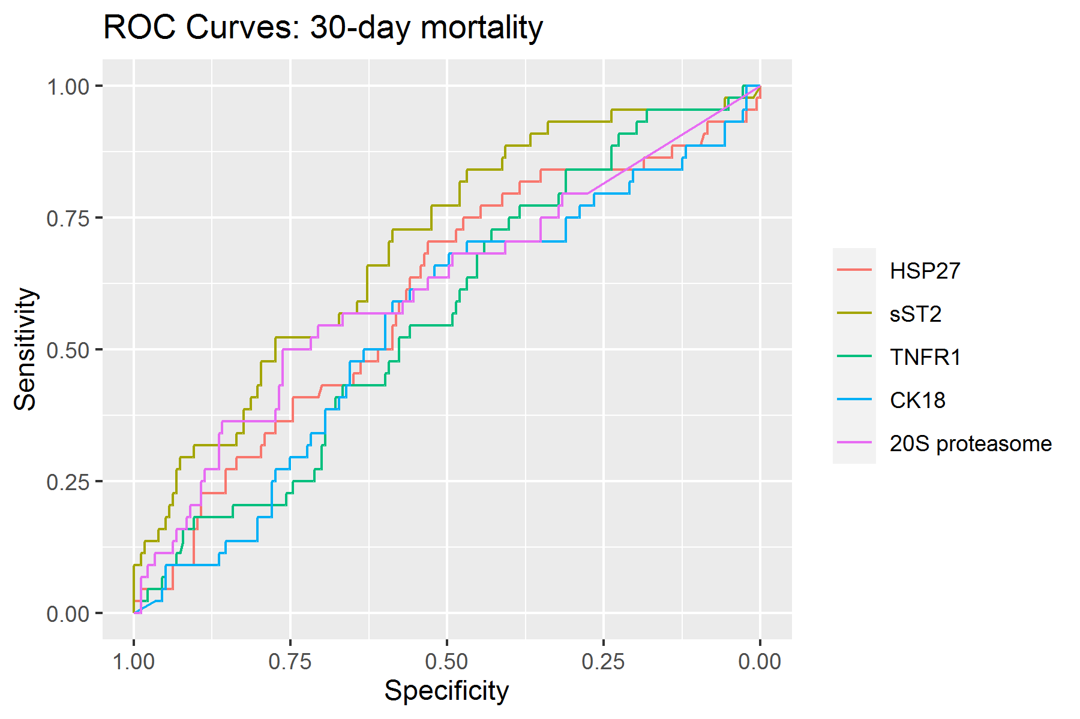

Figure S2 ROC Curves for the endpoint 60-day mortality of investigated parameters
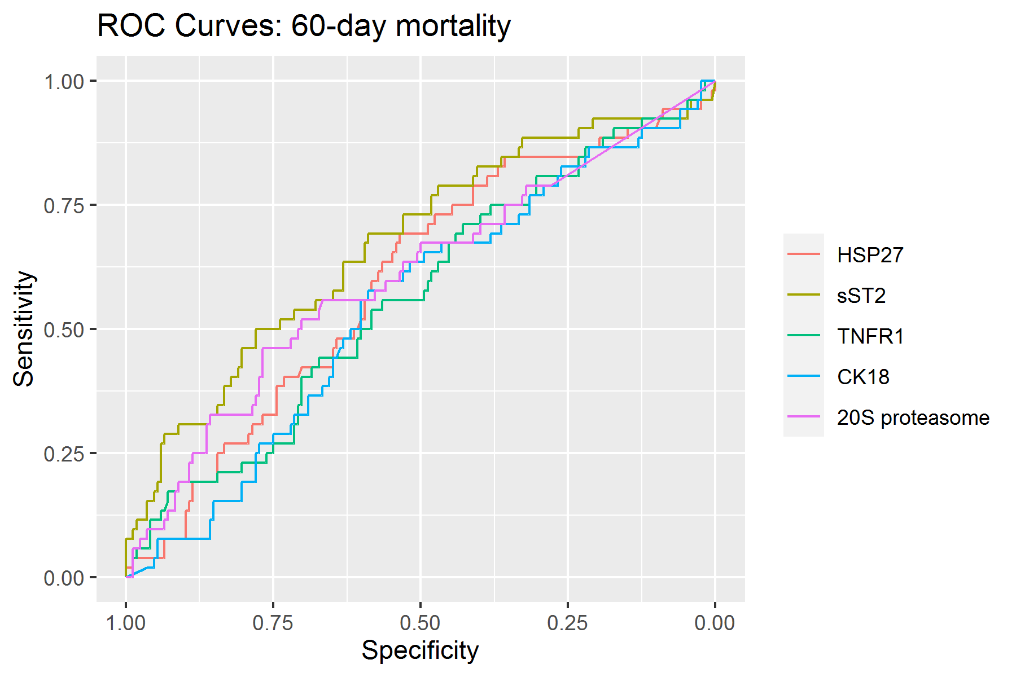

Figure S3 ROC Curves for the endpoint 90-day mortality of investigated parameters
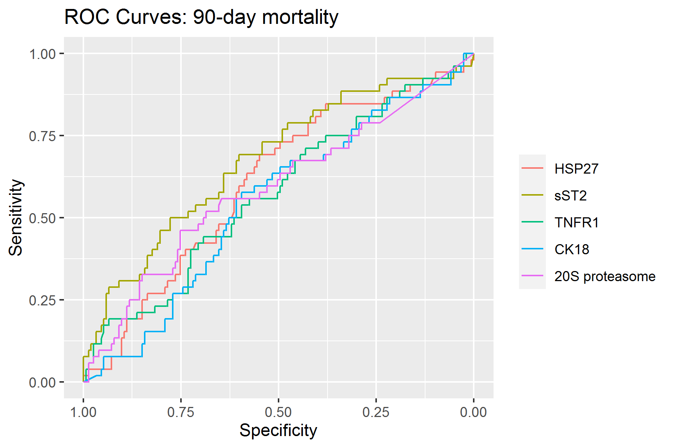

Figure S4 ROC Curves for the endpoint in-hospital mortality of investigated parameters
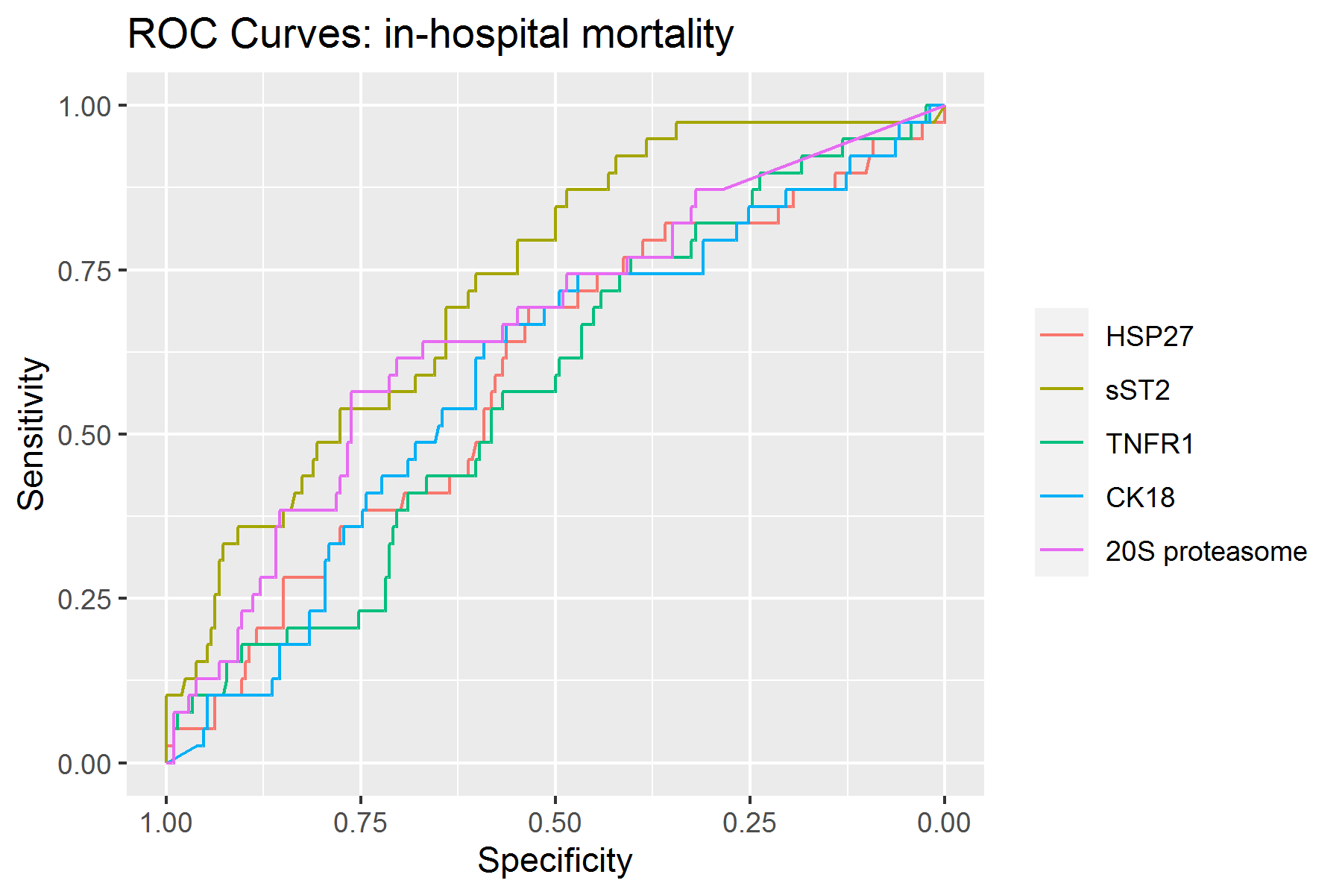

Table S1 AUC of ROC curves for the endpoint 30-day mortality of investigated parameters
 | AUC | 95%CI
HSP27 | 0.6003 | 0.5052-0.6954
sST2 | 0.6974 | 0.6117-0.7830
TNFR1 | 0.5666 | 0.4766-0.6566
CK18 | 0.5479 | 0.4520-0.6438
20S proteasome | 0.6149 | 0.5161-0.7136

Table S2 AUC of ROC curves for the endpoint 60-day mortality of investigated parameters
 | AUC | 95%CI
HSP27 | 0.5963 | 0.5091-0.6836
sST2 | 0.6710 | 0.5834-0.7586
TNFR1 | 0.5634 | 0.4739-0.6528
CK18 | 0.5464 | 0.4581-0.6348
20S proteasome | 0.6046 | 0.5131-0.6962

Table S3 AUC of ROC curves for the endpoint 90-day mortality of investigated parameters
 | AUC | 95%CI
HSP27 | 0.6055 | 0.5178-0.6933
sST2 | 0.6750 | 0.5871-0.7628
TNFR1 | 0.5740 | 0.4828-0.6651
CK18 | 0.5459 | 0.4567-0.6352
20S proteasome | 0.5875 | 0.4935-0.6815

Table S4 AUC of ROC curves for the endpoint in-hospital mortality of investigated parameters
 | AUC | 95%CI
HSP27 | 0.5909 | 0.4928-0.6890
sST2 | 0.7292 | 0.6476-0.8108
TNFR1 | 0.5705 | 0.4761-0.6650
CK18 | 0.5907 | 0.4935-0.6879
20S proteasome | 0.6610 | 0.5656-0.7565

