***Supplemental information***

***Fig. S1: Effect of approved macrolide antibiotics on cell proliferation of U251 and T98G cells***

***Fig. S2*** ***Effect of clindamycin on cell cycle progression in T98G cells***

***Fig. S3 Dose response of temozolomide on cell proliferation in glioblastoma cell lines***

***Fig. S4 Analysis of MGMT mRNA expression***

***Fig. S5*** ***Measurement of mice weight during a treatment period with clindamycin and temozolomide***

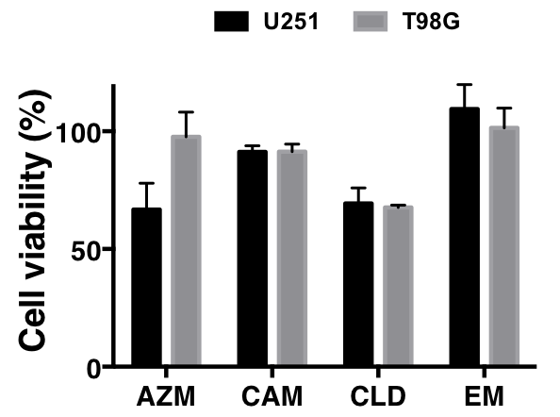

***Fig. S1: Effect of approved macrolide antibiotis on cell proliferation of U251 and T98G cells***

The cytotoxic effect of approved macrolide antibiotics was measured by WST-1 cell proliferation assay. Cells were treated with four approved antibiotics, azithromycin (AZM), clarithromycin (CAM), clindamycin (CLD), and erythromycin (EM) (each 100 μg/mL) for 72 h and subjected to the WST-1 assay. The viability of untreated cells was considered 100%. Data reveals % ratio to the final number of control cultures as means ± SE.

**A**

**B**



***Fig. S2*** ***Effect of clindamycin on cell cycle progression in T98G cells***

Cell cycle analysis after treatment with CLD in T98G cells. Cells were treated with CLD (440 μM) for 24 h and subjected to cell cycle analysis. Cells were classified three phases (A). The graph represent % cells in G0/G1, S, and G2/M phase (B). Data are presented as means ± SE of representative four independent experiments. (* *P* < 0.05, and ** *P* < 0.01 vs. control: *t*-test)



***Fig. S3 Dose response of temozolomide on cell proliferation in glioblastoma cell lines***

The cytotoxic effect of temozolomide (TMZ) was measured by WST-1 assay. Cells were treated with TMZ (0, 62.5, 125, 250, and 500 μM) for 72 h and subjected to the WST-1 cell proliferation assay. The viability of untreated cells was considered 100%. Data are reveals % ratio to the final cell number of control in each cell lines as means ± SE, similar results shown were representative four independent experiments. (* *P* < 0.05, *** *P* < 0.001, ‡ *P* < 0.0001: two-way ANOVA)



***Fig. S4 Analysis of MGMT mRNA expression***

Total RNA was isolated from cell lysate with the guanidinium-phenol solution (ISOGEN; Nippon Gene, Osaka, Japan). Total RNA was converted to cDNA and MGMT was selectively amplified by a RT-PCR kit (One step SYBR PrimeScript PLUS, Takara Bio Inc., Shiga, Japan) using the forward primer (5’-GTGGCCTCACGATGTGTATG) and the reverse primer (5’-ACCCGCTGTGTGACTTATCC). RT-PCR of glyceraldehyde-3-phosphate dehydrogenase (GAPDH) mRNA was similarly carried out with the forward primer (5’-GTCAGTGGTGGACCTGACCT ) and the reverse primer (5’-AGGGGTCTACATGGCAACTG). GAPDH was used as an internal control. PCR amplification was performed with the 30 cycles of 95℃ for 5 sec and 60℃ for 30 sec and products were detected with Gel Red staining (Wako Chemicals Inc., Tokyo, Japan). The amplified products were separated by agarose electrophoresis and visualized by a UV transilluminator.



***Fig. S5*** ***Measurement of mice weight during a treatment period with clindamycin and temozolomide***

Mice were weighed daily to determine the dose. In addition, general condition of mice was closely observed to investigate the adverse events caused by the medication. The data is expressed as means ± SE (*N* = 7).