Method Development and Optimization
Antibody Dilutions
MDA-MB-231 was used as reference cell line for PD-L1 22C3 and PD-L1 28.8; MCF7 for ER, PR; and SKBR3 for HER2, PanCK. Respective reference cell lines were used for optimizing dilutions of antibodies (Ab) against PD-L1 22C3, PD-L1 28.8, ER, PR, HER2 and PanCK. Three different dilutions were evaluated for each Ab with 6 replicates per dilution. FI of each marker was compared at each dilution to determine the lowest concentration with higher FI. The evaluated dilutions, optimal dilutions, list of markers, fluorophores and detection (excitation and emission spectra) are provided in Supplementary tables S2 and S3.

Antibody Multiplexing
Respective reference cells were immunostained with each Ab singly or in combination with other Ab, with 6 replicates per combination. The FI for each marker was evaluated for differences between single-Ab wells and in wells where Ab were used in combinations.
Use of Ab in multiplexed combinations was not associated with any significant suppression in FI of any of the markers (which may have led to loss of sensitivity). The findings established that the Ab were conducive to multiplexed analysis without any interfering effects (Supplementary Figure S1).

Detection Thresholds
Reference cell line MDA-MB-231, known PD-L1 negative (N) and positive (P) cells from a primary malignant breast tumor (TDCs), cells from a benign breast tumor (B-TDCs) and cells from a healthy (asymptomatic) individual were immunostained to determine the expression (FI) of PD-L1 22C3 and PD-L1 28.8. The FI of PD-L1 22C3 and PD-L1 28.8 was higher in MDA-MB-231 and P-TDCs than B-TDCs and N-TDCs. Reference cell lines, triple (ER, PR, HER2 markers) negative (TN) and triple positive (TP) cells from a primary malignant breast tumor (TDCs), cells from a benign breast tumor (B-TDCs) and cells from a healthy (asymptomatic) individual were immunostained to determine the expression (FI) of ER, PR and HER2. The FI of ER and PR was higher in MCF7 and TP-TDCs, while FI of HER2 was higher in SKBR3 and TP-TDCs than MDA-MB-231, B-TDCs and TN-TDCs. The FI of PanCK was higher in SKBR3, primary malignant breast tumor cells (M-TDC) and Breast adenocarcinoma specific Circulating Tumor Cells (BrAD-CTCs) than in SW982 and benign breast tumor cells (B-TDC) (Supplementary Figure S2). Based on these findings, the FI threshold for positivity was assigned as 50,000 (relative fluorescence units, RFU) for PD-L1 22C3, ER and PR; 60,000 RFU for PD-L1 28.8 and HER2; and 70,000 RFU for PanCK. These apply as a lower threshold where expression is essential for positivity, but also accommodate CTCs with lower marker expression than the reference cell lines.

RESULTS

Analytical Validation - ICC
Stability and Recovery
Recoveries of various marker positive cells in the spiked samples are provided in Supplementary Table S5. Higher recoveries (>80%) were observed up to 48h for all markers, (except HER2 which showed >80% recovery only up to 24h), which appeared to be the limit for analyte stability. Similarly, in clinical samples, the recovery of marker positive cells (Supplementary table S6) was >80% up to 48h which appeared to be the limit for analyte stability. The findings of the stability and recovery study indicated that the samples could be stored at 2°C-8°C for up to 48h with <20% loss of cells (except for PD-L1 28.8, which could be stored for up to 24h).

Linearity
Recoveries of spiked cells were generally higher at higher spike densities (8 cells / 5 ml for PD-L1 22C3 and 28.8; 7 cells/ 5 ml for ER, PR, HER2) (Supplementary Figure S3, Supplementary Table S4). R² ≥0.99 in all markers indicated a significant linear response, especially in the range of 7 – 1000 cells / 5 mL for PD-L1 and 7 – 1200 cells / 5 mL for ER, PR and HER2.

Limits of Detection, Quantitation and Blank
No PD-L1 22C3+, PD-L1 28.8+, ER+, PR+ or HER2+ cells were detected in the unspiked samples, i.e., no false positives. Thus, the limit of blank (LoB) was determined to be 0 cells / mL. The Limit of Detection (LoD) was 2 cells/ 5ml for PD-L1 22C3 and PD-L1 28.8; and 3 cells/ 5 ml for ER, PR and HER2. The Limit of Quantitation (LoQ) was 7 cells / 5 mL for PD-L1 22C3 and 28.8 and 5 cells / 5 mL for ER, PR and HER2, based on ≥70% recovery in at least 7 of 8 replicates.

Sensitivity, Specificity and Accuracy
Based on recovery of spiked marker positive cells, the analytical sensitivity for PD-L1 22C3 and PD-L1 28.8 was 87.5% and 90% respectively, while that of ER, PR and HER2 was determined to be 87.5%, 95% and 92.5% respectively. Since cells were undetectable in any of the 25 un-spiked samples, the analytical specificity for all the markers was deemed to be 100%. Accuracy, determined as the combined proportion of true positives and true negatives, was 92.31% for PD-L1 22C3, 93.85% for PD-L1 28.8, 92.31% for ER, 96.92% for PR and 95.38% for HER2 (Table 1 and Supplementary Table S7).

Precision
Precision of the test was determined across 2 operators in samples with high and low spike densities of (marker positive) reference cells. Supplementary Table S13 provides the %CV for intra-run, inter-run and inter-operator precision for low and high spike as well as the cumulative. The overall %CV among the low spiked samples was in the range of 3-5%, which resulted in 95-97% reproducibility while %CV among the high spiked samples was in the range of 1.5 to 2% which resulted in 98 to 99% reproducibility with all types of variation. The test showed CV <3% for all markers, PD-L1 22C3, PD-L1 28.8, ER, PR and HER2, indicating high intra-run, inter-run and inter-operator precision.

Analytical Validation - FISH
Hybridization Efficiency:
Hybridization efficiency was established using PMBCs (n= 20) and SKBR3 (n = 5) samples that were processed as described above and enumerating the proportion of cells with positive signal for ERBB2/CEN17 among all nucleated (DAPI+) cells. The overall median hybridization efficiency was determined to be 99.7% (Supplementary Table S9).

Precision
Inter-user variability was determined for PMBC samples processed for determination of ERBB2/CEN17 positive cells. Median CV for inter-user variability was 1.2% indicating high precision of the test (Supplementary Table S10).

Analytical sensitivity:
Analytical sensitivity was defined as the ability of the test to detect cells with gain of ERBB2 copy where these are known to exist and was established using SKBR3 cells. Median Sensitivity of the test across 5 replicates was 99.7% (Supplementary Table S11).

Analytical Specificity:
Analytical specificity was defined as the ability of the test to not detect cells with gain of ERBB2 copy where these are known to be absent and was established using healthy donor PBMCs. Median Specificity of the test across 20 replicates was 100% (Supplementary Table S12).

Linearity and Limit of Detection
Linearity and Limit of Detection (LoD) were established spiking varying amounts (1, 2, 4, 8, 16, and 32) of SKBR3 cells into 1 mL of healthy donor blood and estimating the recovery of these cells based on ERBB2/CEN17 signal detection. The study was performed independently by 2 separate users. The mean recovery was used to determine the linearity and LoD. R² ≥ 0.99 indicates significant linear response of the test with a low LoD of 1 cell per 1 mL equivalent of PBMCs (Supplementary Figure S3).
SUPPLEMENTARY FIGURES

Supplementary Figure S1. Fluorescence Intensities of Markers Singly and in Multiplexed Combinations. There was no significant suppression or elevation of the FI of markers when the fluorophore conjugated Ab were used singly or in multiplexed combinations.

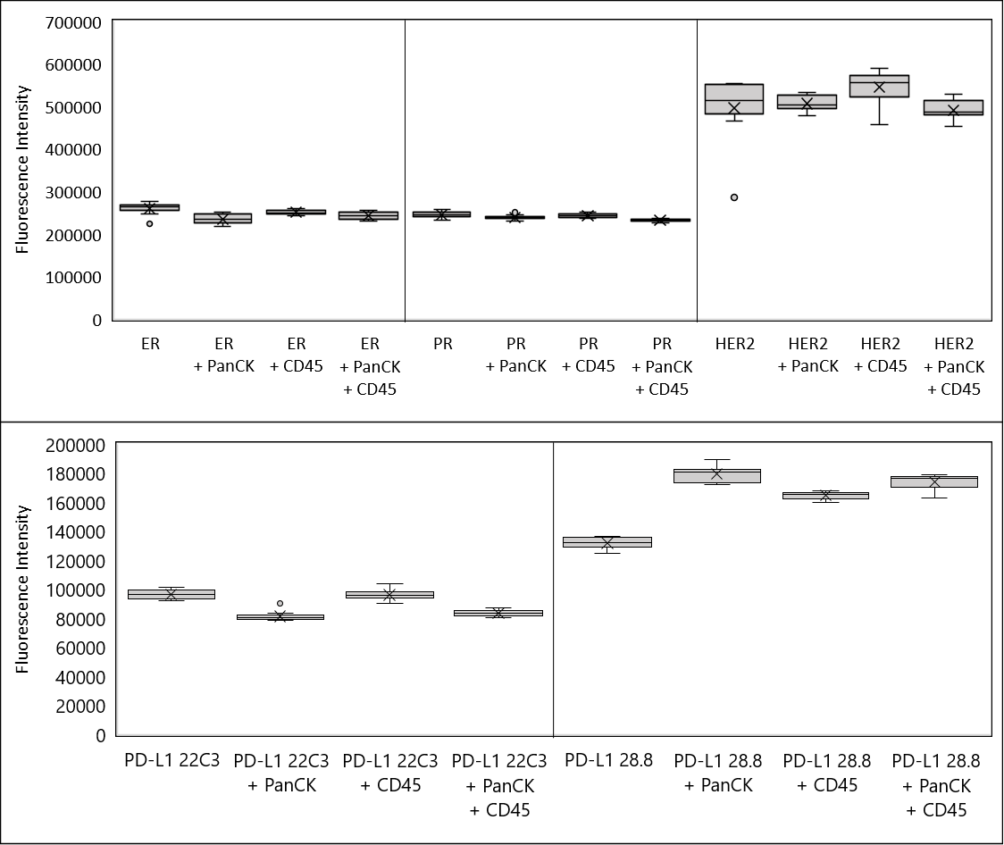

Supplementary Figure S2. Detection Thresholds. The expression level of each marker was evaluated on reference cell lines, malignant breast tumor derived cells (TDCs), benign breast tumor derived cells (B-TDC) and Breast adenocarcinoma specific Circulating Tumor Cells (BrAD-CTCs). The expression levels were considered while assigning positivity thresholds for each marker.

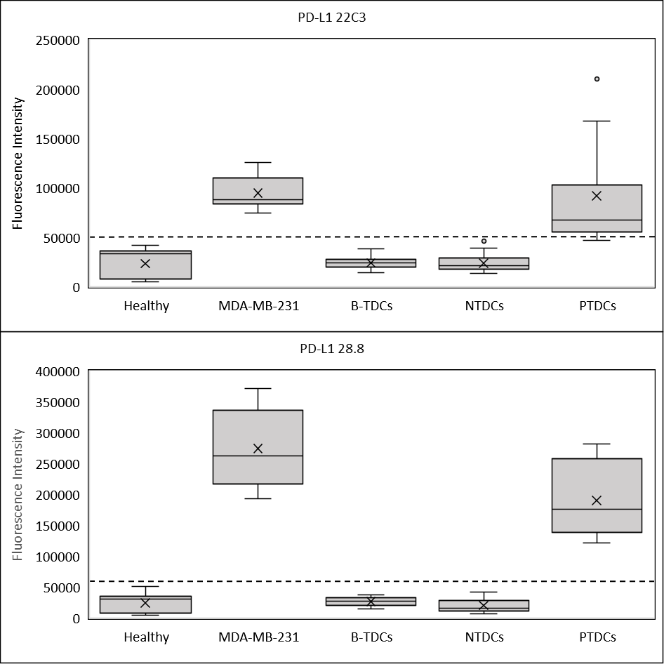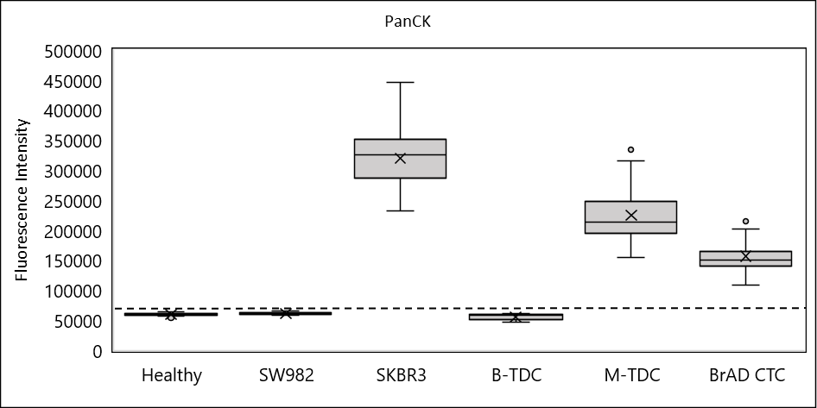
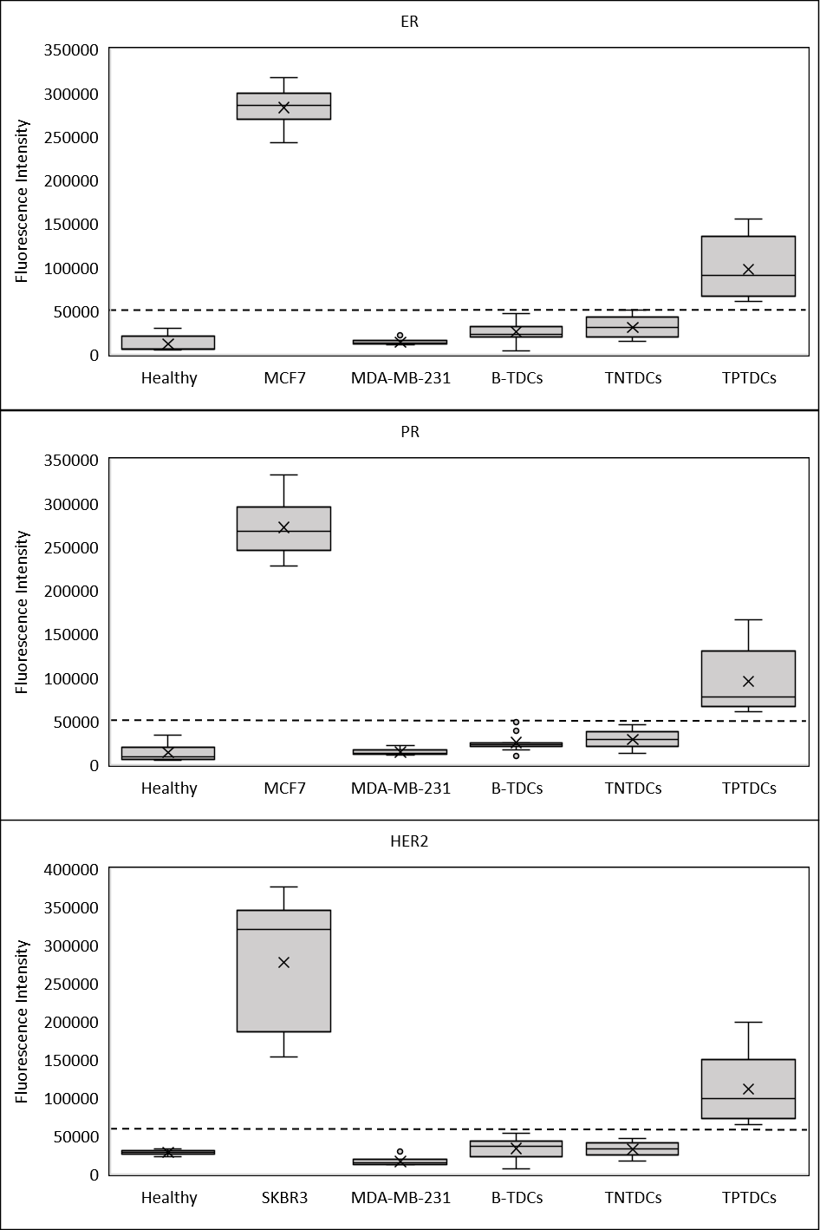
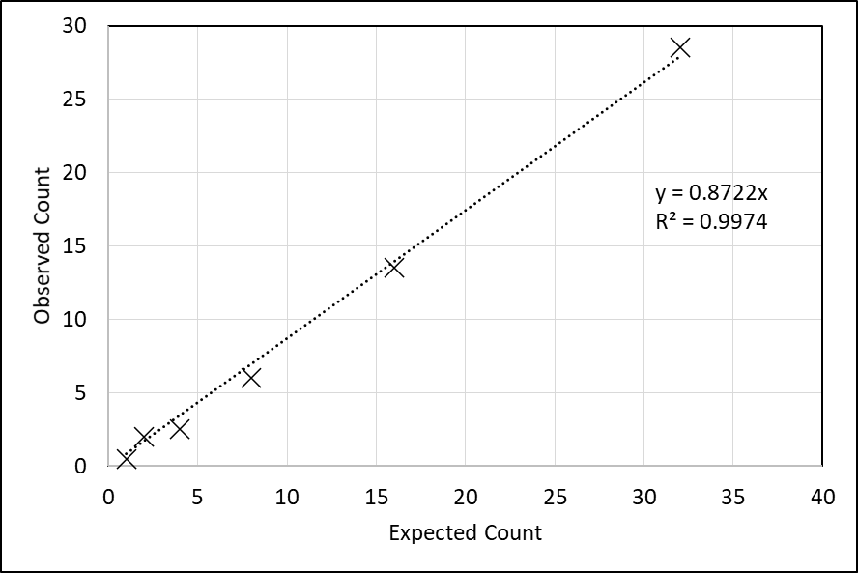
Supplementary Figure S3: Analytical Validation: Linearity (ICC and HER2-FISH). The Test exhibited significant linearity with R² ≥0.99.
HER2 (FISH)
Supplementary Figure S4: Representative fluorescent images of Circulating Tumor Cells (CTCs) from cancer patient samples immuno-stained for A) PD-L1 22C3, B) PD-L1 28.8, C) ER, D) PR, E) HER2.
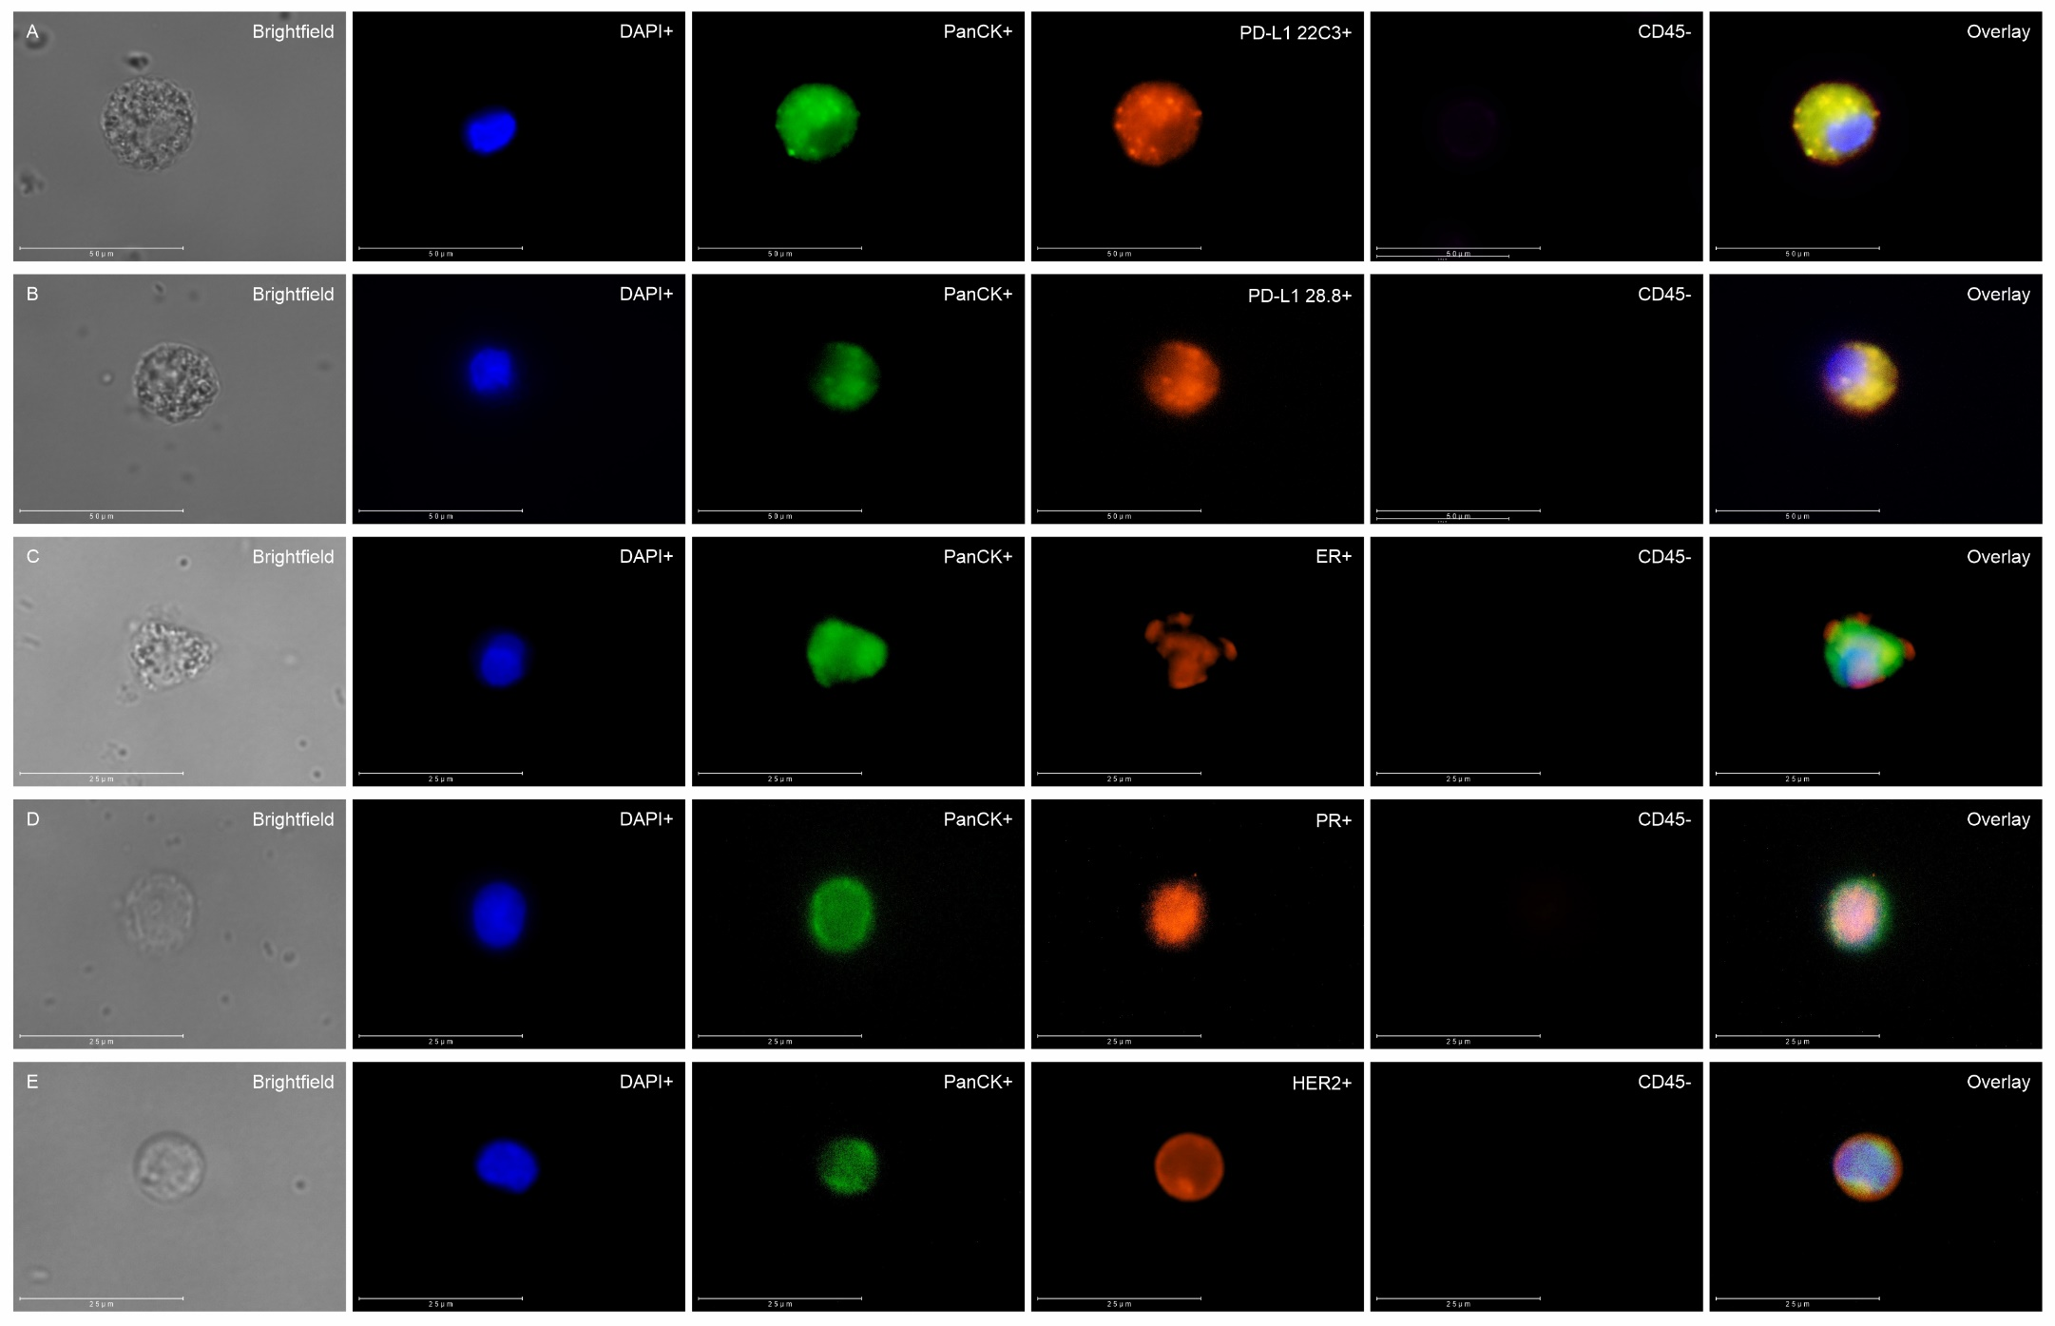
Supplementary Figure S5: Representative fluorescent images of DAPI-stained nuclei of Circulating Tumor Cells (CTCs) and corresponding tumor tissue from a breast cancer patient positive for HER2 gene amplification (green) as evaluated by FISH.
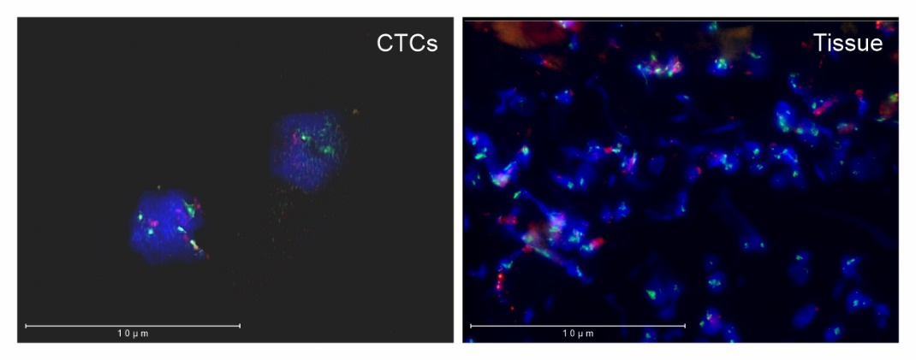

SUPPLEMENTARY TABLES

Supplementary Table S1. Antisera and Control Cells.

Name | Catalog # | Vendor
RH Anti-CK IgG-Vio 515 | 130-112-746 | Miltenyi Biotec
RH Anti-CD45-IgG-APCVio 770 | 130-110-635 | Miltenyi Biotec
Mouse Anti-PD-L1 (22C3) | SK006 | Dako
Rabbit Anti-PD-L1 (28.8) | SK005 | Dako
Rabbit Anti-Estrogen Receptor (Ep1) | IS084 | Dako
Rabbit Anti-PR (SP2) | PRM302AA | Biocare Medical
Rabbit Anti-c-erbB-2 (HER2; polyclonal) | A0485 | Dako
Anti-rabbit Alexa Fluor 594 | A32740 | Invitrogen
Anti-mouse Alexa Fluor 594 | A32742 | Invitrogen
SKBR3 (Breast cancer) cells* | HTB-30™ | ATCC
SW982 (Synovial Sarcoma) cells* | HTB-93™ | ATCC
MOLT-3 (Leukemia) cells* | CRL-1552™ | ATCC
MCF7 (Breast cancer) cells* | HTB-22TM | ATCC#
MDA-MB-231 (Breast cancer) cells* | HTB-26™ | ATCC#
*used as controls in the Test
# procured from ATCC via NCCS, India

Supplementary Table S2. Markers, Fluorophores and Detection.

Marker | Fluorophore | Excitation | Emission Maxima (Range)
DAPI | DAPI | 358 nm | 461 nm (400 – 620 nm)
CD45 | APC Vio 770 | 652 nm | 775 nm (725 – 825 nm)
PanCK | Vio 515 | 488 nm | 514 nm (478 – 570 nm)
PD-L1 22C3 | Alexa Fluor 594 | 590 nm | 617 nm (580 – 740 nm)
PD-L1 28.8
ER
PR
HER2

Supplementary Table S3. Optimization of antibody dilution. All Ab were evaluated at 3 different dilutions. The optimal dilutions are as indicated in bold text.

Antibody | Dilution 1 | Dilution 2 | Dilution 3
Anti-PD-L1 22C3 | Undiluted | 1:2 | 1:4
Anti-PD-L1 28.8 | Undiluted | 1:2 | 1:4
Anti-ER | Undiluted | 1:2 | 1:4
Anti-PR | Undiluted | 1:2 | 1:4
Anti-HER2 | 1:700 | 1:1400 | 1:2800
Anti-PanCK | 1:400 | 1:500 | 1:600
Anti-rabbit AF 594 | 1:250 | 1:500 | 1:1000
Anti-mouse AF 594 | 1:250 | 1:500 | 1:1000
Anti-CD45 | 1:250 | 1:500 | 1:1000

Supplementary Table S4. Analytical Validation: Linearity. The Test exhibited significant linearity with R² ≥0.99. The Tabulated values below show the recovery and range of recovery.
Spiked  Cells | Mean, % and Range of Detected Cell Counts
 | PD-L1 22C3 | PD-L1 28.8
0 | 0 | 0
2 | 1 (50%)  (0-2) | 1 (50%)  (1-2)
4 | 2 (50%)  (0-4) | 4 (100%)  (0-7)
8 | 7 (87.5%)  (5-9) | 7 (87.5%)  (5-10)
16 | 14 (87.5%)  (11-20) | 14 (87.5%)  (12-20)
32 | 30 (93.8%)  (21-35) | 27 (84.4%)  (25-29)
64 | 60 (93.8%)  (55-65) | 53 (82.8%)  (52-55)
125 | 121 (96.8%)  (104-135) | 123 (98.4%)  (120-127)
250 | 257 (102.8%)  (240-275) | 255 (102%)  (236-312)
500 | 501 (100.2%)  (485-531) | 530 (106%)  (510-570)
1000 | 1115 (111.5%)  (1025-1189) | 1041 (104.1%)  (1006-1125)

Spiked  Cells | Mean, % and Range of Detected Cell Counts
 | ER | PR | HER2
0 | 0 | 0 | 0
1 | 0 (0%)  (0-0) | 0 (0%)  (0-0) | 0 (0%)  (0-0)
3 | 2 (66.7%)  (1-4) | 2 (66.7%)  (1-3) | 2 (66.7%)  (0-3)
7 | 5 (71.4%)  (2-7) | 5 (71.4%)  (2-6) | 6 (85.7%)  (5-7)
15 | 11 (73.3%)  (9-14) | 11 (73.3%)  (8-15) | 11 (73.3%)  (8-14)
35 | 28 (80%)  (25-32) | 30 (85.7%)  (27-32) | 29 (82.9%)  (26-32)
75 | 67 (89.3%)  (65-70) | 66 (88%)  (59-72) | 69 (92%)  (61-72)
150 | 136 (90.7%)  (82-173) | 123 (82%)  (75-144) | 127 (84.7%)  (75-154)
300 | 292 (97.3%)  (270-302) | 283 (94.3%)  (269-298) | 288 (96%)  (280-295)
600 | 592 (98.7%)  (578-605) | 592 (98.7%)  (578-610) | 586 (97.7%)  (570-594)
1200 | 1188 (99%)  (1158-1205) | 1186 (98.8%)  (1165-1203) | 1185 (98.8%)  (1172-1198)

Supplementary Table S5. Analytical Validation: Analyte Stability and Recovery (Spiked Cells). Reference cells were spiked into healthy donor blood samples and the recovery of spiked cells was evaluated for up to 120 hours.

Time (h) | Spiked  Cells | Mean Recovery, % Recovery and Recovery Range (%)
 |  | PD-L1 22C3+ | PD-L1 28.8+ | ER+ | PR+ | HER2+
0 | 15 | 14 (93.3%)  (13--15) | 14.3 (95.6%)  (14--15) | 14.3 (95.6%)  (14--15) | 14.7 (97.8%)  (14--15) | 14 (93.3%)  (13--15)
24 | 15 | 13.7 (91.1%)  (13--14) | 13.3 (88.9%)  (13--14) | 13.3 (88.9%)  (13--14) | 13.7 (91.1%)  (13--14) | 13 (86.7%)  (12--14)
48 | 15 | 13 (86.7%)  (12--14) | 12.3 (82.2%)  (12--13) | 12.7 (84.4%)  (12--14) | 12.3 (82.2%)  (12--13) | 11.7 (77.8%)  (11--12)
72 | 15 | 12.3 (82.2%)  (11--13) | 11 (73.3%)  (10--12) | 12.7 (84.4%)  (12--13) | 10.7 (71.1%)  (10--12) | 11 (73.3%)  (10--12)
96 | 15 | 11.3 (75.6%)  (10--12) | 9.7 (64.4%)  (9--10) | 10.7 (71.1%)  (10--11) | 10 (66.7%)  (9--11) | 10 (66.7%)  (9--11)
120 | 15 | 8.7 (57.8%)  (8--9) | 8.3 (55.6%)  (8--9) | 9.7 (64.4%)  (9--10) | 8.7 (57.8%)  (8--9) | 9 (60%)  (8--10)

Supplementary Table S6. Analytical Validation: Analyte Stability and Recovery (CTCs). Blood samples from known CTC positive cases were evaluated for recovery of CTCs for up to 120 hours.

Recovery of marker positive cells
Time (h) | PD-L1 22C3+ | PD-L1 28.8+ | ER+ | PR+ | HER2+
0 | 8 | 7 | 6 | 5 | 6
24 | 8 (100%) | 6 (85.7%) | 6 (100%) | 4 (80%) | 5 (83.3%)
48 | 7 (87.5%) | 5 (71.4%) | 5 (83.3%) | 4 (80%) | 5 (83.3%)
72 | 6 (75%) | 5 (71.4%) | 4 (66.7%) | 3 (60%) | 4 (66.7%)
96 | 5 (62.5%) | 4 (57.1%) | 2 (33.3%) | 2 (40%) | 3 (50%)
120 | 3 (37.5%) | 3 (42.9%) | 2 (33.3%) | 2 (40%) | 2 (33.3%)

Supplementary Table S7. Analytical Validation: Sensitivity, Specificity, Accuracy. Reference cells were spiked into healthy donor blood samples at various seed densities and their recoveries evaluated to determine Sensitivity. Unspiked healthy donor blood samples were evaluated for false positives to determine Specificity. Accuracy was determined from Sensitivity and Specificity.

Spiked cells | Mean (Range) of Cells Detected | Negatives | Sensitivity | Specificity
PD-L1 22C3+
0 | - | - | - | 100%
6 | 4 (4-5) | 5 | 37.5% | -
12 | 11 (9-12) | - | 100.0% | -
25 | 20 (17-22) | - | 100.0% | -
50 | 41 (37-44) | - | 100.0% | -
100 | 82 (80-85) | - | 100.0% | -
Overall (Spiked) | - | 5 | 87.5% | -
PD-L1 28.8+
0 | - | - | - | 100%
6 | 5 (4-5) | 4 | 50.0% | -
12 | 11 (9-12) | - | 100.0% | -
25 | 19 (17-21) | - | 100.0% | -
50 | 40 (38-42) | - | 100.0% | -
100 | 81 (78-84) | - | 100.0% | -
Overall (Spiked) | - | 4 | 90.0% | -
ER+
0 | - | - | - | 100%
6 | 5 (4-6) | 5 | 37.5% | -
12 | 11 (10-12) | - | 100.0% | -
25 | 21 (20-23) | - | 100.0% | -
50 | 41 (39-45) | - | 100.0% | -
100 | 87 (81-92) | - | 100.0% | -
Overall (Spiked) | - | 5 | 87.5% | -
PR+
0 | - | - | - | 100%
6 | 5 (4-6) | 2 | 75.0% | -
12 | 10 (9-11) | - | 100.0% | -
25 | 21 (19-25) | - | 100.0% | -
50 | 42 (40-43) | - | 100.0% | -
100 | 84 (81-85) | - | 100.0% | -
Overall (Spiked) | - | 2 | 95.0% | -
HER2+
0 | - | - | - | 100%
6 | 5 (3-5) | 3 | 62.5% | -
12 | 10 (8-11) | - | 100.0% | -
25 | 21 (19-22) | - | 100.0% | -
50 | 42 (40-43) | - | 100.0% | -
100 | 84 (81-86) | - | 100.0% | -
Overall (Spiked) | - | 3 | 92.5% | -

Supplementary Table S8: Details of asymptomatic samples (HER2-FISH analysis)
 | Male | Female | Total
N = | 10 | 10 | 20
Median Age, Range | 31 (22 – 37) | 29 (21 – 40) | 30 (21 – 40)

Supplementary Table S9: Hybridization Efficiency (HER2-FISH analysis)
Sample Type | No. of Samples | Efficiency
PBMC | 20 | 99.9% (87.2% - 100%)
SKBR3 | 5 | 99.7% (99.7% - 100%)
Overall | 25 | 99.7% (87.2% - 100%)
*Median and Range

Supplementary Table S10: Precision (HER2-FISH analysis)
Sample Type | No of Samples | %CV*
PBMC | 5 | 1.2% (0.5% - 6.3%)
*Median and Range

Supplementary Table S11: Analytical Sensitivity (HER2-FISH analysis)
Sample Type | No of Samples | Sensitivity
SKBR3 | 5 | 99.7% (99.3% - 99.7%)
*Median and Range

Supplementary Table S12: Analytical Specificity (HER2-FISH analysis)
Sample Type | No of Samples | Specificity
PBMCs | 20 | 100% (95.3% - 100%)
*Median and Range

Supplementary Table S13. Analytical Validation: Precision. Recovery of low spiked reference cells in healthy donor blood samples across multiple replicates by 2 users over multiple days were used to determine the %CV.
 |  | Low Spike (15 cells) |  |  | High Spike (150 cells) |  |  | Overall CV%
 |  | Mean | SD | CV% | Mean | SD | CV%
PD-L1 22C3 | Intra-Run
 | User 1 | 14.71 | 0.53 | 3.59% | 149.31 | 2.3 | 1.54% | 2.57%
 | User 2 | 14.69 | 0.48 | 3.29% | 149.06 | 2.48 | 1.66% | 2.48%
 | Cumulative | 14.7 | 0.5 | 3.44% | 149.18 | 2.39 | 1.60% | 2.52%
 | Inter-Run
 | User 1 | 14.73 | 0.52 | 3.52% | 149.43 | 2.37 | 1.59% | 2.56%
 | User 2 | 14.7 | 0.48 | 3.28% | 149.06 | 2.48 | 1.66% | 2.47%
 | Cumulative | 14.71 | 0.5 | 3.40% | 149.24 | 2.42 | 1.63% | 2.52%
 | Inter-User
 | Inter-User | 14.7 | 0.51 | 3.44% | 149.19 | 2.39 | 1.60% | 2.52%
 | OVERALL | - | - | 3.42% | - | - | 1.61% | 2.52%
PD-L1 28.8 | Intra-Run
 | User 1 | 14.8 | 0.51 | 3.47% | 146.81 | 2.07 | 1.41% | 2.44%
 | User 2 | 14.64 | 0.48 | 3.28% | 147 | 2.4 | 1.63% | 2.46%
 | Cumulative | 14.72 | 0.49 | 3.38% | 146.9 | 2.23 | 1.52% | 2.45%
 | Inter-Run
 | User 1 | 14.78 | 0.51 | 3.43% | 146.93 | 2.21 | 1.50% | 2.47%
 | User 2 | 14.64 | 0.48 | 3.28% | 147 | 2.4 | 1.63% | 2.46%
 | Cumulative | 14.71 | 0.49 | 3.36% | 146.96 | 2.3 | 1.57% | 2.47%
 | Inter-User
 | Inter-User | 14.72 | 0.5 | 3.37% | 146.91 | 2.24 | 1.52% | 2.45%
 | OVERALL | - | - | 3.37% | - | - | 1.54% | 2.46%
ER | Intra-Run
 | User 1 | 14.56 | 0.62 | 4.26% | 149.15 | 2.17 | 1.46% | 2.86%
 | User 2 | 14.4 | 0.63 | 4.40% | 149.25 | 2.27 | 1.52% | 2.96%
 | Cumulative | 14.48 | 0.62 | 4.33% | 149.2 | 2.22 | 1.49% | 2.91%
 | Inter-Run
 | User 1 | 14.58 | 0.62 | 4.23% | 149.15 | 2.17 | 1.46% | 2.85%
 | User 2 | 14.4 | 0.63 | 4.40% | 149.23 | 2.28 | 1.53% | 2.97%
 | Cumulative | 14.49 | 0.62 | 3.85% | 149.19 | 2.22 | 1.50% | 2.68%
 | Inter-User
 | Inter-User | 14.48 | 0.63 | 4.33% | 149.2 | 2.22 | 1.49% | 2.91%
 | OVERALL | - | - | 4.26% | - | - | 1.49% | 2.88%
PR | Intra-Run
 | User 1 | 14.7 | 0.59 | 4.03% | 149.31 | 2.45 | 1.50% | 2.77%
 | User 2 | 14.61 | 0.59 | 4.05% | 149.4 | 2.28 | 1.53% | 2.79%
 | Cumulative | 14.65 | 0.59 | 4.04% | 149.35 | 2.36 | 1.52% | 2.78%
 | Inter-Run
 | User 1 | 14.77 | 0.59 | 3.99% | 149.34 | 2.26 | 1.51% | 2.75%
 | User 2 | 14.61 | 0.59 | 4.00% | 149.4 | 2.28 | 1.53% | 2.77%
 | Cumulative | 14.69 | 0.59 | 4.00% | 149.37 | 2.27 | 1.52% | 2.76%
 | Inter-User
 | Inter-User | 14.69 | 0.59 | 4.04% | 149.36 | 2.26 | 1.51% | 2.78%
 | OVERALL | - | - | 4.02% | - | - | 1.52% | 2.77%
HER2 | Intra-Run
 | User 1 | 14.76 | 0.57 | 3.86% | 149.54 | 2.27 | 1.52% | 2.69%
 | User 2 | 14.56 | 0.52 | 3.59% | 149.4 | 2.28 | 1.53% | 2.56%
 | Cumulative | 14.66 | 0.54 | 3.73% | 149.47 | 2.27 | 1.53% | 2.63%
 | Inter-Run
 | User 1 | 14.77 | 0.57 | 3.84% | 149.53 | 2.26 | 1.51% | 2.68%
 | User 2 | 14.74 | 0.55 | 3.70% | 149.4 | 2.28 | 1.53% | 2.62%
 | Cumulative | 14.75 | 0.56 | 3.77% | 149.46 | 2.27 | 1.52% | 2.65%
 | Inter-User
 | Inter-User | 14.66 | 0.55 | 3.73% | 149.47 | 2.27 | 1.52% | 2.63%
 | OVERALL | - | - | 3.75% | - | - | 1.52% | 2.64%

Supplementary Table S14. Demographics of Clinical Validation Cohort (ICC and HER2-FISH).

 | PD-L1 22C3 | PD-L1 28.8 | ER | PR | HER2 | HER2 (FISH)
Age (years)  Median  Range | 53  (23 – 88) |  | 51  (30 - 73) |  |  | 54  (27 – 78)
Gender  Male  Female | 34  73 |  | 6  95 |  | 6  93 | 4  50
Tumor types  Breast  Bladder  Cervix  Colon/Rectum  Esophagus  Head and Neck  Lung  Stomach  Uterus  Vulva | 48  4  6  -  6  23  13  6  -  1 |  | 101  -  -  -  -  -  -  -  -  - |  | 99  -  -  -  -  -  -  -  -  - | 46  -  -  3  1  -  -  2  2  -
Total | 107 |  | 101 |  | 99 | 54

Supplementary Table S15. Cross Validation. The performance characteristics were determined via a 20-fold cross validation.

- PD-L1 22C3
Iteration | Sample Type | Samples | Test Classification
 |  |  | PD-L1 22C3+ | PD-L1 22C3-
Training Set | PD-L1 22C3+ | 20 | TP = 19 | FN = 1
 | PD-L1 22C3- | 28 | FP = 3 | TN = 25
Test Set 1 | PD-L1 22C3+ | 9 | TP = 9 | FN = 0
 | PD-L1 22C3- | 12 | FP = 1 | TN = 11
Test Set 2 | PD-L1 22C3+ | 10 | TP = 10 | FN = 0
 | PD-L1 22C3- | 11 | FP = 0 | TN = 11
Test Set 3 | PD-L1 22C3+ | 8 | TP = 8 | FN = 0
 | PD-L1 22C3- | 13 | FP = 2 | TN = 11
Test Set 4 | PD-L1 22C3+ | 8 | TP = 8 | FN = 0
 | PD-L1 22C3- | 13 | FP = 2 | TN = 11
Test Set 5 | PD-L1 22C3+ | 9 | TP = 9 | FN = 0
 | PD-L1 22C3- | 12 | FP = 1 | TN = 11
Test Set 6 | PD-L1 22C3+ | 9 | TP = 9 | FN = 0
 | PD-L1 22C3- | 12 | FP = 1 | TN = 11
Test Set 7 | PD-L1 22C3+ | 9 | TP = 9 | FN = 0
 | PD-L1 22C3- | 12 | FP = 1 | TN = 11
Test Set 8 | PD-L1 22C3+ | 10 | TP = 10 | FN = 0
 | PD-L1 22C3- | 11 | FP = 0 | TN = 11
Test Set 9 | PD-L1 22C3+ | 8 | TP = 8 | FN = 0
 | PD-L1 22C3- | 13 | FP = 2 | TN = 11
Test Set 10 | PD-L1 22C3+ | 10 | TP = 10 | FN = 0
 | PD-L1 22C3- | 11 | FP = 0 | TN = 11
Test Set 11 | PD-L1 22C3+ | 10 | TP = 10 | FN = 0
 | PD-L1 22C3- | 11 | FP = 0 | TN = 11
Test Set 12 | PD-L1 22C3+ | 10 | TP = 10 | FN = 0
 | PD-L1 22C3- | 11 | FP = 0 | TN = 11
Test Set 13 | PD-L1 22C3+ | 9 | TP = 9 | FN = 0
 | PD-L1 22C3- | 12 | FP = 1 | TN = 11
Test Set 14 | PD-L1 22C3+ | 10 | TP = 10 | FN = 0
 | PD-L1 22C3- | 11 | FP = 0 | TN = 11
Test Set 15 | PD-L1 22C3+ | 9 | TP = 9 | FN = 0
 | PD-L1 22C3- | 12 | FP = 1 | TN = 11
Test Set 16 | PD-L1 22C3+ | 9 | TP = 9 | FN = 0
 | PD-L1 22C3- | 12 | FP = 1 | TN = 11
Test Set 17 | PD-L1 22C3+ | 7 | TP = 7 | FN = 0
 | PD-L1 22C3- | 14 | FP = 3 | TN = 11
Test Set 18 | PD-L1 22C3+ | 10 | TP = 10 | FN = 0
 | PD-L1 22C3- | 11 | FP = 0 | TN = 11
Test Set 19 | PD-L1 22C3+ | 9 | TP = 9 | FN = 0
 | PD-L1 22C3- | 12 | FP = 1 | TN = 11
Test Set 20 | PD-L1 22C3+ | 9 | TP = 9 | FN = 0
 | PD-L1 22C3- | 12 | FP = 1 | TN = 11

- PD-L1 28.8
Iteration | Sample Type | Samples | Test Classification
 |  |  | PD-L1 28.8+ | PD-L1 28.8-
Training Set | PD-L1 28.8+ | 20 | TP = 19 | FN = 1
 | PD-L1 28.8- | 28 | FP = 3 | TN = 25
Test Set 1 | PD-L1 28.8+ | 9 | TP = 9 | FN = 0
 | PD-L1 28.8- | 12 | FP = 1 | TN = 11
Test Set 2 | PD-L1 28.8+ | 10 | TP = 10 | FN = 0
 | PD-L1 28.8- | 11 | FP = 0 | TN = 11
Test Set 3 | PD-L1 28.8+ | 8 | TP = 8 | FN = 0
 | PD-L1 28.8- | 13 | FP = 2 | TN = 11
Test Set 4 | PD-L1 28.8+ | 9 | TP = 8 | FN = 1
 | PD-L1 28.8- | 12 | FP = 2 | TN = 10
Test Set 5 | PD-L1 28.8+ | 9 | TP = 8 | FN = 1
 | PD-L1 28.8- | 12 | FP = 2 | TN = 10
Test Set 6 | PD-L1 28.8+ | 9 | TP = 9 | FN = 0
 | PD-L1 28.8- | 12 | FP = 1 | TN = 11
Test Set 7 | PD-L1 28.8+ | 10 | TP = 10 | FN = 0
 | PD-L1 28.8- | 11 | FP = 0 | TN = 11
Test Set 8 | PD-L1 28.8+ | 8 | TP = 8 | FN = 0
 | PD-L1 28.8- | 13 | FP = 2 | TN = 11
Test Set 9 | PD-L1 28.8+ | 10 | TP = 9 | FN = 1
 | PD-L1 28.8- | 11 | FP = 1 | TN = 10
Test Set 10 | PD-L1 28.8+ | 10 | TP = 9 | FN = 1
 | PD-L1 28.8- | 11 | FP = 1 | TN = 10
Test Set 11 | PD-L1 28.8+ | 10 | TP = 9 | FN = 1
 | PD-L1 28.8- | 11 | FP = 1 | TN = 10
Test Set 12 | PD-L1 28.8+ | 10 | TP = 9 | FN = 1
 | PD-L1 28.8- | 11 | FP = 1 | TN = 10
Test Set 13 | PD-L1 28.8+ | 10 | TP = 9 | FN = 1
 | PD-L1 28.8- | 11 | FP = 1 | TN = 10
Test Set 14 | PD-L1 28.8+ | 10 | TP = 10 | FN = 0
 | PD-L1 28.8- | 11 | FP = 0 | TN = 11
Test Set 15 | PD-L1 28.8+ | 8 | TP = 8 | FN = 0
 | PD-L1 28.8- | 13 | FP = 2 | TN =11
Test Set 16 | PD-L1 28.8+ | 10 | TP = 9 | FN = 1
 | PD-L1 28.8- | 11 | FP = 1 | TN = 10
Test Set 17 | PD-L1 28.8+ | 9 | TP = 9 | FN = 0
 | PD-L1 28.8- | 12 | FP = 1 | TN = 11
Test Set 18 | PD-L1 28.8+ | 9 | TP = 9 | FN = 0
 | PD-L1 28.8- | 12 | FP = 1 | TN = 11
Test Set 19 | PD-L1 28.8+ | 7 | TP = 7 | FN = 0
 | PD-L1 28.8- | 14 | FP = 3 | TN = 11
Test Set 20 | PD-L1 28.8+ | 10 | TP = 9 | FN = 1
 | PD-L1 28.8- | 11 | FP = 1 | TN = 10

- ER
Iteration | Sample Type | Samples | Test Classification
 |  |  | ER+ | ER-
Training Set | ER+ | 37 | TP = 35 | FN = 2
 | ER- | 36 | FP = 7 | TN = 29
Test Set 1 | ER+ | 17 | TP = 14 | FN = 3
 | ER- | 15 | FP = 4 | TN = 11
Test Set 2 | ER+ | 19 | TP = 16 | FN = 3
 | ER- | 13 | FP = 2 | TN = 11
Test Set 3 | ER+ | 14 | TP = 13 | FN = 1
 | ER- | 18 | FP = 5 | TN = 13
Test Set 4 | ER+ | 18 | TP = 15 | FN = 3
 | ER- | 14 | FP = 3 | TN = 11
Test Set 5 | ER+ | 14 | TP = 13 | FN = 1
 | ER- | 18 | FP = 5 | TN = 13
Test Set 6 | ER+ | 16 | TP = 15 | FN = 1
 | ER- | 16 | FP = 3 | TN = 13
Test Set 7 | ER+ | 17 | TP = 15 | FN = 2
 | ER- | 15 | FP = 3 | TN = 12
Test Set 8 | ER+ | 15 | TP = 15 | FN = 0
 | ER- | 17 | FP = 3 | TN = 14
Test Set 9 | ER+ | 19 | TP = 17 | FN = 2
 | ER- | 13 | FP = 1 | TN = 12
Test Set 10 | ER+ | 16 | TP = 15 | FN = 1
 | ER- | 16 | FP = 3 | TN = 13
Test Set 11 | ER+ | 16 | TP = 15 | FN = 1
 | ER- | 16 | FP = 3 | TN = 13
Test Set 12 | ER+ | 19 | TP = 15 | FN = 4
 | ER- | 13 | FP = 3 | TN = 10
Test Set 13 | ER+ | 16 | TP = 15 | FN = 1
 | ER- | 16 | FP = 3 | TN = 13
Test Set 14 | ER+ | 16 | TP = 16 | FN = 0
 | ER- | 16 | FP = 2 | TN = 14
Test Set 15 | ER+ | 18 | TP = 16 | FN = 2
 | ER- | 14 | FP = 2 | TN = 12
Test Set 16 | ER+ | 16 | TP = 14 | FN = 2
 | ER- | 16 | FP = 4 | TN = 12
Test Set 17 | ER+ | 18 | TP = 16 | FN = 2
 | ER- | 14 | FP = 2 | TN = 12
Test Set 18 | ER+ | 14 | TP = 13 | FN = 1
 | ER- | 18 | FP = 5 | TN = 13
Test Set 19 | ER+ | 15 | TP = 14 | FN = 1
 | ER- | 17 | FP = 4 | TN = 13
Test Set 20 | ER+ | 19 | TP = 15 | FN = 4
 | ER- | 13 | FP = 3 | TN = 10

- PR
Iteration | Sample Type | Samples | Test Classification
 |  |  | PR+ | PR-
Training Set | PR+ | 32 | TP = 29 | FN = 3
 | PR- | 42 | FP = 6 | TN = 36
Test Set 1 | PR+ | 10 | TP = 9 | FN = 1
 | PR- | 21 | FP = 6 | TN = 15
Test Set 2 | PR+ | 15 | TP = 14 | FN = 1
 | PR- | 16 | FP = 1 | TN = 15
Test Set 3 | PR+ | 12 | TP = 12 | FN = 0
 | PR- | 19 | FP = 3 | TN = 16
Test Set 4 | PR+ | 14 | TP = 13 | FN = 1
 | PR- | 17 | FP = 2 | TN = 15
Test Set 5 | PR+ | 15 | TP = 13 | FN = 2
 | PR- | 16 | FP = 2 | TN = 14
Test Set 6 | PR+ | 14 | TP = 12 | FN = 2
 | PR- | 17 | FP = 3 | TN = 14
Test Set 7 | PR+ | 14 | TP = 13 | FN = 1
 | PR- | 17 | FP = 2 | TN = 15
Test Set 8 | PR+ | 14 | TP = 14 | FN = 0
 | PR- | 17 | FP = 1 | TN = 16
Test Set 9 | PR+ | 12 | TP = 11 | FN = 1
 | PR- | 19 | FP = 4 | TN = 15
Test Set 10 | PR+ | 10 | TP = 10 | FN = 0
 | PR- | 21 | FP = 5 | TN = 16
Test Set 11 | PR+ | 11 | TP = 10 | FN = 1
 | PR- | 20 | FP = 5 | TN = 15
Test Set 12 | PR+ | 15 | TP = 13 | FN = 2
 | PR- | 16 | FP = 2 | TN = 14
Test Set 13 | PR+ | 13 | TP = 12 | FN = 1
 | PR- | 18 | FP = 3 | TN = 15
Test Set 14 | PR+ | 15 | TP = 14 | FN = 1
 | PR- | 16 | FP = 1 | TN = 15
Test Set 15 | PR+ | 11 | TP = 10 | FN = 1
 | PR- | 20 | FP = 5 | TN = 15
Test Set 16 | PR+ | 12 | TP = 11 | FN = 1
 | PR- | 19 | FP = 4 | TN = 15
Test Set 17 | PR+ | 12 | TP = 11 | FN =1
 | PR- | 19 | FP = 4 | TN = 15
Test Set 18 | PR+ | 12 | TP = 11 | FN = 1
 | PR- | 19 | FP = 4 | TN = 15
Test Set 19 | PR+ | 12 | TP = 12 | FN = 0
 | PR- | 19 | FP = 3 | TN = 16
Test Set 20 | PR+ | 13 | TP = 12 | FN = 1
 | PR- | 18 | FP = 3 | TN = 15

- HER2 (ICC)
Iteration | Sample Type | Samples | Test Classification
 |  |  | HER2+ | HER2-
Training Set | HER2+ | 16 | TP = 12 | FN = 4
 | HER2- | 45 | FP = 6 | TN = 39
Test Set 1 | HER2+ | 8 | TP = 5 | FN = 3
 | HER2- | 18 | FP = 3 | TN = 15
Test Set 2 | HER2+ | 6 | TP = 3 | FN = 3
 | HER2- | 20 | FP = 5 | TN = 15
Test Set 3 | HER2+ | 7 | TP = 5 | FN = 2
 | HER2- | 19 | FP = 3 | TN = 16
Test Set 4 | HER2+ | 7 | TP = 6 | FN = 1
 | HER2- | 19 | FP = 2 | TN = 17
Test Set 5 | HER2+ | 8 | TP = 6 | FN = 2
 | HER2- | 18 | FP = 2 | TN = 16
Test Set 6 | HER2+ | 10 | TP = 6 | FN = 4
 | HER2- | 16 | FP = 2 | TN = 14
Test Set 7 | HER2+ | 7 | TP = 4 | FN = 3
 | HER2- | 19 | FP = 4 | TN = 15
Test Set 8 | HER2+ | 7 | TP = 4 | FN = 3
 | HER2- | 19 | FP = 4 | TN = 15
Test Set 9 | HER2+ | 7 | TP = 5 | FN = 2
 | HER2- | 19 | FP = 3 | TN = 16
Test Set 10 | HER2+ | 7 | TP = 4 | FN = 3
 | HER2- | 19 | FP = 4 | TN = 15
Test Set 11 | HER2+ | 8 | TP = 4 | FN = 4
 | HER2- | 18 | FP = 4 | TN = 14
Test Set 12 | HER2+ | 3 | TP = 3 | FN = 0
 | HER2- | 23 | FP = 5 | TN = 18
Test Set 13 | HER2+ | 10 | TP = 5 | FN = 5
 | HER2- | 16 | FP = 3 | TN = 13
Test Set 14 | HER2+ | 6 | TP = 6 | FN = 0
 | HER2- | 20 | FP = 2 | TN = 18
Test Set 15 | HER2+ | 10 | TP = 8 | FN = 2
 | HER2- | 16 | FP = 0 | TN = 16
Test Set 16 | HER2+ | 6 | TP = 5 | FN = 1
 | HER2- | 20 | FP = 3 | TN = 17
Test Set 17 | HER2+ | 8 | TP = 5 | FN = 3
 | HER2- | 18 | FP = 3 | TN = 15
Test Set 18 | HER2+ | 5 | TP = 4 | FN = 1
 | HER2- | 21 | FP = 4 | TN = 17
Test Set 19 | HER2+ | 6 | TP = 4 | FN = 2
 | HER2- | 20 | FP = 4 | TN = 16
Test Set 20 | HER2+ | 6 | TP = 5 | FN = 1
 | HER2- | 20 | FP = 3 | TN = 17

- HER2 (FISH)
Iteration | Sample Type | Samples | Test Classification (HER2 FISH)
 |  |  | HER2+ | HER2-
Training Set | HER2+ | 9 | TP = 8 | FN = 1
 | HER2- | 29 | FP = 1 | TN = 28
Test Set 1 | HER2+ | 5 | TP = 4 | FN = 1
 | HER2- | 11 | FP = 0 | TN = 11
Test Set 2 | HER2+ | 3 | TP = 3 | FN = 0
 | HER2- | 13 | FP = 1 | TN = 12
Test Set 3 | HER2+ | 4 | TP = 4 | FN = 0
 | HER2- | 12 | FP = 0 | TN = 12
Test Set 4 | HER2+ | 5 | TP = 4 | FN = 1
 | HER2- | 11 | FP = 0 | TN = 11
Test Set 5 | HER2+ | 4 | TP = 4 | FN = 0
 | HER2- | 12 | FP = 0 | TN = 12
Test Set 6 | HER2+ | 4 | TP = 4 | FN = 0
 | HER2- | 12 | FP = 0 | TN = 12
Test Set 7 | HER2+ | 4 | TP = 3 | FN = 1
 | HER2- | 12 | FP = 1 | TN = 11
Test Set 8 | HER2+ | 4 | TP = 4 | FN = 0
 | HER2- | 12 | FP = 0 | TN = 12
Test Set 9 | HER2+ | 6 | TP = 4 | FN = 2
 | HER2- | 10 | FP = 0 | TN = 10
Test Set 10 | HER2+ | 5 | TP = 4 | FN = 1
 | HER2- | 11 | FP = 0 | TN = 11
Test Set 11 | HER2+ | 4 | TP = 4 | FN = 0
 | HER2- | 12 | FP = 0 | TN = 12
Test Set 12 | HER2+ | 5 | TP = 4 | FN = 1
 | HER2- | 11 | FP = 0 | TN = 11
Test Set 13 | HER2+ | 5 | TP = 4 | FN = 1
 | HER2- | 11 | FP = 0 | TN = 11
Test Set 14 | HER2+ | 4 | TP = 4 | FN = 0
 | HER2- | 12 | FP = 0 | TN = 12
Test Set 15 | HER2+ | 4 | TP = 4 | FN = 0
 | HER2- | 12 | FP = 0 | TN = 12
Test Set 16 | HER2+ | 4 | TP = 3 | FN = 1
 | HER2- | 12 | FP = 1 | TN = 11
Test Set 17 | HER2+ | 5 | TP = 4 | FN = 1
 | HER2- | 11 | FP = 0 | TN = 11
Test Set 18 | HER2+ | 5 | TP = 4 | FN = 1
 | HER2- | 11 | FP = 0 | TN = 11
Test Set 19 | HER2+ | 5 | TP = 3 | FN = 2
 | HER2- | 11 | FP = 1 | TN = 10
Test Set 20 | HER2+ | 4 | TP = 4 | FN = 0
 | HER2- | 12 | FP = 0 | TN = 12

Supplementary Table S16. Clinical validation (HER2 FISH Cohort 2) - Three-way concordance study.

N = 33 samples, Female, Breast Cancer, Median age = 55 years (40 - 78)
IHC | Tissue FISH |  | CTAC FISH
 | Positive | Negative | Positive | Negative
Positive = 10 | 8 (80%) | 2 | 9 (90%) | 1
Negative = 25 | 0 | 25 (100%) | 1 | 24 (96%)
Equivocal = 9 | 2 | 7 (77.8%) | 2 | 7 (77.8%)

