Supplementary materials:
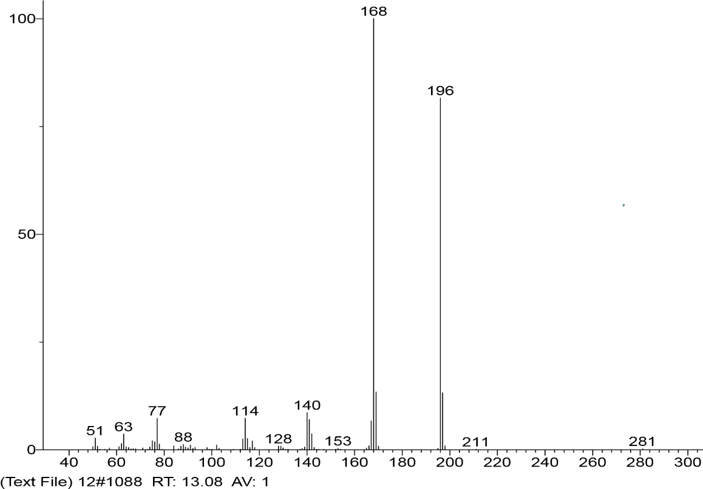
RT:
0.00 - 17.00
2
4
6
8
10
12
14
16
Time (min)
0
10
20
30
40
50
60
70
80
90
100
Relative Abundance
13.09

A

B

Figure S1. The gas chromatography-mass spectrometry (GCMS) profile of purified compound SF-1. The GC profile (A) and MS profile (B).

Figure S2. ¹H NMR spectrum of compound SF-1, measured in CDCl₃ at 600 MHz.

Figure S3. ¹³C NMR spectrum of compound SF-1, measured in CDCl₃ at 151 MHz.

Figure S4. DEPT 135 spectrum of compound SF-1, measured in CDCl₃ at 151 MHz.

Figure S5. DEPT 90 spectrum of compound SF-1, measured in CDCl₃ at 151 MHz.

Figure S6. DEPT 45 spectrum of compound SF-1, measured in CDCl₃ at 151 MHz.

