Supplementary material to:

Degradation of P(3HB-*co*-4HB) films in Simulated Body Fluids

Juraj Vodicka1, Monika Wikarska1, Monika Trudicova1, Zuzana Juglova1, Aneta Pospisilova1, Michal Kalina1, Eva Slaninova1, Stanislav Obruca1, Petr Sedlacek1,*

1 Faculty of Chemistry, Brno University of Technology, Purkynova 118, 612 00 Brno, Czech Republic

**\*** Corresponding author: Petr Sedlacek, sedlacek-p@fch.vut.cz; Tel.: +420 541 149 486

**Table S1:** MES composition.

|  |  |
| --- | --- |
| Component | Amount [g/L] |
| FeCl3 ∙ 6 H2O | 9.7 |
| CaCl2 ∙ 2 H2O | 7.8 |
| CuSO4 ∙ 5 H2O | 0.156 |
| CoCl2 ∙ 6 H2O | 0.119 |
| NiCl2 ∙ 6 H2O | 0.118 |
| CrCl2 | 0.062 |
| 0,1 M HCl | 1000 mL |

**Table S2:** TES composition.

|  |  |
| --- | --- |
| Component | Amount [g/L] |
| EDTA | 50 |
| FeCl3 | 8.3 |
| ZnCl2 | 0.84 |
| CuCl2 ∙ 2 H2O | 0.13 |
| CoCl2 ∙ 6 H2O | 0.1 |
| MnCl2 ∙ 6 H2O | 0.016 |
| H3BO3 | 0.1 |
| Water | 1000 mL |

**Table S3:** Composition of phosphate buffer solution (PBS) for films incubation.

|  |  |
| --- | --- |
| Component | Amount [g/L] |
| NaCl | 8 |
| KCl | 0.2 |
| Na2HPO4 | 1.44 |
| KH2PO4 | 0.245 |
| Water | 1000 mL |

**Table S4:** Composition of simulated gastric juice (SGJ).

|  |  |
| --- | --- |
| Component | Amount [g/L] |
| Sodium taurocholate | 0.043 |
| Lecithin (soy) | 0.002 |
| Pepsin | 0.1 |
| NaCl | 2.0 |
| Water | 1000 mL |

**Table S5:** Composition of artificial colonic fluid (ACF). Tris-maleate buffer consisted of 5.5 g of Tris and 8.8 g o maleic acid, adjusted by 0.5M NaOH to pH 7.8.

|  |  |
| --- | --- |
| Component | Amount [g/L] |
| Porcine bile extract | 0.113 |
| Lecithin (soy) | 0.222 |
| Palmitic acid | 0.026 |
| Bovine serum albumin | 3 |
| Pancreatin (porcine) | 0.1 |
| Tris-maleate buffer | 1000 mL |



P(3HB-*co*-66 mol. % 4HB)

Temperature [°C]

Normalized Heat Flow [W/g]



P(3HB-*co*-36 mol. % 4HB)

Temperature [°C]

Normalized Heat Flow [W/g]



P3HB

↑ Exo Up

Temperature [°C]

Normalized Heat Flow [W/g]

**Figure S1:** DSC thermograms of initial-state polymer films.

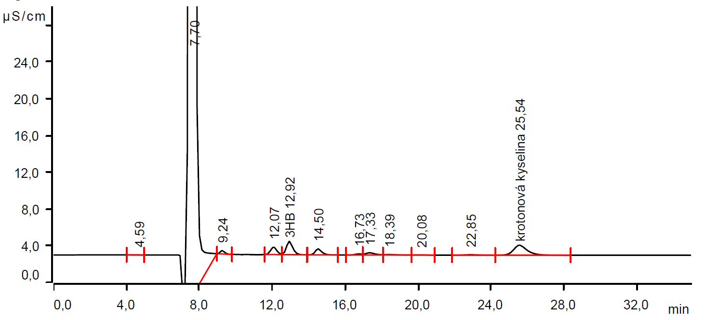

crotonic acid

**Figure S2:** IC chromatogram of pure ACF with 3HB and crotonic acid standards. The arrows point peaks of standards.

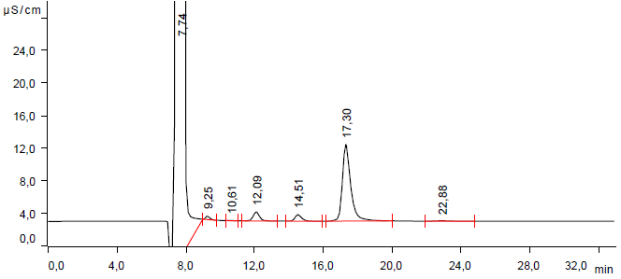

**Figure S3:** IC chromatogram of waste ACF. The arrows point missing peaks of 3HB and crotonic acid.