Supplementary Materials

- Respondent Response

Missing data was expected in a longitudinal study. However, despite our best effort, not all respondents completed their responses. Among reasons for missing data include uncontactable and refusal, at specific time events, and some of the caregivers were recruited only after several weeks or months after the patient was discharged. As a result, only 39.3% of the caregiver had a complete response, as shown in Table S1. The number of responses for each time event was summarised in Table S2.

Table S1: Number of responses
Response |  | n (%)
Category | No. of Response
Baseline Only | 0 | 37 (24.9)
Incomplete | 1 | 20 (12.9)
 | 2 | 21 (13.5)
 | 3 | 16 (10.3)
Complete | 4 | 61 (39.3)

Table S2: Number of responses for each time event
Time Event | No response, n (%)
Baseline | 155 (100)
Week 1, T₀ | 104 (67.1)
Month 1, T₁ | 92 (59.4)
Month 2, T₂ | 75 (48.4)
Month 3, T₃ | 83 (53.5)

- Correlation between scores.

Correlation between mRS, Shah-mBI, MZBI and Malay-CAFU were visualised in Figure S1 and Figure S2.

The correlation matrix shows that mRS strongly correlated with Shah-mBI and Malay-CAFU dependence scores – both for IADL and ADL. Malay-CAFU mean upset score and total upset score, both for IADL and ADL were strongly correlated, and thus only the mean upset score will be reported in the main body text.

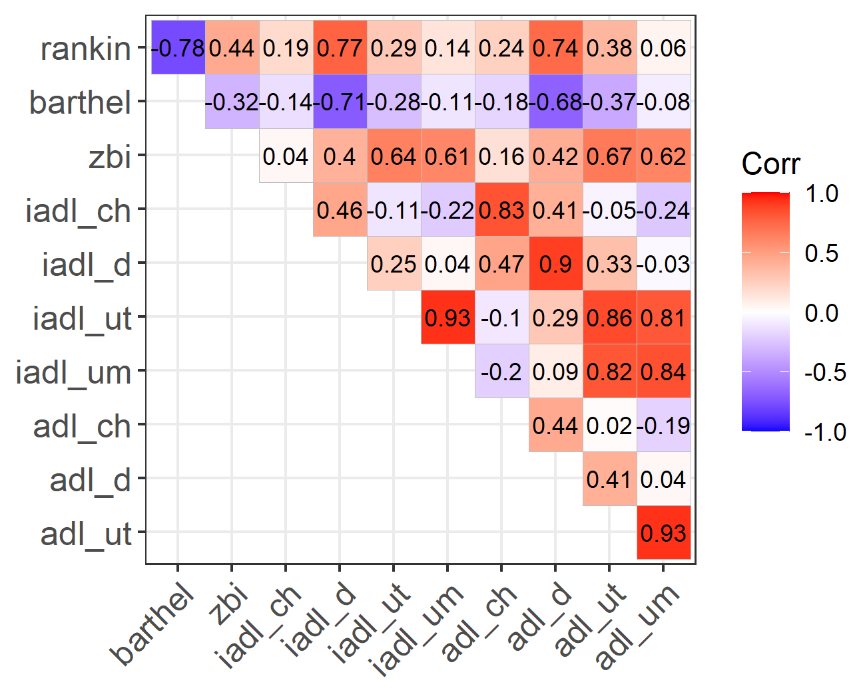
Figure S1: Correlation matrix between Rankin Score (rankin), Barthel Index Score (barthel), Zarit Burden Interview Score (zbi), IADL care-hour (iadl_ch), IADL Dependence Score (iadl_d), IADL Total Upset Score (iadl_ut), IADL Mean Upset Score (iadl_um), ADL care-hour (adl_ch), ADL Dependence Score (adl_d), ADL Total Upset Score (adl_ut) and ADL Mean Upset Score (adl_um), at overall

a) | 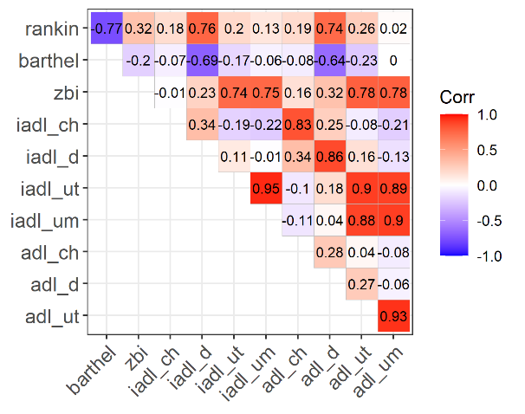 | b) | 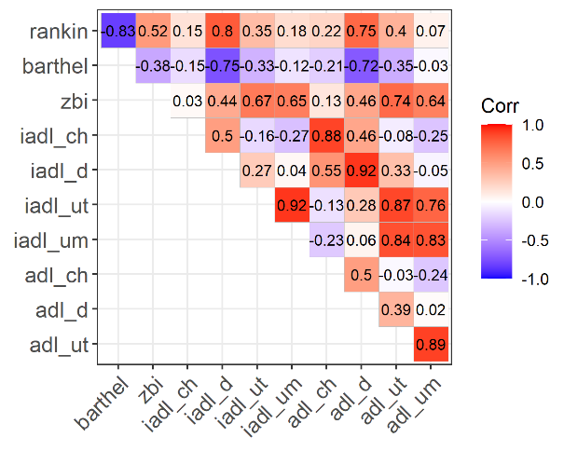
c) | 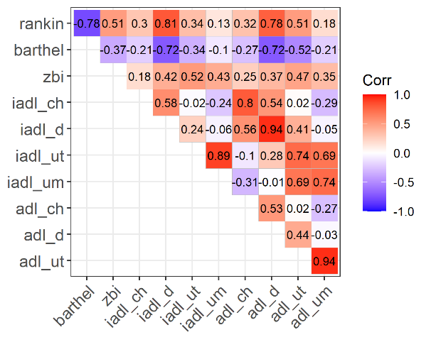 | d) | 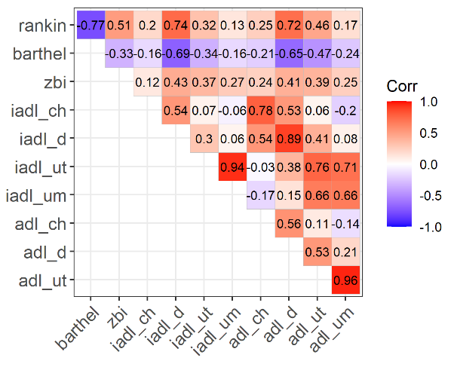
Figure S2: Correlation matrix between Rankin Score, Barthel Index Score, Zarit Burden Interview Score, IADL care-hour, IADL Dependence Score, IADL Total Upset Score, IADL Mean Upset Score, ADL care-hour, ADL Dependence Score, ADL Total Upset Score and ADL Mean Upset Score, at a) 1 week, b) 1 month, c) 2 month, d) 3 month

- ZBI and Malay-CAFU Trend

ZBI and Malay-CAFU trend was stratified into patient’s dependence category (Figure S4) and caregiver’s gender (Figure S3)

a) | 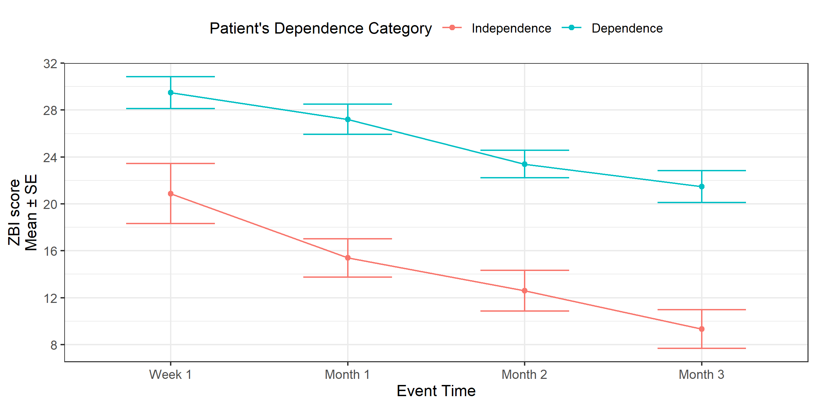
b) | 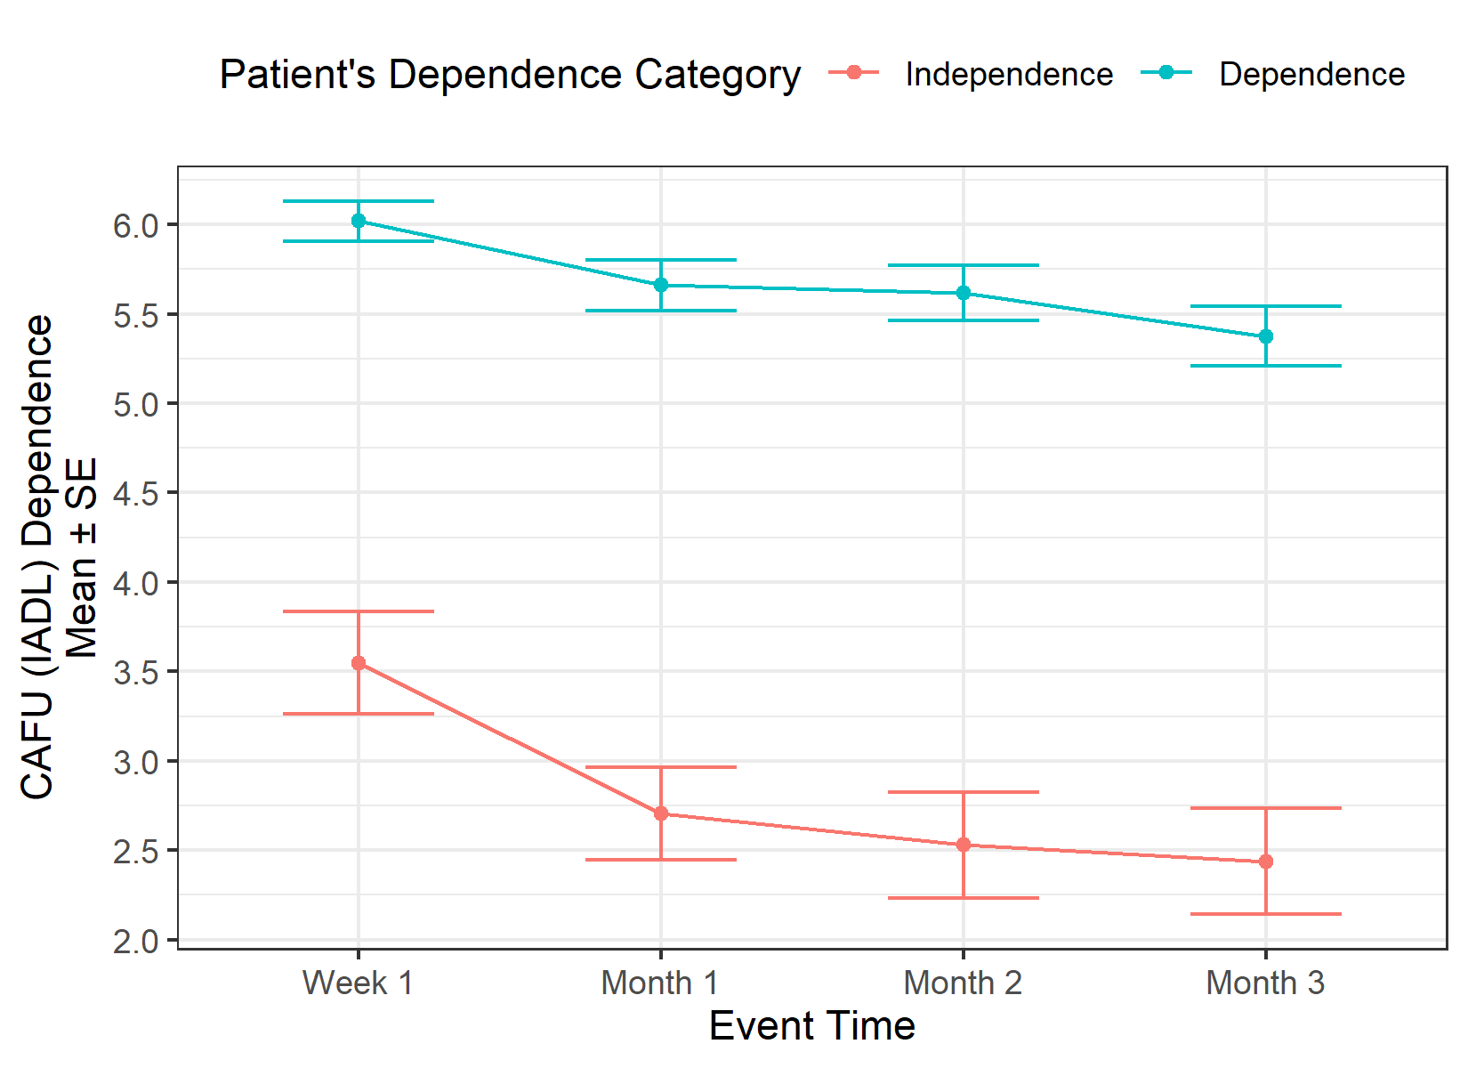 | c) | 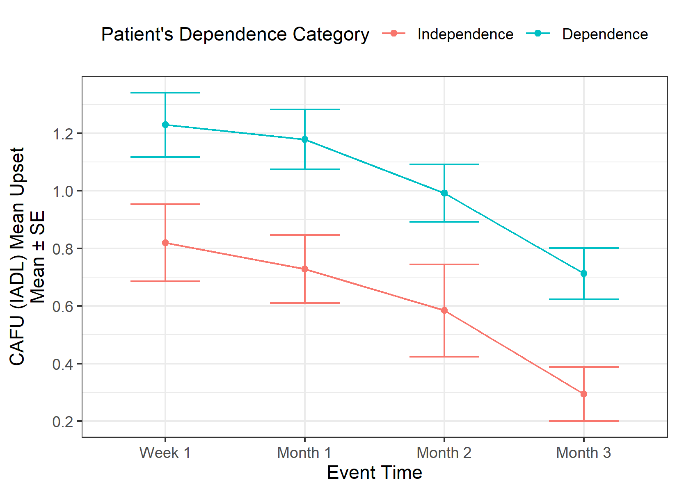
d) | 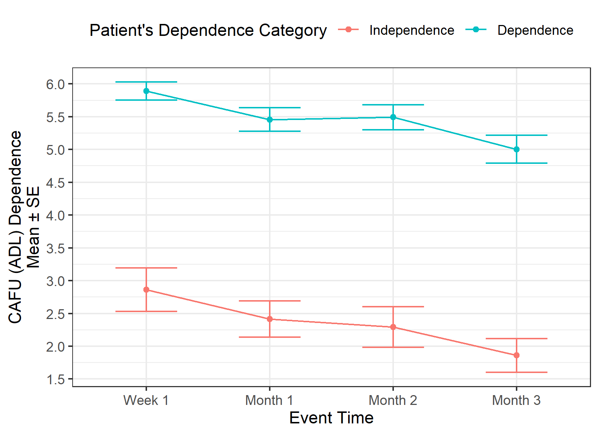 | e) | 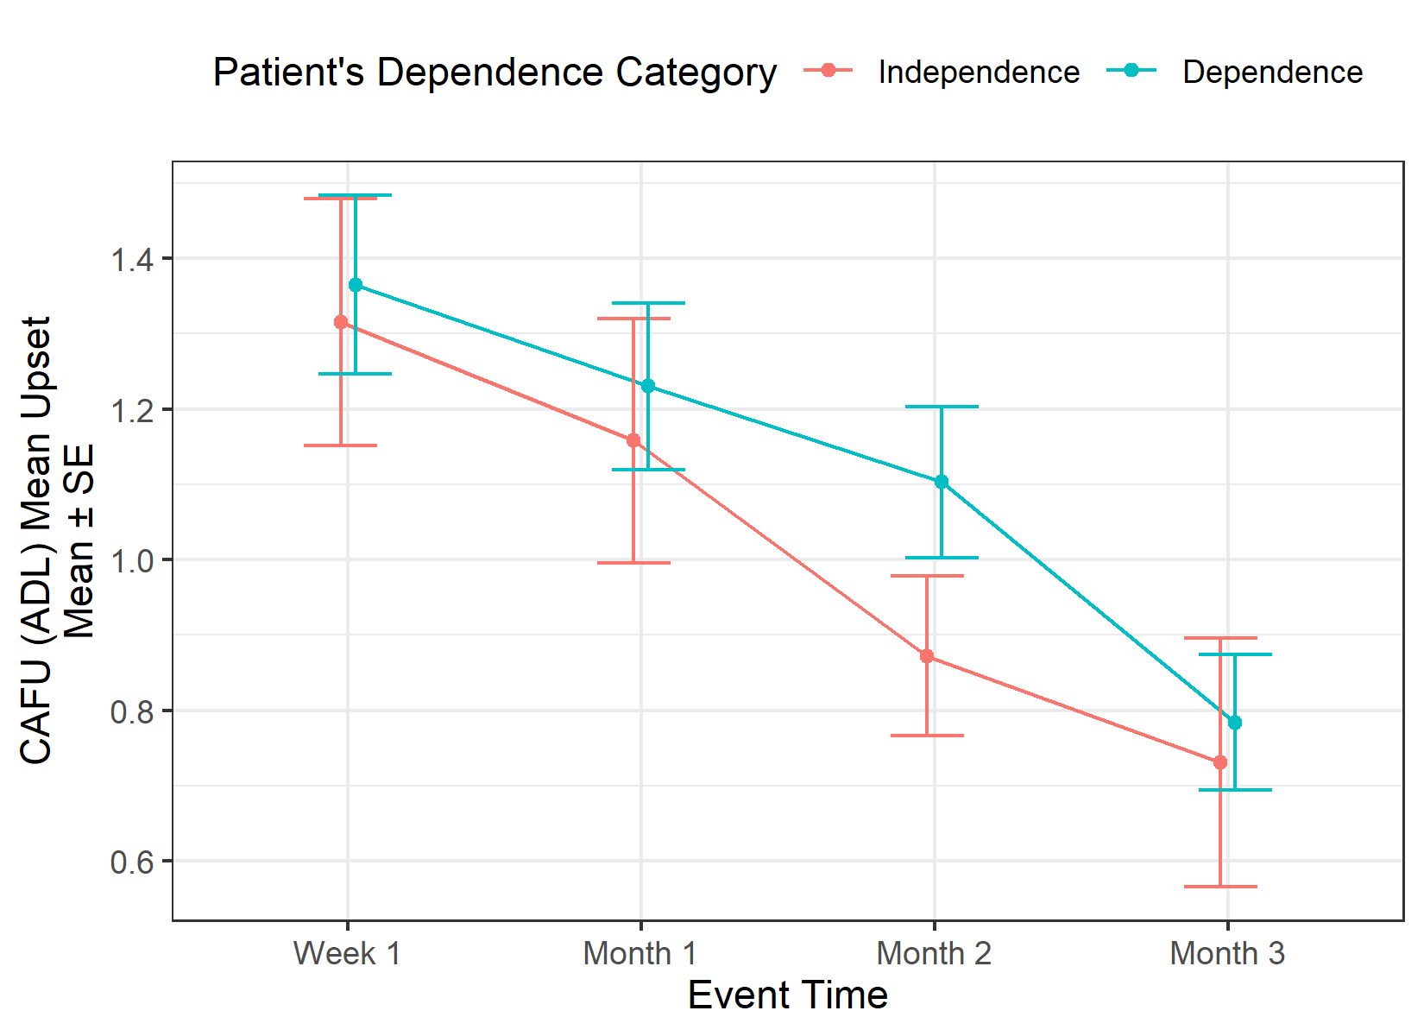
Figure S3: MZBI and Malay-CAFU trend, when stratified to patient’s dependence level

a) | 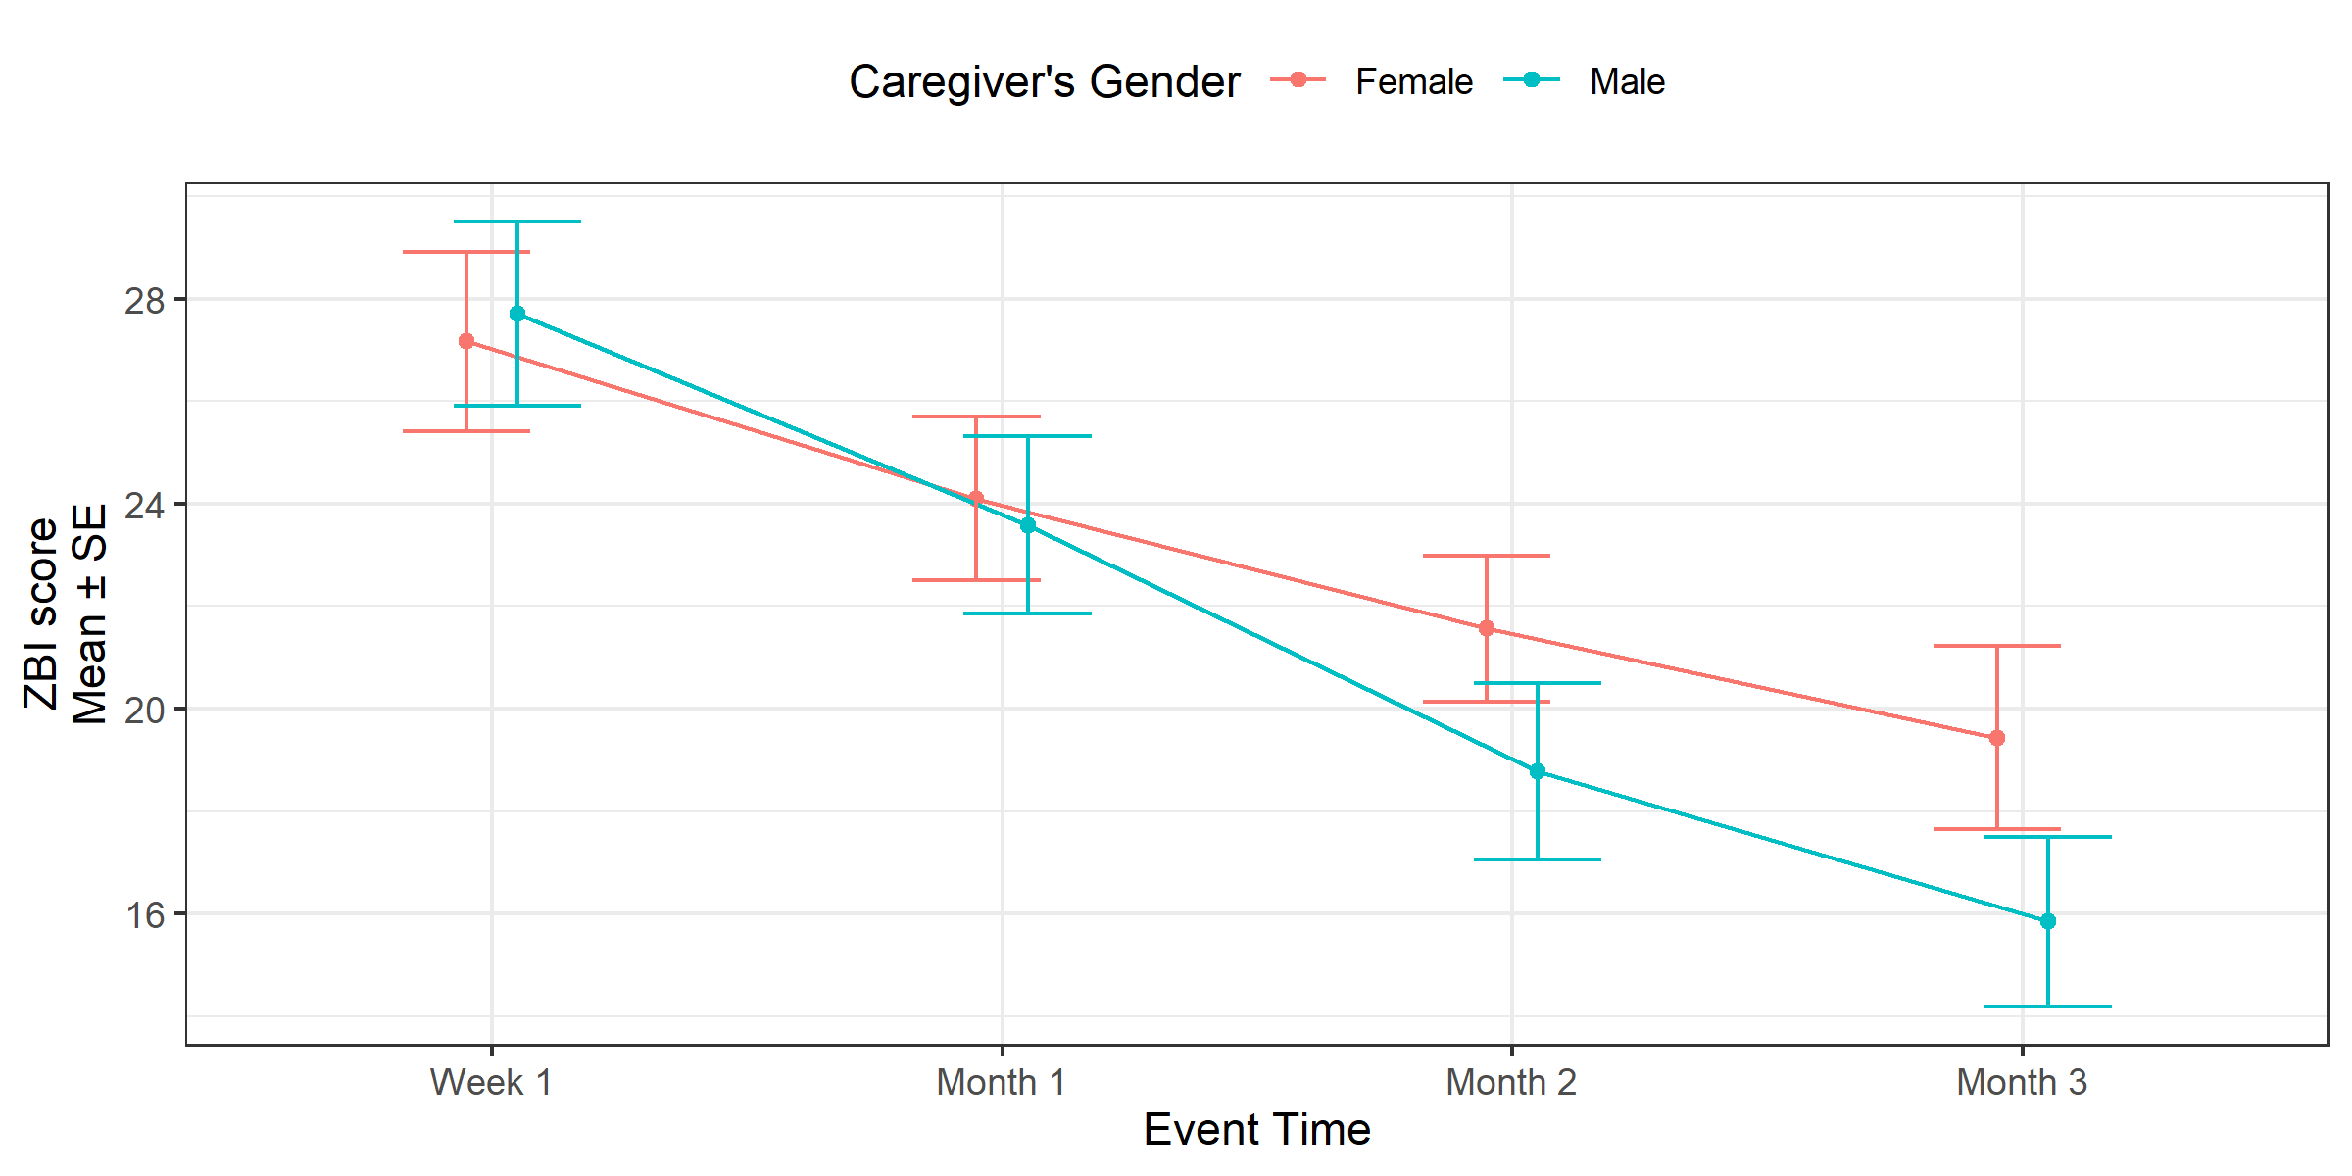
b) | 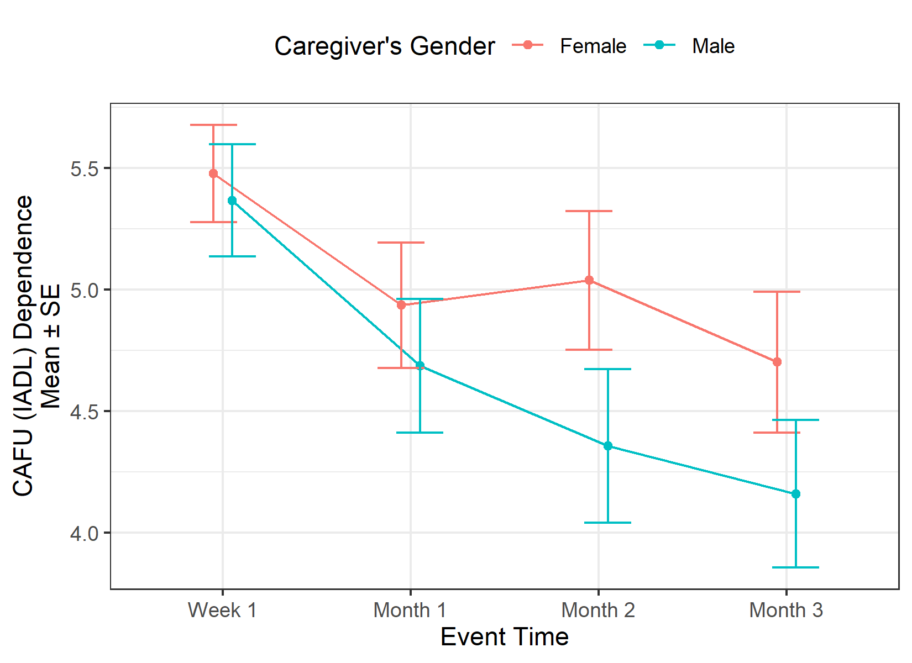 | c) | 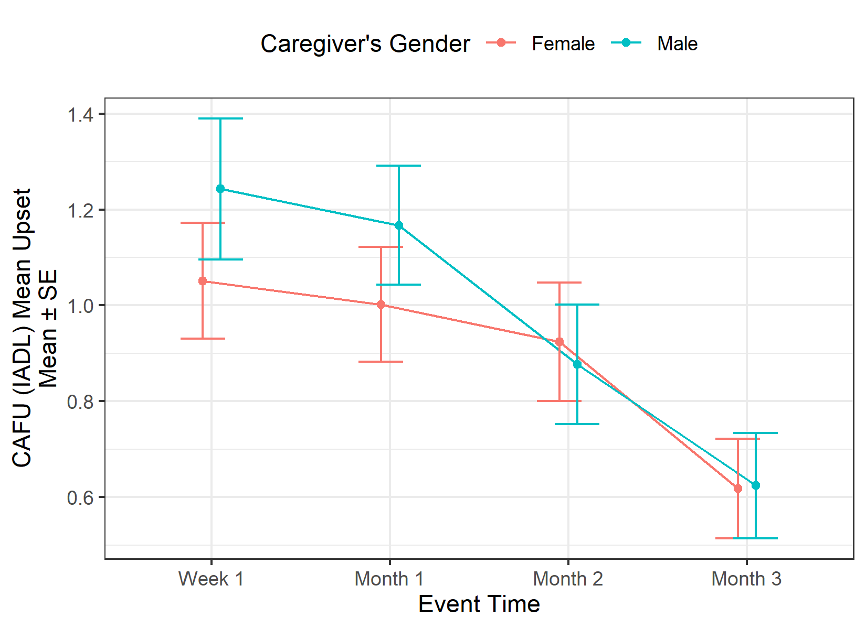
d) | 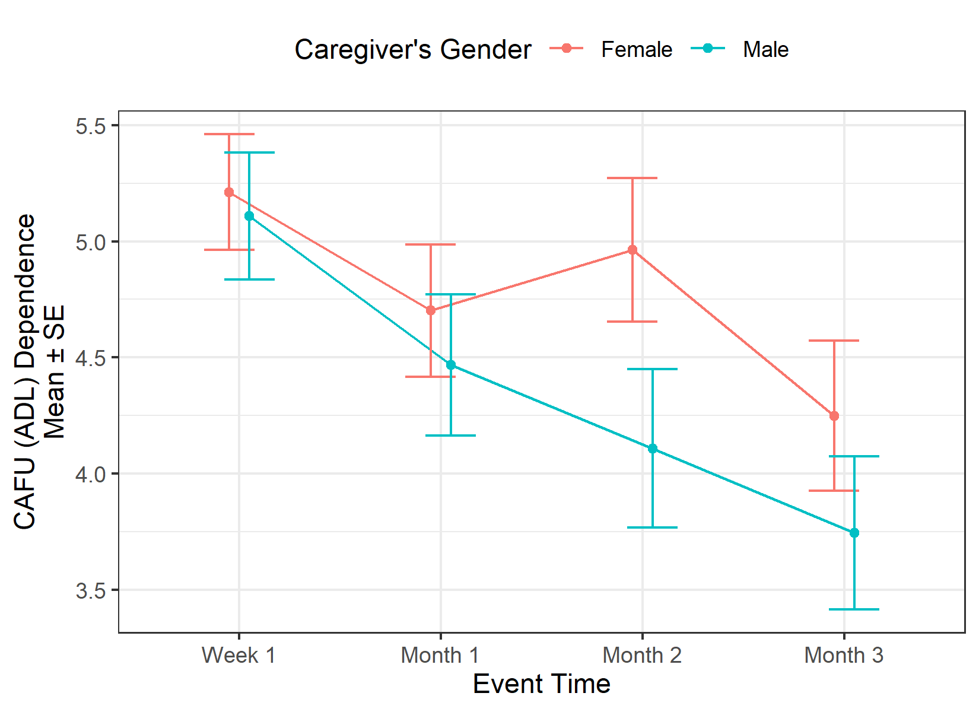 | e) | 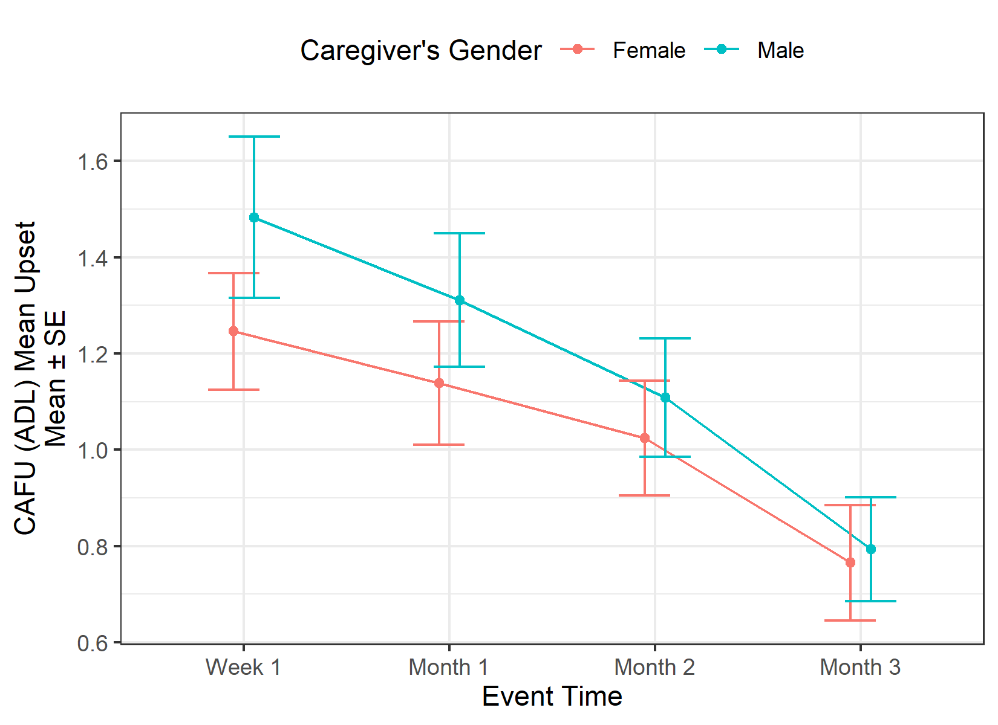
Figure S4: MZBI and Malay-CAFU trend, when stratified to caregiver’s gender

- R script

Data available from doi: 10.5281/zenodo.6998141
Please download the data and run the R script in the data repository to label and level the dataset before running these R codes.

## Library
require(tidyverse)
require(gtsummary)
require(rstatix)

## Patient’s Demographic
## Table 1
strokeds_wide %>%
distinct(pt_id, .keep_all = T) %>%
select(pt_gender, pt_age, stroke_episode, pt_nocg, pt_nohh,
dc_mrslab, pt_bi_score) %>%
tbl_summary(type = list(pt_nocg ~ "continuous"),
digits = list(all_continuous() ~ 1,
pt_age ~ 2,
all_categorical() ~ c(0,1)),
statistic = list(all_continuous() ~ "{median} ({p25}, {p75})",
pt_age ~ "{mean} ({sd})",
all_categorical() ~ "{n} ({p})"))

## Caregiver’s Demographic
## Table 2
strokeds_wide %>%
select(cg_gender, cg_age:cg_occupation, cg_personalincome:cg_nocr) %>%
tbl_summary(type = list(c(cg_livept, cg_othercr) ~ "categorical",
c(cg_age, cg_nocr) ~ "continuous"),
statistic = list(all_continuous() ~ "{mean} ({sd})",
all_categorical() ~ "{n} ({p})",
cg_nocr ~ "{median} ({p25}, {p75})"),
digits = list(all_categorical() ~ c(0,1),
all_continuous() ~ 2,
cg_nocr ~ 1))

## Outcome Score Trend (Overall)
## Table 3
strokeds_long %>%
select(c(event_name, starts_with("zbi_total_score"),
cafu_iadl_d_avescore, cafu_iadl_u_totscore, cafu_iadl_u_meanscore,
cafu_adl_d_avescore, cafu_adl_u_totscore, cafu_adl_u_meanscore)) %>%
filter(event_name != "Base") %>%
droplevels() %>%
tbl_summary(by = event_name,
digits = all_continuous() ~ 2,
statistic = all_continuous() ~ c("{mean} ({sd})"))

## Outcome Score Trend (By MRS and Cg Gender)
## Table 4
roww1 <- strokeds_wide %>%
select(dc_mrscat, cg_gender, zbi_total_score_W1,
cafu_iadl_d_avescore_W1, cafu_iadl_u_totscore_W1, cafu_iadl_u_meanscore_W1,
cafu_adl_d_avescore_W1, cafu_adl_u_totscore_W1, cafu_adl_u_meanscore_W1) %>%
tbl_strata(strata = dc_mrscat,
.tbl_fun = ~ .x %>%
tbl_summary(by = cg_gender,
type = everything() ~ "continuous",
digits = all_continuous() ~ 2,
statistic = all_continuous() ~ c("{mean} ({sd})"),
missing = "no"),
.header = "**{strata}**, N = {n}")
rowm1 <- strokeds_wide %>%
select(dc_mrscat, cg_gender, zbi_total_score_M1,
cafu_iadl_d_avescore_M1, cafu_iadl_u_totscore_M1, cafu_iadl_u_meanscore_M1,
cafu_adl_d_avescore_M1, cafu_adl_u_totscore_M1, cafu_adl_u_meanscore_M1) %>%
tbl_strata(strata = dc_mrscat,
.tbl_fun = ~ .x %>%
tbl_summary(by = cg_gender,
type = everything() ~ "continuous",
digits = all_continuous() ~ 2,
statistic = all_continuous() ~ c("{mean} ({sd})"),
missing = "no"),
.header = "**{strata}**, N = {n}")
rowm2 <- strokeds_wide %>%
select(dc_mrscat, cg_gender, zbi_total_score_M2,
cafu_iadl_d_avescore_M2, cafu_iadl_u_totscore_M2, cafu_iadl_u_meanscore_M2,
cafu_adl_d_avescore_M2, cafu_adl_u_totscore_M2, cafu_adl_u_meanscore_M2) %>%
tbl_strata(strata = dc_mrscat,
.tbl_fun = ~ .x %>%
tbl_summary(by = cg_gender,
type = everything() ~ "continuous",
digits = all_continuous() ~ 2,
statistic = all_continuous() ~ c("{mean} ({sd})"),
missing = "no"),
.header = "**{strata}**, N = {n}")
rowm3 <- strokeds_wide %>%
select(dc_mrscat, cg_gender, zbi_total_score_M3,
cafu_iadl_d_avescore_M3, cafu_iadl_u_totscore_M3, cafu_iadl_u_meanscore_M3,
cafu_adl_d_avescore_M3, cafu_adl_u_totscore_M3, cafu_adl_u_meanscore_M3) %>%
tbl_strata(strata = dc_mrscat,
.tbl_fun = ~ .x %>%
tbl_summary(by = cg_gender,
type = everything() ~ "continuous",
digits = all_continuous() ~ 2,
statistic = all_continuous() ~ c("{mean} ({sd})"),
missing = "no"),
.header = "**{strata}**, N = {n}")
tbl_stack(list(roww1, rowm1, rowm2, rowm3), group_header = c("W1", "M1", "M2", "M3"))

## Outcome Score Trend (By MRS and Cg Gender) Plots
## Figure 1
strokeds_long_mrsxcggen <- strokeds_long %>%
mutate(mrsxcggen =
case_when(dc_mrscat == "Independence" & cg_gender == "Female" ~ "Ind-F",
dc_mrscat == "Independence" & cg_gender == "Male" ~ "Ind-M",
dc_mrscat == "Dependence" & cg_gender == "Female" ~ "Dep-F",
dc_mrscat == "Dependence" & cg_gender == "Male" ~ "Dep-M"))
posd <- position_dodge(.2)
scalexlab <- c("Week 1", "Month 1", "Month 2", "Month 3")
scalecollab <- c("Patient Dependence &\nCaregiver Female",
"Patient Dependence &\nCaregiver Male",
"Patient Independence &\nCaregiver Female",
"Patient Independence &\nCaregiver Male")
### ZBI - Figure 1a
strokeds_long_mrsxcggen %>%
select(event_name, zbi_total_score, mrsxcggen) %>%
group_by(event_name, mrsxcggen) %>%
get_summary_stats(zbi_total_score,type = "mean_se") %>%
droplevels() %>%
ggplot(aes(x = event_name, y = mean,
group = mrsxcggen, colour = mrsxcggen,
ymin = mean - se, ymax = mean + se)) +
geom_point(position = posd) + geom_line(position = posd) +
geom_errorbar(position = posd, width = .5) +
scale_x_discrete(labels = scalexlab, name = "Event Time") +
scale_y_continuous(breaks = seq(0,40,4), name = "ZBI score\nMean \u00B1 SE") +
scale_colour_discrete(name = "Group", labels = scalecollab,
type = getOption("ggplot2.discrete.colour")) +
theme_bw()
### CAFU IADL Dependence Figure 1b
strokeds_long_mrsxcggen %>%
select(event_name, cafu_iadl_d_avescore, mrsxcggen) %>%
group_by(event_name, mrsxcggen) %>%
get_summary_stats(cafu_iadl_d_avescore,type = "mean_se") %>%
droplevels() %>%
ggplot(aes(x = event_name, y = mean,
group = mrsxcggen, colour = mrsxcggen,
ymin = mean - se, ymax = mean + se)) +
geom_point(position = posd) + geom_line(position = posd) +
geom_errorbar(position = posd, width = .5) +
scale_x_discrete(labels = scalexlab, name = "Event Time") +
scale_y_continuous(breaks = seq(0, 10, .5),
name = "CAFU (IADL) Dependence\nMean \u00B1 SE") +
scale_colour_discrete(name = "Group", labels = scalecollab,
type = getOption("ggplot2.discrete.colour")) +
theme_bw()
### CAFU IADL Mean Upset Figure 1c
strokeds_long_mrsxcggen %>%
select(event_name, cafu_iadl_u_meanscore, mrsxcggen) %>%
group_by(event_name, mrsxcggen) %>%
get_summary_stats(cafu_iadl_u_meanscore,type = "mean_se") %>%
droplevels() %>%
ggplot(aes(x = event_name, y = mean,
group = mrsxcggen, colour = mrsxcggen,
ymin = mean - se, ymax = mean + se)) +
geom_point(position = posd) + geom_line(position = posd) +
geom_errorbar(position = posd, width = .5) +
scale_x_discrete(labels = scalexlab, name = "Event Time") +
scale_y_continuous(breaks = seq(0, 2, .2),
name = "CAFU (IADL) Mean Upset\nMean \u00B1 SE") +
scale_colour_discrete(name = "Group", labels = scalecollab,
type = getOption("ggplot2.discrete.colour")) +
theme_bw()
### CAFU ADL Dependence Figure 1d
strokeds_long_mrsxcggen %>%
select(event_name, cafu_adl_d_avescore, mrsxcggen) %>%
group_by(event_name, mrsxcggen) %>%
get_summary_stats(cafu_adl_d_avescore,type = "mean_se") %>%
droplevels() %>%
ggplot(aes(x = event_name, y = mean,
group = mrsxcggen, colour = mrsxcggen,
ymin = mean - se, ymax = mean + se)) +
geom_point(position = posd) + geom_line(position = posd) +
geom_errorbar(position = posd, width = .5) +
scale_x_discrete(labels = scalexlab, name = "Event Time") +
scale_y_continuous(breaks = seq(0, 10, .5),
name = "CAFU (ADL) Dependence\nMean \u00B1 SE") +
scale_colour_discrete(name = "Group", labels = scalecollab,
type = getOption("ggplot2.discrete.colour")) +
theme_bw()
### CAFU ADL Mean Upset Figure 1e
strokeds_long_mrsxcggen %>%
select(event_name, cafu_adl_u_meanscore, mrsxcggen) %>%
group_by(event_name, mrsxcggen) %>%
get_summary_stats(cafu_adl_u_meanscore,type = "mean_se") %>%
droplevels() %>%
ggplot(aes(x = event_name, y = mean,
group = mrsxcggen, colour = mrsxcggen,
ymin = mean - se, ymax = mean + se)) +
geom_point(position = posd) + geom_line(position = posd) +
geom_errorbar(position = posd, width = .5) +
scale_x_discrete(labels = scalexlab, name = "Event Time") +
scale_y_continuous(breaks = seq(0, 2, .2),
name = "CAFU (ADL) Mean Upset\nMean \u00B1 SE") +
scale_colour_discrete(name = "Group", labels = scalecollab,
type = getOption("ggplot2.discrete.colour")) +
theme_bw()

