Mutational landscape of bladder cancer in Mexican patients: KMT2D mutations and chr11q15.5 amplifications are associated with muscle invasion
María D. Pérez-Montiel¹, Dennis Cerrato-Izaguirre^{2,3}, Yesennia Sánchez-Pérez³, Jose Diaz-Chavez³, Carlo Cortés-González³, Jairo A. Rubio³, Miguel Jiménez-Ríos⁴, Luis A. Herrera⁵, Anna Scavuzzo⁴, Abelardo Meneses-García⁷, Ricardo Hernández-Martínez³, Felipe Vaca-Paniagua⁸, Andrea Ramírez⁹, Alicia Orozco⁹, David Cantú-de-León⁶, Diddier Prada^{3,10}.
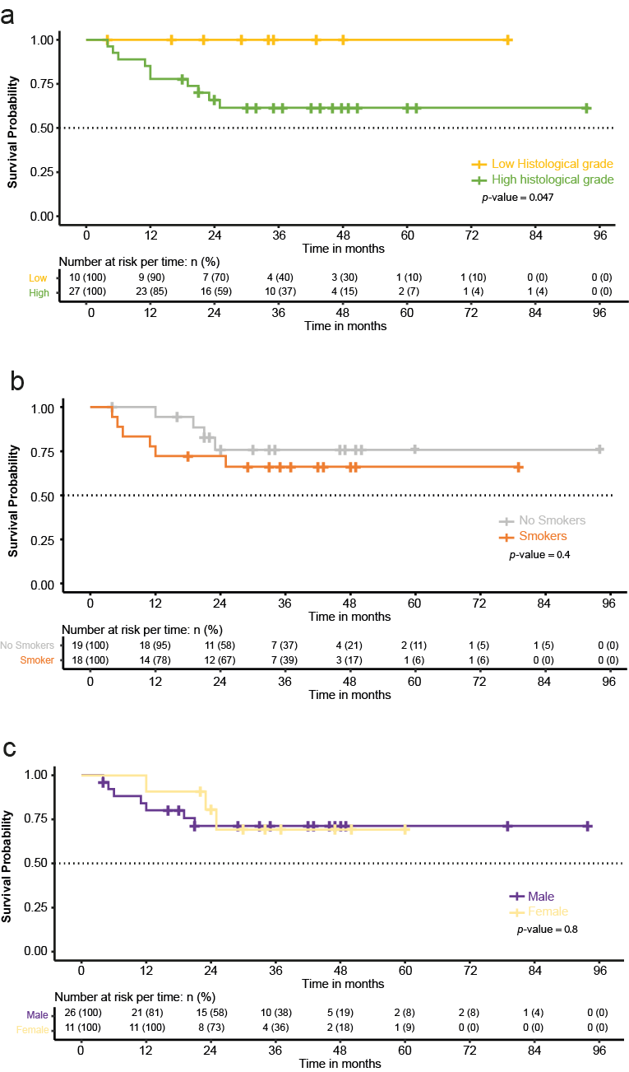
Supplementary S1. Overall survival of the patients with bladder cancer with other clinical features. a) Kaplan-Meier curve of the overall survival by histological grade of histological, b) smokers and c) sex. No significant differences exist using the Log Rank test.

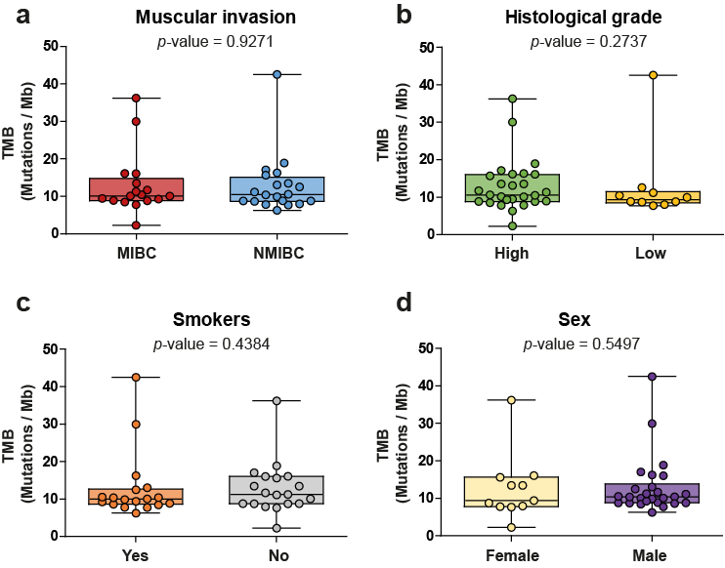

Supplementary S2: Relationship between TMB value and clinical features. a) Comparison of TMB value with the muscular invasion. In red when the muscular invasion is present (Muscle Invasive Bladder Cancer). In blue without muscular invasion (Non-Muscle Invasive Bladder Cancer) b) Comparison of TMB value with histological grade. c) Comparison of TMB value if the people are smokers or not. D) Comparison of TMB value by sex. Each dot shows individual data. p-values were calculated using the Mann-Whitney U test.

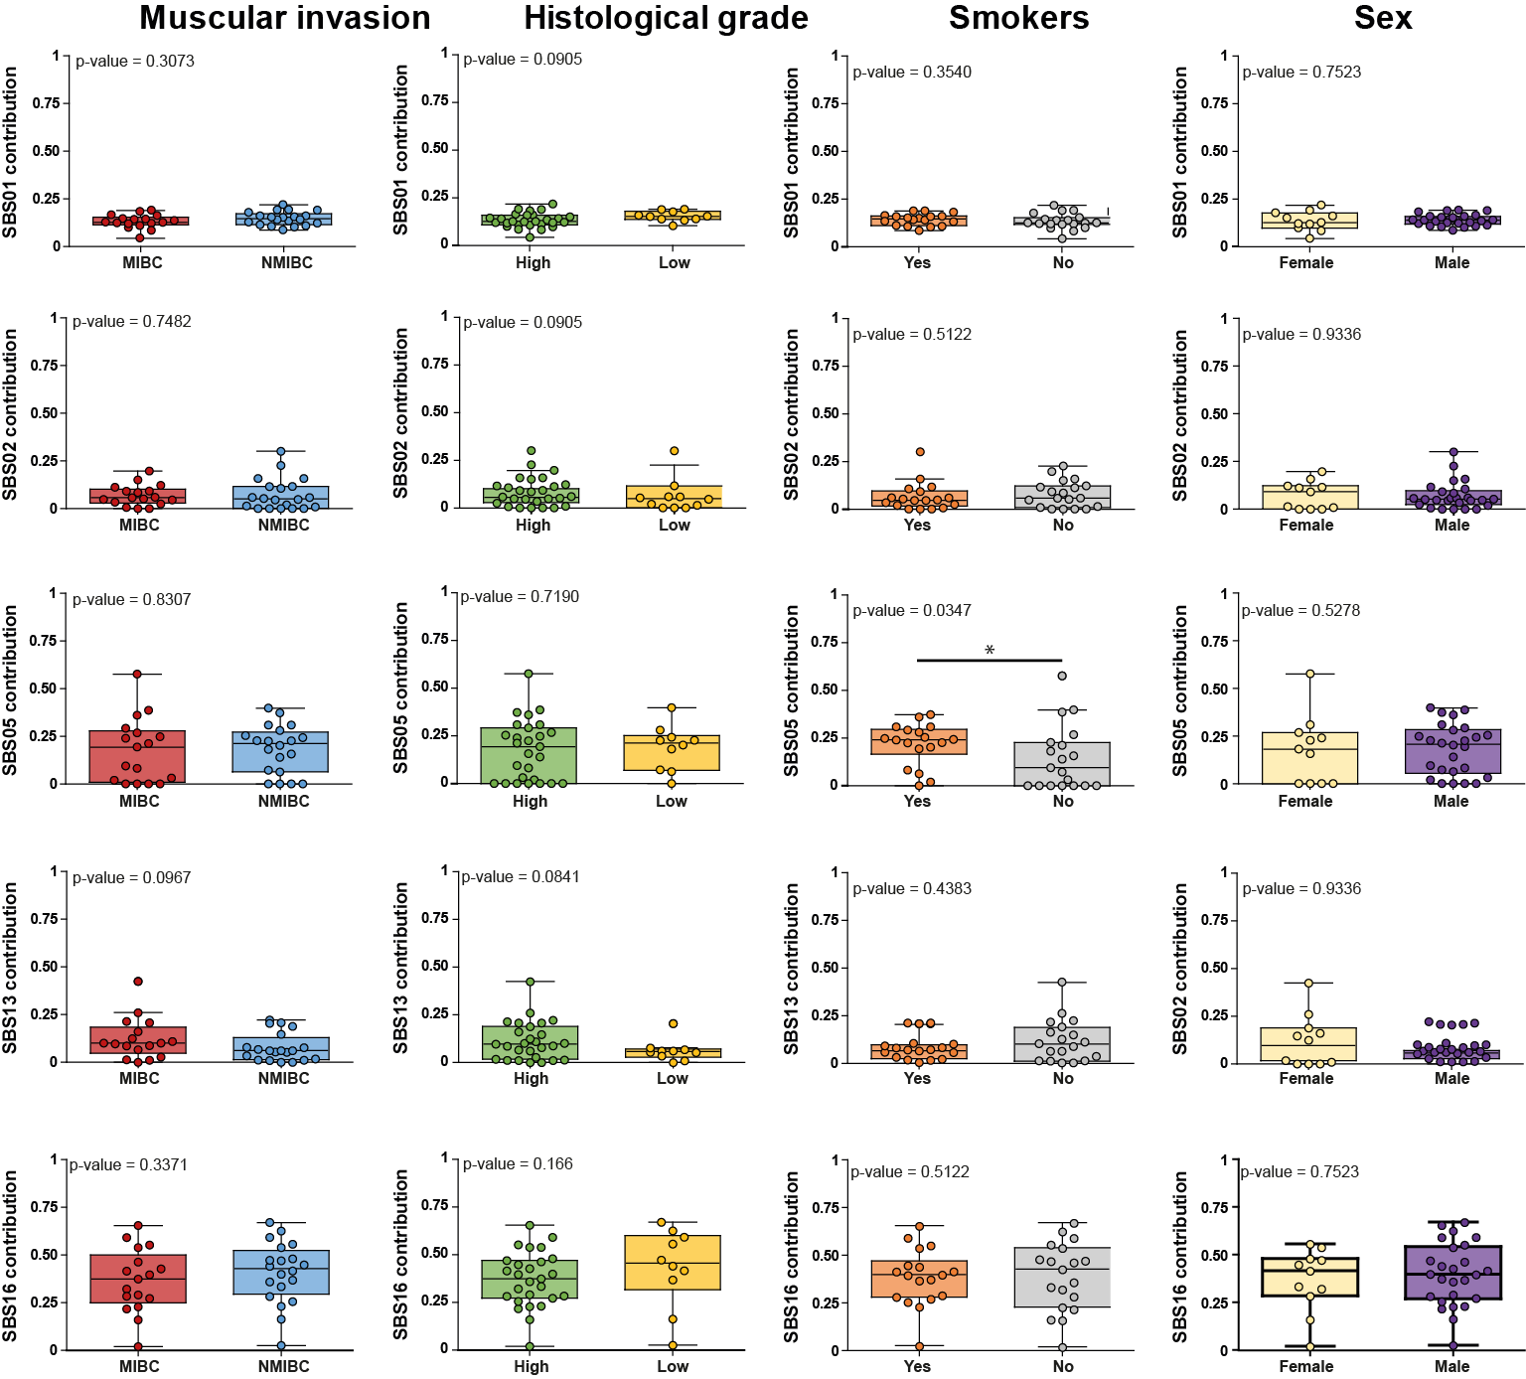

Supplementary S2: Association between mutational signature contribution and clinical characteristics of patients with bladder cancer of the SBS01, SBS02, SBS05, SBS13, and SBS016. Watch the mutation SB05 is statistically significant with previous reports. Each dot shows individual data. p-values were calculated using the Mann-Whitney U test.

