Supplementary material for
Exploring the unbinding mechanism of drugs from SERT via molecular dynamics simulation and its implication in antidepressants

Xin-Guan Tan¹, Xue-Feng Liu^{1*}, Xin Li³, Ming-Hui Pang¹, Yu-Qing Wang¹, Yun-Jie Zhao^{2*}
1 College of Mathematics and Physics, Chengdu University of Technology, Chengdu 610059, China.
2 Institute of Biophysics and Department of Physics, Central China Normal University, Wuhan 430079, China.
3 College of Chemistry and Chemical Engineering, Chongqing University, Chongqing 400010, China.

Table S1. Hydrogen bond analysis with the equilibrium trajectories of the SERT- serotonin at S1 site complex.
Acceptor | Donor | Occupancy  (%) | Average Distance(Å) | Average  Angle(°)
SRO_s1@N2 | 438SER@OG | 82.45 | 2.71 | 166.42
SRO_s1@O1 | 497THR@OG1 | 21.55 | 2.79 | 163.22
95TYR@OH | SRO_s1@N1 | 15.67 | 2.91 | 159.19
97VAL@O | SRO_s1@N2 | 14.79 | 2.90 | 158.94
SRO_s1@O1 | SRO_s2@N2 | 13.11 | 2.89 | 154.35
SRO_s1@O1 | 175TYR@OH | 6.52 | 2.80 | 153.39
336SER@O | SRO_s1@N1 | 6.51 | 2.88 | 152.86
335PHE@O | SRO_s1@N1 | 4.56 | 2.84 | 150.32
SRO_s1@O1 | SRO_s2@N2 | 3.14 | 2.88 | 154.32
438SER@OG | SRO_s1@N2 | 0.97 | 2.90 | 151.94
438SER@O | SRO_s1@N2 | 0.82 | 2.90 | 158.90
95TYR@O | SRO_s1@N2 | 0.41 | 2.88 | 143.11
97VAL@O | SRO_s1@N2 | 0.36 | 2.87 | 160.77
95TYR@O | SRO_s1@N1 | 0.32 | 2.86 | 142.90
176TYR@OH | SRO_s1@N2 | 0.12 | 2.90 | 153.71
438SER@OG | SRO_s1@N2 | 0.11 | 2.89 | 154.45
98ASP@OD2 | SRO_s1@N1 | 0.02 | 2.77 | 154.50
438SER@O | SRO_s1@N2 | 0.02 | 2.92 | 157.22
98ASP@OD2 | SRO_s1@N2 | 0.01 | 2.78 | 138.34
SRO_s1@N2 | 439THR@OG1 | 0.01 | 2.84 | 154.93
336SER@O | SRO_s1@N2 | 0.01 | 2.93 | 159.12
Table S2. Hydrogen bond analysis with the equilibrium trajectories of the SERT- serotonin at S2 site complex.
Acceptor | Donor | Occupancy  (%) | Average Distance(Å) | Average  Angle(°)
SRO_s2@N2 | 497THR@OG1 | 33.82 | 2.76 | 165.20
SRO_s2@O1 | 104ARG@NH2 | 25.63 | 2.86 | 151.13
494GLU@O | SRO_s2@N1 | 17.97 | 2.86 | 157.76
SRO_s1@O1 | SRO_s2@N2 | 13.11 | 2.89 | 154.35
98ASP@O1 | SRO_s2@N2 | 9.22 | 2.83 | 159.59
493GLU@OE1 | SRO_s2@N2 | 3.57 | 2.86 | 158.11
493GLU@O | SRO_s2@N2 | 3.41 | 2.87 | 150.61
SRO_s2@N2 | 175TYR@OH | 3.39 | 2.80 | 158.24
SRO_s1@O1 | SRO_s2@N2 | 3.14 | 2.88 | 154.32
SRO_s2@O1 | 104ARG@NE | 1.92 | 2.87 | 146.38
175TYR@OH | SRO_s2@N2 | 1.54 | 2.91 | 161.87
497THR@OG1 | SRO_s2@N2 | 0.45 | 2.88 | 147.00
493GLN@OE1 | SRO_s2@N2 | 0.21 | 2.90 | 153.74
497THR@OG1 | SRO_s2@N2 | 0.14 | 2.92 | 162.26
494ARG@OE2 | SRO_s2@N1 | 0.13 | 2.83 | 153.69
SRO_s2@O1 | 104ARG@NH1 | 0.12 | 2.89 | 150.38
98ASP@OD2 | SRO_s2@N2 | 0.09 | 2.91 | 162.64
493GLU@O | SRO_s2@N2 | 0.07 | 2.87 | 148.39
175TYR@OH | SRO_s2@N2 | 0.06 | 2.94 | 156.14
SRO_s2@O1 | 332GLN@NE2 | 0.02 | 2.94 | 153.25
494GLU@OE1 | SRO_s2@O1 | 0.02 | 2.96 | 138.07
492LEU@O | SRO_s2@N2 | 0.01 | 2.86 | 153.94
335PHE@O | SRO_s2@N2 | 0.01 | 2.96 | 148.44
332GLN@NE2 | SRO_s2@O1 | 0.01 | 2.98 | 135.10

Table S3. Hydrogen bond analysis with the equilibrium trajectories of the SERT- cocaine at S1 site complex.

Acceptor | Donor | Occupancy  (%) | Average Distance(Å) | Average  Angle(°)
COC_s1@O4 | 176TYR@OH | 52.65 | 2.74 | 161.46
COC_s1@O4 | 438SER@OG | 11.57 | 2.75 | 160.61
COC_s1@O2 | 176TYR@OH | 8.55 | 2.80 | 162.59
COC_s1@O2 | 438SER@OG | 0.28 | 2.85 | 157.49
COC_s1@O1 | 96TYR@OH | 0.19 | 2.86 | 153.41
COC_s1@O2 | 96TYR@OH | 0.09 | 2.73 | 154.79
COC_s1@O4 | 439THR@OG1 | 0.01 | 2.75 | 141.88
Table S4. Hydrogen bond analysis with the equilibrium trajectories of the SERT- cocaine at S2 site complex.
Acceptor | Donor | Occupancy  (%) | Average Distance(Å) | Average  Angle(°)
COC_s2@O2 | 104AGR@NH1 | 7.10 | 2.85 | 154.12
COC_s2@O2 | 104AGR@NE | 0.27 | 2.91 | 147.75
COC_s2@O4 | 104AGR@NH11 | 0.01 | 2.87 | 140.70
COC_s2@O4 | 104AGR@NE | 0.01 | 2.91 | 140.09

Table S5. Hydrogen bond analysis with the equilibrium trajectories of the SERT- escitalopram at S1 site complex.
Acceptor | Donor | Occupancy  (%) | Average Distance(Å) | Average  Angle(°)
68P_s1@N2 | 438SER@OG | 78.36 | 2.86 | 156.74
68P_s1@F1 | 104ARG@NH2 | 6.12 | 3.01 | 132.08
68P_s1@F1 | 104ARG@NH1 | 0.09 | 3.20 | 122.55
68P_s1@F1 | 104ARG@NH2 | 0.06 | 3.06 | 127.50
68P_s1@N2 | 176TYR@OH | 0.02 | 3.28 | 134.00

Table S6. Hydrogen bond analysis with the equilibrium trajectories of the SERT-escitalopram at S2 site complex.
Acceptor | Donor | Occupancy  (%) | Average Distance(Å) | Average  Angle(°)
68P_s2@N2 | 104ARG@NE | 55.00 | 3.26 | 159.56
68P_s2@N2 | 104ARG@NH1 | 9.77 | 3.25 | 144.23
68P_s2@F1 | 498GLY@N | 0.52 | 3.40 | 123.85
68P_s2@N2 | 107TYR@OH | 0.06 | 3.10 | 163.02
68P_s2@N1 | 559SER@OG | 0.01 | 3.38 | 126.41
68P_s2@N2 | 562GLN@NE2 | 0.01 | 3.44 | 158.11
Table S7. Hydrogen bond analysis with the equilibrium trajectories of the SERT-paroxetine at S1 site complex.
Acceptor | Donor | Occupancy  (%) | Average Distance(Å) | Average  Angle(°)
95TYR@O | 8PR_s1@N1 | 99.52 | 2.91 | 161.93
8PR_s1@O | 175TYR@OH | 8.43 | 3.17 | 132.33
336SER@O | 8PR_s1@N1 | 1.41 | 3.36 | 126.37
8PR_s1@F1 | 498GLY@N | 0.75 | 3.21 | 125.58
8PR_s1@F1 | 497THR@OG1 | 0.70 | 2.95 | 150.25
8PR_s1@O1 | 438SER@OG | 0.32 | 3.34 | 126.84
94GLY@O | 8PR_s1@N1 | 0.03 | 3.29 | 132.59
8PR_s1@N1 | 98ASP@N | 0.03 | 3.40 | 122.96
338GLY@N | 8PR_s1@N1 | 0.02 | 3.35 | 145.49
337LEU@N | 8PR_s1@N1 | 0.01 | 3.45 | 125.13

Table S8. The energy component of binding free energy (MM/GBSA method).
complex | ΔE_{vdW} | ΔE_{ele} | ΔG_{pol, GB} | ΔG_{nonpol} | ΔG_{gas} | ΔG_{sol} | ΔG_{total}
SERT-serotonin_s1ª | -29.26^{c} | -17.80 | 22.15 | -3.47 | -47.06 | 18.68 | -28.38
hSET-cocaine_s1 | -42.53 | -1.71 | 2.93 | -5.11 | -44.24 | -2.18 | -46.42
SERT-escitalopram_s1 | -43.67 | -66.25 | 64.53 | -6.07 | -109.93 | 58.46 | -51.47
SERT-paroextine_s1 | -50.63 | -7.47 | 12.68 | -5.92 | -58.10 | 6.76 | -51.34
SERT-serotonin_s2^{b} | -24.00 | -13.59 | 21.87 | -3.16 | -37.59 | 18.71 | -18.88
SERT-cocaine_s2 | -39.47 | -0.45 | 5.12 | -4.80 | -39.92 | 0.32 | -39.60
SERT-escitalopram_s2 | -39.55 | -63.00 | 69.38 | -5.48 | -102.55 | 64.80 | -38.76
ªSubstrate/Drug binding to the orthosteric (S1) site of SERT. ^{b}Substrate/Drug binding to the allosteric (S2) site of SERT. ^{c}All values are in kcal/mol

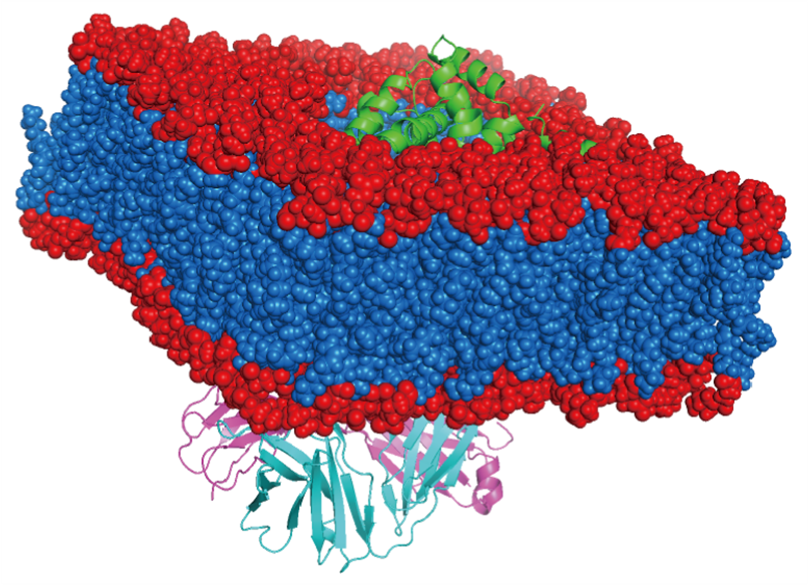
Figure S1. The model of the membrane protein of SERT. the protein is inserted into DOPC lipid bilayer used by CHARMM-GUI. lipid bilayer are colored in red and blue with spheres representation. sodium-dependent serotonin transporter and two 8B6 antibody molecules are colored in green, cyan, and magenta in cartoon representations respectively.

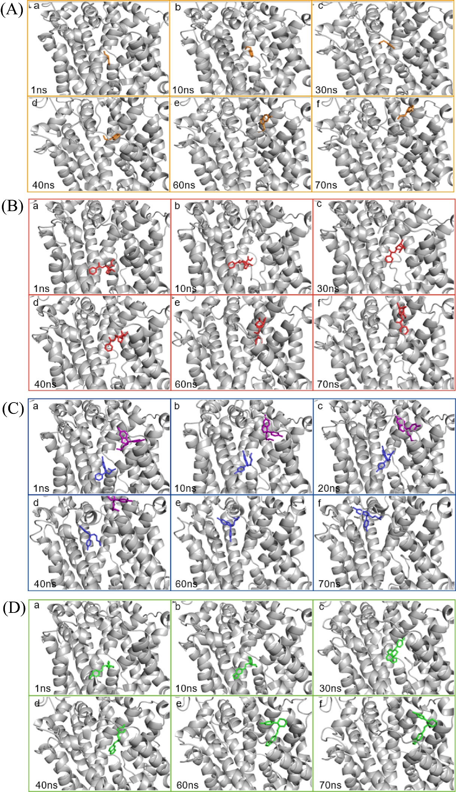
Figure S2. The intermediate snapshots of four system during the PMF simulation, SERT and ligands were represented as gray cartoon and colored sticks, respectively. Only the escitalopram of at S1 site pulled out the channel directly along MT6, other six molecules moved towards between MT1b and MT6a. (A) The SERT-serotonin system. The serotonin at S1 site, colored in orange, dissociated from SERT moving towards between MT1b and MT6a similar to the one at S2 site. (B)The SERT-cocaine system. the cocaine at S1 site, colored in red, dissociated from SERT moving towards between MT1b and MT6a similar to the one at S2 site. (C) The SERT-escitalopram system. The escitalopram (colored in blue) at S1 site pulled out the channel directly along MT6 and the one (colored in purple) at S2 site moved toward between MT1b and MT6a. (D) The SERT-paroxetine system. the paroxetine at S1 site, colored in green, dissociated from SERT moving towards between MT1b and MT6a similar to the one at S2 site.

