Supplement Figure legends
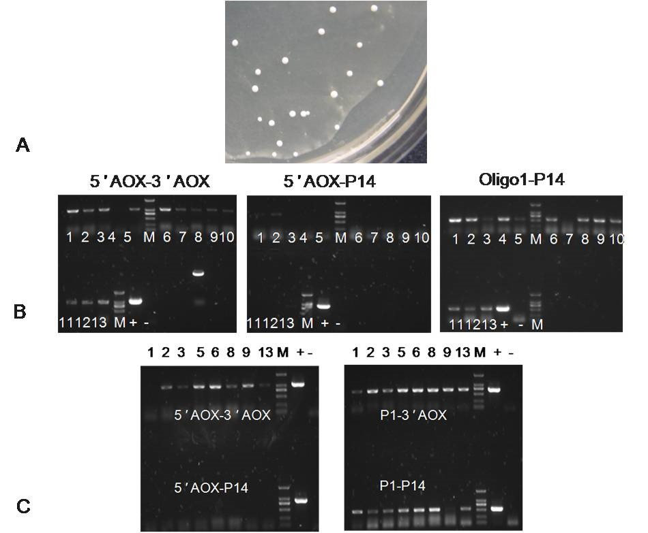
Figure. S1. The selection and identification of recombinant GS115-pPICZαA-boIFN-λ3
(A). The colony of the GS115-pPICZαA-boIFN-λ3. (B). PCR product amplified from the first generation of GS115-pPICZαA-boIFN-λ3 1to13; + Positive control; - Negative control. (C). PCR identified from the second generation of GS115-pPICZαA-boIFN-λ3 1, 2, 3, 5, 6, 8, 9 and 13; + Positive control; - Negative control.
Figure. S2. The predicted N-linked and O-linked glycosylation sequence of boIFN-λ3
Figure. S3. Inhibation of VSV in MDBK cell by recombinant boIFN-λ3

