Impacts of exposure to glyphosate and diquat on microbial diversity and community structure shifts in a lateritic paddy soil

Xiaoyu He^{1, 2}, Chunyuan Wu^{2, 3, 4, 5}, Huadong Tan ^{2, 3, 4, 5*}, Xiao Deng^{2, 3, 4, 5*}, Yi Li ^{2, 3, 4, 5}

¹ National Key Laboratory of Green Pesticide, Key Laboratory of Green Pesticide and Agricultural Bioengineering, Ministry of Education, Center for R&D of Fine Chemicals of Guizhou University, Guiyang 550025, PR China.
² Environment and Plant Protection Institute, Chinese Academy of Tropical Agricultural Sciences, Haikou 571101, PR China.
³ Danzhou Scientific Observing and Experimental Station of Agro-Environment, Ministry of Agriculture and Rural Affairs, Danzhou 571737, PR China.
⁴ National Agricultural Experimental Station for Agricultural Environment, Danzhou 571737, PR China.
⁵ Hainan Engineering Research Center for Non-point Source and Heavy Metal Pollution Control, Danzhou 571737, PR China.

* Correspondence: Huadong Tan, Environment and Plant Protection Institute, Chinese Academy of Tropical Agricultural Sciences, Haikou, China; E-mail: tanhuadong1991@163.com; Xiao Deng, Environment and Plant Protection Institute, Chinese Academy of Tropical Agricultural Sciences, Haikou, China; E-mail: dx0928@qq.com.
Table S1 Primer information
Type | Region | Primer name | Primer sequence | Product length | Reference
16S | V1-V9 | 27F | AGRGTTTGATYNTGGCTCAG | ~1465 | [1]
 |  | 1492R | TASGGHTACCTTGTTASGACTT
 | V4 | 515F | GTGYCAGCMGCCGCGGTAA | ~292 | [1-2]
 |  | 806R | GGACTACNVGGGTWTCTAAT
 | V3-V4 | 341F | CCTACGGGNGGCWGCAG | ~466 | [3]
 |  | 806R | GGACTACHVGGGTATCTAAT
 | V4-V5 | 515F | GTGCCAGCMGCCGCGGTAA | ~412 | [4]
 |  | 907R | CCGTCAATTCCTTTGAGTTT
 | V5-V7 | 799F | AACMGGATTAGATACCCKG | ~414 | [5]
 |  | 1193R | ACGTCATCCCCACCTTCC
 | V4-V5 | Arch519F | CAGCMGCCGCGGTAA | ~416 | [6]
 |  | Arch915R | GTGCTCCCCCGCCAATTCCT
18S | V4 | 528F | GCGGTAATTCCAGCTCCAA | ~260 | [7]
 |  | 706R | AATCCRAGAATTTCACCTCT
ITS | ITS1 | ITS1_F_KYO2 | TAGAGGAAGTAAAAGTCGTAA | ~366 | [8]
 |  | ITS86R | TTCAAAGATTCGATGATTCAC
 |  | ITS1-F | CTTGGTCATTTAGAGGAAGTAA | ~321 | [9]
 |  | ITS2 | GCTGCGTTCTTCATCGATGC
 | ITS2 | ITS3_KYO2 | GATGAAGAACGYAGYRAA | ~381 | [10]
 |  | ITS4 | TCCTCCGCTTATTGATATGC

Reference
[1] Singer, E.; Bushnell, B.; Coleman-Derr, D.; Bowman, B.; Bowers, R.M.; Levy, A.; Gies, E.A.; Cheng, J.F.; Copeland A.; Klenk H.P.; Hallam S J.; Hugenholtz P.; Tringe, S.G.; Woyke, T. High-resolution phylogenetic microbial community profiling. ISME J. 2016, 10, 2020-2032.
[2] Parada, A.E.; Needham, D.M.; Fuhrman, J.A. Every base matters: assessing small subunit rRNA primers for marine microbiomes with mock communities, time series and global field samples. Environ. Microbiol. 2016, 18, 1403–1414.
[3] Apprill, A.; McNally, S.; Parsons, R.; Weber, L. Minor revision to V4 region SSU rRNA 806R gene primer greatly increases detection of SAR11 bacterioplankton. Aquat. Microb. Ecol. 2015, 75, 129–137.
[4] Guo, M.; Wu F.; Hao, G.; Qi, Q.; Li, R.; Li N.; Wei L.M.; Chai T.J. Bacillus subtilis improves immunity and disease resistance in rabbits. Front. Immunol. 2017, 8, 354.
[5] Fazzini R.A.B; Levican, G.; Parada, P. Acidithiobacillus thiooxidans secretome containing a newly described lipoprotein Licanantase enhances chalcopyrite bioleaching rate. Appl. Microbiol. Biot. 2011, 89, 771-780.
[6] Beckers, B.; Op De Beeck, M.; Thijs, S.; Truyens, S.; Weyens, N.; Boerjan, W.; Vangronsveld, J. Performance of 16s rDNA Primer Pairs in the Study of Rhizosphere and Endosphere Bacterial Microbiomes in Metabarcoding Studies. Front. Microbiol. 2016, 7, 650.
[7] Teske A.; Sørensen K.B. Uncultured archaea in deep marine subsurface sediments: have we caught them all?. ISME J, 2008, 2, 3.
[8] Cheung, M.K.; Au, C.H.; Chu, K.H.; Kwan, H.S.; Wong, C.K. Composition and genetic diversity of picoeukaryotes in subtropical coastal waters as revealed by 454 pyrosequencing. ISME J, 2010, 4, 1053.
[9] Scibetta, S.; Schena, L.; Abdelfattah, A.; Pangallo, S.; Cacciola, S. O. Selection and experimental evaluation of universal primers to study the fungal microbiome of higher plants. Phytobiomes J. 2018, 2, 225- 236.
[10] Toju, H.; Tanabe, A. S.; Yamamoto, S.; & Sato, H. High-coverage ITS primers for the DNA-based identification of ascomycetes and basidiomycetes in environmental samples. PloS one, 2012, 7, e40863.

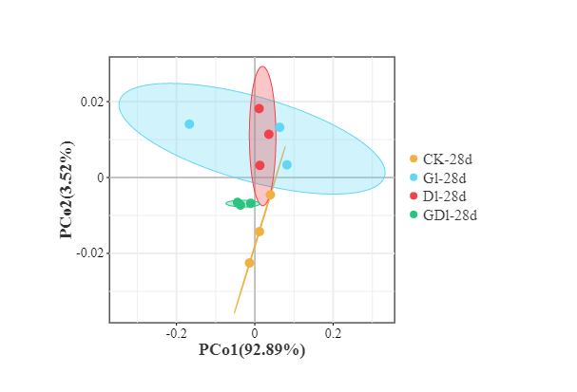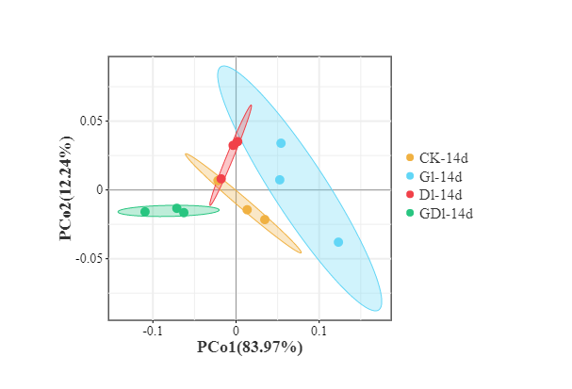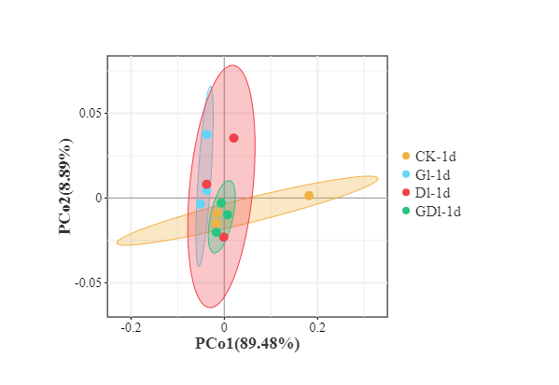
(a)
(b)
(c)

Figure S1. Principal coordinate analysis for the bacterial communities at the phylum level. .

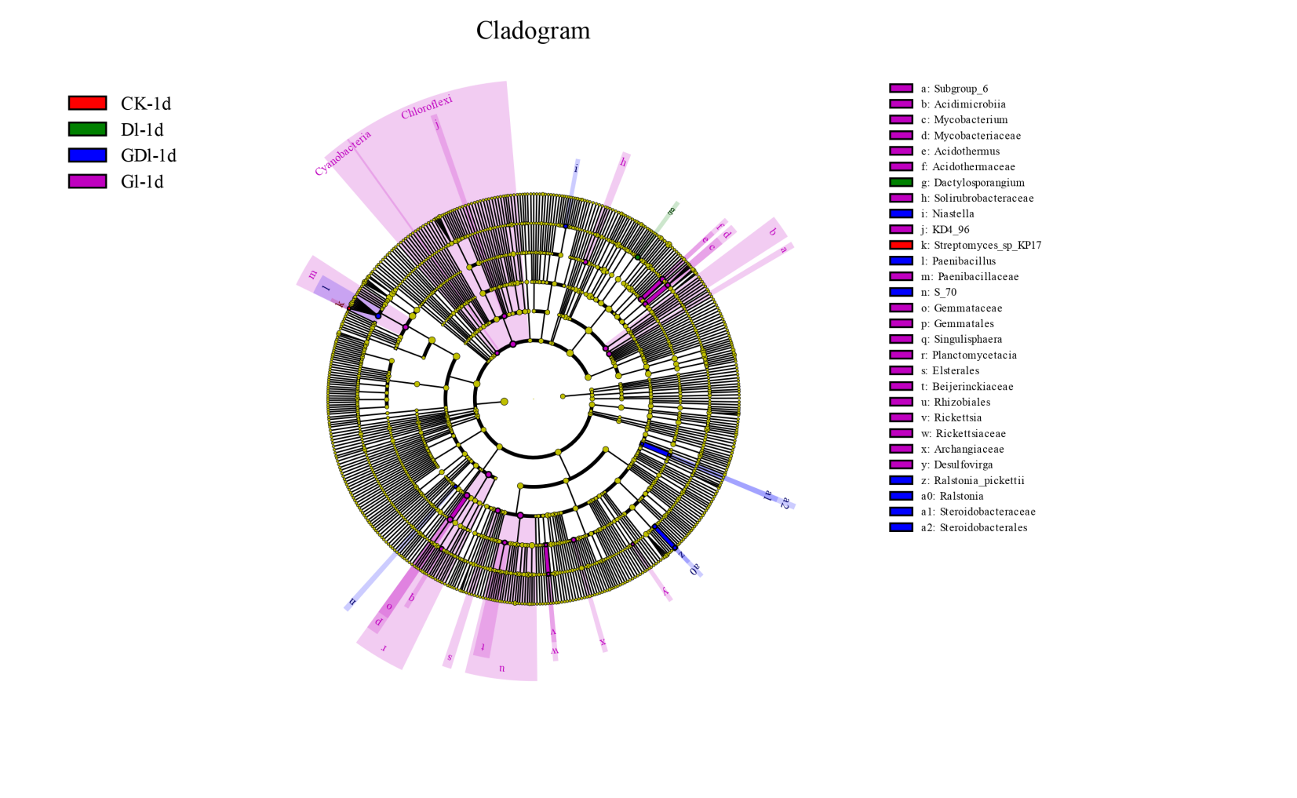
(a)
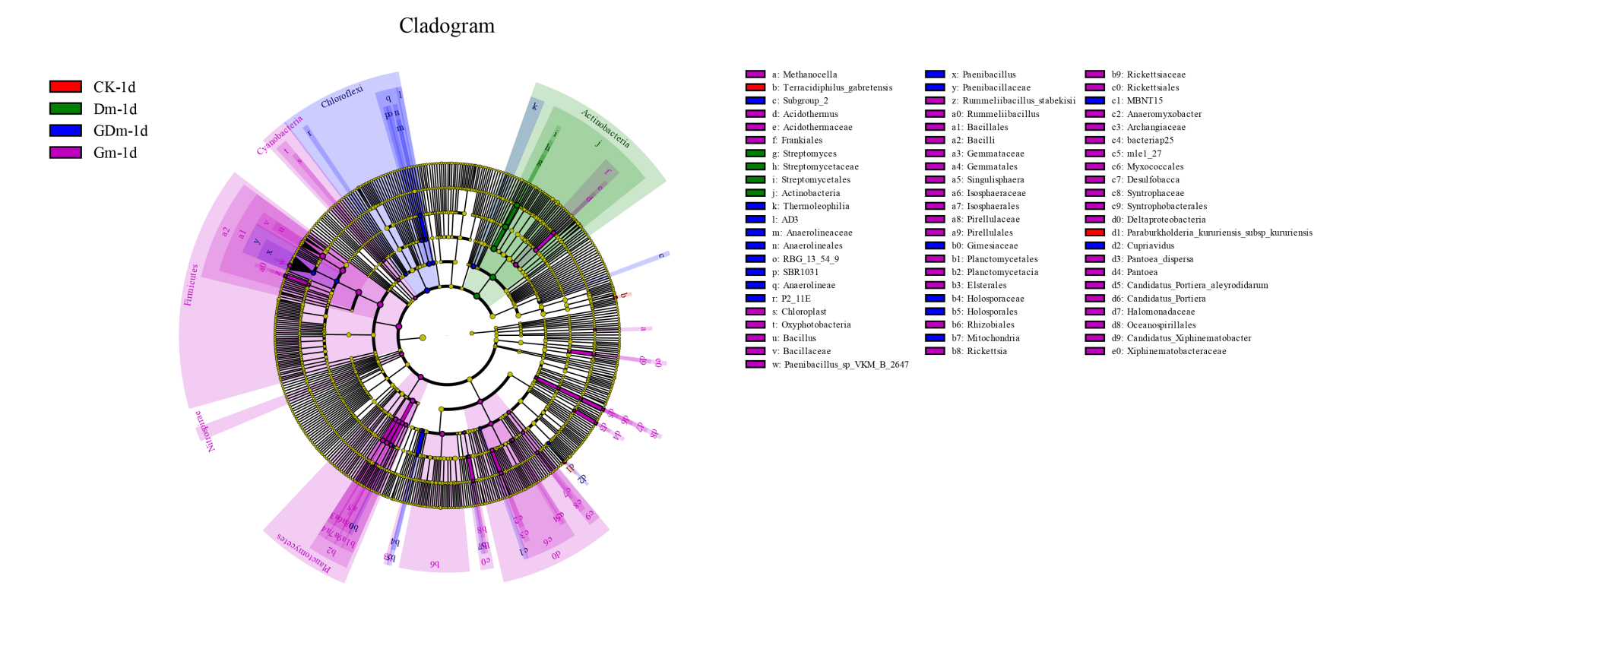
(b)
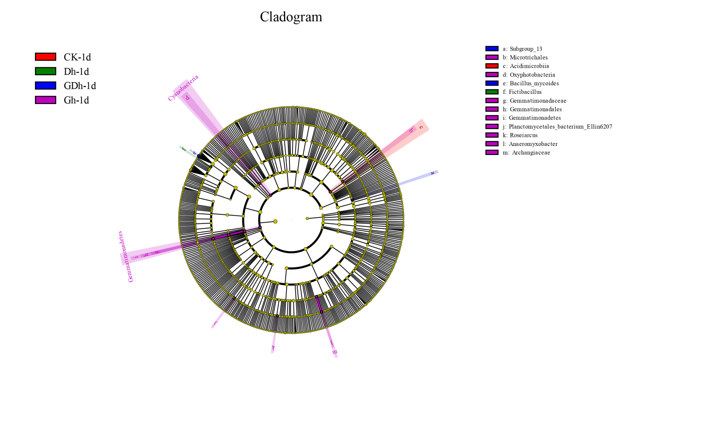
(c)

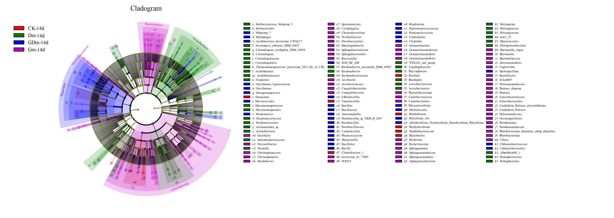
(d)
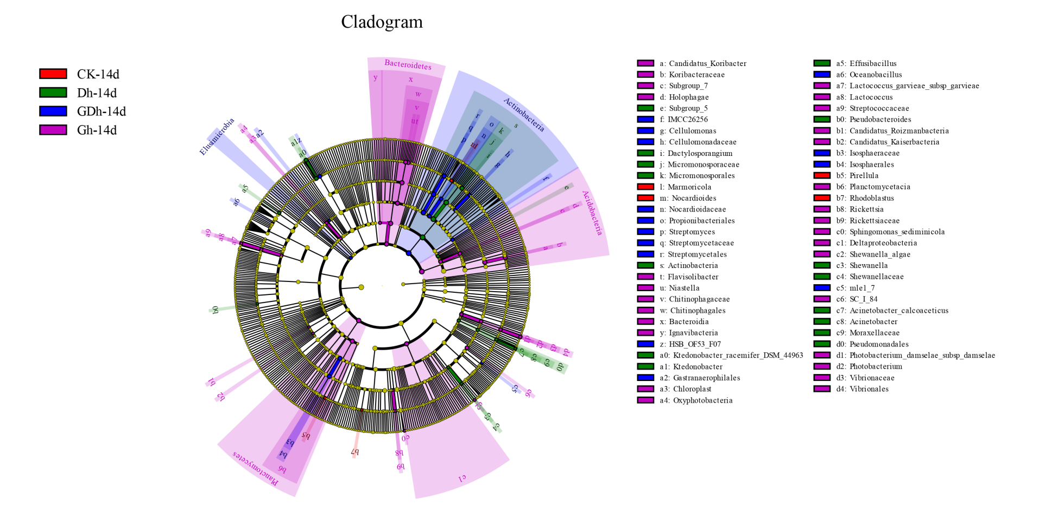
(e)

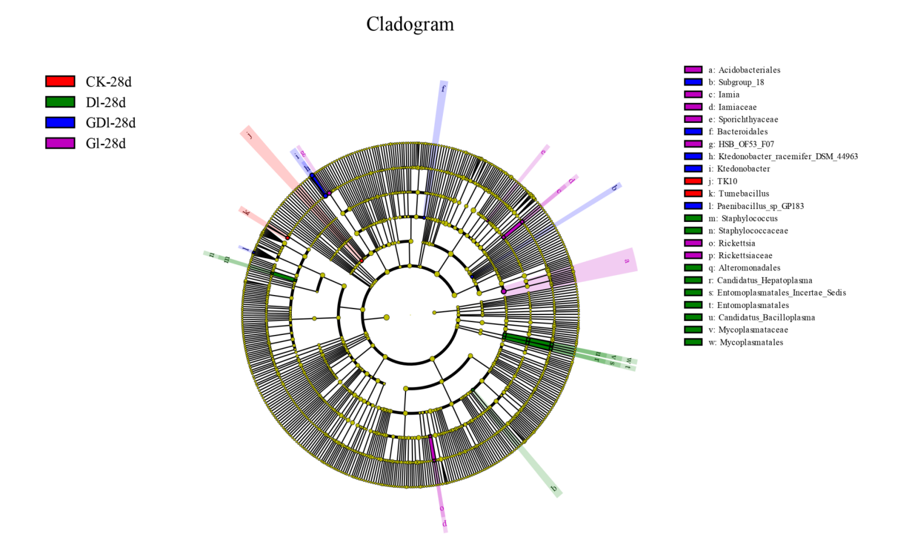
(f)
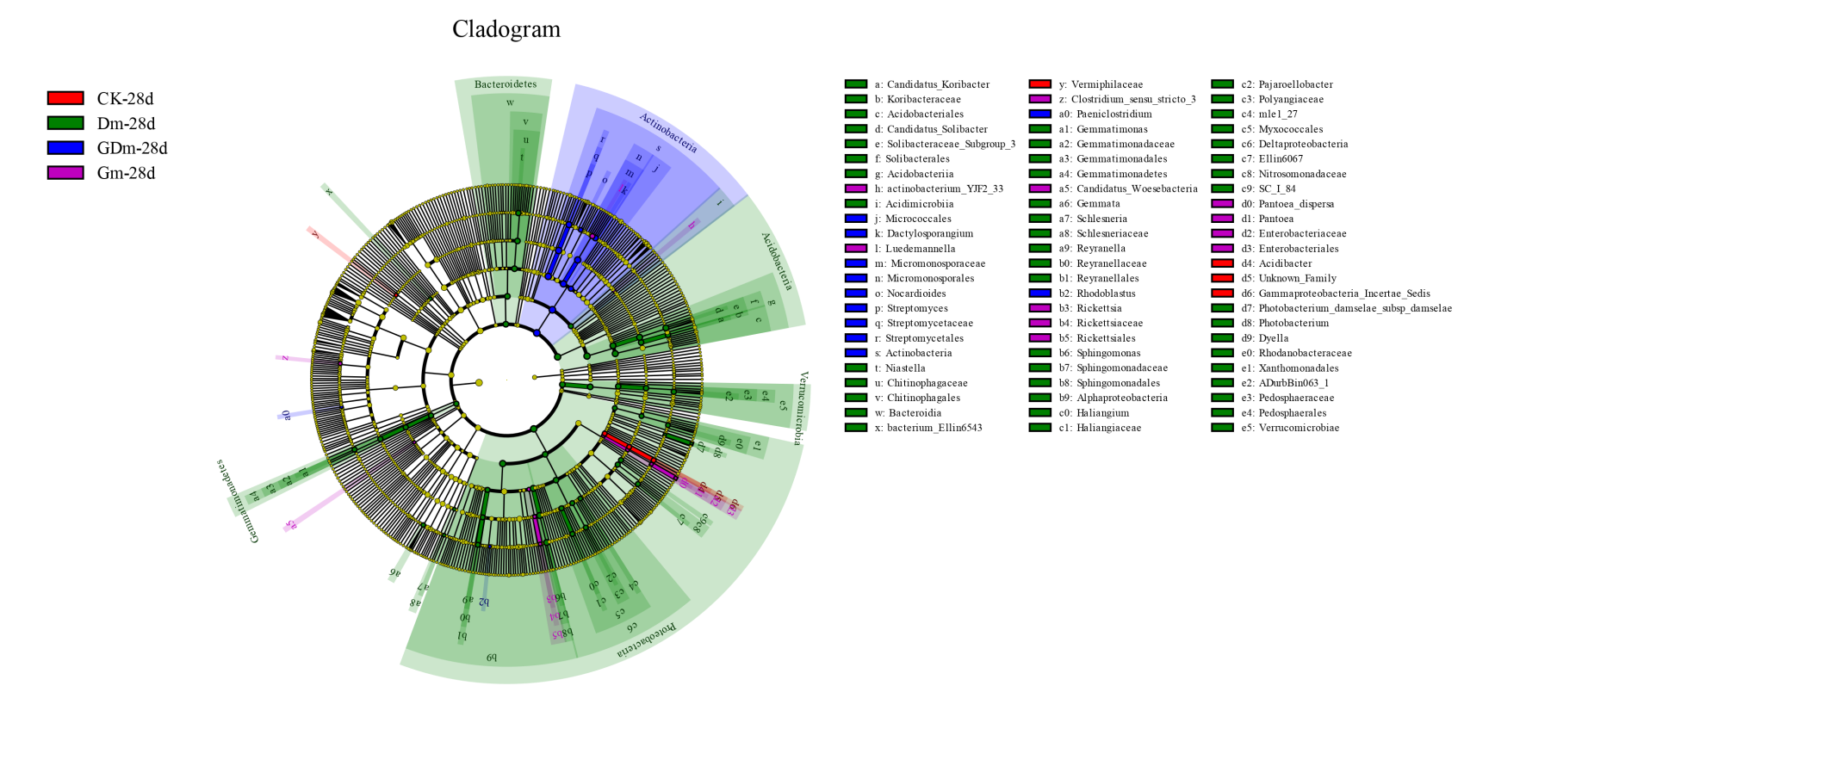
(g)
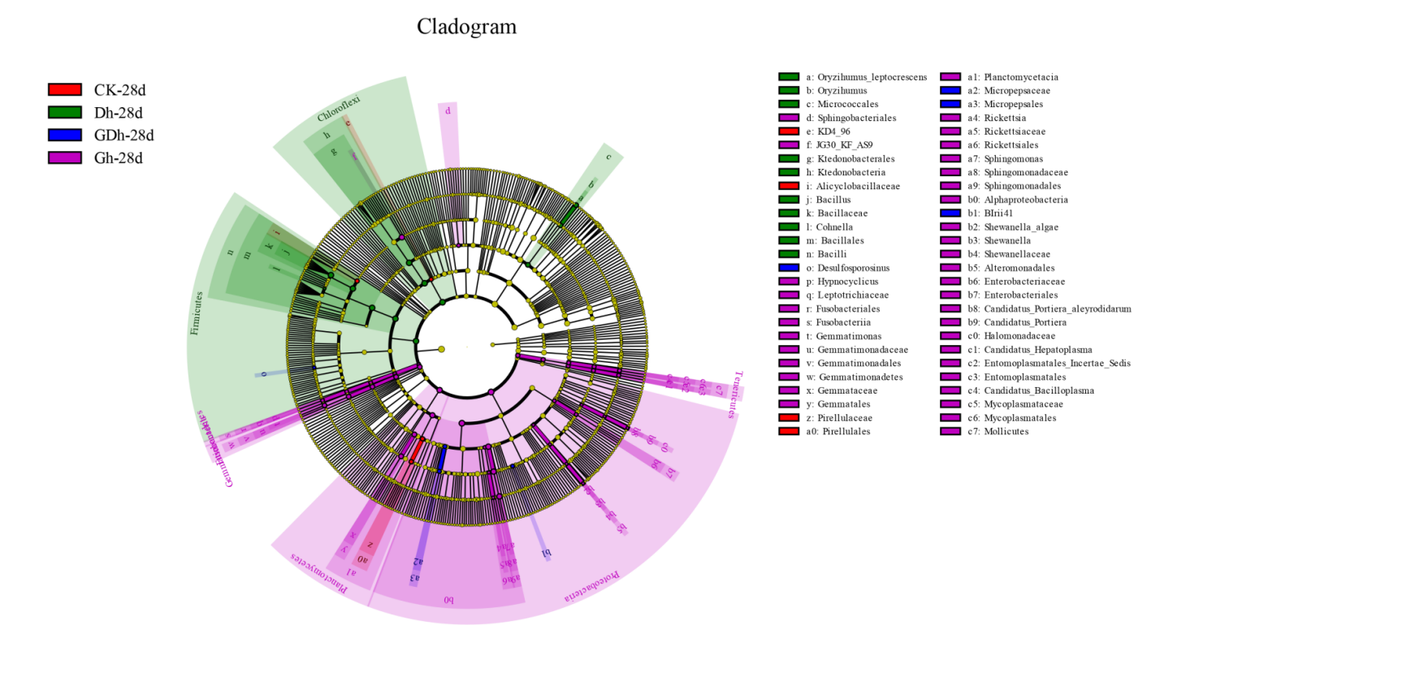
(h)

Figure S2. Cladograms of line discriminant analysis effect size (LEfSe) analyses of bacteria.
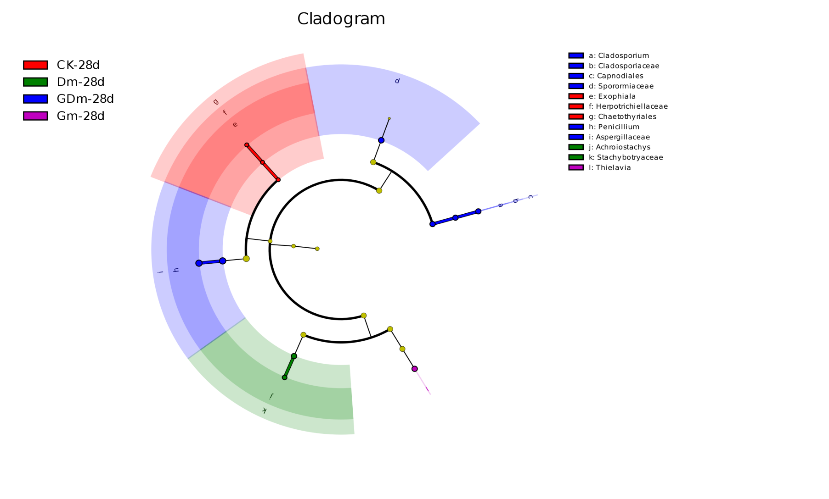
CK-28d
Dm-28d
GDm-28d
Gm-28d
a: Cladosporium
b: Cladosporiaceae
c: Capnodiales
d: Sporormiaceae
e: Exophiala
f: Herpotrichiellaceae
g: Chaetothyriales
h: Penicllium
i: Aspergillaceae
j: Achroiostachys
k: Stachybotryaceae
l: Thielavia
Cladogram

Figure S3. Cladograms of line discriminant analysis effect size (LEfSe) analyses of fungus.

