Annex
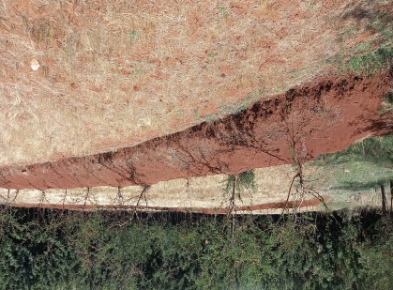
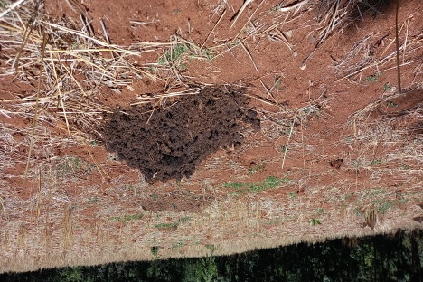
Pictorial presentation of some of CSA techniques being used by farmers in the research area (taken during survey data collection).

Compost spread on farmers’ field
Conservation agriculture on
Farmers’ field

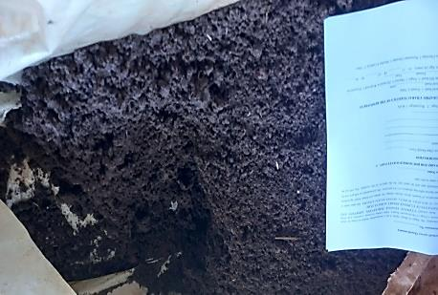

Vermi compost being used by farmers

