Supplementary Materials

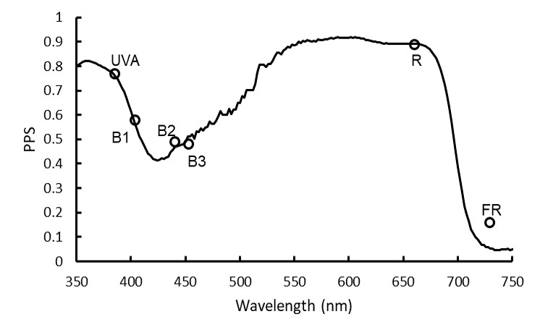
Figure S1. Estimated phytochrome photostationary state (PPS) of the following narrowband LED spectrum treatments: UVA (λpeak= 385 nm), B1 (λpeak= 404 nm), B2 (λpeak= 440 nm), B3 (λpeak= 453 nm), R (λpeak= 659 nm), and FR (λpeak= 729 nm) superimposed on the PPS spectrum, from monochromatic wavelengths, based on the data from Sager et al. (1988) [3]. The open circles represent the calculated PPS values based on the actual spectral distributions of the different spectrum treatments, rather than their peak wavelengths.

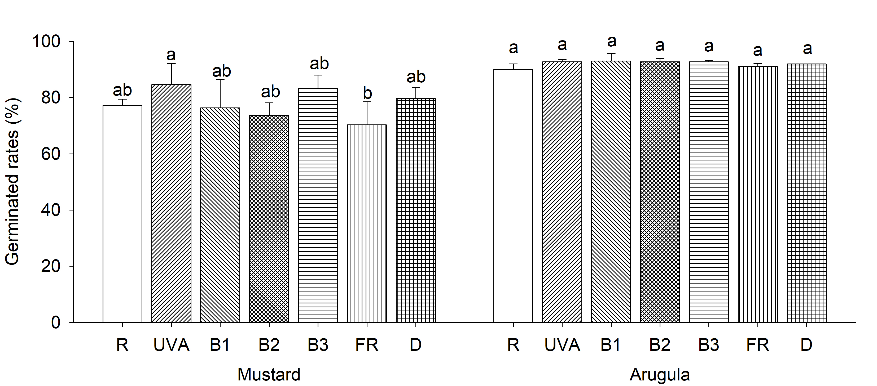
Figure S2. Germination percentages of mustard and arugula microgreens under narrowband lights with different peak wavelengths. R (λpeak= 660 nm), UVA (λpeak= 385 nm), B1 (λpeak= 405 nm), B2 (λpeak= 440 nm), B3 (λpeak= 455 nm), FR (λpeak= 730 nm), D is dark. Data are means ± SE (n = 3). Within the same species, means bearing the same letter are not significantly different at P ≤ 0.05 according to Duncan’s new multiple range test.

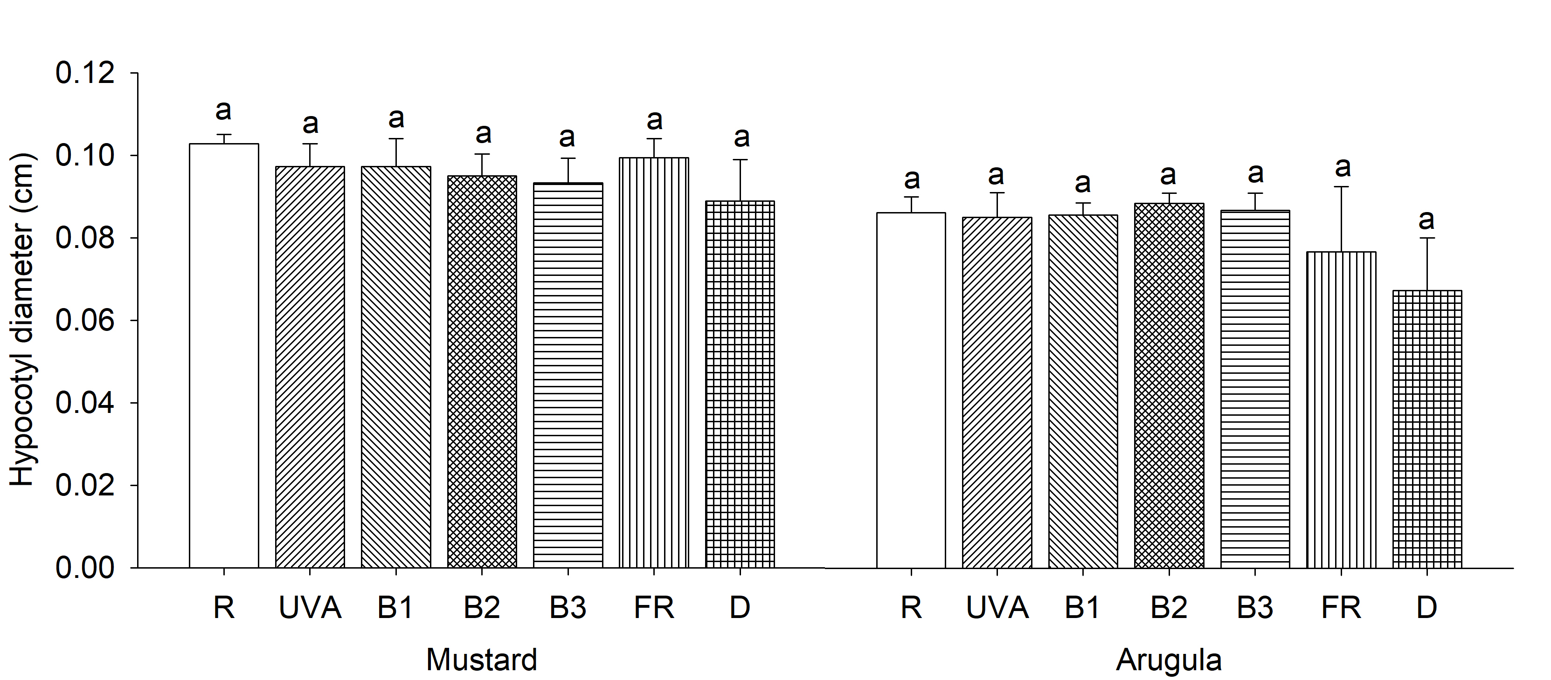
Figure S3. Hypocotyl diameters of two species of mustard and arugula microgreens under narrowband lights with different peak wavelengths. R (λpeak= 660 nm), UVA (λpeak= 385 nm), B1 (λpeak= 405 nm), B2 (λpeak= 440 nm), B3 (λpeak= 455 nm), FR (λpeak= 730 nm), D is dark. Data are means ± SE (n = 3). Within the same species, means bearing the same letter are not significantly different at P ≤ 0.05 according to Duncan’s new multiple range test.

