Electrochemical Multiplexed N-terminal Natriuretic Peptide and Cortisol detection in human artificial saliva: heart failure biomedical application
El Kahina Ghedir¹, Abdoullatif Baraket², Messaoud Benounis¹, Nadia Zine², Abdelhamid Errachid²
¹Laboratory of Sensors, Instrumentations and Process (LCIP), Institute of Science and Technology, University of Khenchela;Route de El Hamma, 40000 Khenchela, Algeria.
²Institut de Sciences Analytiques (ISA), Université de Lyon - UMR 5280, 5 rue de la Doua, 69100, Villeurbanne, France.

Supplementary Material

Figure 1S: Ghedir et al.
RE
WE

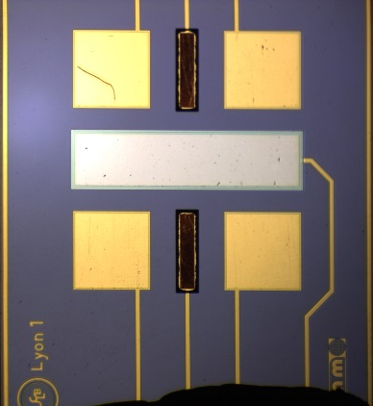
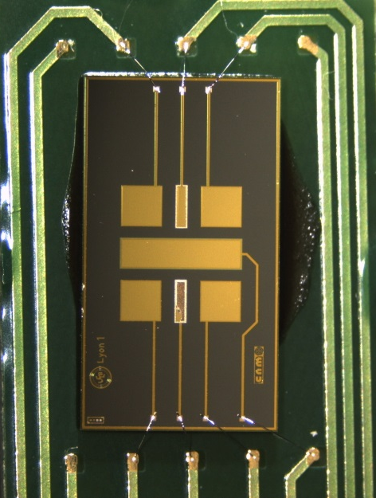
CE
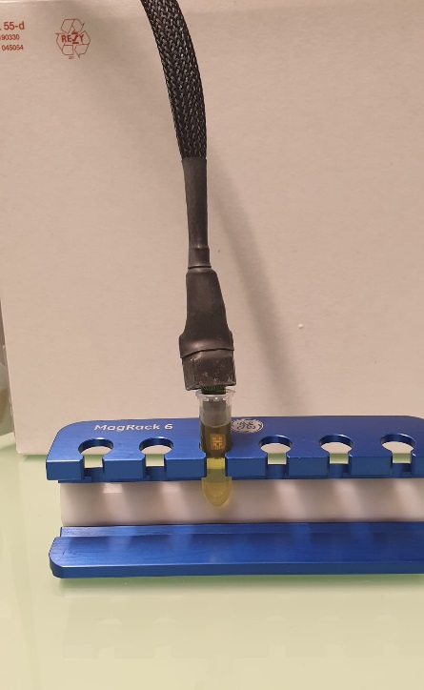

Figure 1S: (A) Electrochemical biosensor platform sealed onto the PCB board using an epoxy resin (Epo-Tek H70E-2LC, from Epoxy Technology) and the microelectrode pads were wire bonded to the gold tracks of the BCP through aluminum wire (25μm Ø) by wire-bonding (Kulicke&Soffa 4523A). (B) The bonding area of the device, the bonding wires, and the gold tracks of the PCB were encapsulated using the same resin (Epo-Tek H70E-2LC) to protect them from the electrolyte solution. (C) The biosensor based on silicon substrate sizes 7x4mm and contains four gold WE, two RE and central platinum CE (D) The biosensor is dropped in 1.5 mL of ferric electrolyte solution and connected to the potentiostate through sheilded cable to avoid all electrical noises.

Figure 2S: Ghedir et al.
Figure 2S: Randles equivalent circuit used for Nyquist plot semi-circles fitting, where Rs represents the electrolyte resistance, Rct is the charge-transfer resistance, W is Warburg impedance, and Q1 the constant phase element, an equivalent model of the double-layer capacitance.

