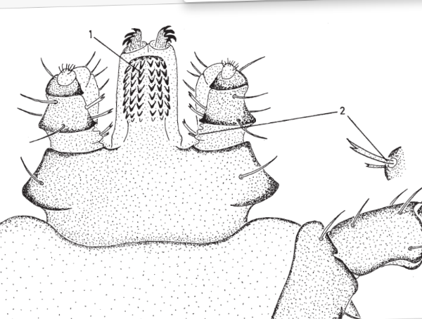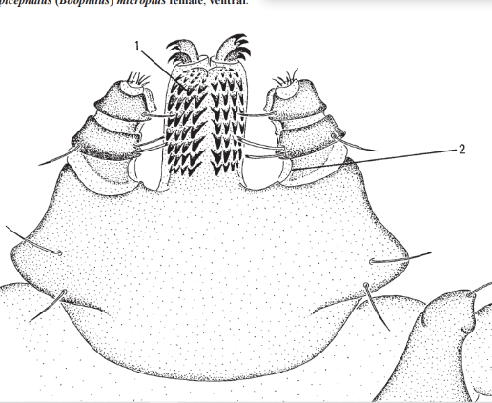

Figure S1: Morphological keys used in the identification of Rhipicephalus Boophilus species, Walker et al. (2003).

