Article
Encapsulation of Ciprofloxacin into Cyclodextrin Polymer Matrix: The Complex Formation with Human Serum Albumin and In Vitro Studies
Tatiana Yu. Kopnova, Anna A. Skuredina, Natalya G. Belogurova, Elena V. Kudryashova
Supplementary
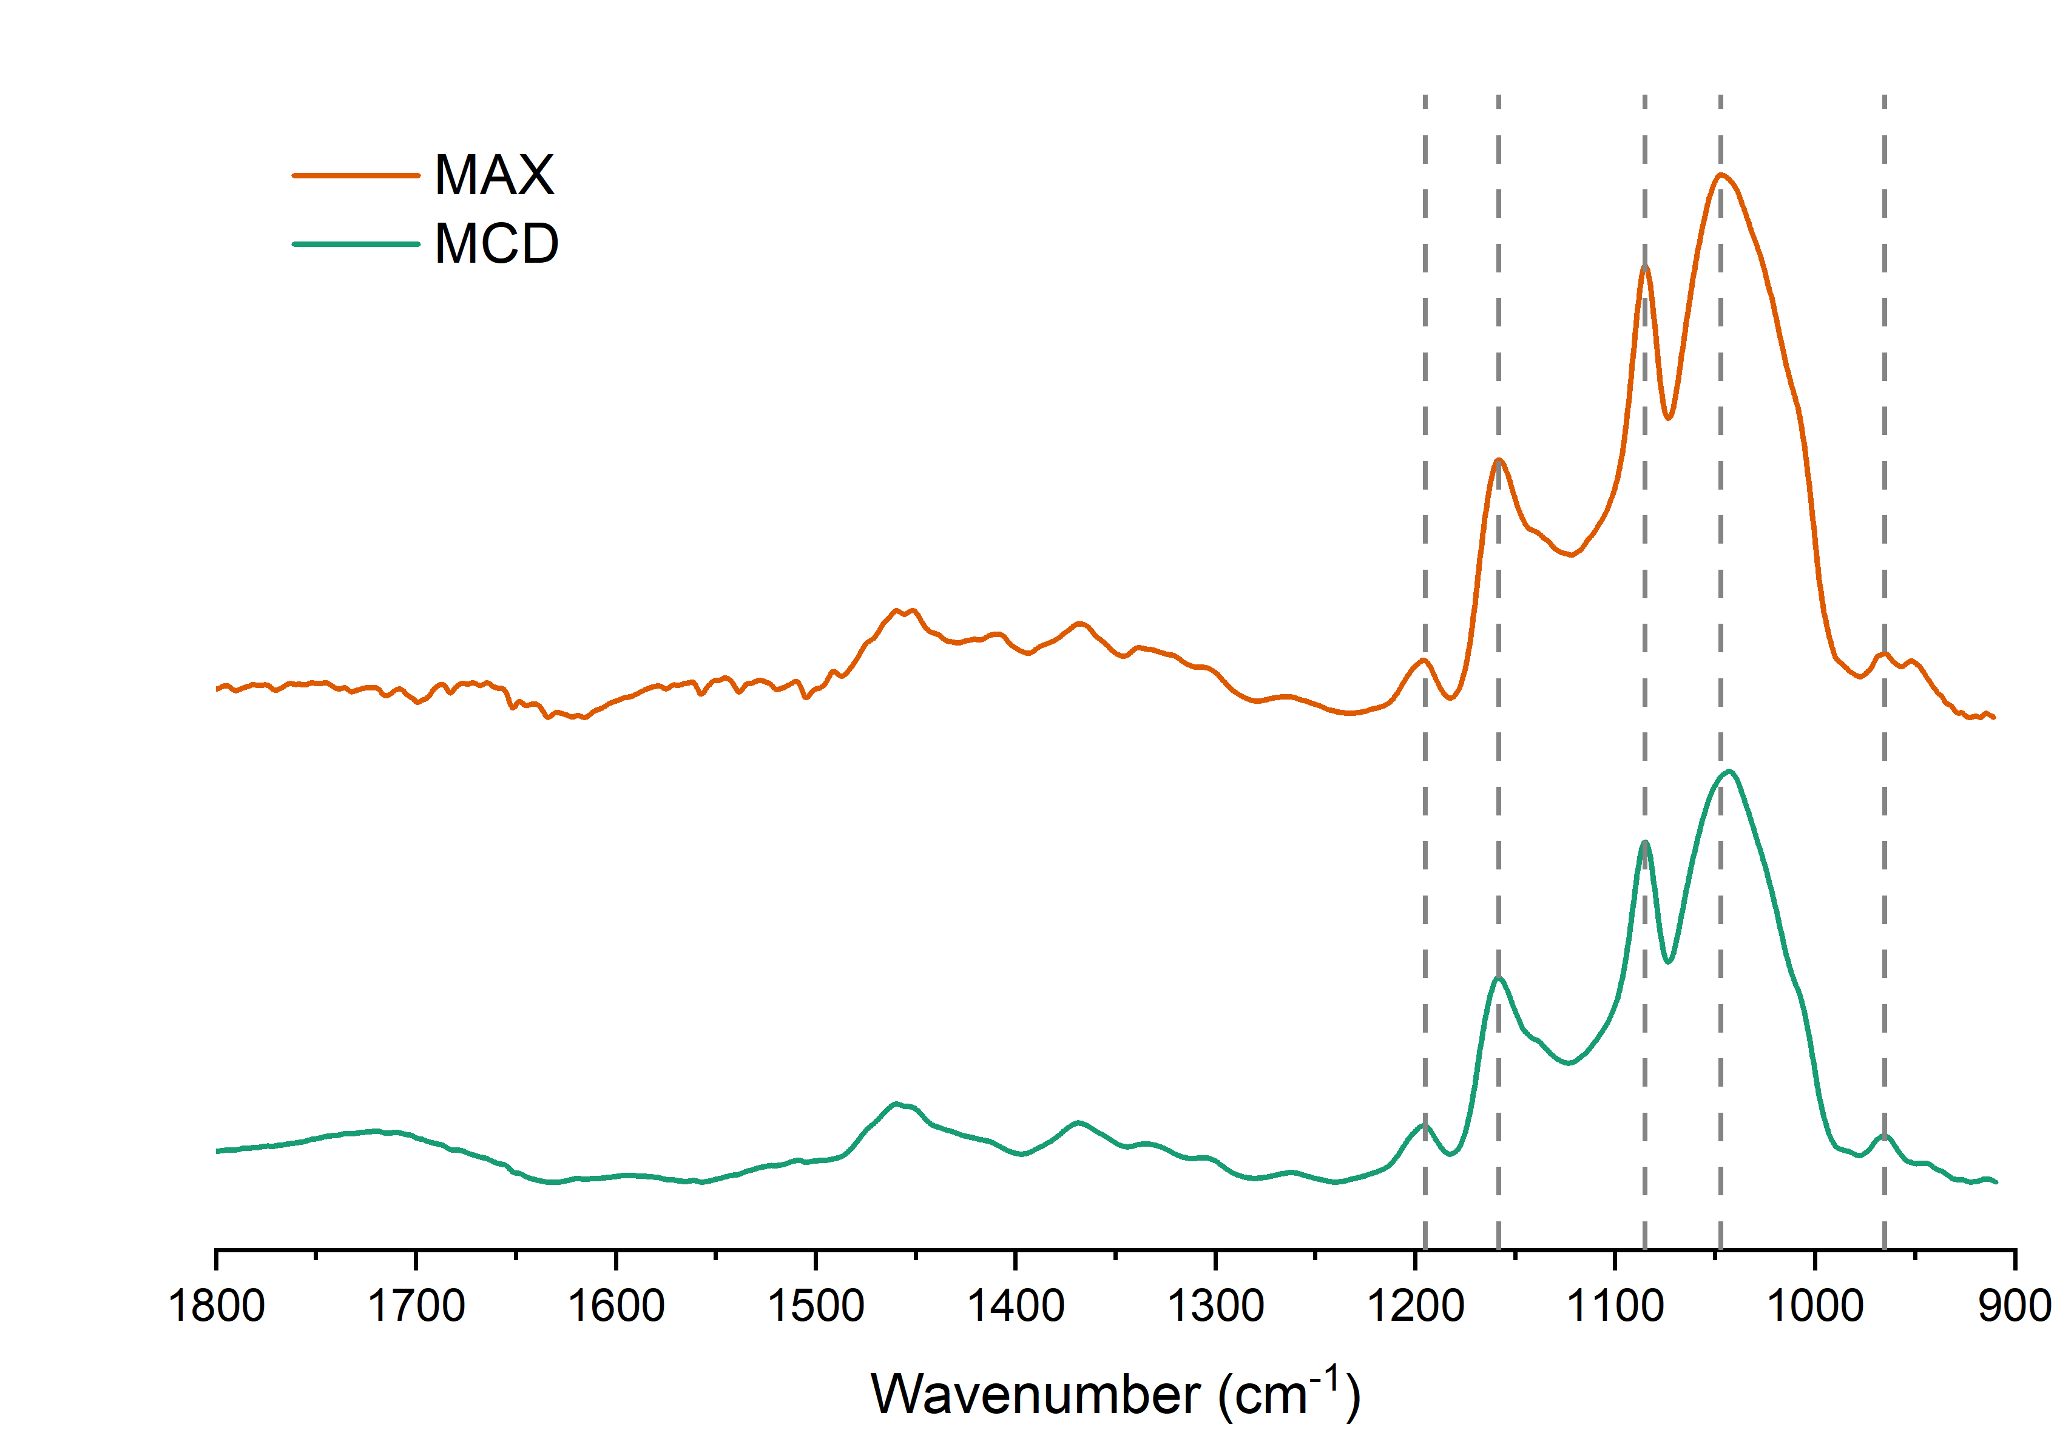 | 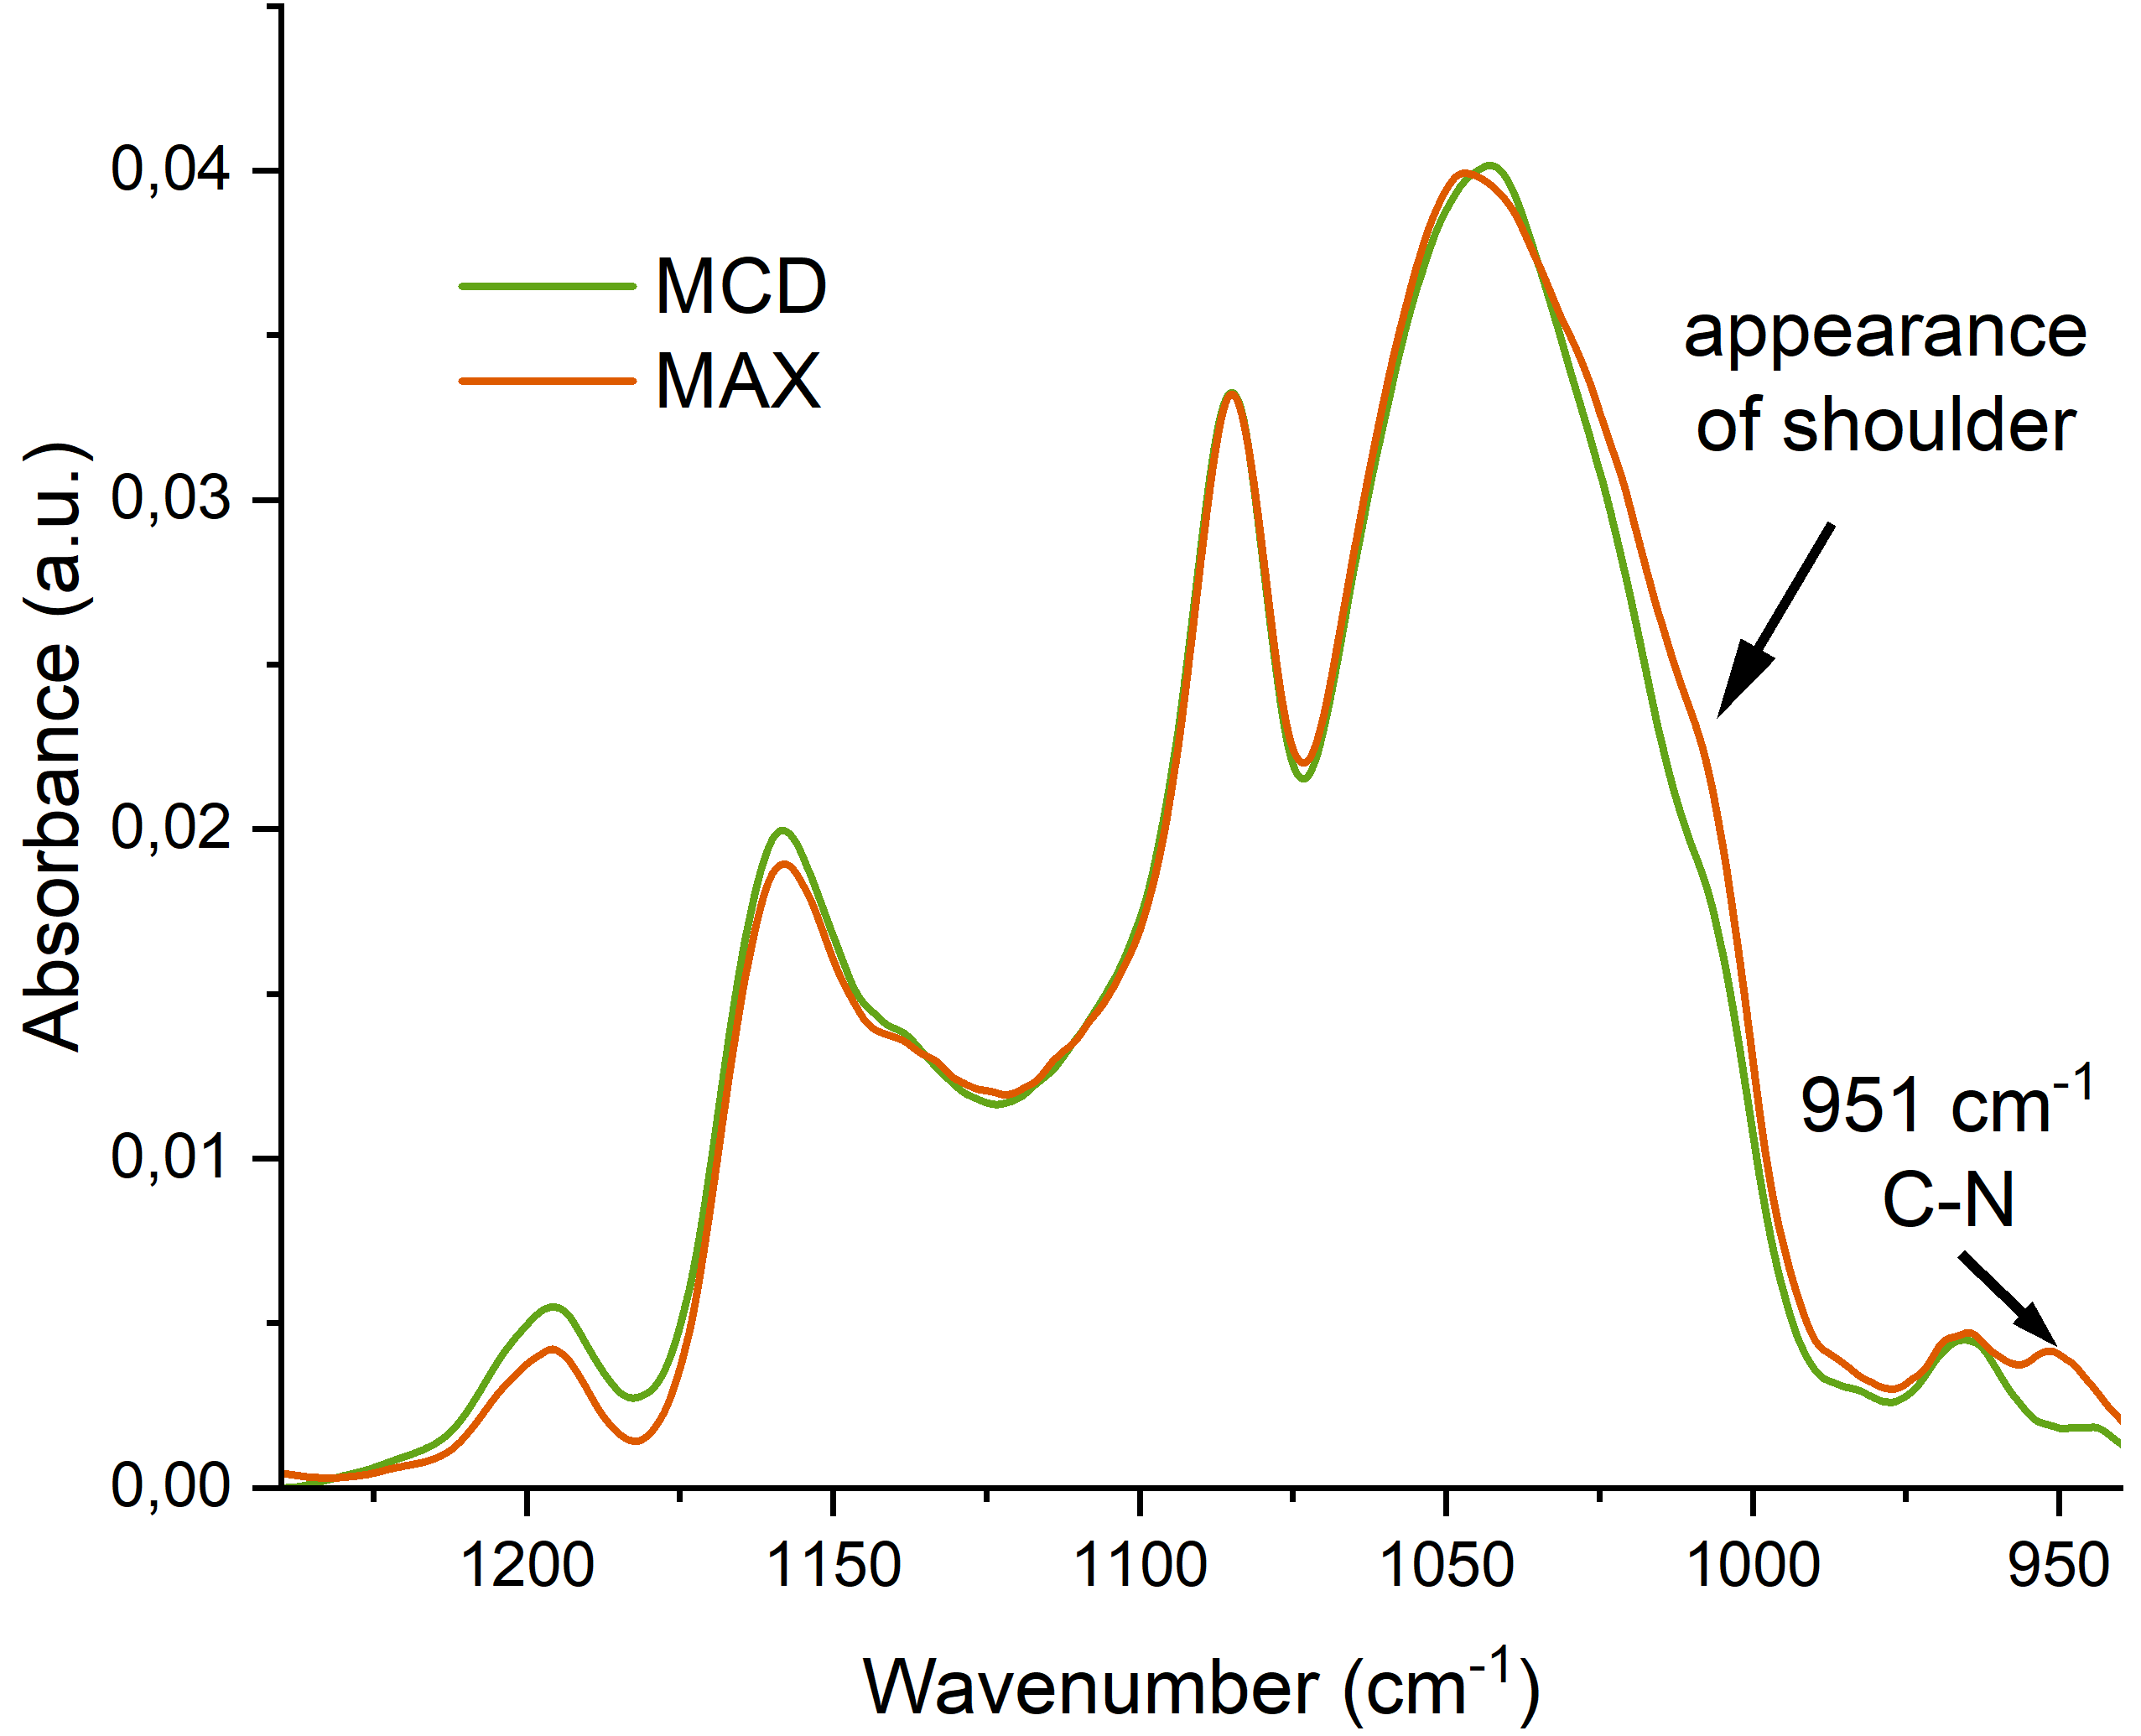
(a) | (b)
Figure S1. (a) Normalized FTIR spectra of MCD (green) and MAX (orange) pH 7.4, 22 °C. (b) Normalized FTIR spectra of MCD (green) and MAX (orange) range 1240 − 900 cm−1 in details pH 7.4, 22 °C.

