Supplementary Material
A Green Voltammetric Determination of Molnupiravir using a Disposable Screen-Printed Reduced Graphene Oxide Electrode: Application to Pharmaceutical Dosage Form and Biological Fluid

Abdelrahman Nabil¹, Hassan A.M. Hendawy², Randa Abdel-Salam³, Rasha M. Ahmed¹, Ahmed Shawky¹, Samy Emara¹*, Noha Ibrahim¹.

¹Pharmaceutical Chemistry Department, Faculty of Pharmacy, Misr International University, Km 28 Ismailia Road, Cairo 44971, Egypt.
²Chemistry Department, Egyptian Drug Authority, Giza 12512, Egypt.
Citation: To be added by editorial staff during production.
Academic Editor: First nameLast name
Received: date
Revised: date
Accepted: date
Published: date
Copyright:© 2023 by the authors. Submitted for possible open access publication under the terms and conditions of the Creative Commons Attribution (CC BY) license (https://creativecommons.org/licenses/by/4.0/).

³ Analytical Chemistry Department, Faculty of Pharmacy, Suez Canal University Ismailia, 41522, Ismailia, Egypt.
* Correspondence: sami.omara@miuegypt.edu.eg; Tel.: +202-01004052675

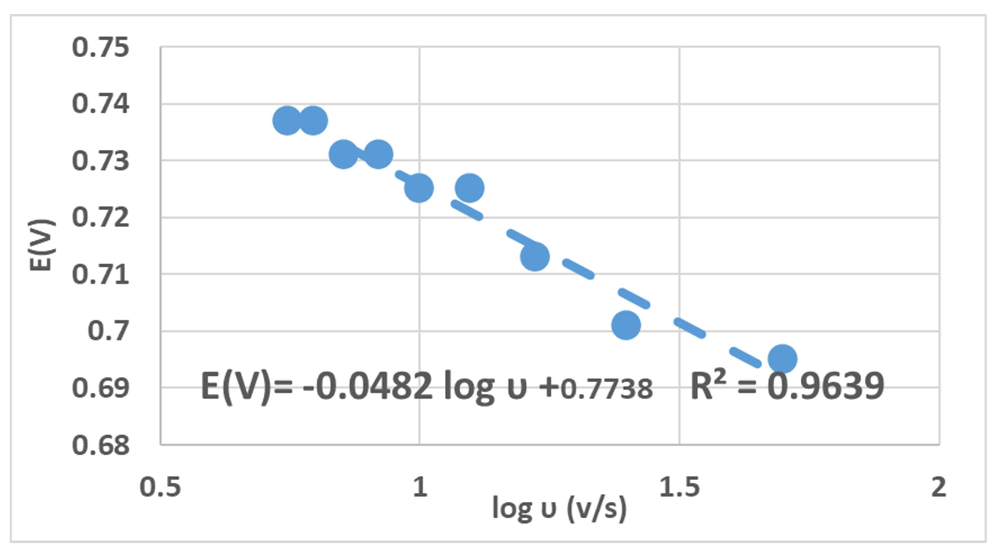

Figure S1. A linear relationship between the logarithm of the scan rate and the peak potential

