Supplementary materials
Theoretical Study of Structure and Photophysics of Homologous Series of Bis(arylydene)cycloalkanones
Roman Starostin, Alexandra Freidzon, S.P. Gromov

Table S1 Comparison of experimental and calculated chemical shifts
Cyclobutanones
Proton  group |  | 4-H |  |  |  | 4-OMe |  |  |  | 3,4-OMe
 |  | Calculation |  | Experiment |  | Calculation |  | Experiment |  | Calculation |  | Experiment
4H (С(3)Н₂) |  | 3.93 |  | 3.89 |  | 3.80 |  | 3.78 |  | 3.77 |  | 3.81
2H (methine) |  | 7.36 |  | 7.19 |  | 7.23 |  | 7.11 |  | 7.20 |  | 7.10
Cyclopentanones
Proton  group |  | 4-H |  |  |  | 4-OMe |  |  |  | 3,4-OMe
 |  | Calculation |  | Experiment |  | Calculation |  | Experiment |  | Calculation |  | Experiment
4H (С(3-4)Н₂) |  | 3.25 |  | 3.12 |  | 3.06 |  | 3.08 |  | 3.05 |  | 3.08
2H (methine) |  | 7.86 |  | 7.6 |  | 7.67 |  | 7.56 |  | 7.66 |  | 7.51
 | Cyclopentanones
 | Proton  group |  | 4-H |  |  |  | 4-OMe |  |  |  | 3,4-OMe
 |  |  | Calculation |  | Experiment |  | Calculation |  | Experiment |  | Calculation |  | Experiment
 | 4H (С(3,5)Н₂) |  | 3.05 |  | 2.96 |  | 3.00 |  | 2.94 |  | 3.11 |  | 2.95
 | 4H (С(4)Н₂) |  | 1.69 |  | 1.80 |  | 1.70 |  | 1.80 |  | 1.75 |  | 1.81
 | 2H (methine) |  | 8.38 |  | 7.72 |  | 8.28 |  | 7.67 |  | 8.27 |  | 7.66

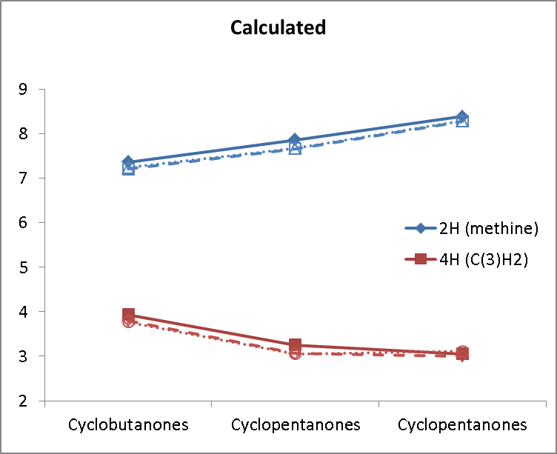 | 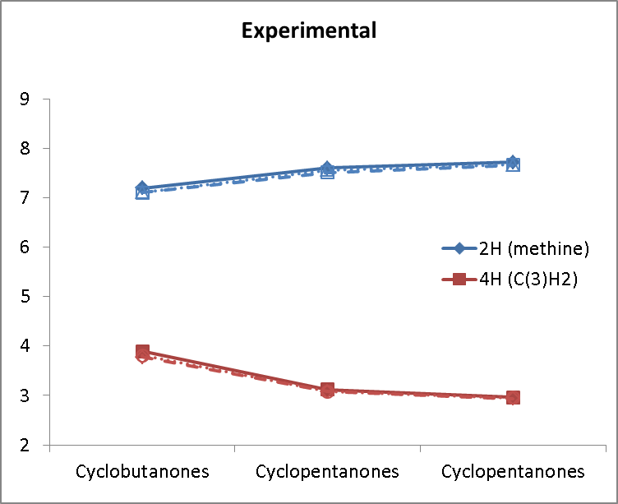
Figure S1 Calculated and experimental chemical shifts in 4-H (solid), 4-OMe (dashed), and 3,4-OMe (dotted).

Cyclobutanone
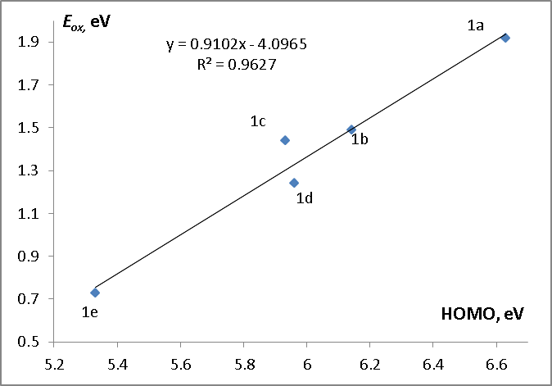 | 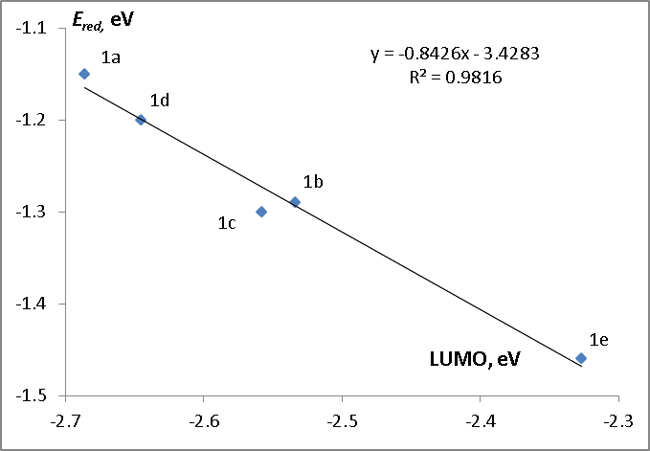
Cyclopentanone
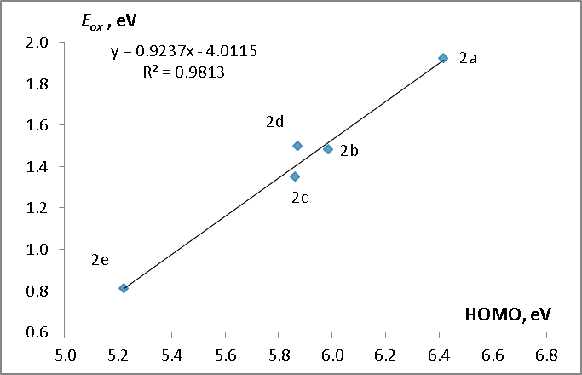 | 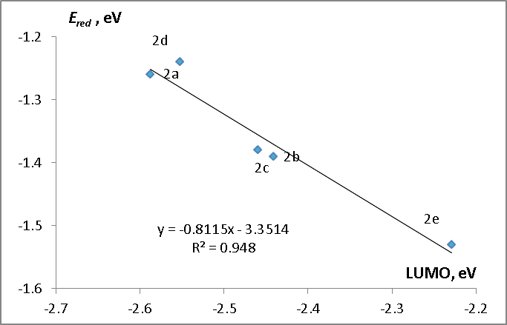
Cyclohexanone
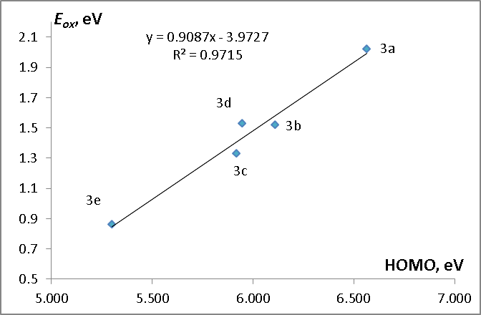 | 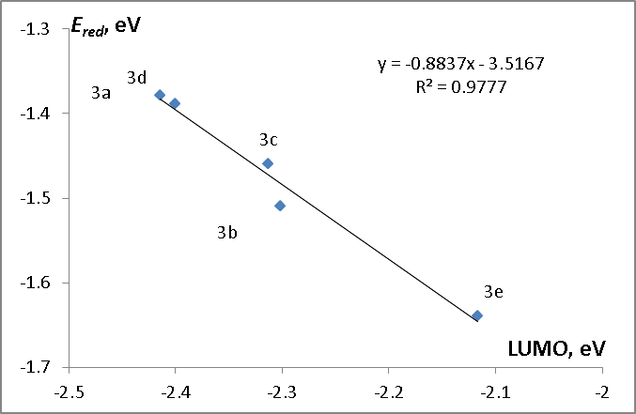
Figure S2 Correlations between the calculated HOMO and LUMO energies and experimental oxidation and reduction potentials.
Cyclobutanone
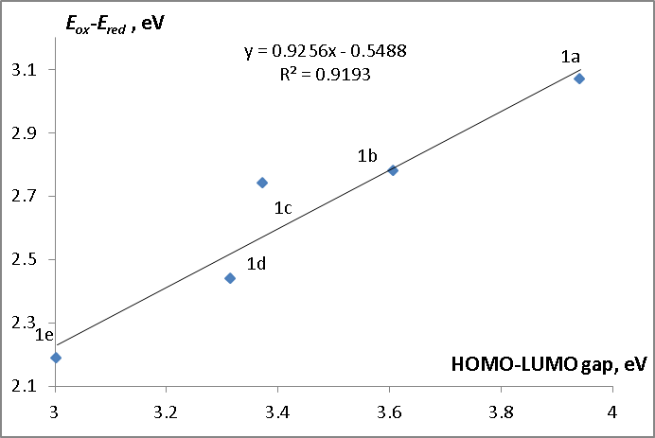
Cyclopentanone
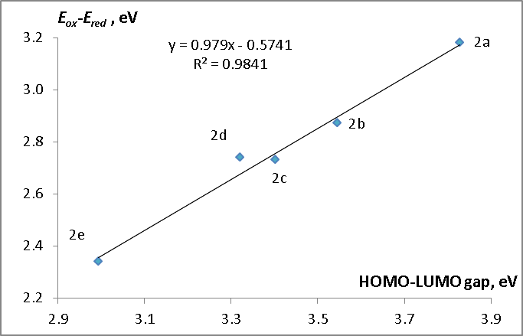
Cyclohexanone
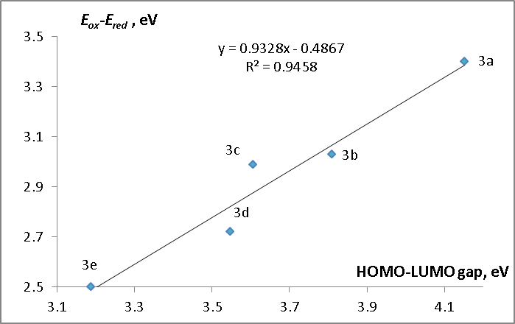
Figure S3. Correlations between the calculated HOMO-LUMO gap and experimental gap between the oxidation and reduction potentials.
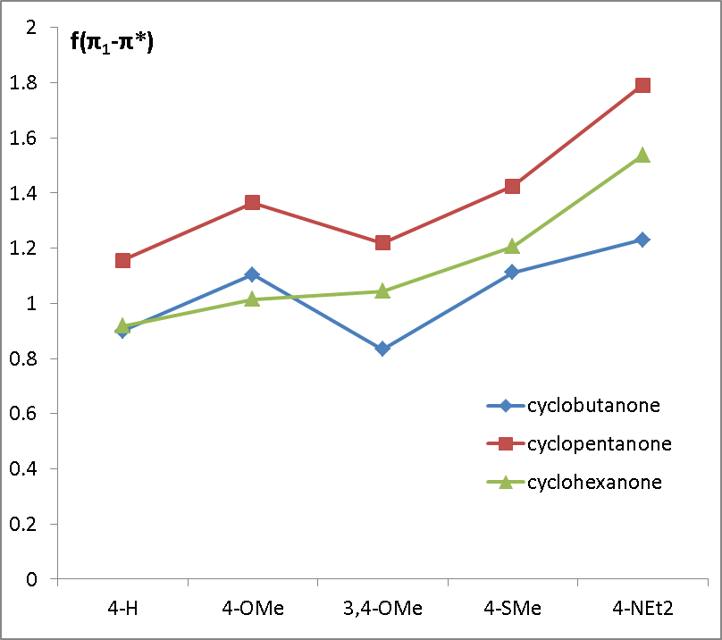 | 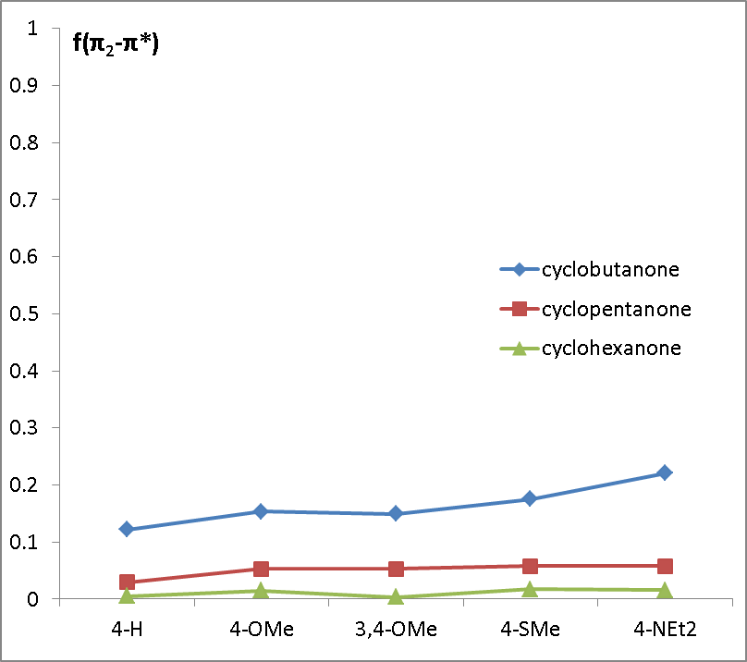
a | b
Figure S4. Oscillator strengths of the first and second ππ* transitions.

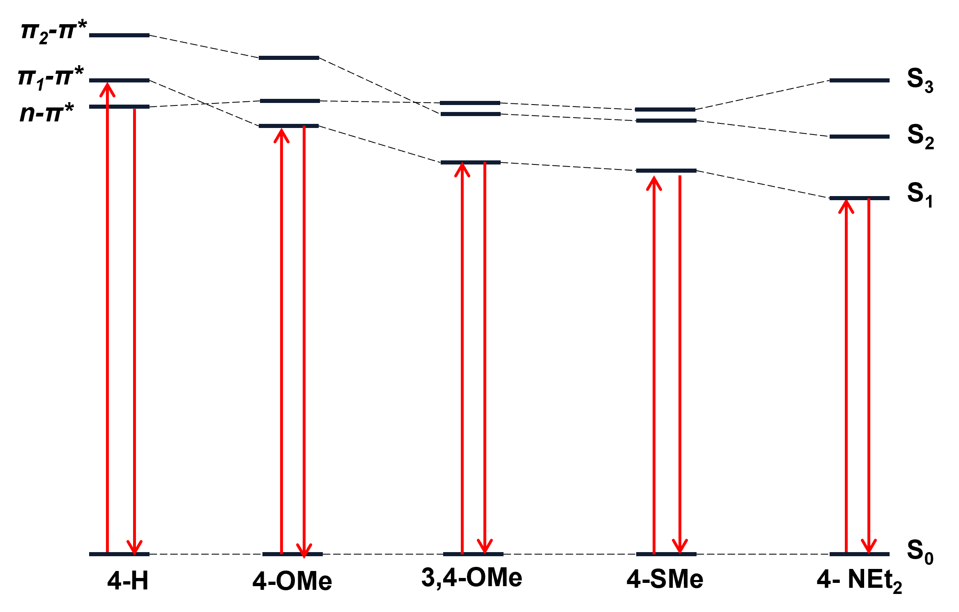
(a)
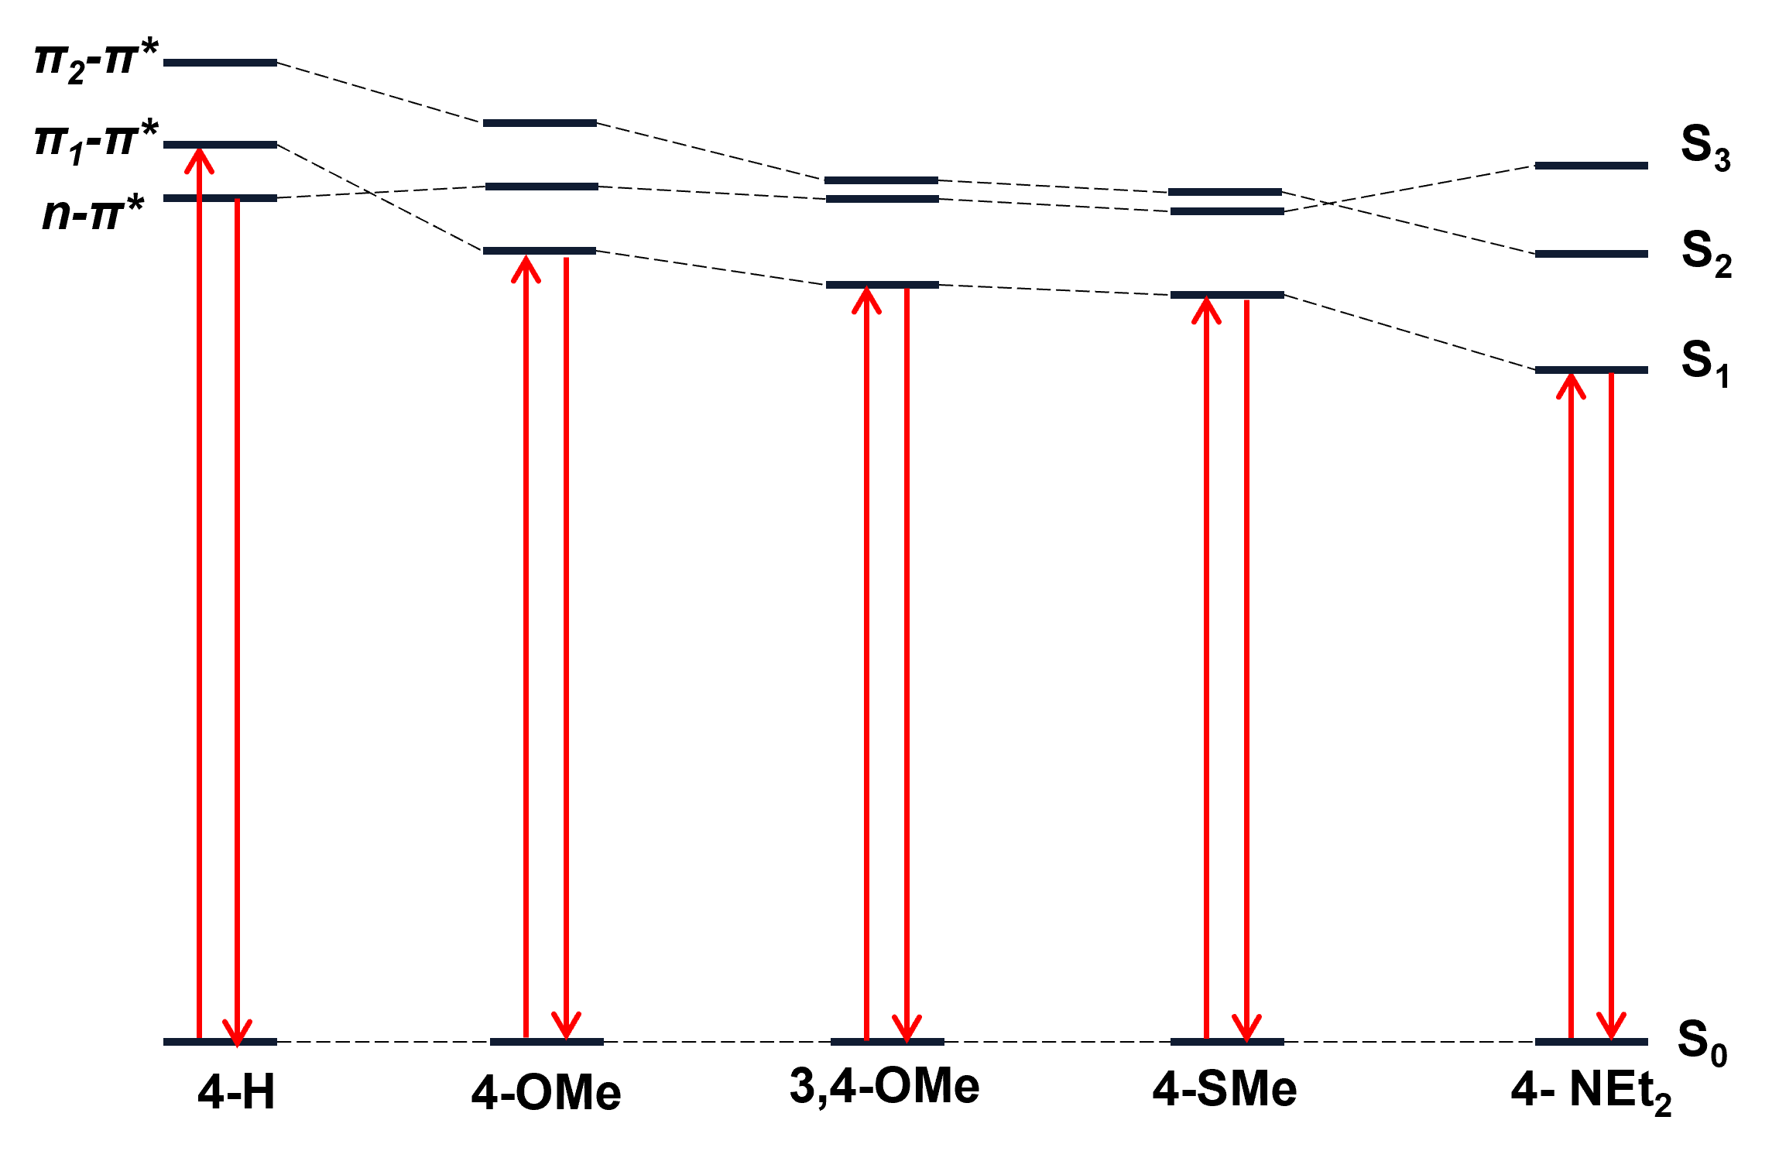
(b)
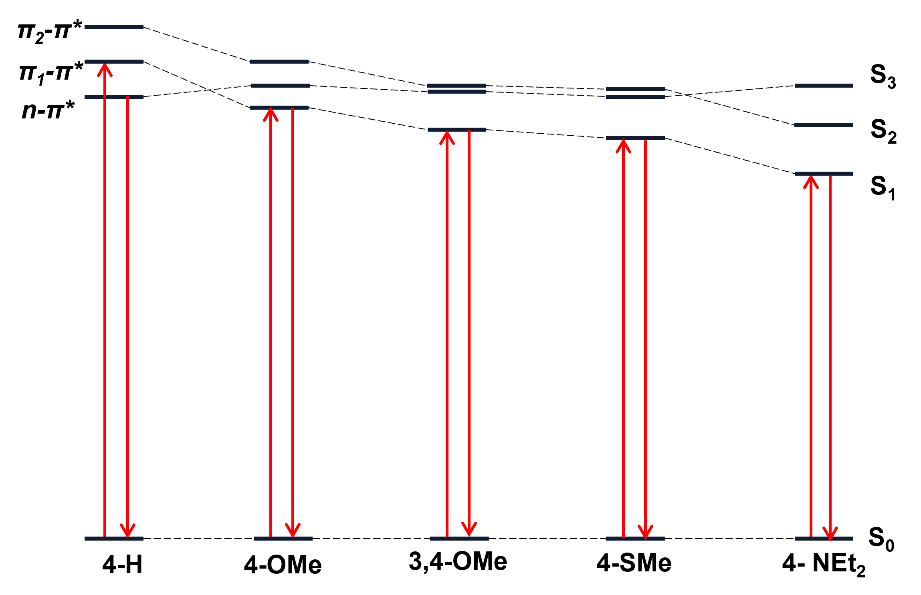
(c)
Figure S5. Energy diagrams of the excited states of (E,E) isomer in cyclobutanone (a), cyclopentanone (b) and cyclopentanone (c) series.

Table S2 Experimental and calculated electronic transitions
Cyclobutanones
 |  | λ_{abs}, nm |  |  | λ_{fl}, nm
Dienone |  | Experiment | Calculation (Osc. Strength) | type | Experiment | Calculation (τ_{rad}, ns) | type
1a |  | 356 | 359 (0.90)  378 (2·10⁻⁷) | π–π*  n–π* | - | 411 (2.3·10⁷) | n–π*
1b |  | 385 | 393 (1.10) | π–π* | - | 419 (2.28) | π–π*
1c |  | 401 | 427 (0.83) | π–π* | 505 | 446 (3.48) | π–π*
1d |  | 402 | 432 (1.11) | π–π* | 522 | 452 (2.62) | π–π*
1e |  | 481 | 471 (1.23) | π–π* | 575 | 491 (2.86) | π–π*
Cyclopentanones
 |  | λ_{abs}, nm |  |  | λ_{fl}, nm
Dienone |  | Experiment | Calculation (Osc. Strength) | type | Experiment | Calculation (τ_{rad}, ns) | type
2a |  | 347 | 371 (1.16)  379 (6.5·10⁻⁵) | π–π*  n–π* | - | 401 (1.0·10⁷) | n–π*
2b |  | 380 | 395 (1.36) | π–π* | - | 422 (1.8) | π–π*
2c |  | 395 | 420 (1.22) | π–π* | 500 | 439 (2.2) | π–π*
2d |  | 396 | 424 (1.42) | π–π* | 508 | 458 (2.0) | π–π*
2e |  | 471 | 472 (1.79) | π–π* | 562 | 482 (1.9) | π–π*
Cyclohexanones
 |  | λ_{abs}, nm |  |  | λ_{fl}, nm
Dienone | Experiment |  | Calculation (Osc. Strength) | type | Experiment | Calculation (τ_{rad}, ns) | type
3a | 326 |  | 348 (0.92)  375 (0.07) | π–π*  n–π* | - | 414 (778) | n–π*
3b | 356 |  | 385 (1.02) | π–π* | - | 431 (2.90) | π–π*
3c | 370 |  | 404 (1.04) | π–π* | - | 432 (2.26) | π–π*
3d | 368 |  | 410 (1.21) | π–π* | - | 441 (2.02) | π–π*
3e | 445 |  | 455 (1.54) | π–π* | 562 | 495 (2.46) | π–π*

