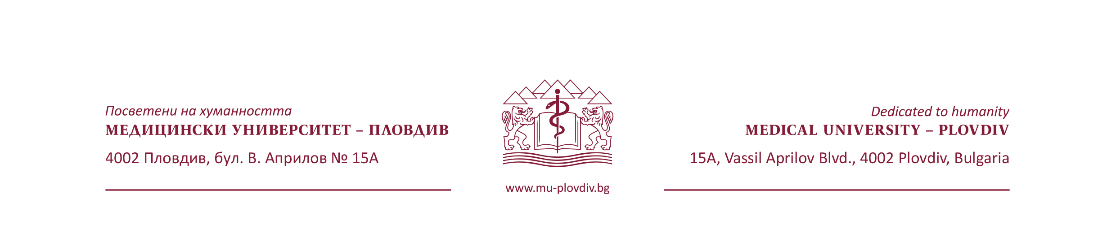

|  |  |  |
| --- | --- | --- |
| Факултет по обществено здраве  Катедра „Епидемиология и МБС“  4002 Пловдив, бул. В. Априлов № 15 А |  | ***Faculty of Public Health***  Department of Epidemiology and disaster medicine  15A, Vasil Aprilov Blvd, 4002 Plovdiv |

**Participant Consent Form for Articles Containing   
Participant Details and/or Images**

This form provides consent for MDPI to publish details and/or images from patients. It must be completed prior to publication.

**PARTICIPANT CONSENT FOR PUBLICATION**

Participants have the right to refuse to sign this consent form; refusal to sign this

form will not affect their care in any way.

• I hereby give my consent for clinical information relating to my case to be reported in a

medical publication. I have read the above named article in full and agree to its

publication. I am fully aware of the implications of publication and accept any

associated risk.

• I understand that my name and initials will not be published and that efforts will be

made to conceal my identity and no personal information will be used for the

publication.

• I understand that the paper will be published online in open access format (using a

creative common CC BY 4.0 license, http://creativecommons.org/licenses/by/4.0) ,

meaning that it can be downloaded, copied and reused without limitation. This includes

any figures, tables, and supplementary data. The primary audience for the published

paper will be healthcare professionals, research academics and students from across the

globe.

• Publication in the journal mentioned is not guaranteed and will take place at the

discretion of the publisher, and with permission of the Editor-in-Chief (or a qualified

Editorial Board member) after a peer-review process.

• I understand that I/the patients will receive no financial benefit or compensation from

publication of the article.

• I understand that I may revoke consent at any point prior to publication, but after

publication my consent can no longer be withdrawn.

**Article details**

**Article title:** COVID-19 vaccination and potential predictors for vaccination among students in Bulgarian medical universities

**Journal: MDPI Vaccines**

**Authors: Vanya Rangelova, Ralitsa Raycheva, Ani Kevorkyan, Nevena Ivanova, Momchil Baev, Sara Sariyan, Nikoleta Pamukova, Milena Karcheva, Tsonko Paunov**

**Name of participant /Name of participant representative**

…………………………………………………………………………………………………………………………………………………………..

**Signature of participant/Signature of participant representative**

…………………………………………………………………………………………………………………………………………………………….

**Date:**