Supplementary Information
Experimental study on photodegradation and leaching of typical pesticides in greenhouse soil from Shouguang, Shandong Province, northern China

Li-Ting Hua*, Rui-Lin Wu*, Chao-Nan Wang, Yi-Long Li, Fu-Liu Xu**

MOE Laboratory for Earth Surface Processes, College of Urban & Environmental Sciences, Peking University, Beijing 100871, China

* Co-first author
** Corresponding author
E-mail address: xufl@urban.pku.edu.cn
Tables:
Table S1. List of commonly used pesticides and registered quantities of pesticides in vegetable areas under Shouguang facilities.
Table S2. Elution gradient of mobile phase in liquid chromatography.
Table S3. Instrumental analysis parameters of target pesticides.
Table S4. Recovery of typical pesticides in soil.

Figure:
Figure S1. Structural formulas of 17 target pesticides.

Table S1. List of commonly used pesticides and registered quantities of pesticides in vegetable areas under Shouguang facilities.
Category | Pesticide | Classification | Unit dose package | Pesticides mixture | Integral dose
Insecticide | Nitenpyram | Neonicotinoid | 107 | 5 | 112
 | Acetamiprid | Neonicotinoid | 619 | 102 | 721
 | Chlorantraniliprole | O-formamide benzoamide | 23 | 3 | 26
 | Emamectin benzoate | Microbial derivative | 646 | 0 | 646
 | Buprofezin | Chitin synthesis inhibitor | 201 | 84 | 285
 | Avermectin B1A | Biogenic pesticide | 830 | 11 | 841
Fungicide | Carbendazim | Benzimidazole | 277 | 304 | 581
 | Oxadixyl | Phenylamide | 177 | 131 | 308
 | Metalaxyl | Benzoamide | 39 | 35 | 74
 | Diethofencarb | Carbamate pesticide | 4 | 14 | 18
 | Boscalid | Formamide | 68 | 4 | 72
 | Tebuconazole | Triazole | 377 | 215 | 592
 | Isoprothiolane | Malonic acid pesticide | 108 | 53 | 161
 | Hexaconazole | Triazole | 155 | 70 | 225
 | Difenoconazole | Triazole | 340 | 3 | 343
 | Pyraclostrobin | Methoxy acrylate | 294 | 18 | 312
 | Trifloxystrobin | Methoxy acrylate | 39 | 29 | 68
Note: The registration status of 17 typical pesticides (including single and mixed formulations) were queried through Chinese Pesticide Information Network (http://www.chinapesticide.org.cn/) (as of November 22, 2021), where the registration quantity of emamectin benzoate was excluded from that of avermectin B1A.

Table S2. Elution gradient of mobile phase in liquid chromatography.
Time (min) | Flow rate (mL/min) | %Aª | %B^{b}
0 | 0.4 | 80 | 20
0.5 | 0.4 | 80 | 20
1.5 | 0.4 | 60 | 40
2 | 0.4 | 60 | 40
2.5 | 0.4 | 55 | 45
4 | 0.4 | 55 | 45
5 | 0.425 | 40 | 60
6.5 | 0.5 | 25 | 75
7 | 0.5 | 25 | 75
7.5 | 0.65 | 5 | 95
8.5 | 1 | 5 | 95
9.5 | 1 | 5 | 95
9.6 | 0.4 | 80 | 20
12 | 0.4 | 80 | 20
ª Mobile phase A: 0.1% formic acid aqueous solution containing 5 mmol ammonium formate.
^{b} Mobile phase B: 100% acetonitrile

Table S3. Instrumental analysis parameters of target pesticides.
Category | Pesticide | Retention time (min) | Cone  voltage (V) | Parent  ion (m/z) | Product  ion 1 (m/z) | Collision  energy 1 (eV) | Product  ion 2 (m/z) | Collision  energy 2 (eV)
Insecticide | Nitenpyram | 1.58 | 22 | 271 | 189 | 12 | 126 | 26
 | Acetamiprid | 2.48 | 50 | 223 | 187 | 12 | 126 | 15
 | Chlorantraniliprole | 5.41 | 15 | 484 | 453 | 10 | 286 | 10
 | Emamectin benzoate | 6.4 | 20 | 886.6 | 158 | 35 | 126 | 30
 | Buprofezin | 7.85 | 20 | 306 | 201 | 12 | 116 | 16
 | Avermectin B1A | 8.08 | 16 | 890.3 | 567 | 14 | 305 | 24
Fungicide | Carbendazim | 1.45 | 10 | 192 | 160 | 30 | 132 | 30
 | Oxadixyl | 2.47 | 10 | 190 | 163 | 20 | 136 | 25
 | Metalaxyl | 4.28 | 10 | 280 | 220 | 15 | 192 | 20
 | Diethofencarb | 5.8 | 10 | 168 | 226 | 10 | 124 | 30
 | Boscalid | 6.11 | 46 | 343 | 307 | 18 | 140 | 20
 | Tebuconazole | 6.14 | 30 | 308 | 125 | 40 | 70 | 24
 | Isoprothiolane | 6.45 | 17 | 291 | 231 | 12 | 189 | 22
 | Hexaconazole | 6.27 | 30 | 314 | 159 | 40 | 70 | 20
 | Difenoconazole | 6.84 | 35 | 406 | 251 | 25 | 188 | 40
 | Pyraclostrobin | 7.17 | 25 | 388 | 194 | 12 | 163 | 25
 | Trifloxystrobin | 7.43 | 25 | 409 | 186 | 14 | 145 | 40

Table S4. Recovery of typical pesticides in soil.
Category | Pesticide | Recovery (%) | Relative standard deviation | Matrix effect (%)
Insecticide | Nitenpyram | 89.1 | 5.5 | 98.1
 | Acetamiprid | 76.7 | 1.5 | 94.9
 | Chlorantraniliprole | 99.3 | 1.6 | 81.8
 | Emamectin benzoate | 96.2 | 0.7 | 97.7
 | Buprofezin | 94.1 | 1.3 | 92.9
 | Avermectin B1A | 84.8 | 2.9 | 86.0
Fungicide | Carbendazim | 89.3 | 1.5 | 95.9
 | Oxadixyl | 74.4 | 1.7 | 95.3
 | Metalaxyl | 94.3 | 3.7 | 95.6
 | Diethofencarb | 97.0 | 2.2 | 100.1
 | Boscalid | 105.8 | 6.8 | 78.1
 | Tebuconazole | 96.3 | 1.7 | 77.9
 | Isoprothiolane | 97.6 | 2.4 | 95.9
 | Hexaconazole | 81.2 | 4.8 | 82.1
 | Difenoconazole | 98.8 | 2.0 | 87.3
 | Pyraclostrobin | 96.3 | 2.1 | 95.1
 | Trifloxystrobin | 94.6 | 1.2 | 87.9

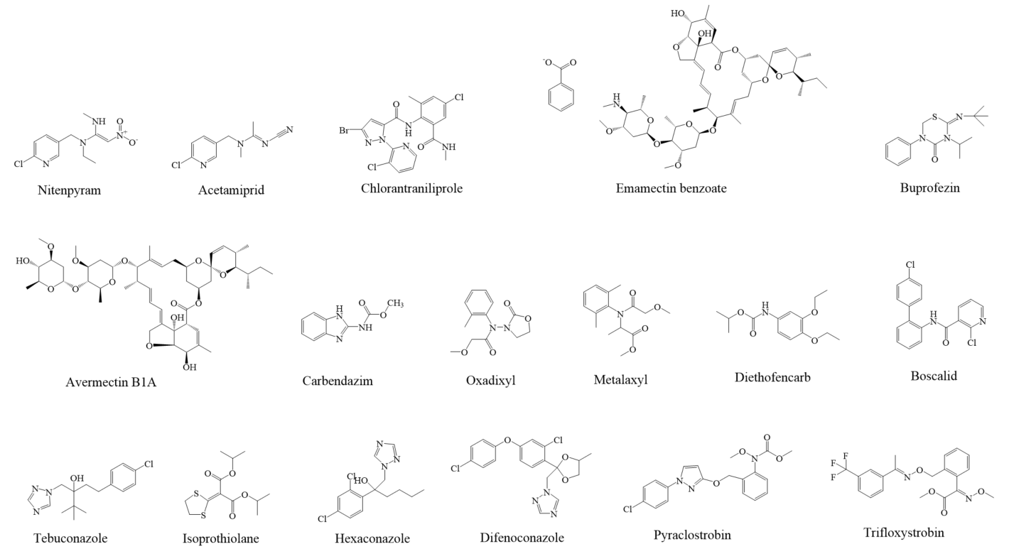
Figure S1. Structural formulas of 17 target pesticides.

