Supplementary contents 1
Methodology:
1. BODIPY™ 493/503 (4,4-Difluoro-1,3,5,7,8-Pentamethyl-4-Bora-3a,4a-Diaza-s-Indacene Molecular Probes Invitrogen™) is a lipophilic fluorophore used for the identification of neutral lipids (reserve lipids) present in abundance in the form of intracellular CLs, being used for quantification, analysis of these structures by flow cytometry [56]. and morphological observation by fluorescence microscopy. For the quantification of lipids, promastigotes of L. (L.) amazonensis (strain MHOM/BR/26361) were maintained in culture in RPMI 1640 medium, supplemented with 10% SBF at 27ºC. After 24, 48 and 72 h of culture the cells were washed with PBS pH 7.2 and incubated with BODIPY™ 493/503 at a concentration of 10 μg/mL for 30 minutes, in the absence of light [57]. After incubation, the cells were analyzed in the flow cytometer BD FACSCanto IITM. A total of 10,000 events were collected for each sample and the average flowering intensity data were analyzed using the GraphPad Prism program (version 6.01).
2. Peritoneal macrophages from mice (2x106/mL) were cultured and infected with L. (L.) amazonensis 1:10 promastigotes in the stationary phase [58]. After 72 h of infection, the cells were washed with PBS pH 7.2, followed by fixation for 1 hour with 2.5% glutaraldehyde type II (70%), 4% paraformaldehyde, 2.5% sucrose, in 0.1 M sodium cacodilate buffer, pH 7.2, after fixation, the cells were incubated in solution with 1% osmium tetroxide and potassium ferrocyanide (0.8%) for 1 hour. After this period, the cells were dehydrated in a growing series of acetone for 10 minutes (50%, 70%, 90% and 3 times in 100%). After dehydration, the cells were slowly impregnated in Epon® resin (2:1, 1:1 and 1:2 - 100% acetone: Epon®). Subsequently, the material was placed in pure Epon® for 6 hours and finally polymerized at 60ºC for 48 hours. The blocks were cut in ultramicrotome (Leica EM UC6) and the sections obtained were contrasted in 5% uranyl acetate and lead citrate and observed in JEOL Transmission Electronic Microscope.

Supplementary contents 2 for future comparative studies
All articles cited in these 2 overviews were mainly searched through the electronic databases of PubMed Central® (PMC) available on the NCBI Entrez system (http://www.ncbi.nlm.nih.gov/), which were published from April, 2011 to April, 2016 for studies on the association between leishmaniasis and other parasitic diseases: babesiosis, toxoplasmosis, neosporosis and dirofilariasis in dogs and cats. Also searched bibliographies of identified reports, including previous reviews, for additional references. The search was limited to studies performed in dogs and cats worldwide during one period of 5 years (concomitant with the initial results for the doctoral research of our corresponding author) can be increased for longer time and including others diseases. The search terms that were used as Medical Subject Headings MeSH terms or direct keywords for the search on the following items: 1. leishmaniasis, 2. zoonoses, 3. dog, 4. cat, 5. co-infection, 6. hemiparasites, 7. neosporosis, 8. babesiosis, 9. toxoplasmosis, 10. dirofilariasis. Thus, the risk of co-infection with the zoonoses from companion animals. Further studies focusing on the clinical diagnosis and epidemiological aspects of co-infection of zoonotic diseases in endemic and non-endemic regions are necessary for better control them in companion animals, as a source of infection is important and maybe underrated. Moreover, multidisciplinary contributions between medical scientists and veterinarians able to accurately diagnose of zoonotic protozoal and helminth infections are necessary, prevention efforts may include a world-wide network of surveillance for the co-infection in continuous adaptation in front of global environment changes.

Table S1. Overview reports of coinfection between Leishmania sp. and hemoparasites of dogs.
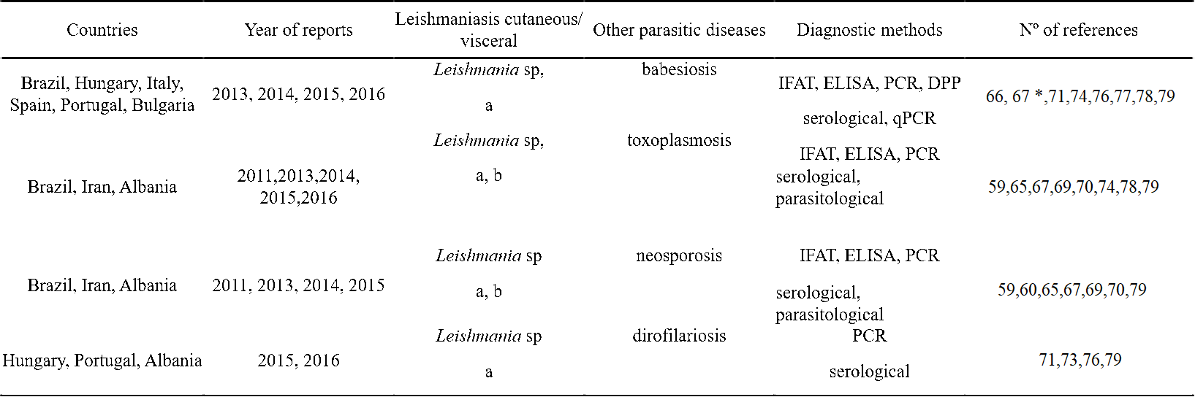
a) L. infantum, b) L. chagasi. * Commonly differential diagnosis can also be difficult, and coinfection, particularly with Babesia sp. or Ehrlichia species can occur.
Table S2. Overview reports of coinfection between Leishmania sp. and hemoparasites of cats.
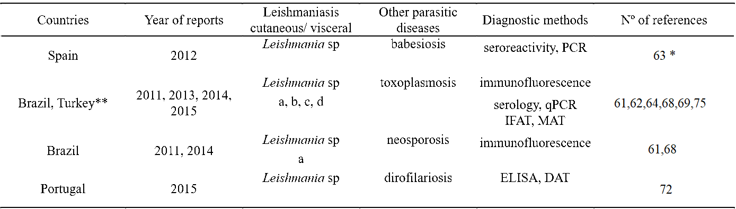
a) L. infantum, b) L. chagasi c) L. major d) L. tropica. * Commonly differential diagnosis can also be difficult, and coinfection, particularly with Babesia sp. or Ehrlichia species can occur. ** Coinfection of L. major and L. tropica.

