Supplementary figures
Figure S1. A representative OCTA image of PNV. MNV observed in a 3mm x 3mm OCTA image in a patient with PNV.
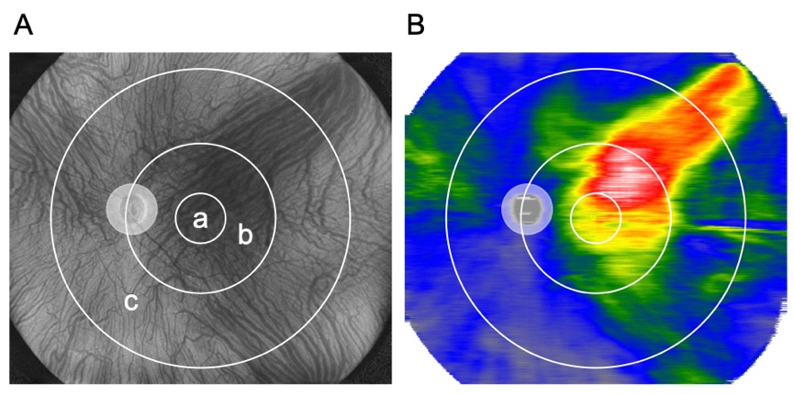
Figure S2. Choroidal thickness map and subfields divided by circle grids. Representative images of subfields and choroidal thickness map obtained by UWF SS-OCT. A. Three subfields are illustrated on an en face UWF SS-OCT image: < 3mm subfield (a), < 9mm subfield (b), and 9-18mm subfield (c) subfield. B. A representative image of choroidal thickness map calculated by the Bruch’s membrane to the chorioscleral interface in UWF OCT b-scans.

