Supplement Material

Title: Title: Prevalence and Genomic Characterization of Rotavirus A from Domestic Pigs in Zambia: Evidence for Porcine-Human Interspecies Transmission
Joseph Ndebe ^{1,†,}*, Hayato Harima ^{2,†}, Herman Moses Chambaro³, Michihito Sasaki⁴, Junya Yamagishi⁵, Annie Kalonda⁶, Misheck Shawa^{7,8}, Yongjin Qiu^{9,10}, Kajihara Masahiro^{7,8}, Ayato Takada^{1,11,12,13}, Hirofumi Sawa^{1,11,13,14,15}, Ngonda Saasa¹ and Edgar Simulundu^{1,16,}*
Citation: Lastname, F.; Lastname, F.; Lastname, F. Title. Pathogens 2021, 10, x. https://doi.org/10.3390/xxxxx
Academic Editor: Firstname Lastname
Received: date
Accepted: date
Published: date
Publisher’s Note: MDPI stays neutral with regard to jurisdictional claims in published maps and institutional affiliations.
Copyright: © 2021 by the authors. Submitted for possible open access publication under the terms and conditions of the Creative Commons Attribution (CC BY) license (https://creativecommons.org/licenses/by/4.0/).
- Department of Disease Control, School of Veterinary Medicine, University of Zambia, Lusaka 10101, Zambia
- Laboratory of Veterinary Public Health, Faculty of Agriculture, Tokyo University of Agriculture and Technology, Saiwai-cho 3-5-8, Fuchu 183-8509, Tokyo, Japan
- Central Veterinary Research Institute (CVRI), Ministry of Fisheries and Livestock, Lusaka 10101, Zambia
- Division of Molecular Pathobiology, International Institute for Zoonosis Control, Hokkaido University, N20 W10, Kita-ku, Sapporo 001-0020, Japan
- Division of Collaboration and Education, International Institute for Zoonosis Control, Hokkaido University, N 20 W 10, Kita‐ku, Sapporo 001‐0020, Japan
- Department of Biomedical Sciences, School of Health Sciences, University of Zambia, Lusaka 10101, Zambia
- Hokudai Center for Zoonosis Control in Zambia, School of Veterinary Medicine, University of Zambia, Lusaka 10101, Zambia
- Division of International Research Promotion, International Institute for Zoonosis Control, Hokkaido University, N20 W10, Kita-ku, Sapporo 001-0020, Japan
- Management Department of Biosafety, Laboratory Animal, and Pathogen Bank, National Institute of Infectious Diseases, Toyama 1‐23‐1, Shinjuku, Tokyo 162‐8640, Japan
- Department of Virology-I, National Institute of Infectious Diseases, Tokyo 162-8640, Japan
- Africa Centre of Excellence for Infectious Diseases of Humans and Animals, School of Veterinary Medicine, University of Zambia, Lusaka 10101, Zambia
- Division of Global Epidemiology, International Institute for Zoonosis Control, Hokkaido University N20 W10, Kita-ku, Sapporo 001-0020, Japan
- One Health Research Center, Hokkaido University, N18 W9, Kita-ku, Sapporo 001-0020, Japan
- Hokkaido University, Institute for Vaccine Research and Development (HU-IVReD), N21 W11, Kita-ku, Sapporo 001-0020, Japan
- Global Virus Network, 725 W Lombard Street, Baltimore, MD 21201, USA
- Macha Research Trust, Choma P.O. Box 630166, Zambia
† These authors contributed equally to this work
* Correspondence: j.ndebe@yahoo.com (J.N.); esikabala@yahoo.com (E.S)
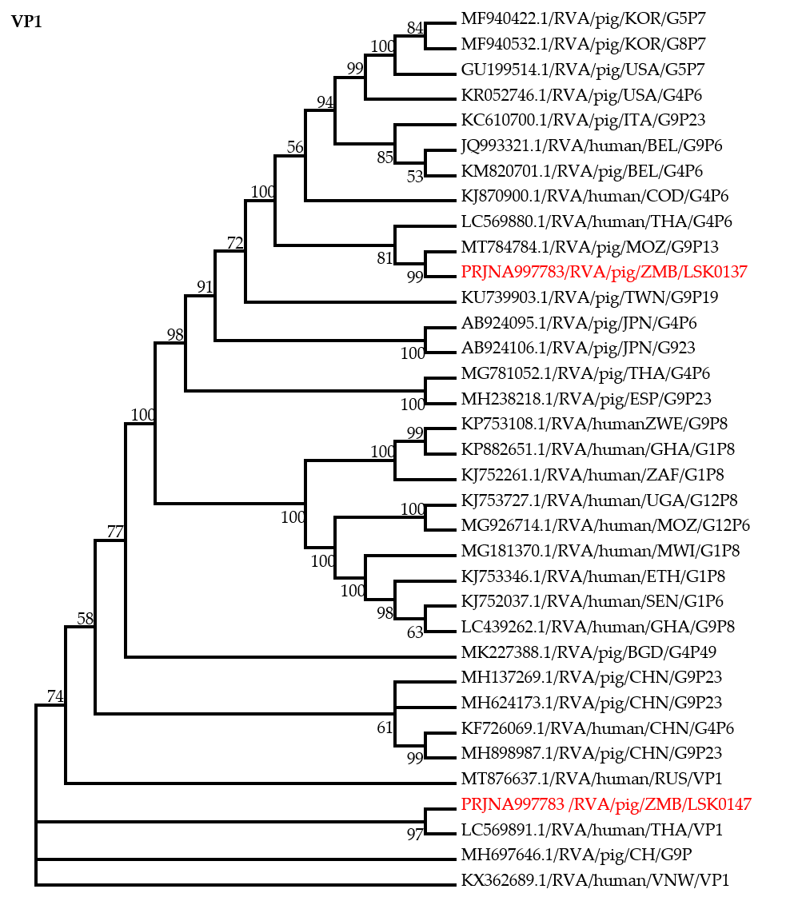
Figure S1. Phylogenetic tree of VP1 genes that belong to genotype R1. The analysis was based on 3218 nucleotides. Bootstrap values on branch nodes ≥ 50% are shown. The GenBank accession number/ Rotavirus group/Species origin/country of origin / G/P-types represent the reference sequences included in the tree. The viruses characterized in this study with their Bioproject accession number are shown in red text.

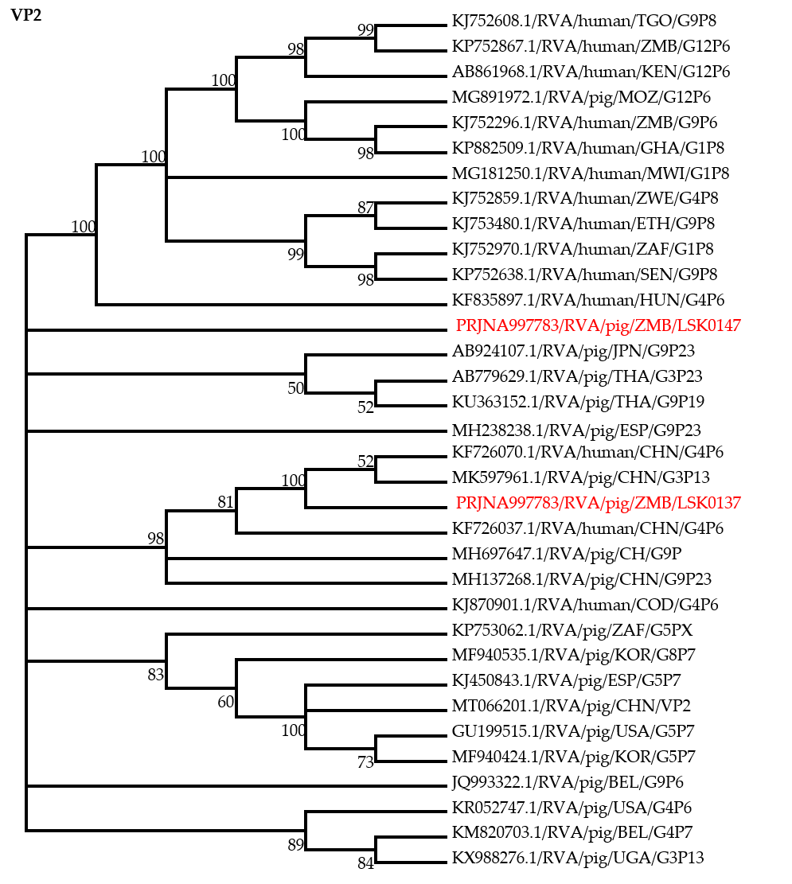
Figure S2. Phylogenetic tree of VP2 genes that belong to genotype C1. The analysis was based on 2605 nucleotides. Bootstrap values on branch nodes ≥ 50% are shown. The GenBank accession number/ Rotavirus group/Species origin/country of origin / G/P-types represent the reference sequences included in the tree. The viruses characterized in this study with their Bioproject accession number are shown in red text.

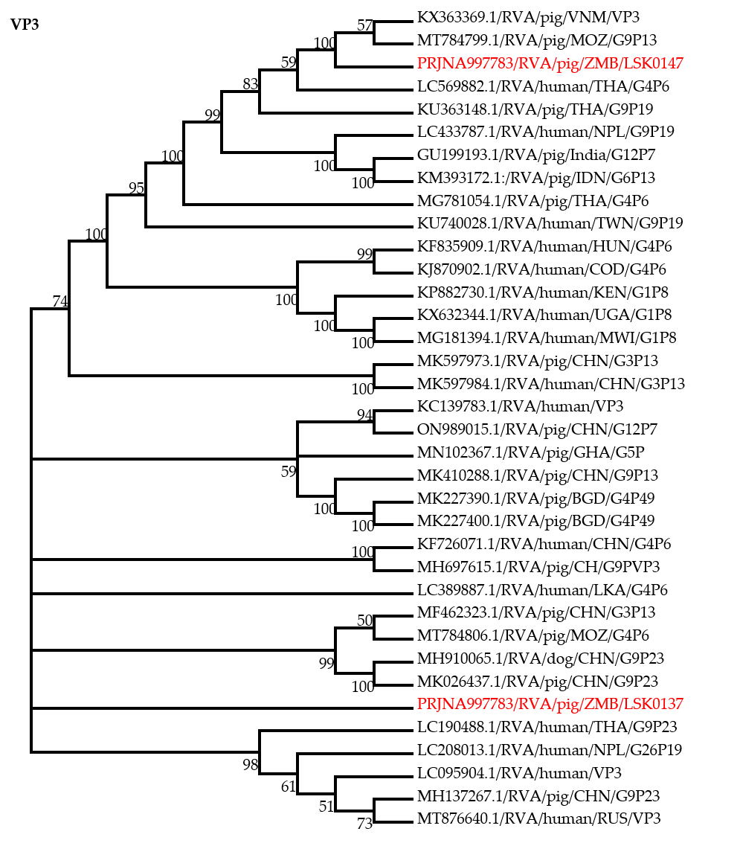
Figure S3. Phylogenetic tree of VP3 genes that belongs to genotype M1. The analysis was based on 2505 nucleotides. Bootstrap values on branch nodes ≥ 50% are shown. The GenBank accession number/ Rotavirus group/Species origin/country of origin / G/P-types represent the reference sequences included in the tree. The viruses characterized in this study with their Bioproject accession number are shown in red text.

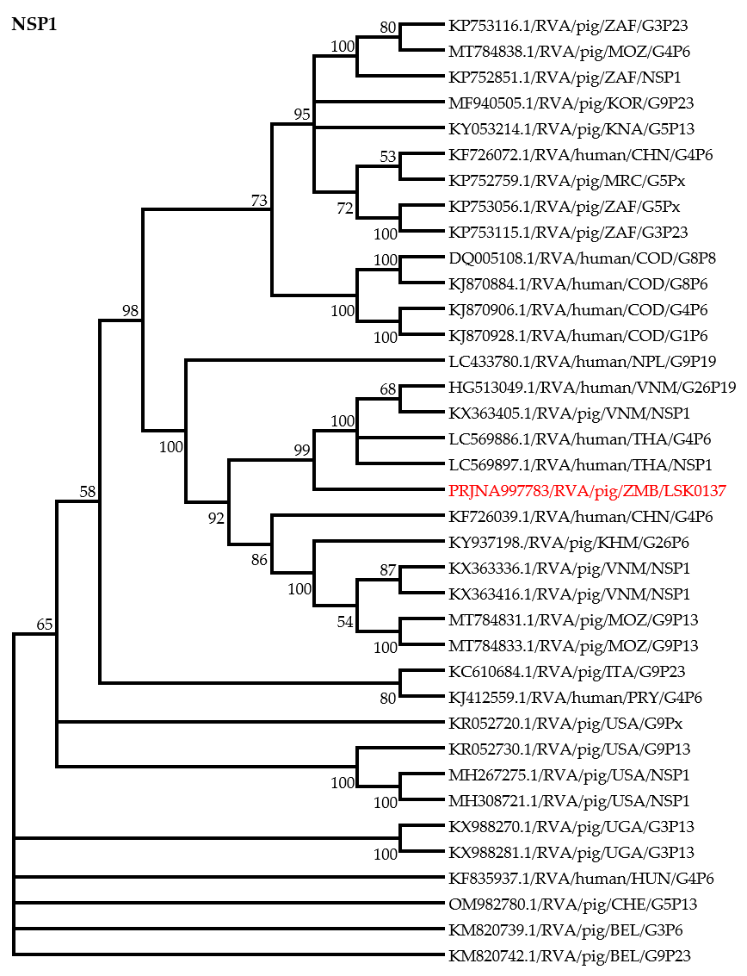 Figure S4. Phylogenetic tree of NSP1 genes. The analysis was based on 1443 nucleotides. Bootstrap values on branch nodes ≥ 50% are shown. The GenBank accession number/ Rotavirus group/Species origin/country of origin / G/P-types represent the reference sequences included in the tree. The virus characterized in this study with its Bioproject accession number is shown in red text.

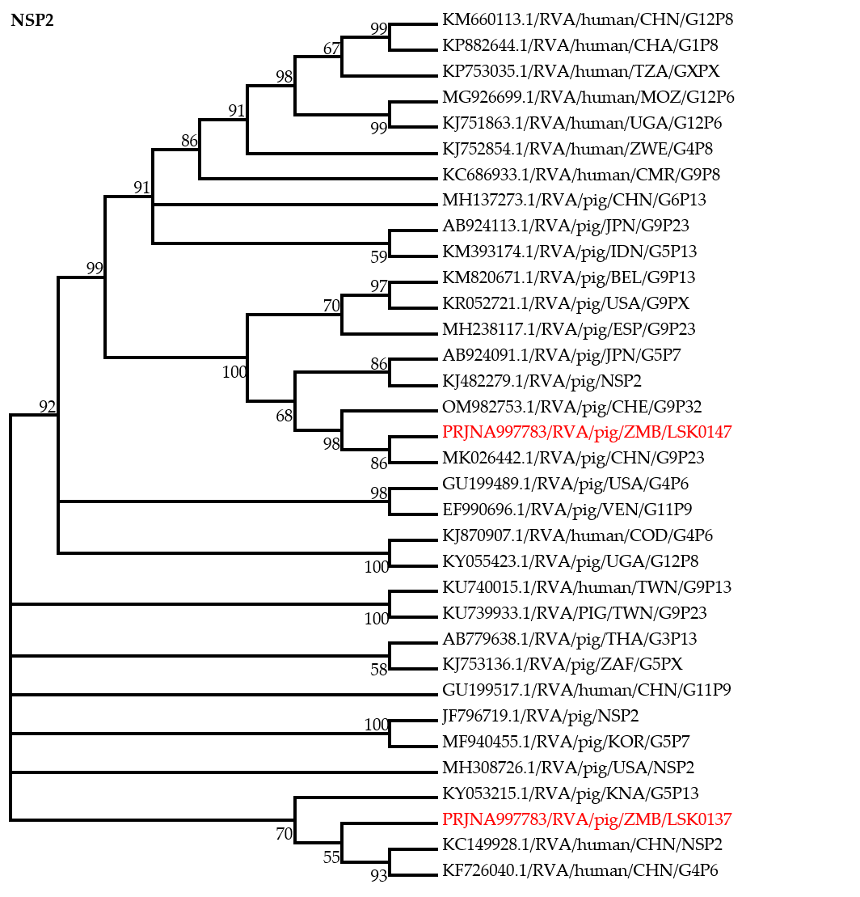
Figure S5. Phylogenetic tree of NSP2 genes that belong to genotype N1. The analysis was based on 804 nucleotides. Bootstrap values on branch nodes ≥ 50% are shown. The GenBank /accession number/ Rotavirus group/Species origin/country of origin / G/P-types represent the reference sequences included in the tree. The viruses characterized in this study with their Bioproject accession number are shown in red text.

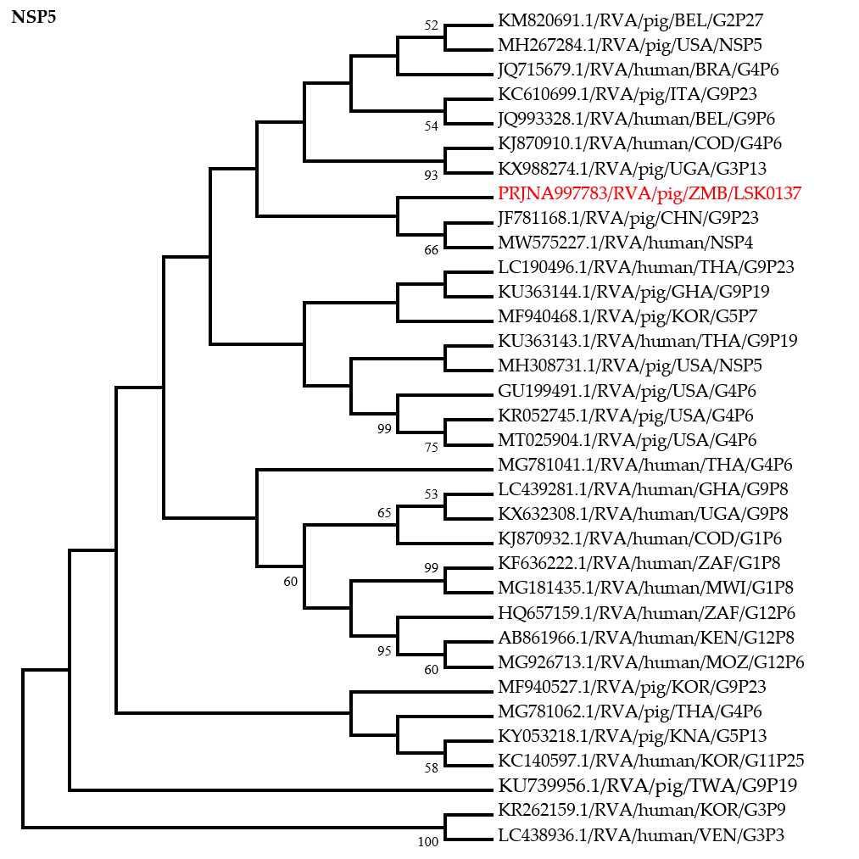

Figure S6. Phylogenetic tree of NSP5 genes that belong to genotype H1. The analysis was based on 582 nucleotides. Bootstrap values on branch nodes ≥ 50% are shown. The GenBank accession number/ Rotavirus group/Species origin/country of origin / G/P-types represent the reference sequences included in the tree. The virus characterized in this study with its Bioproject accession number is shown in red text.

