Supporting Information

Boosting lithium storage properties of flexible Li₄Ti₅O₁₂/ graphene fiber anode through a 3D printing assembly strategy
Chenpeng Zhao ¹, Rui Wang ¹, Biao Fang ¹, Han Liang ¹, Biyuan Nie ¹, Ruyi Wang ¹, Biao Xu ¹, Songyang Feng ¹, Ruqing Li ¹, Shuaifei Li ¹, Yuhui Xiong ¹, Yuye Shao ¹, Runwei Mo ¹∗

Experimental Section

Preparation of printing ink: Firstly, dissolve 10g of Polyvinylidene Fluoride (PVDF) (Dongguan Zhan Yang polymer materials Co., LTD) into 90ml of N-methylpyrrolidone (NMP), stir well for 10h to obtain a PVDF solution; then dissolve 100mg of GO powder(WOWMATERIALS, Changzhou) into 100ml of deionized water(DI), ultrasonically disperse for 30mins, add 200mg of LTO powder; and then add 400mg of Vitamin C, heated in a water bath at 80°C for 12 hours to reduce GO to rGO. After freeze-drying 24 h, 3 g of PVDF solution was added and stirred for 2 h to obtain printing ink.
Fabrication of Flexible Fiber Electrodes: Firstly, poly (vinylidene fluoride-co-hexafluoropropylene) (PVDF-HFP) (Shanghai Aichun Biological Technology Co., Ltd.) was added to acetone solution (wt%: 0.5%) with magnetic stirring overnight to obtain PVDF-HFP solution. Put the printing ink into the printing syringe, adjust the pressure and printing parameters of the 3D printer (Finsar F4200n), and slowly(about 100mm s⁻¹) squeeze the ink from the needle (the inner diameter is 0.65 mm) into the DI. Due to the solvent exchange between DI and NMP, PVDF will precipitate on the surface of the fiber electrode to form the fiber; after passing through PVDF-HFP solution, a separator is formed on the surface of the fiber electrode that prohibits the passage of electrons and allows ions to pass through. After drying overnight at room temperature ,finally obtaining the reduced graphene oxide-based flexible fiber electrode. The collected fiber electrodes were used for the subsequent characterization and performance evaluation.
Characterization and Electrochemical Measurement:
The rheological tests were carried out using the SNB2T viscosimeter (Shanghai FangRui Insurument CO,.LTD) at 25 °C. A strain sweep was performed at various shear rates from 10⁻² to 10 s⁻¹ to record the apparent viscosity. Raman characterization of the samples was performed using the Raman spectrometer(Laser Micro-Raman Spectrometer, England) of a 532nm laser. The microstructures and surface morphologies of the samples were analyzed by scanning electron microscopy (SEM) on FEI Quanta. The crystallographic structure of the samples was determined by X-ray diffractometer (XRD, Rotating Anode X-ray Powder Diffractometer, Japan) measurement with a Cu Kα radiation source (λ=0.154 nm), at a scanning rate of 10° min-1 in the range of 5°-80°. A Neware testing system (CT-ZWJ-4S-T-1U) was used to collect the electrochemical data with assembly half-cell. Lithium hexafluorophosphate (LiPF6, 1.0 M) dissolved in a solution of ethylene carbonate (EC) and diethylene carbonate (DEC) with a volumetric ratio of 1:1 was used as the electrolyte. The potential window of the half-cell tests were 1-2.5 V. Rate performance characterization was carried out at the current densities of 0.1-5 C, and then back to 0.1 C, with 5 cycles for each rate. Cyclic voltammetry and electrochemical impedance spectroscopy were used to test the half cell with CHI760E electrochemical workstation (Shanghai Chenhua Instrument Co., LTD).

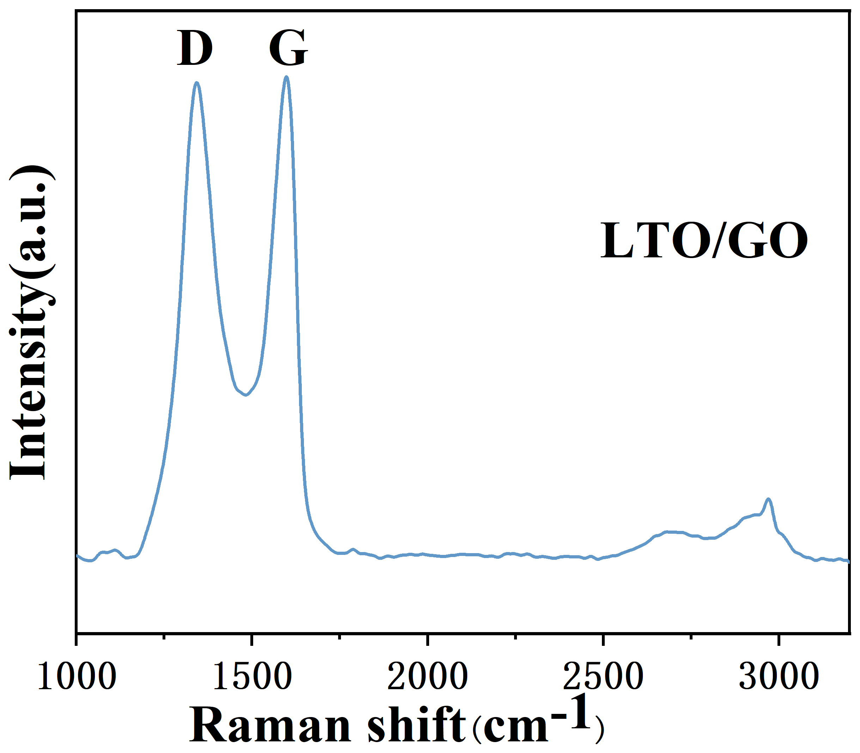
Figure S1. Raman pattern of LTO/GO fiber electrode.
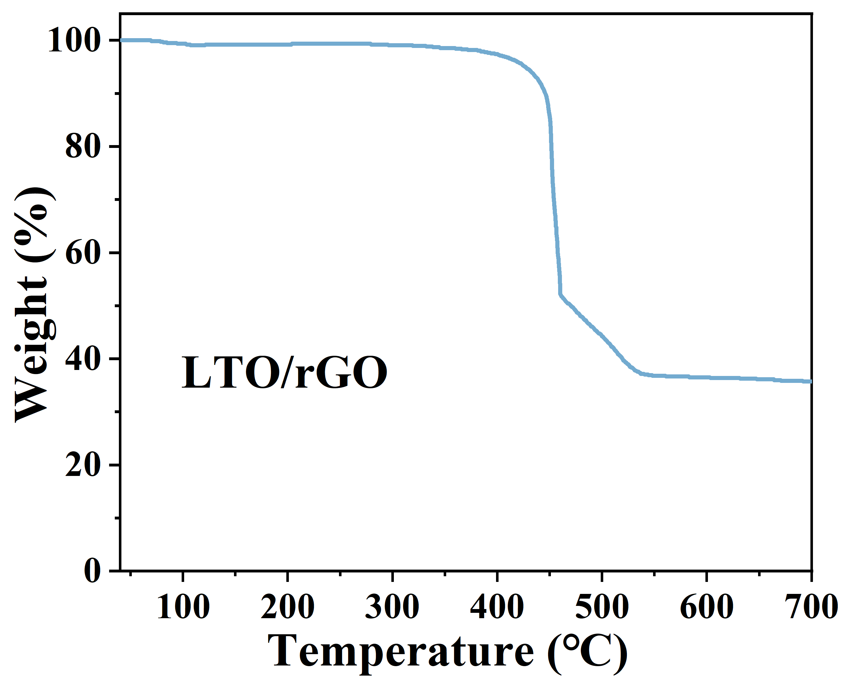
Figure S2. Thermogravimetric analysis of LTO/GO fiber electrodes

