Supplementary Materials
Association of blood leukocytes and hemoglobin with hospital mortality in acute pulmonary embolism
Obradovic Slobodan^{1,2}, Dzudovic Boris^{2,3}*, Subotic Bojana¹, Salinger Sonja^{4,5}, Matijasevic Jovan^{6,7}, Benic Marija⁶, Kovacevic Tamara^{8,9}, Kovacevic-Kuzmanovic Ana¹⁰, Mitevska Irena¹¹, Miloradovic Vladimir^{13,14}, Jevtic Ema¹³, and Neskovic Aleksandar^{15,16}
¹ Clinic of Cardiology, Military Medical Academy of Belgrade, Serbia
² School of Medicine, University of Defense, Belgrade, Serbia
³ Clinic of Emergency Internal Medicine, Military Medical Academy, Belgrade, Serbia
⁴ Clinic of Cardiology, Clinical Center Nis, Serbia
⁵ School of Medicine, University of Nis, Serbia
⁶ Institute of Pulmonary Diseases Vojvodina, Novi Sad, Serbia
⁷ School of Medicine, University of Novi Sad, Serbia
⁸ Clinic of Cardiology, Clinical Center Banja Luka, Bosnia and Herzegovina
⁹ School of Medicine, University of Banja Luka, Bosnia and Herzegovina
¹⁰ General Hospital Pancevo, Serbia
¹¹ University Cardiology Clinic, Intensive Care Unit, Skopje, North Macedonia
¹² Clinic of Cardiology, Clinical Center Kragujevac, Serbia,
¹³ School of Medicine, University of Kragujevac, Serbia
¹⁴ Clinic of Cardiology, University Clinical Center Zemun, Serbia
¹⁵ School of Medicine, University of Belgrade, Serbia
* Correspondence: dzuda1977@gmail.com (BDZ)
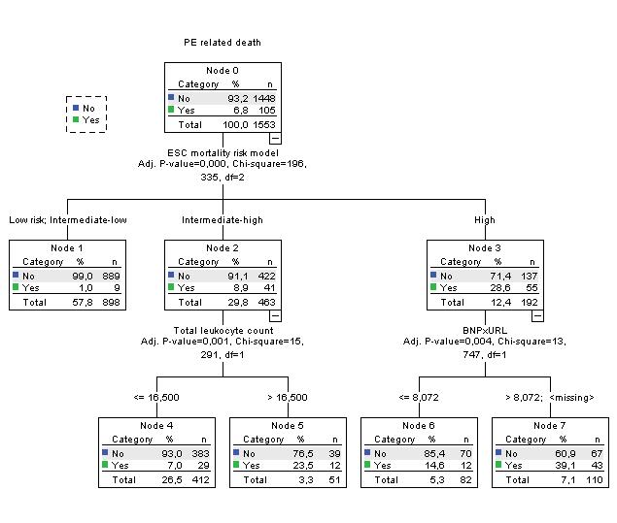
Figure S1. Decision tree using ESC mortality risk model, TLC, and BNP or NTproBNP x URL.

(a) | (b)
Figure S2. ROC curves for TLC for the prediction of all-cause (panel a) and PE related (panel b) hospital death. TLC level of >11.78x109/L has PPV=17,6% and NPV = 93% for all-cause death and PPV=12,1% and NPV = 96% for PE related hospital death.
(a) | (b)
Figure S3. ROC curves for Hb levels for the prediction of all-cause (panel a) and PE related (panel b) hospital death. TLC level of >11.78x109/L has PPV=17,6% and NPV = 93% for all-cause death and PPV=12,1% and NPV = 96% for PE related hospital death.

