Usable Observations over Europe:
evaluation of compositing windows for Landsat and Sentinel-2 time series

Supplement

Katarzyna Ewa Lewińska ^{1,2}, David Frantz ³, Ulf Leser ⁴, Patrick Hostert ^{1,5}

¹ Geography Department, Humboldt-Universität zu Berlin, Unter den Linden 6, 10099 Berlin, Germany.
² SILVIS Lab, Department of Forest and Wildlife Ecology, University of Wisconsin-Madison, 1630 Linden Drive, Madison WI 53706, USA.
³ Geoinformatics – Spatial Data Science, Trier University, 54286 Trier, Germany
⁴ Department of Computer Science, Humboldt-Universität zu Berlin, Unter den Linden 6, 10099 Berlin, Germany
⁵ Integrative Research Institute on Transformations of Human-Environment Systems (IRI THESys), Humboldt-Universität zu Berlin, Unter den Linden 6, 10099 Berlin, Germany.

* corresponding author: Katarzyna Ewa Lewińska
lewinska@hu-berlin.de
phone +49 (0)30 2093-6883
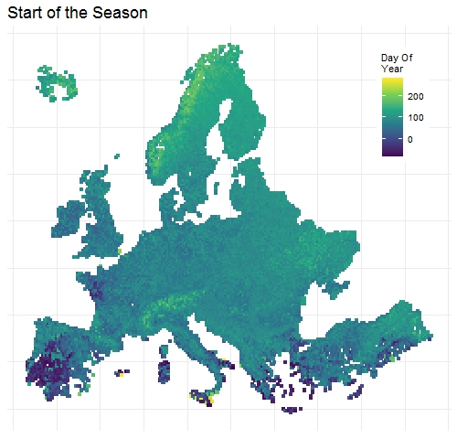
Figure S1 Start of the Season (SOS) derived as the 25th percentile of SOS 2001-2019 distribution. Values <0 indicate SOS initiated in the previous year.
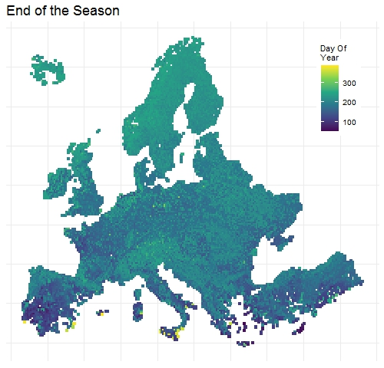
Figure S2 End of the Season (EOS) derived as the 75th percentile of SOS 2001-2019 distribution. Values >365 indicate EOS concluding in the following year.
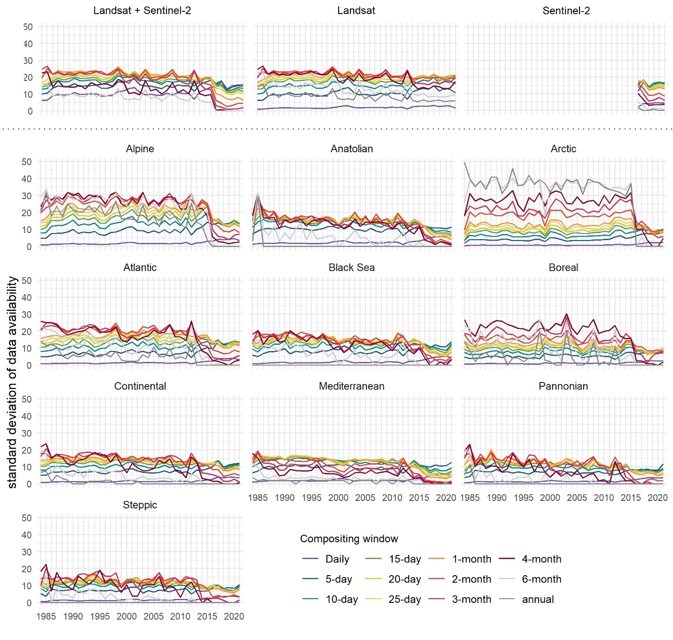Figure S3 Standard deviation of annual data availability over Europe (top) based on combined Landsat and Sentinel-2, Landsat, and Sentinel-2 time series (left to right) and within biogeographical regions of Europe (bottom part) for composites derived for different aggregation periods based on combined Landsat and Sentinel-2 data.
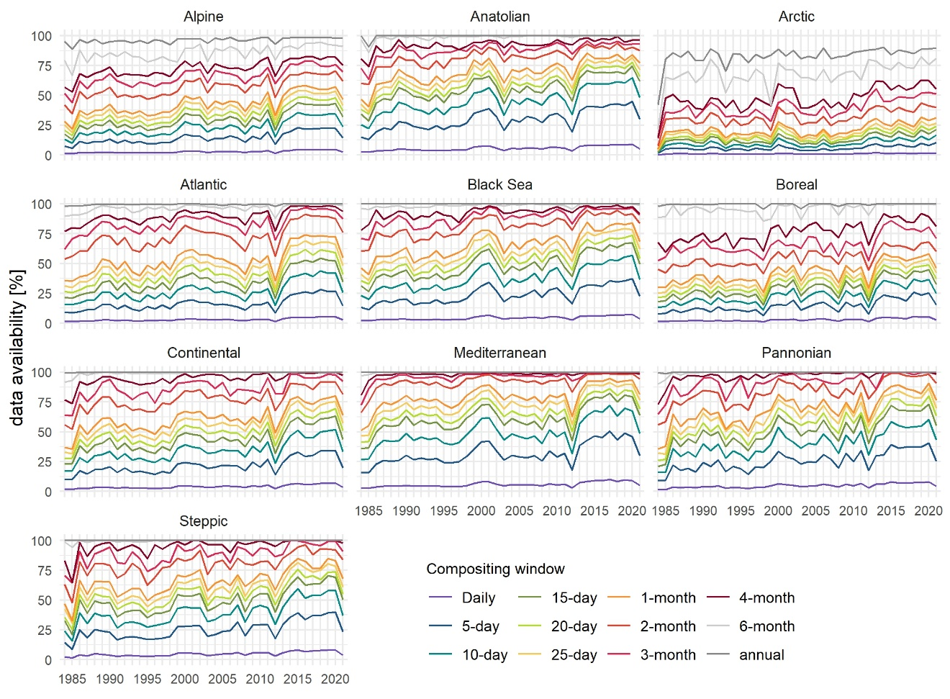
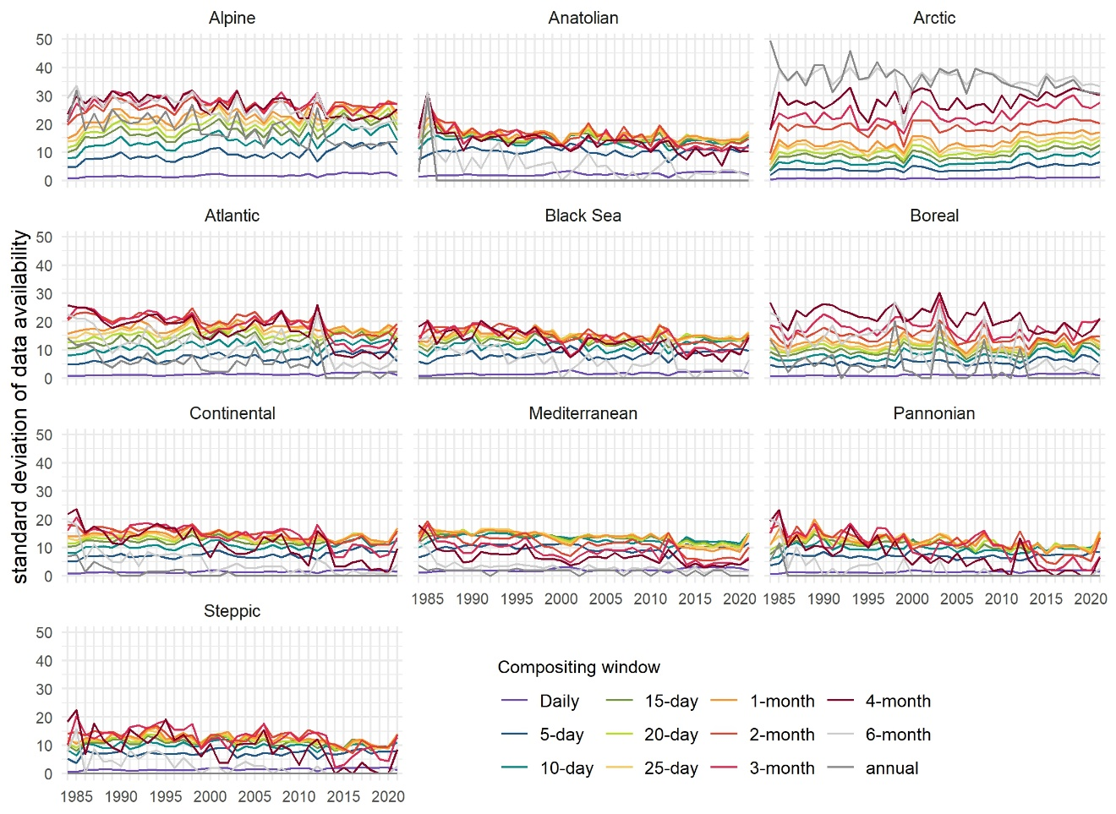
Figure S4 Annual mean (top) data availability and its standard deviation (bottom) within biogeographical regions across Europe for composites derived based on Landsat data using different compositing windows.
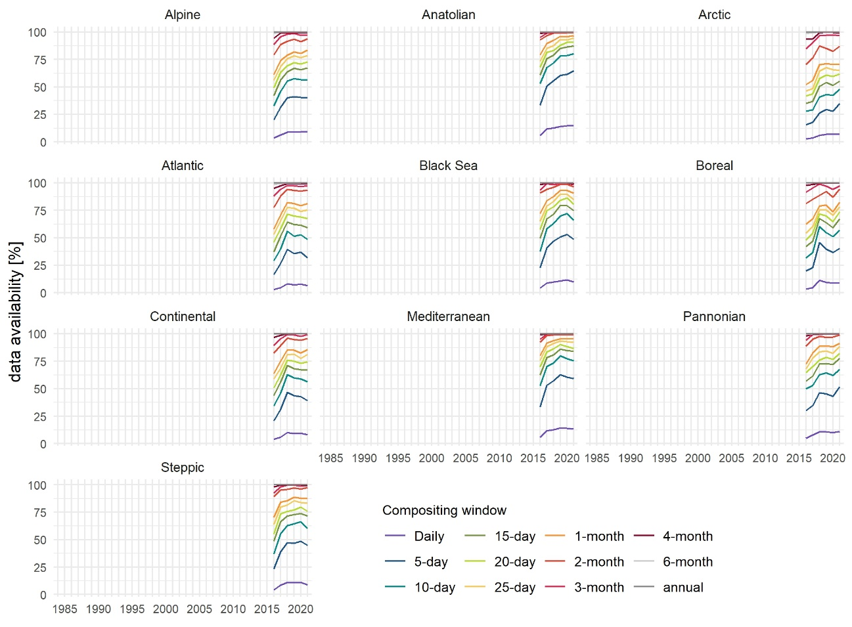
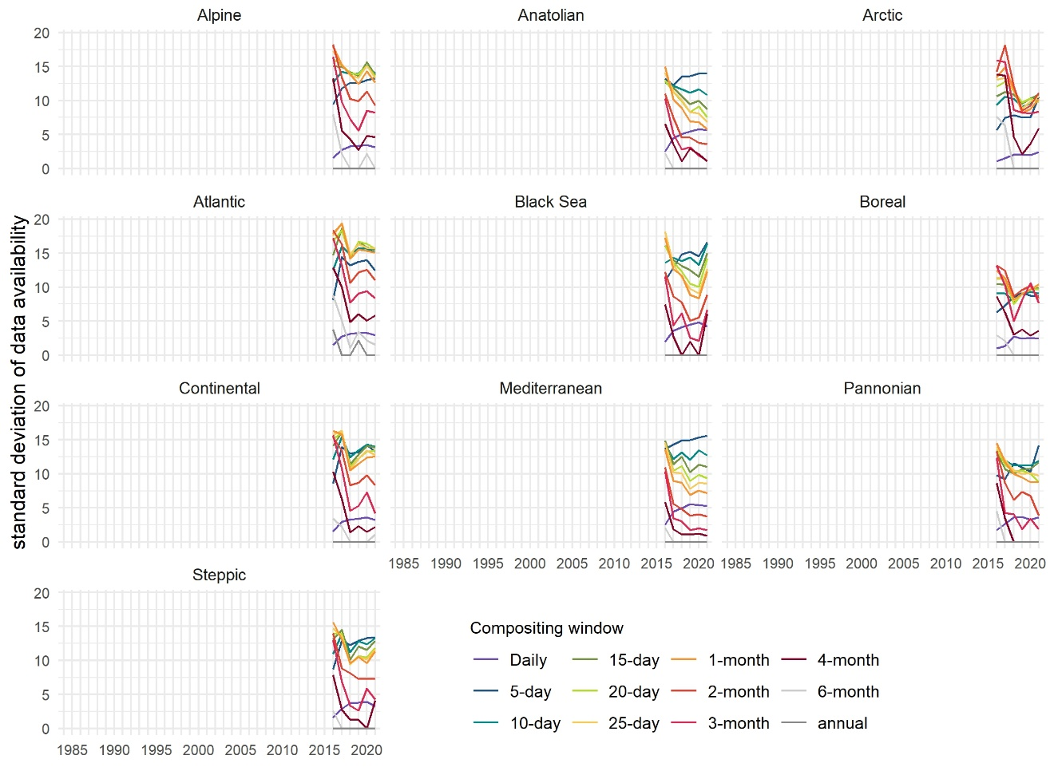
Figure S5 Annual mean (top) data availability and its standard deviation (bottom) within biogeographical regions across Europe for composites derived based on Sentinel-2 data using different compositing windows.
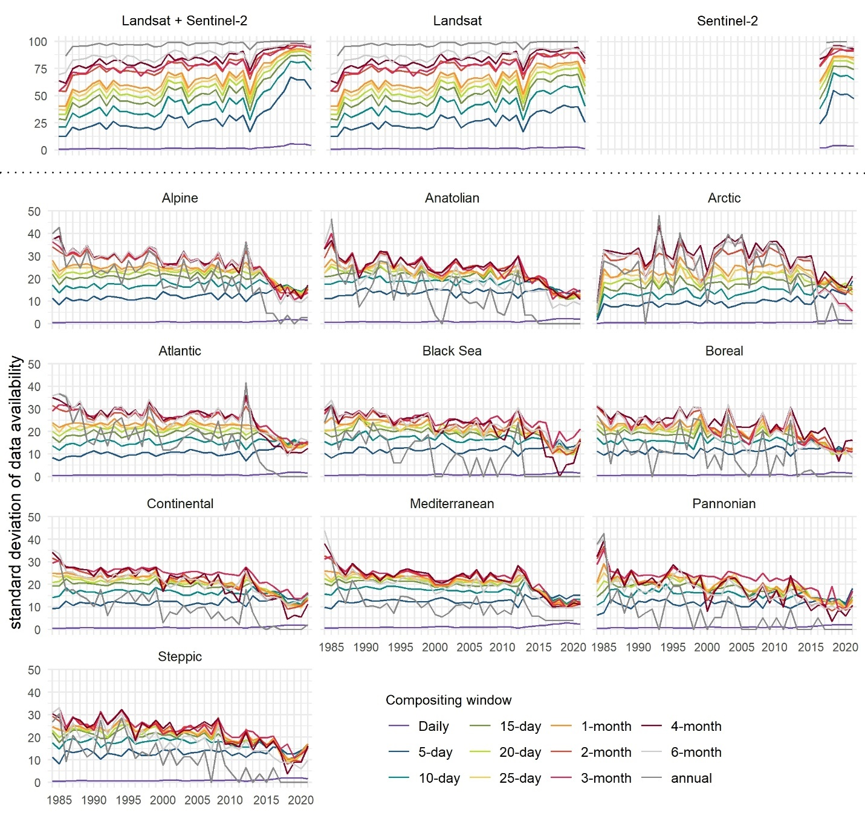
Figure S6 Standard deviation of annual data availability during the growing season across Europe (top row) based on combined Landsat and Sentinel-2, Landsat and Sentinel-2 time series (left to right), and within biogeographical regions of Europe (bottom part) for composites derived for different aggregation periods based on combined Landsat and Sentinel-2 data.
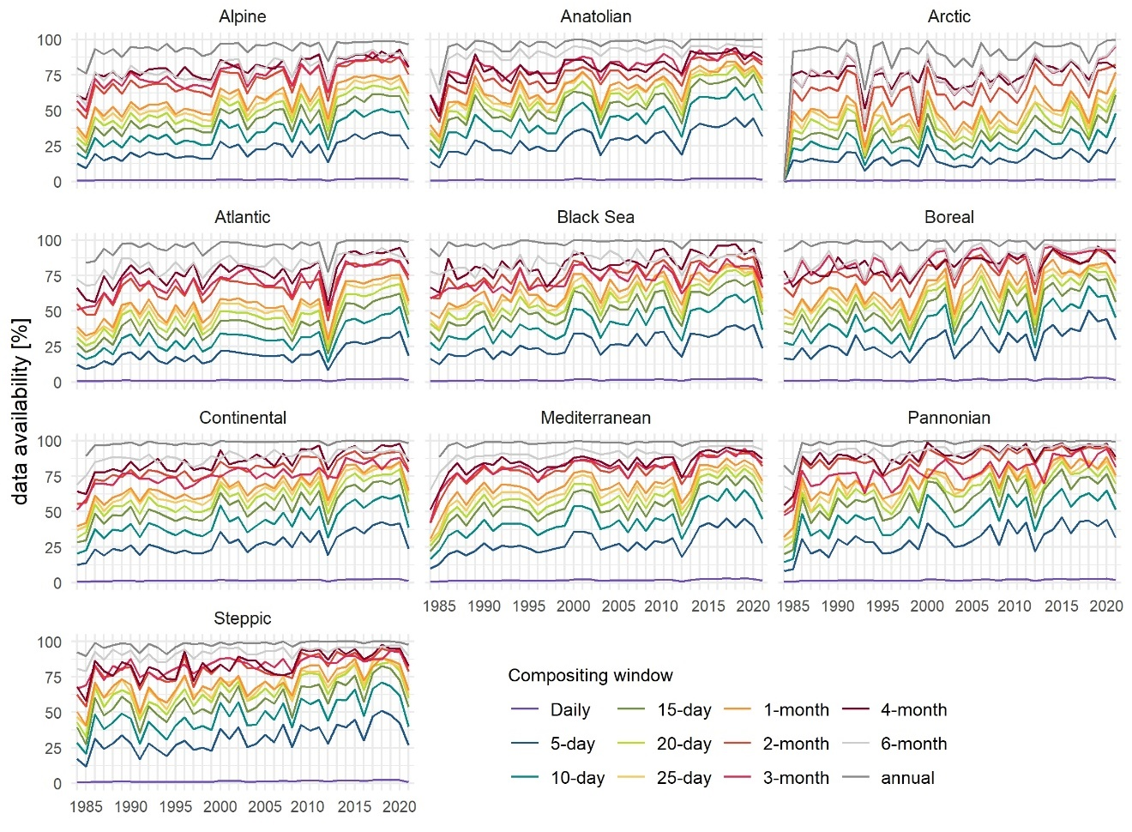
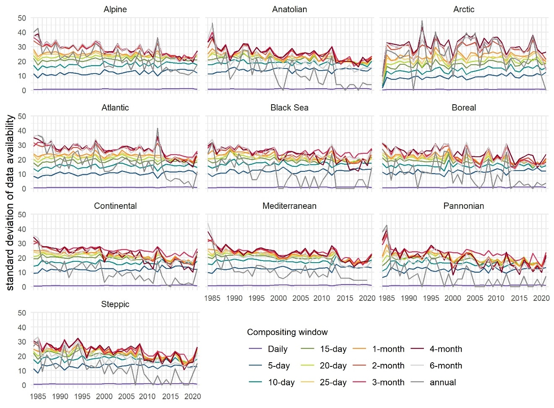
Figure S7 Annual mean (top)data availability and its standard deviation (bottom) during the respective growing season within biogeographical regions across Europe for composites derived based on the Landsat data using different compositing windows.
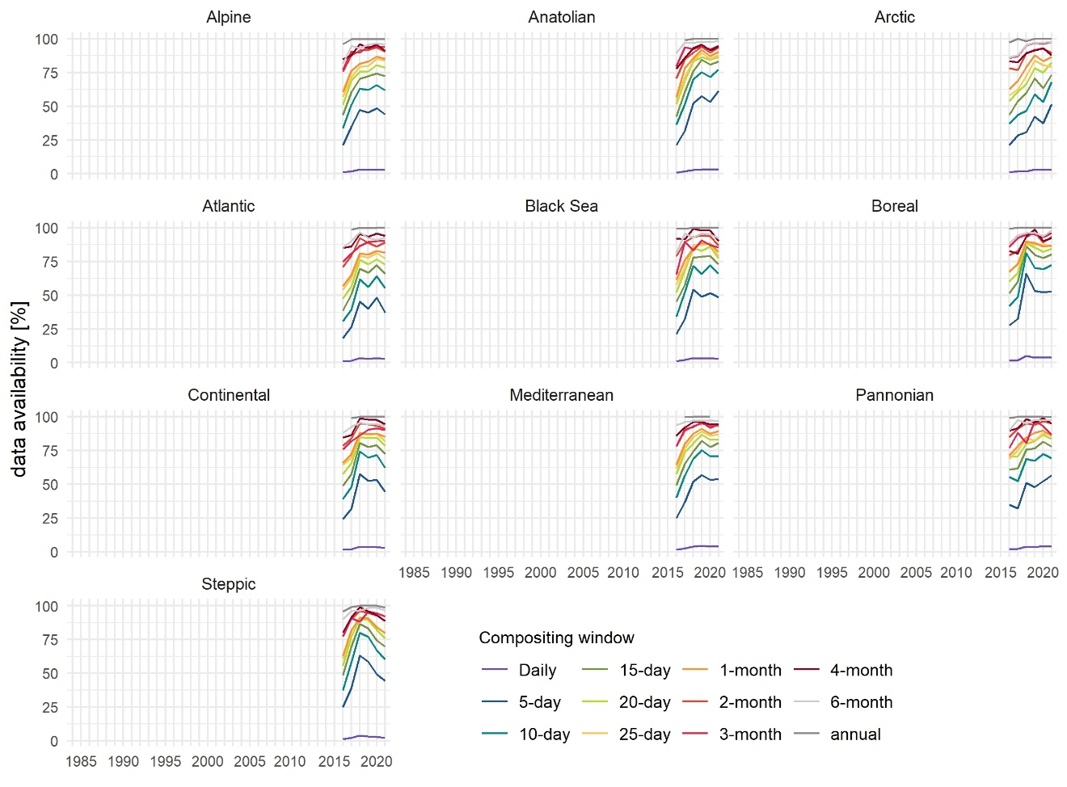
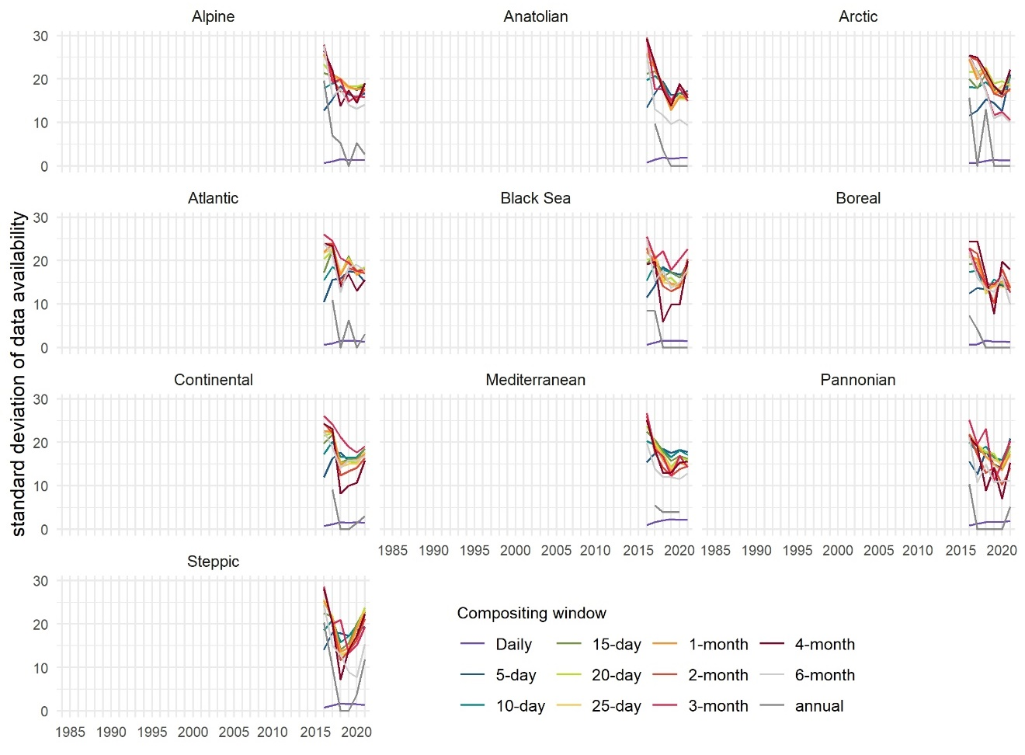
Figure S8 Annual mean (top) data availability and its standard deviation (bottom) during the respective growing season within biogeographical regions across Europe for composites derived based on the Sentinel-2 data using different compositing windows.
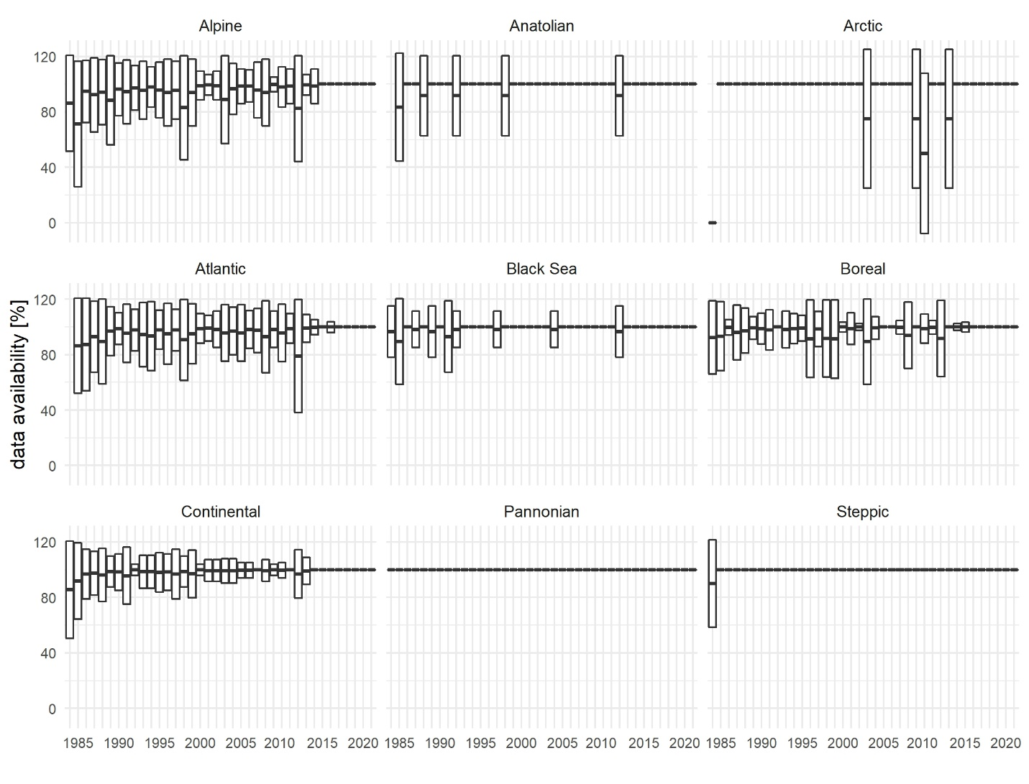
Figure S9 Mean (± standard deviation) annual data availability for annual growing season composites over forests derived based on combined Landsat and Sentinel-2 data.
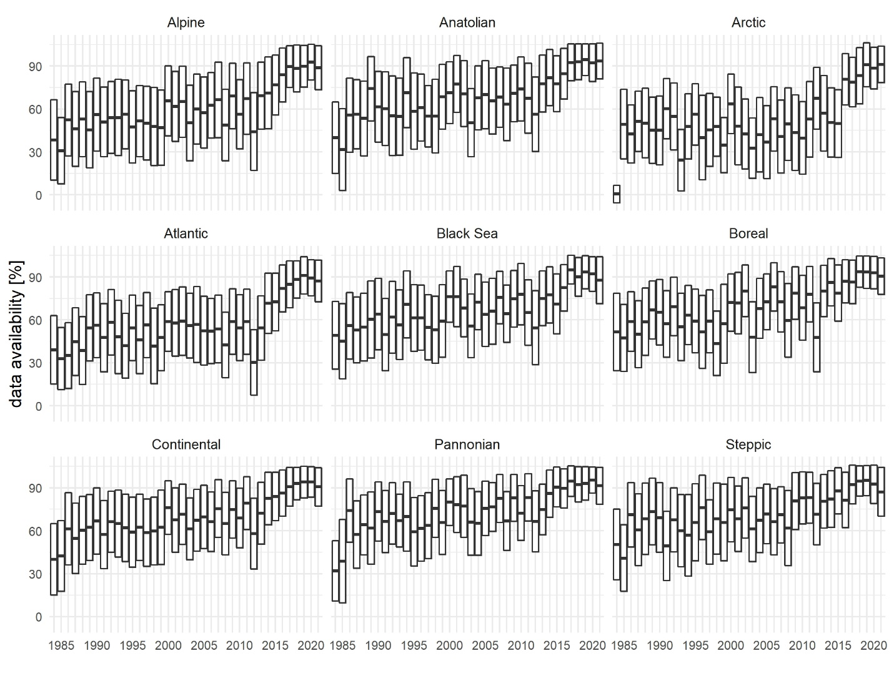
Figure S10 Mean (± standard deviation) annual data availability for monthly composites over all land cover classes derived based on combined Landsat and Sentinel-2 data.
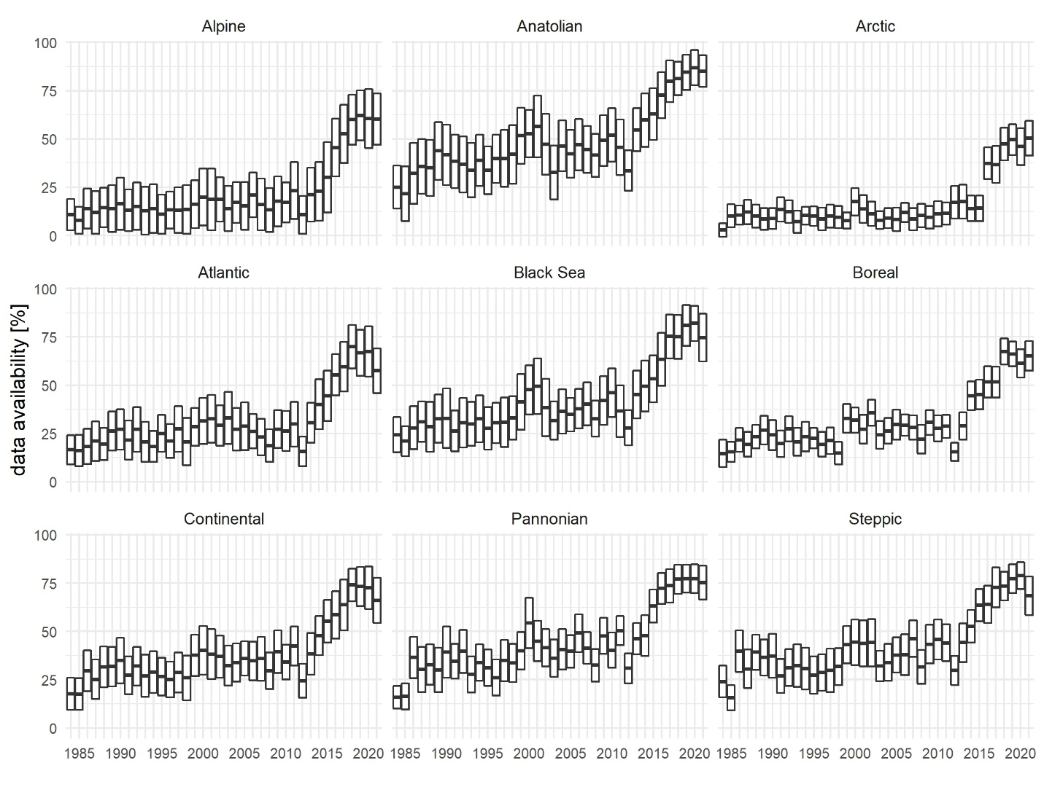
Figure S11 Mean (± standard deviation) annual data availability for 10-day composites over grasslands and croplands derived based on combined Landsat and Sentinel-2 data.
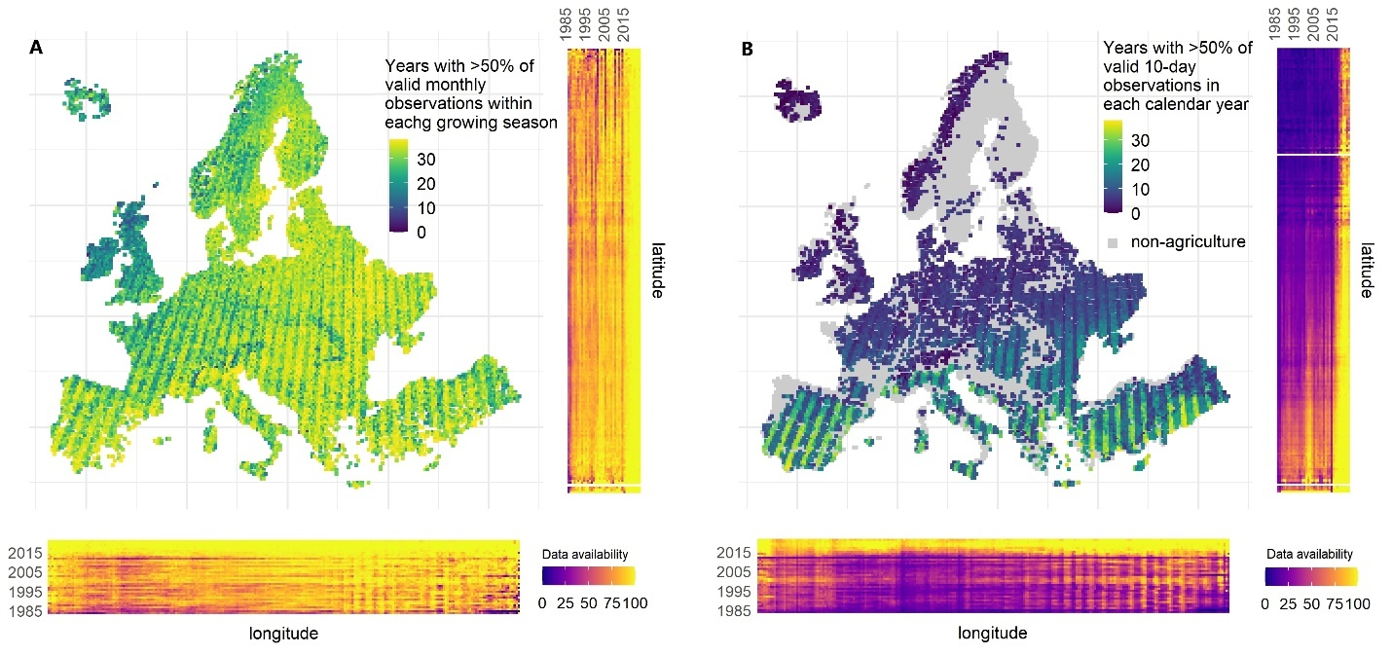
Figure S12 Number of years within the 1984-2021 time series with >50% of (A) growing season monthly composites for all land cover classes and (B) calendar year 10-day composites for agricultural land. Spatio-temporal variability of data availability along latitude and longitude in respective side panels.
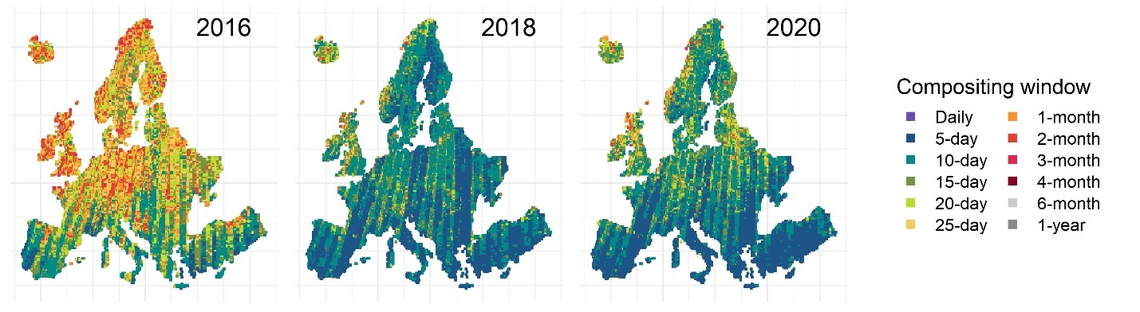
Figure S13 The shortest feasible compositing window assuming interpolation of up to 50% of data each calendar year based on Sentinel-2 data.

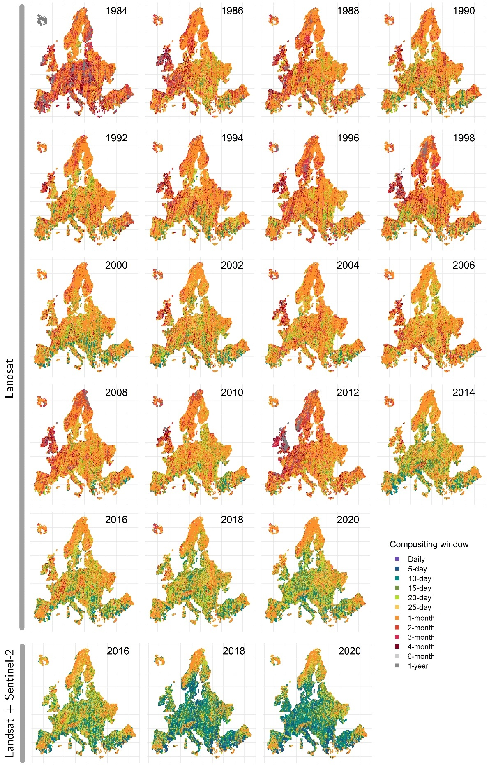
Figure S14 The shortest feasible compositing window assuming interpolation of up to 50% of data each respective growing season. Sentinel-2 in Figure S15.
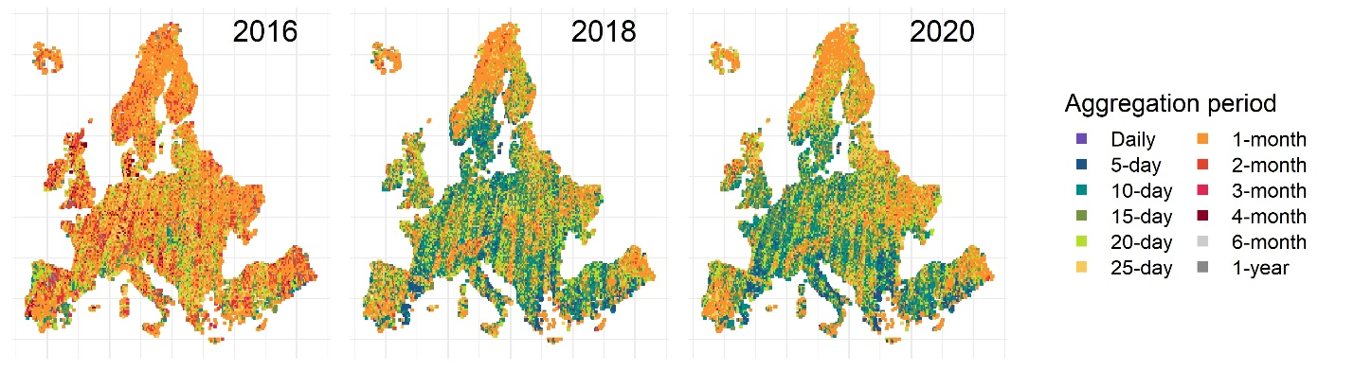
Compositing window
Figure S15 The shortest feasible compositing window assuming interpolation of up to 50% of data each respective growing season based on Sentinel-2.
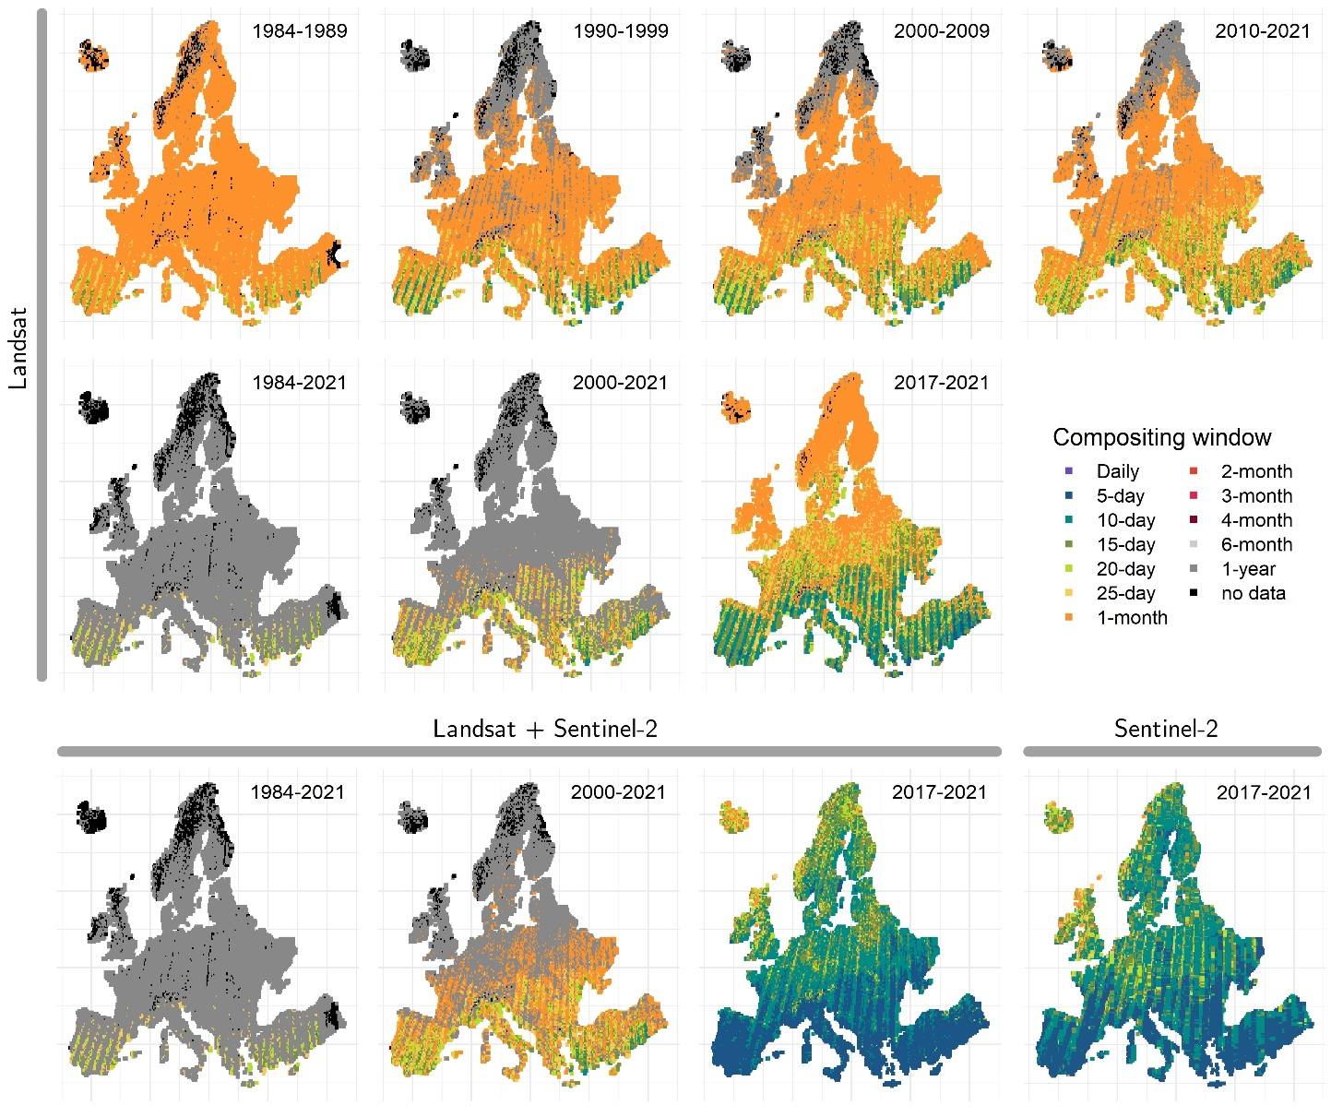
Figure S16 Feasible the shortest aggregation window providing ≥50% temporal data coverage for each calendar year across a selection of medium- and long-term time periods.
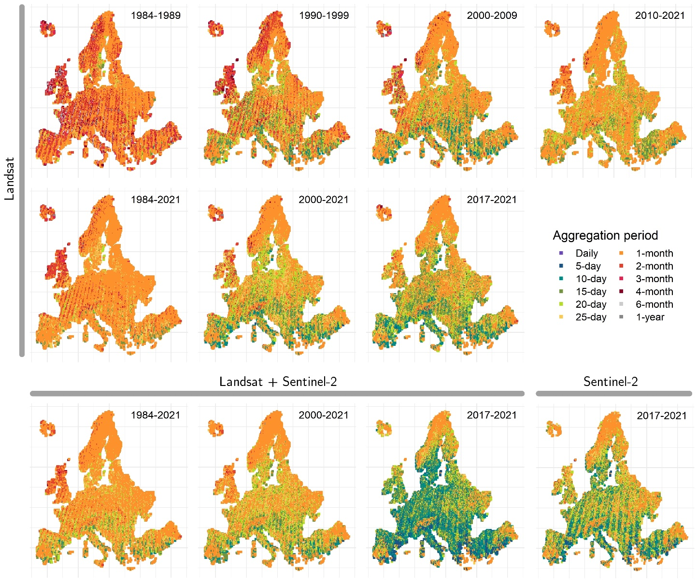
Figure S17 Feasible shortest aggregation window providing ≥50% temporal data coverage for each respective growing season across a selection of medium- and long-term time periods.
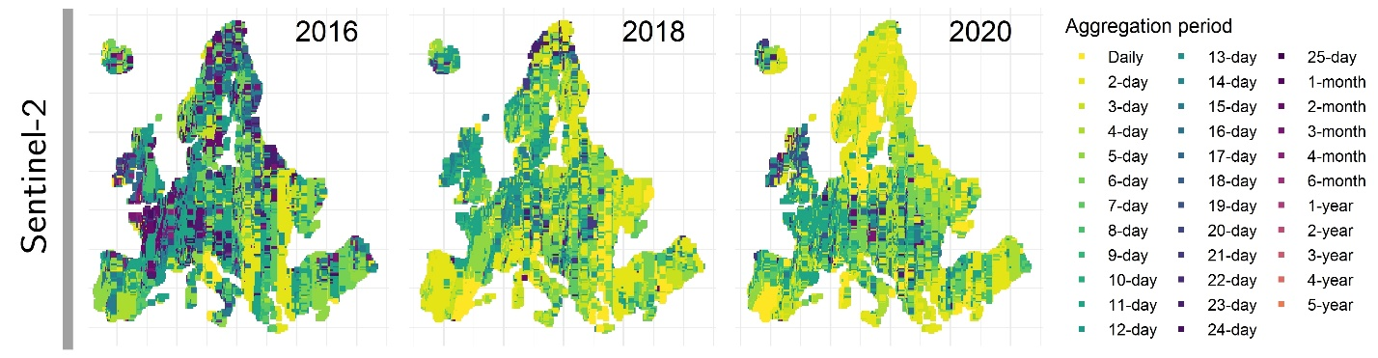
Compositing window
Figure S18 Temporal granularity of Sentinel-2 based composites targeting 15th June.
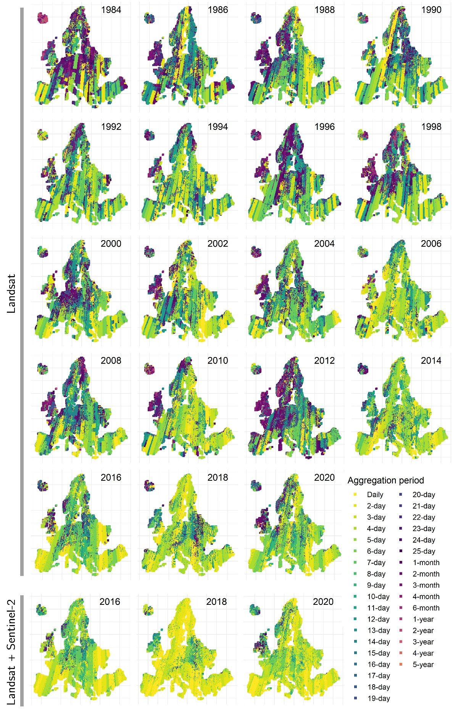
Compositing window
Figure S19 Temporal granularity of composites targeting 15th July. Sentinel-2 results in Figure SA20.
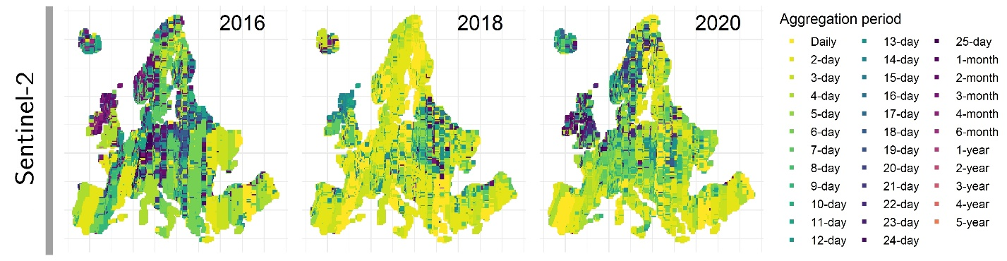
Compositing window
Figure S20 Temporal granularity of Sentinel-2 based composites targeting 15th July.
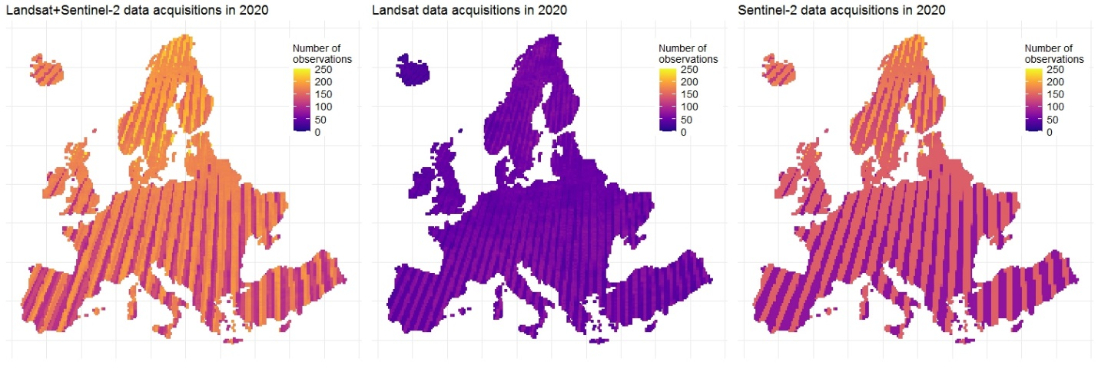
Figure S21 Number of data acquisitions in 2020) for Landsat and Sentinel-2.

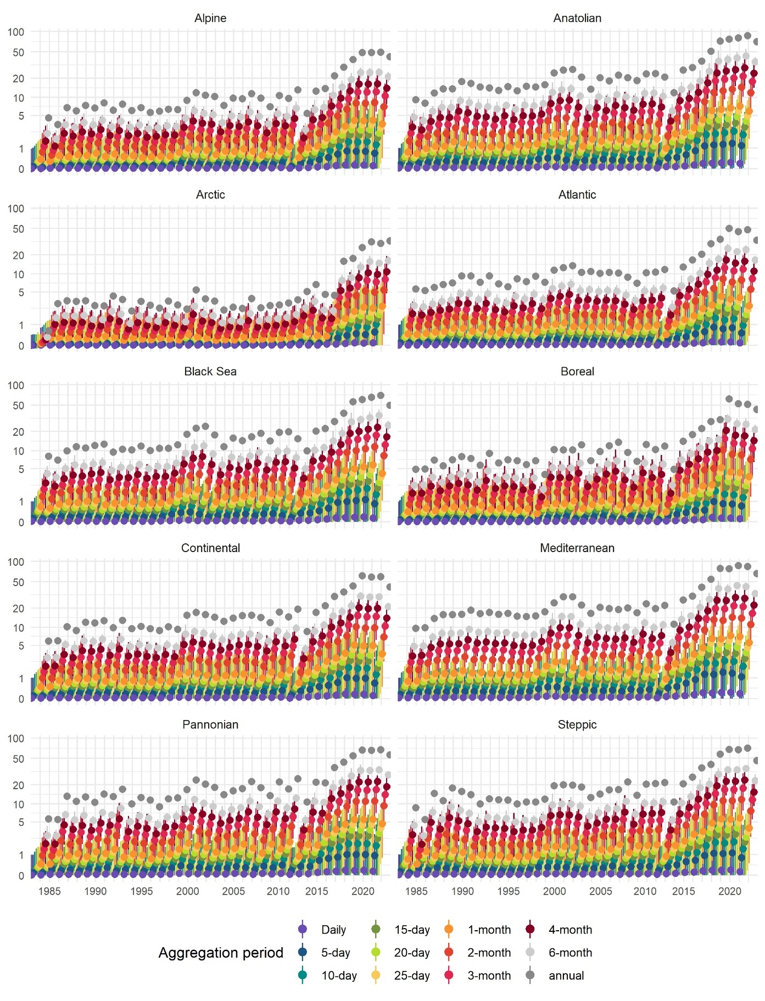
Compositing window
Figure S22 Minimum, mean, and maximum data availability for Landsat and Sentinel-2 data records within biogeographical regions of Europe. Logarithmic scale.
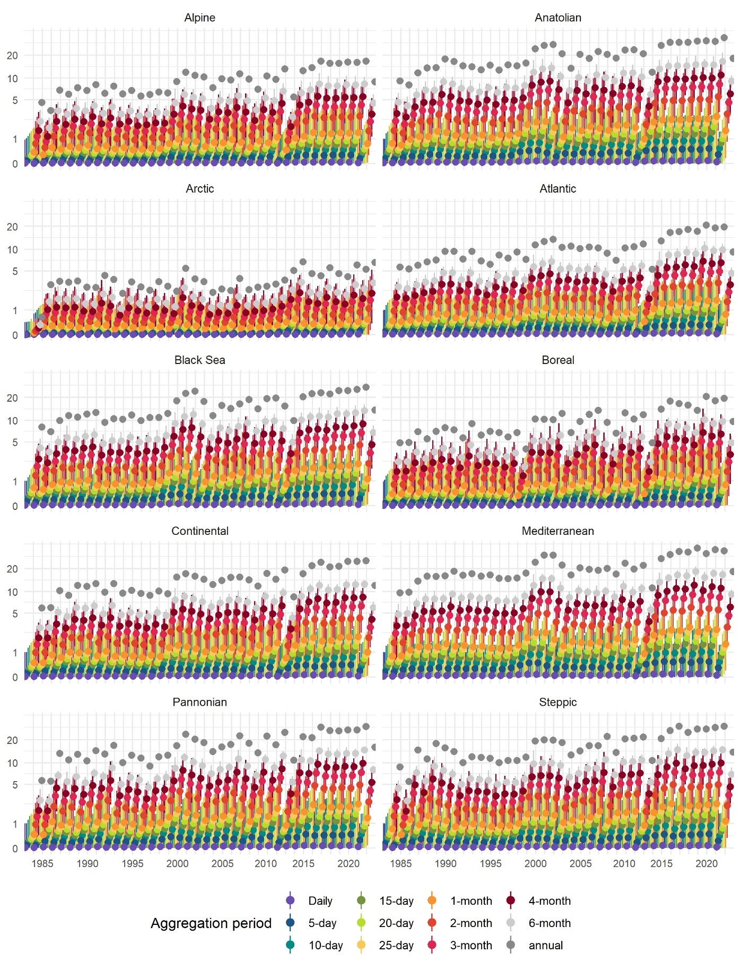
Compositing window
Figure S23 Minimum, mean, and maximum data availability for Landsat data records within biogeographical regions of Europe. Logarithmic scale.
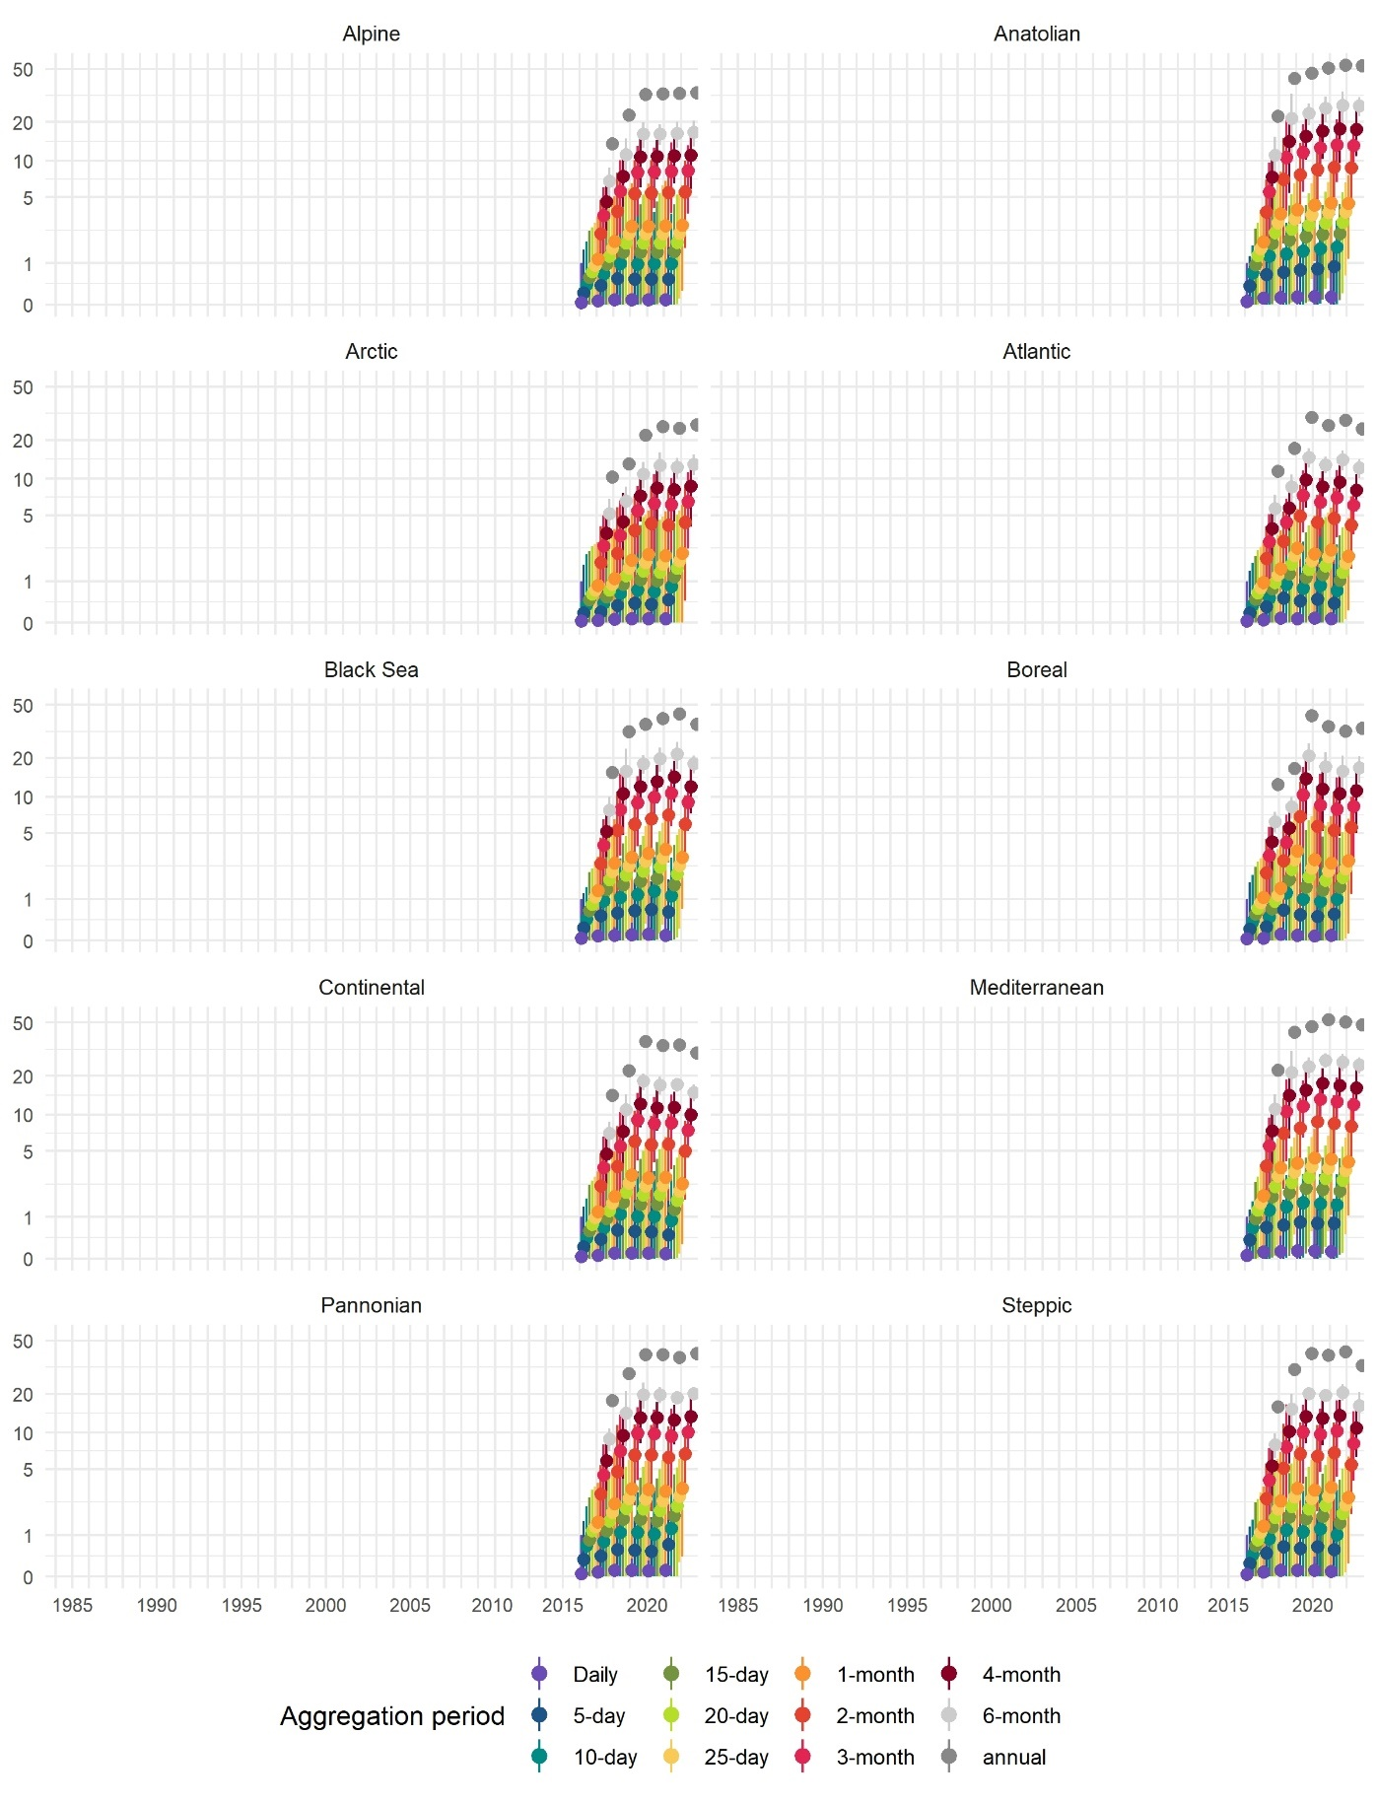
Compositing window
Figure S32 Minimum, mean, and maximum data availability for Sentinel-2 data records within biogeographical regions of Europe. Logarithmic scale.
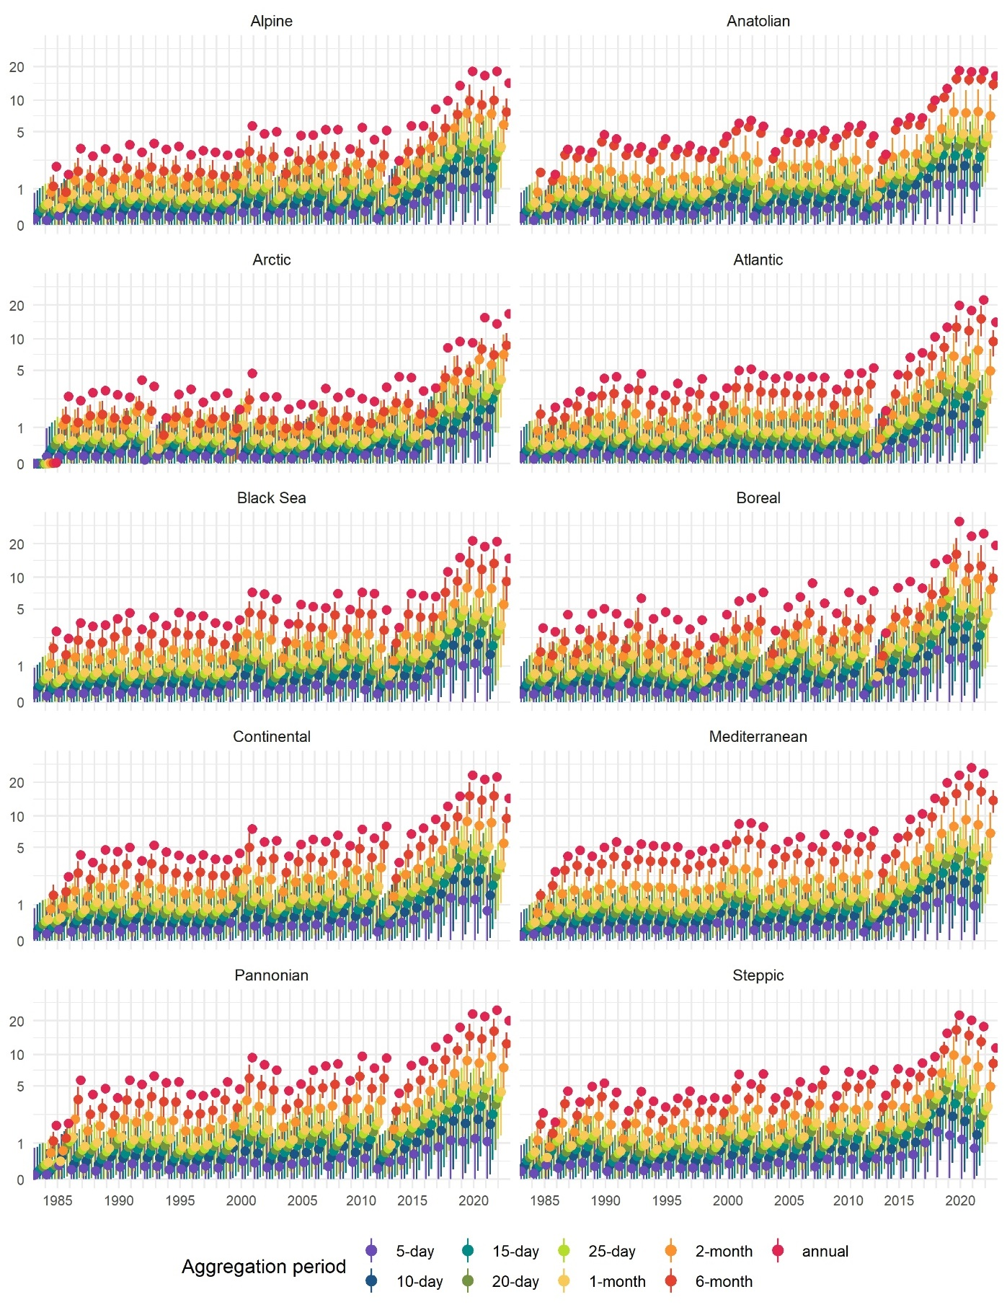
Compositing window
Figure S25 Minimum, mean, and maximum data availability for Landsat and Sentinel-2 data records during a growing season within biogeographical regions of Europe. Logarithmic scale.
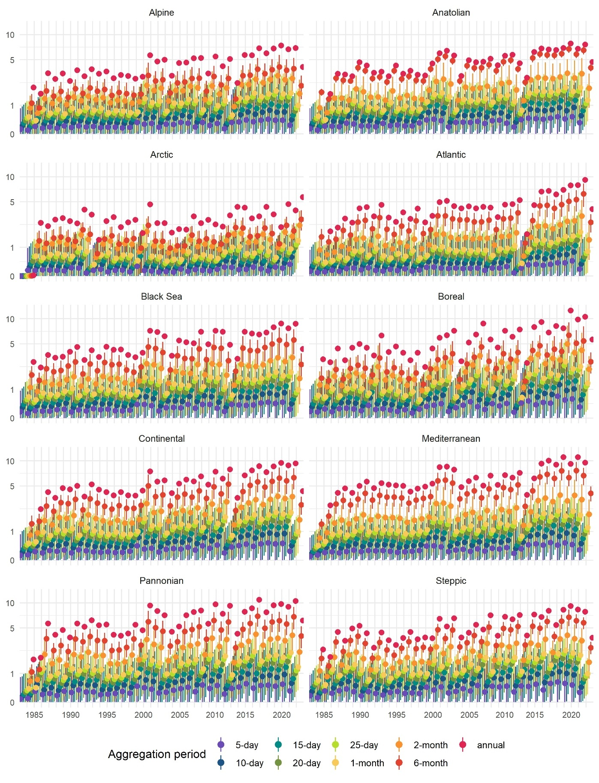
Compositing window
Figure S26 Minimum, mean, and maximum data availability for Landsat data records during a growing season within biogeographical regions of Europe. Logarithmic scale.
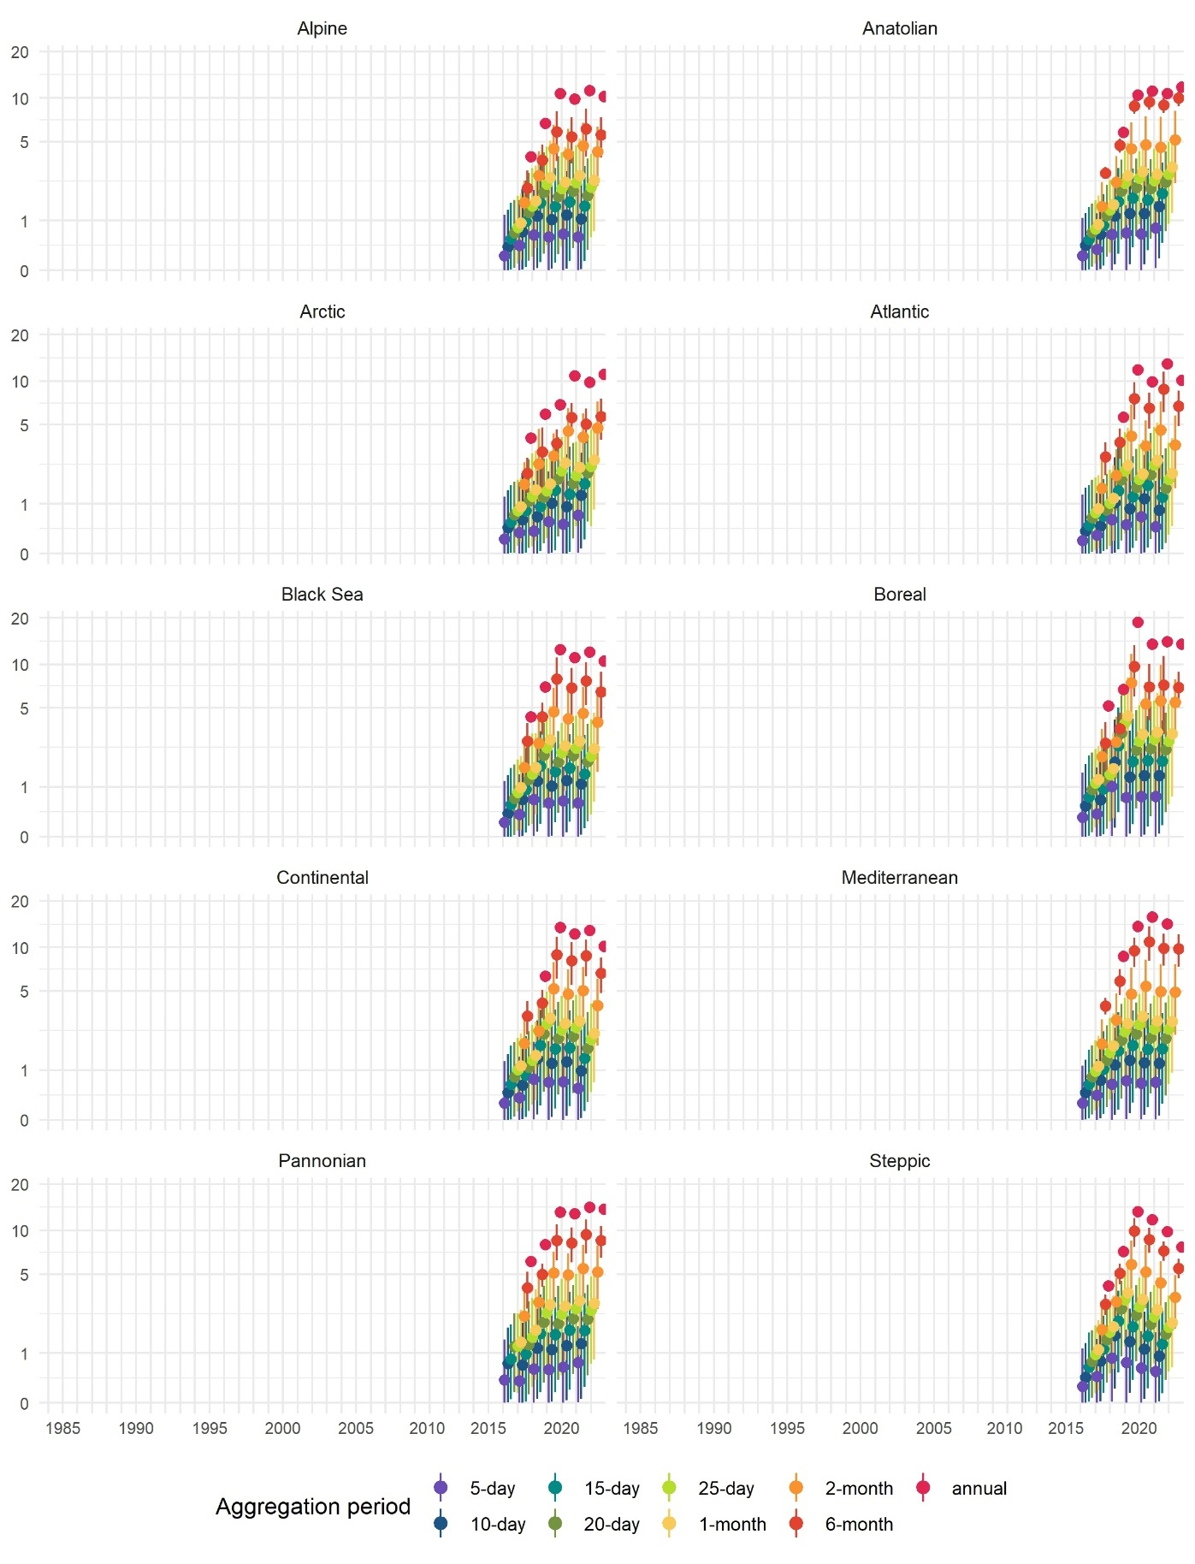
Compositing window
Figure S27 Minimum, mean, and maximum data availability for Sentinel-2 data records during a growing season within biogeographical regions of Europe. Logarithmic scale.

