Effect of Carrier-Gas on the Sensitivity of Co_{1-2x}Ni_{x}Mn_{x}Fe_{2-y}Ce_{y}O₄ Double-Substitution Spinel to Flammable Gases and Volatile Organic Compounds

Sunday A. Ogundipeª, Ceboliyazakha L. Ndlangamandlaª, Gumani E. Mphaphuli^{d}, David E. Motaung^{c}, Hendrik C. Swart^{c}, Steven S. Nkosi^{e}

ªDepartment of Physics, University of Zululand, Private Bag X1001, KwaDlangezwa ZA3886, South Africa
^{b}Department of Chemistry, University of Zululand, Private Bag X1001, KwaDlangezwa ZA3886, South Africa
^{c}Department of Physics, University of the Free State, Box 339, Bloemfontein, ZA9300, South Africa
^{d}National Metrology Institute of South Africa (NMISA), CSIR Campus, Building 5, Meiring Naude Road, Brummeria, Pretoria, ZA0182, South Africa
^{e}Department of Physics, University of Limpopo, Private Bag X1106, Sovenga, ZA0727, South Africa

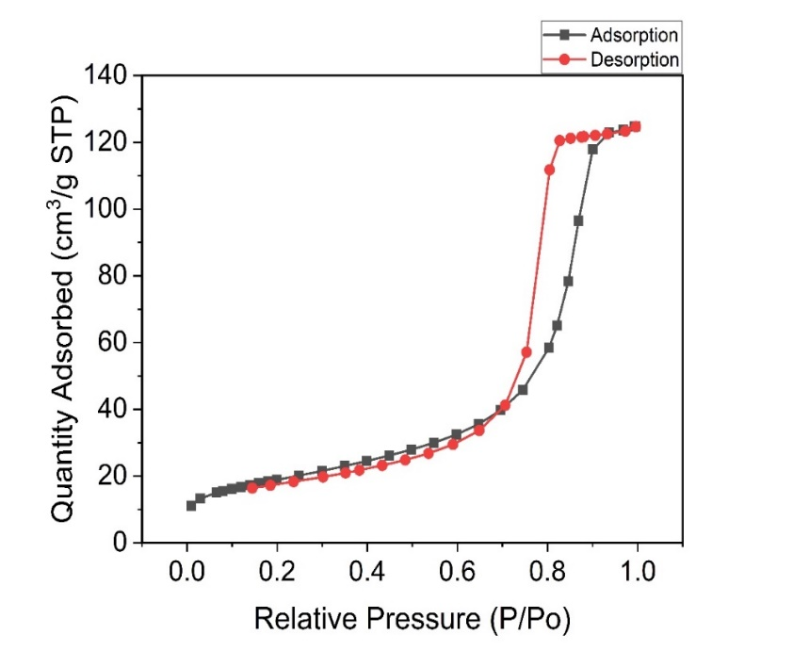
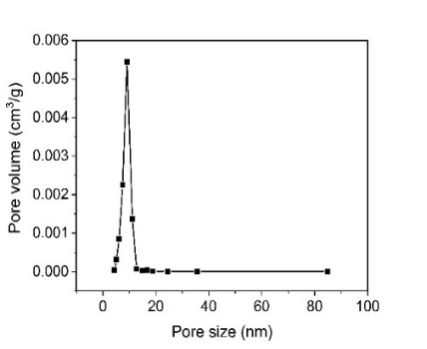
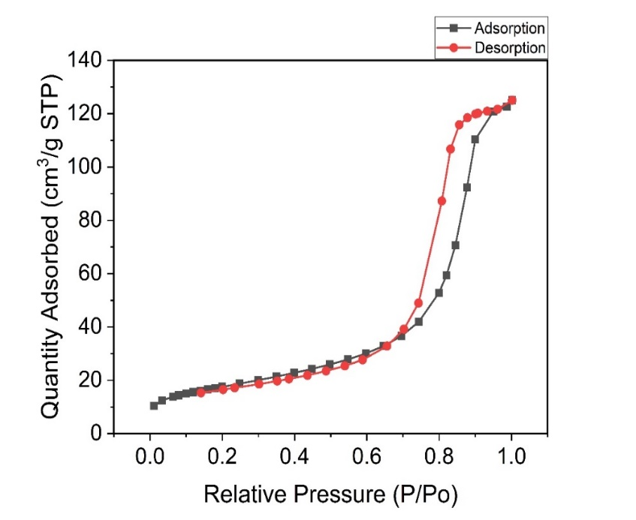
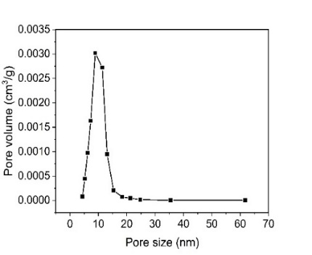
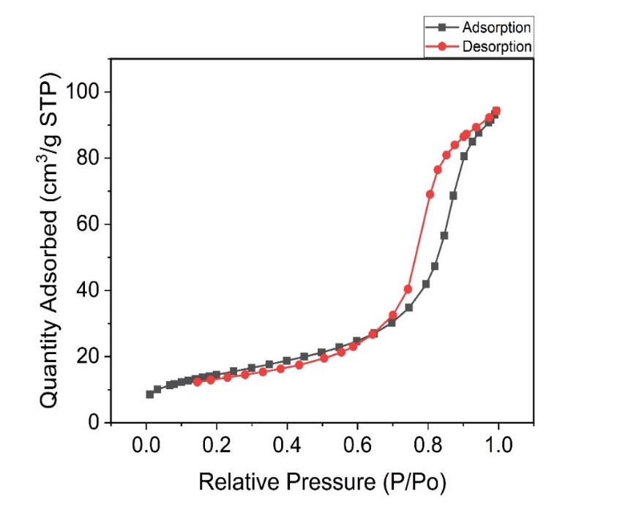
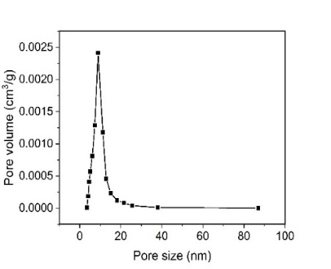
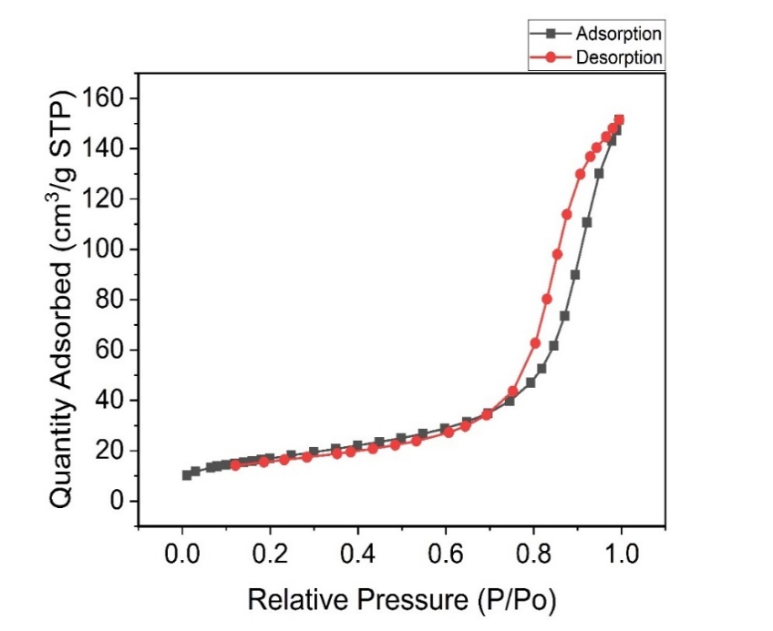
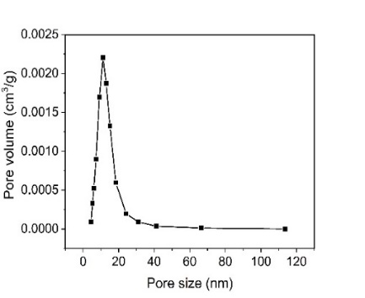
(a)
(b)
(c)
(d)

Figure S1. Nitrogen adsorption-desorption isotherms of Co_{1-2x}Ni_{x}Mn_{x}Fe_{2-y}Ce_{y}O₄ samples with (a) x = y = 0: dried with infrared lamp, (b) x = y = 0: dried naturally, (c) x = y = 0.2 and (d) x = y = 0.3. Insets: The corresponding pore size distribution.

200 nm
(a)
(b)
200 nm
200 nm
(c)
200 nm
(d)
200 nm

Figure S2. SEM images of the Co_{1-2x}Ni_{x}Mn_{x}Fe_{2-y}Ce_{y}O₄ samples with (a) x = y = 0: dried with infrared lamp, (b) x = y = 0: dried naturally, (c) x = y = 0.2 and (d) x = y = 0.3.

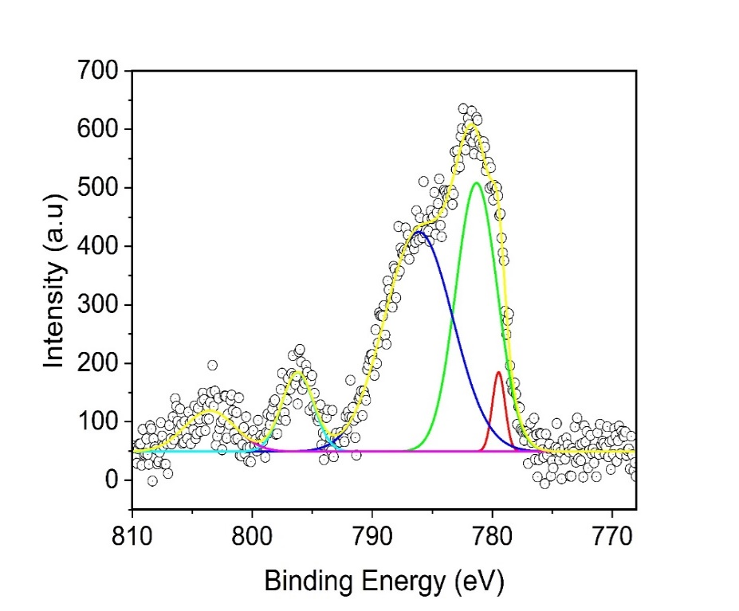
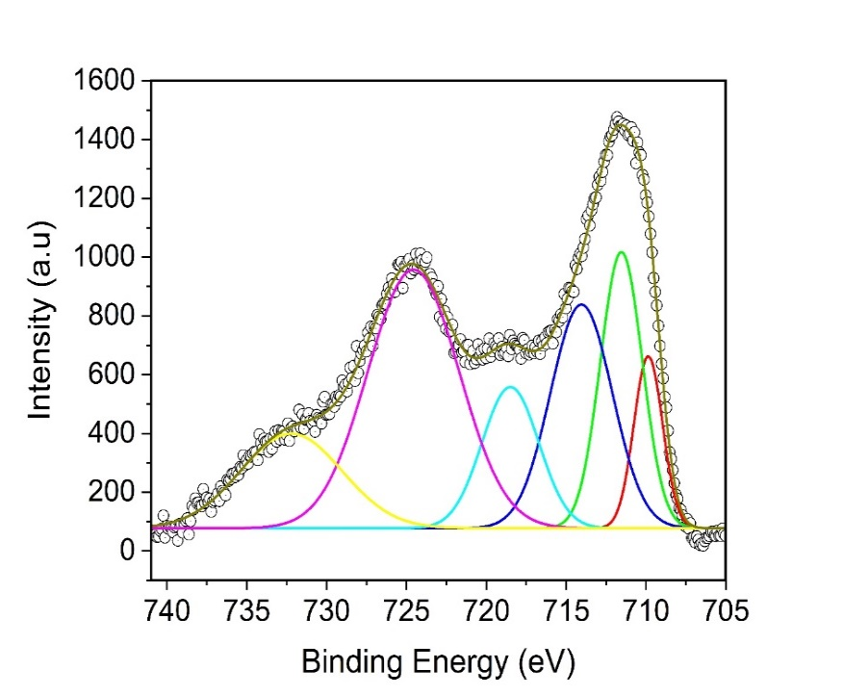
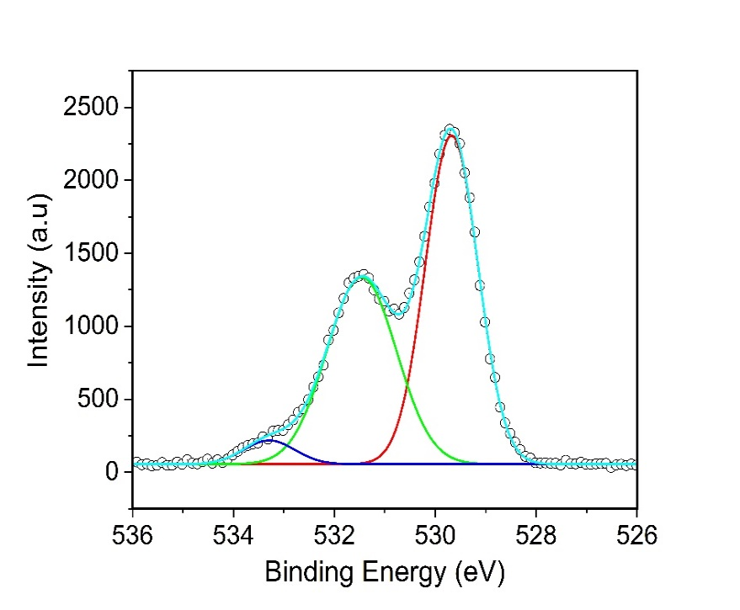
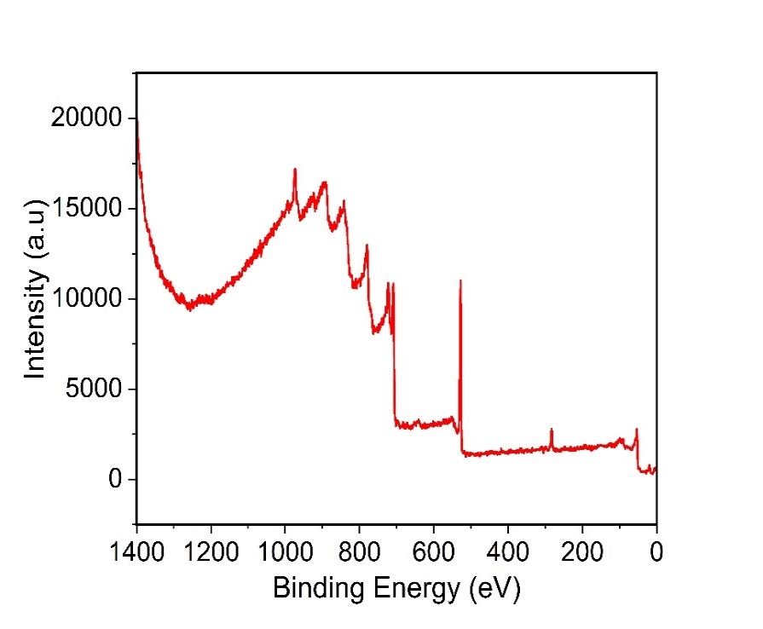
Co 2p scan
Fe 2p scan

B-site Co²⁺
A-site Co²⁺
Co 2p_{1/2}
satellite

Co 2p_{1/2}
Co 2p_{3/2}
B-site Fe³⁺
A-site Fe³⁺
B-site Fe³⁺
satellite
A-site Fe³⁺
satellite
Fe 2p_{3/2}
Fe 2p_{1/2}
Fe 2p_{1/2} satellite
O1s scan
529.68 eV
531.46 eV
533.24 eV
B-site Co²⁺
satellite
(b)
(c)
Fe3p
Co3s
C1s
O1s
Co2p
Fe2p
Co2s
Co LMM
O KLL
(a)
Survey scan
(d)

Figure S3. (a) Survey spectrum, before sputtering, of CoFe₂O₄ samples. XPS spectra of Co_{1-2x}Ni_{x}Mn_{x}Fe_{2-y}Ce_{y}O₄ sample for which x = y = 0 (lamp-dried): (b) Co 2p scan, (c) Fe 2p scan, and (d) O 1s scan.

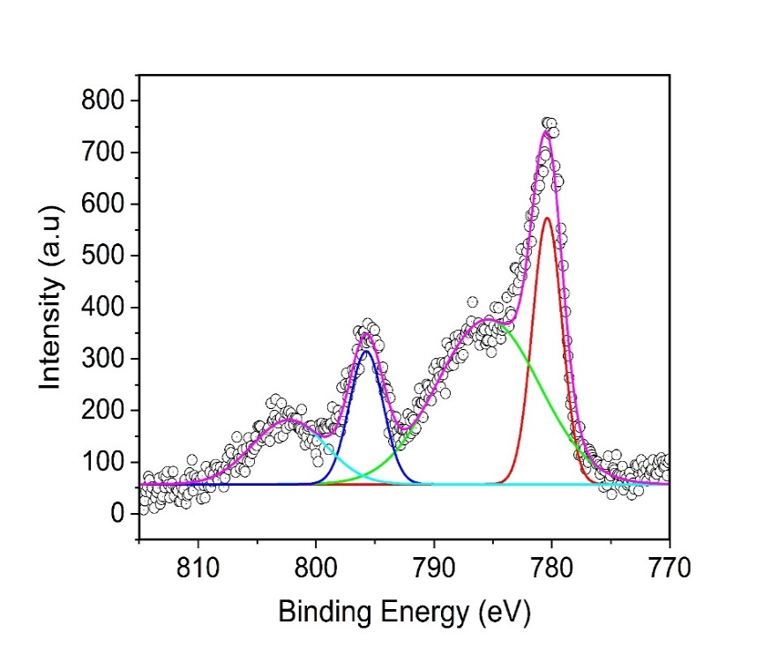
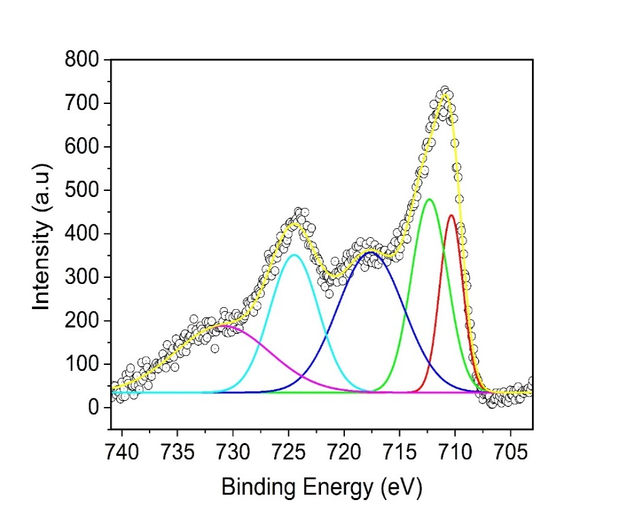
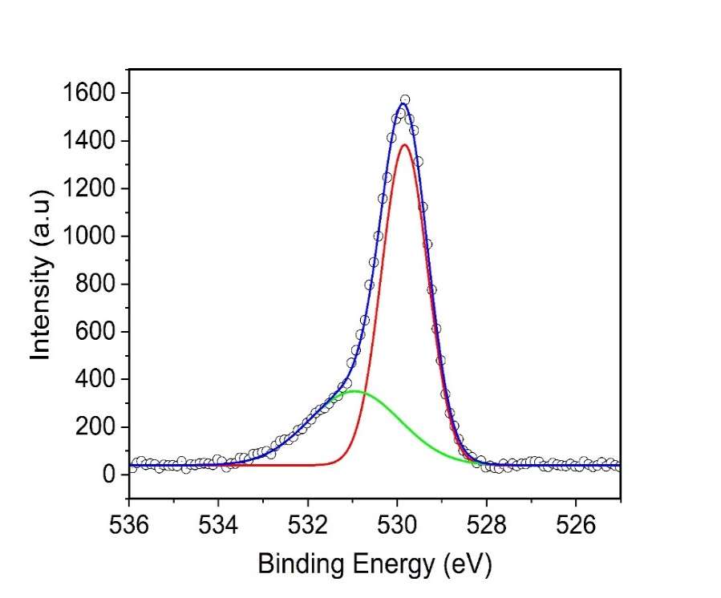
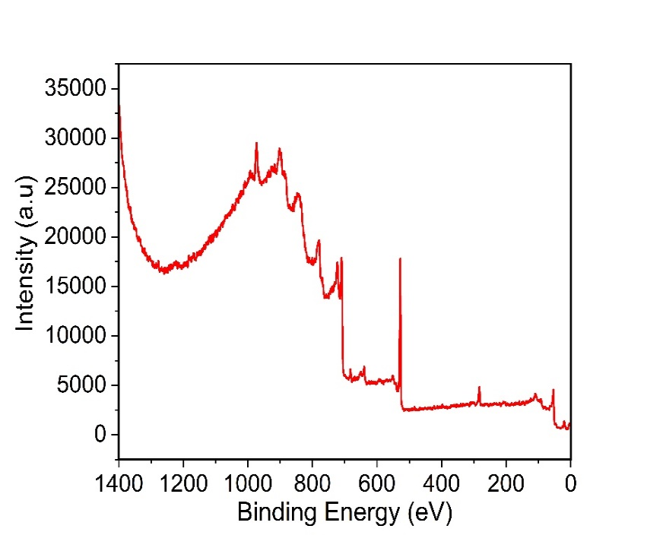
Co 2p scan
Fe 2p scan
O 1s scan
529.84 eV
530.93 eV
B-site Fe³⁺
A-site Fe³⁺
A-site Fe³⁺
satellite
Fe 2p_{1/2}
Fe 2p_{1/2} satellite
Fe 2p_{3/2}
Co 2p_{1/2}
satellite

Co 2p_{1/2}
B-site Co²⁺
Co 2p_{3/2}
B-site Co²⁺
satellite
(b)
(c)
(d)
Survey scan
(a)
Fe3p
Co3s
C1s
O1s
Mn2p
Fe2p
Co2p
Ni2p
Ce3d
Co2s
Ni2s

Figure S4. (a) Survey spectrum, before sputtering, of Co_{1-2x}Ni_{x}Mn_{x}Fe_{2-y}Ce_{y}O₄ samples. XPS spectra of Co_{1-2x}Ni_{x}Mn_{x}Fe_{2-y}Ce_{y}O₄ sample for which x = y = 0 (natural-dried): (b) Co 2p scan, (c) Fe 2p scan, and (d) O 1s scan.

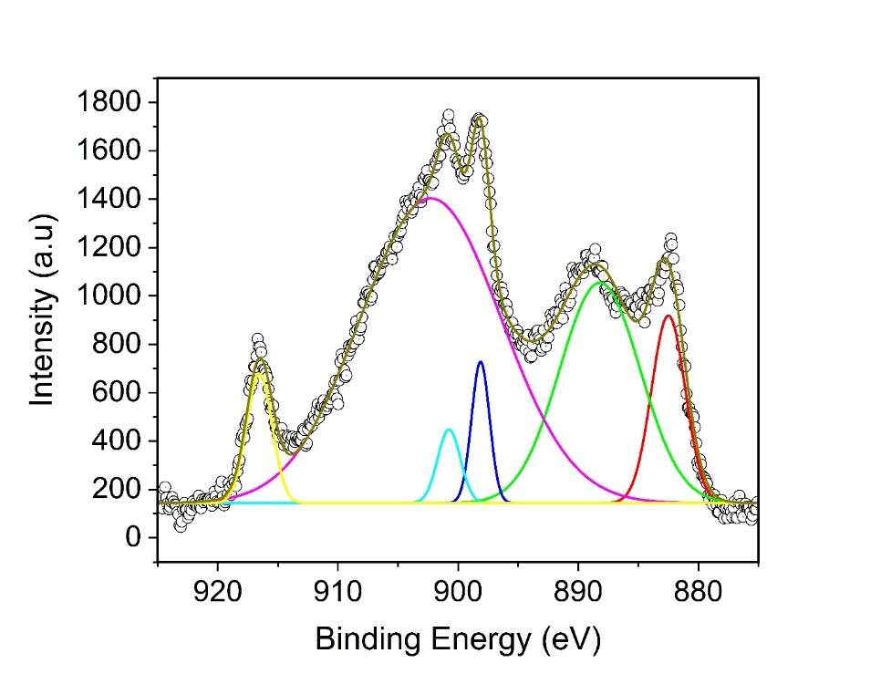
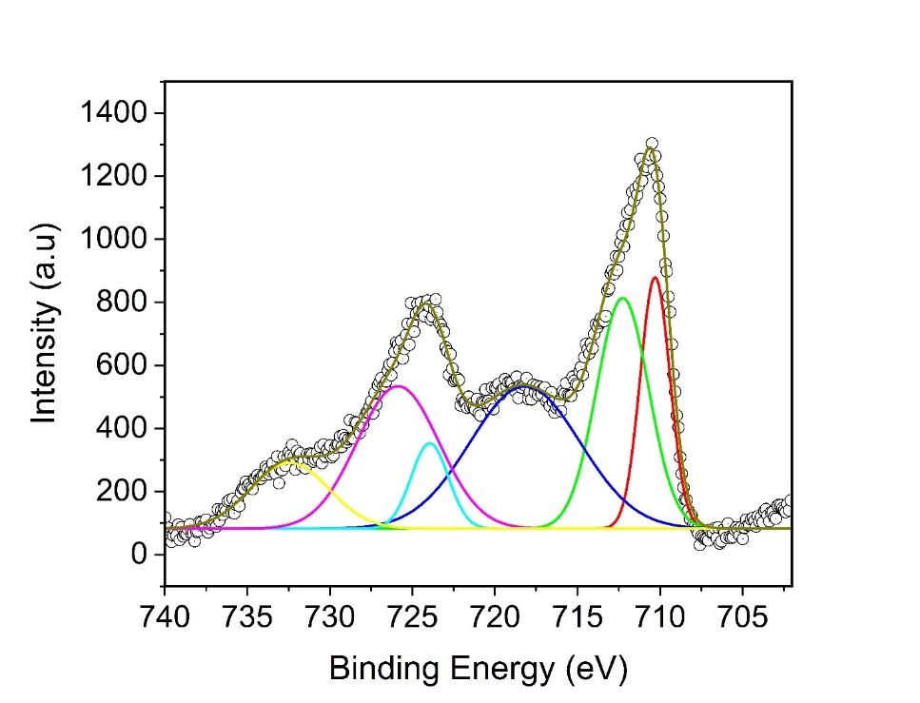
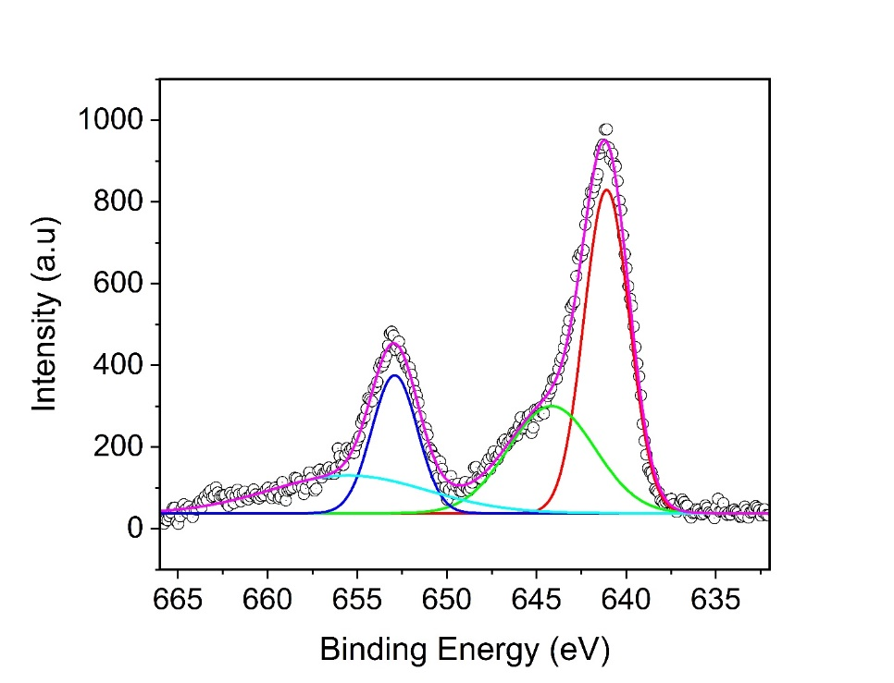
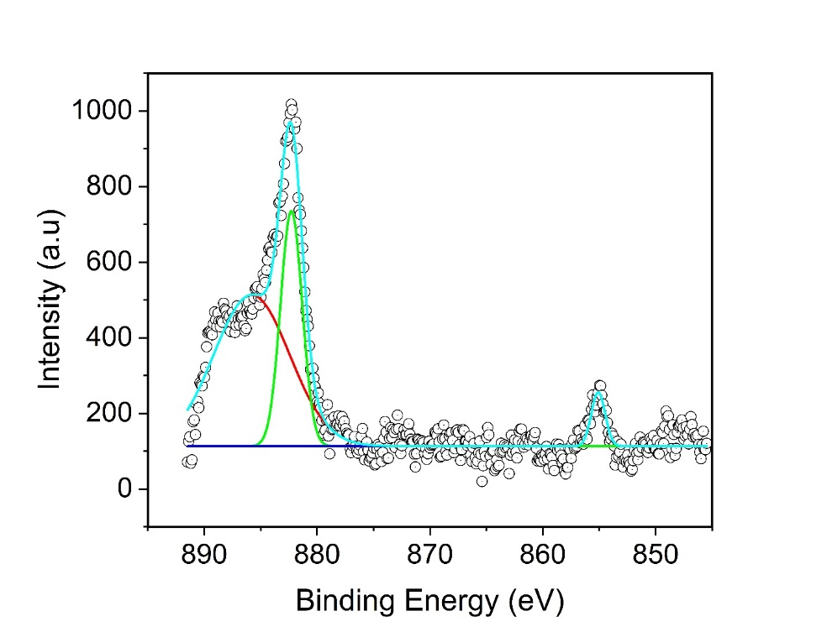
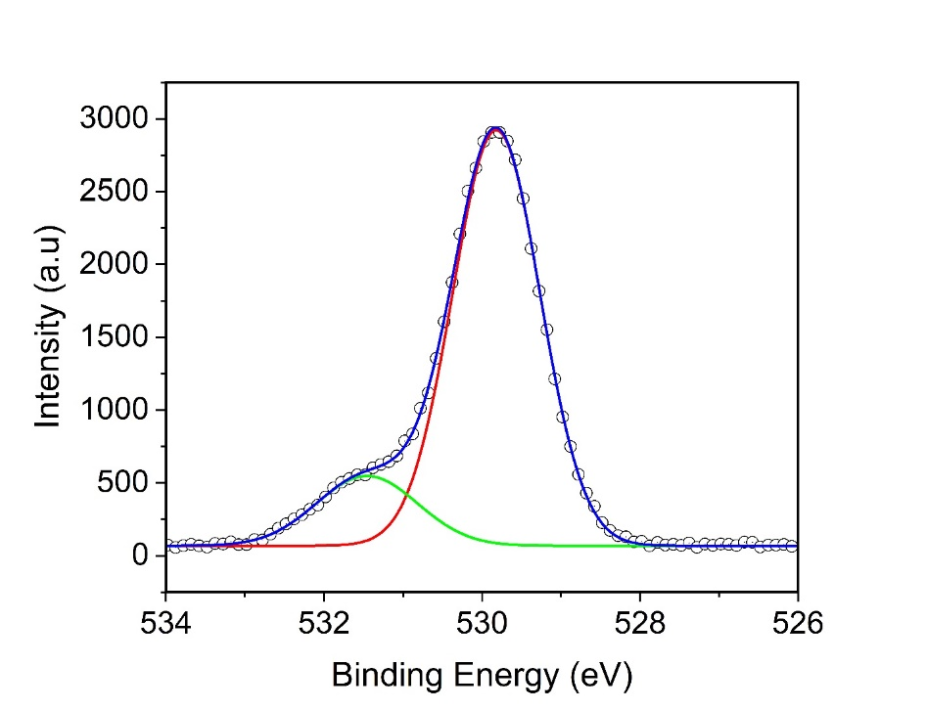
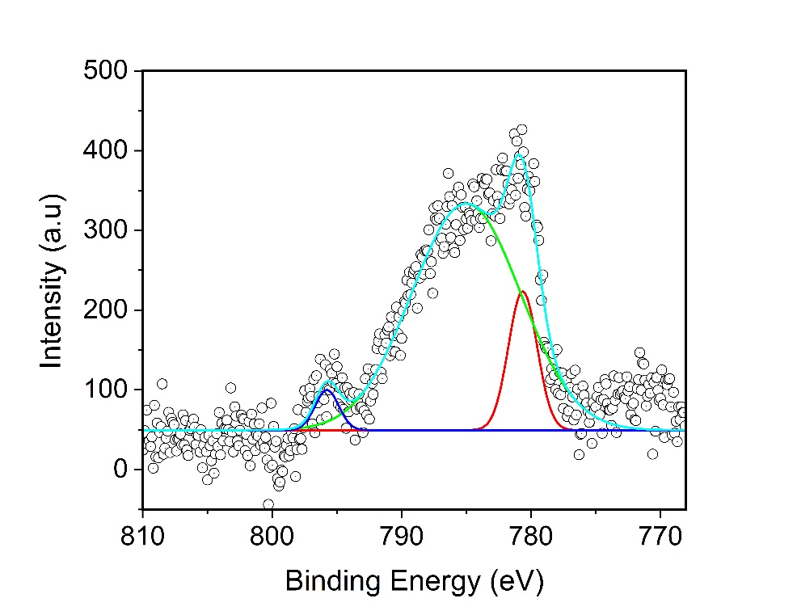
Ce 3d scan
Fe 2p scan
Mn 2p scan
Ni 2p scan
O 1s scan
529.81 eV
531.39 eV
Co 2p scan
B-site Co²⁺
B-site Co²⁺
satellite
Co 2p_{1/2}
Co 2p_{3/2}
Ni 2p_{1/2}
Ni 2p_{3/2}
B-site Fe³⁺
A-site
Fe³⁺
A-site Fe³⁺
satellite
B-site Fe³⁺
A-site
Fe ³⁺
Fe 2p_{1/2} satellites
Fe 2p_{3/2}
Fe 2p_{1/2}
Mn 2p_{1/2}
Mn 2p_{1/2} satellite
Mn 2p_{3/2} satellite
Mn 2p_{3/2}
v
vʹ
vʹʹ
vʹʹʹ

u
vʹʹʹʹ
(a)
(b)
(c)
(d)
(e)
(f)

Figure S5: XPS spectra of Co_{1-2x}Ni_{x}Mn_{x}Fe_{2-y}Ce_{y}O₄ sample for which x = y = 0.2: (a) Co 2p scan, (b) Ni 2p scan, (c) Mn 2p scan (d) Ce 3d scan, (e) Fe 2p scan, and (f) O 1s scan.

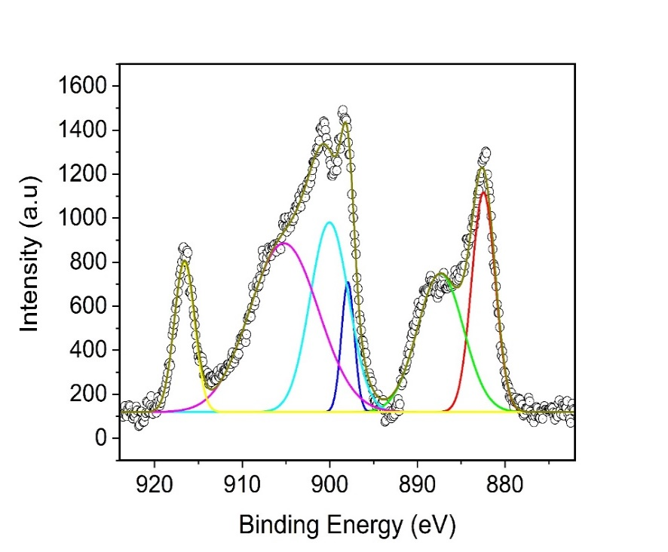
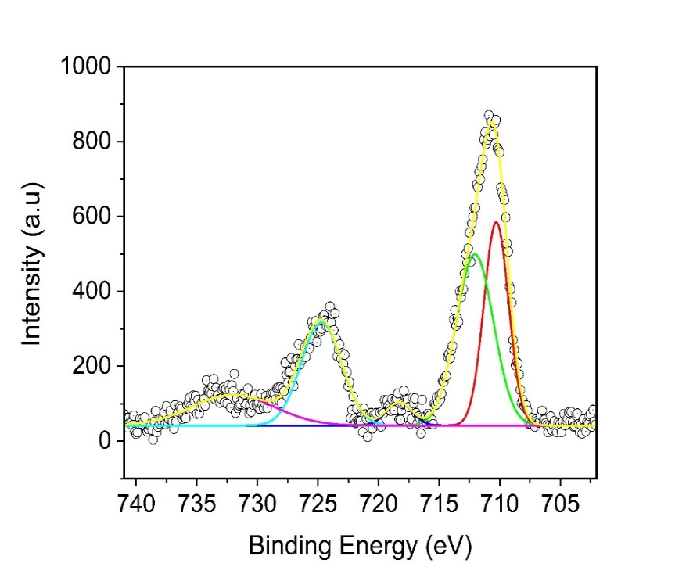
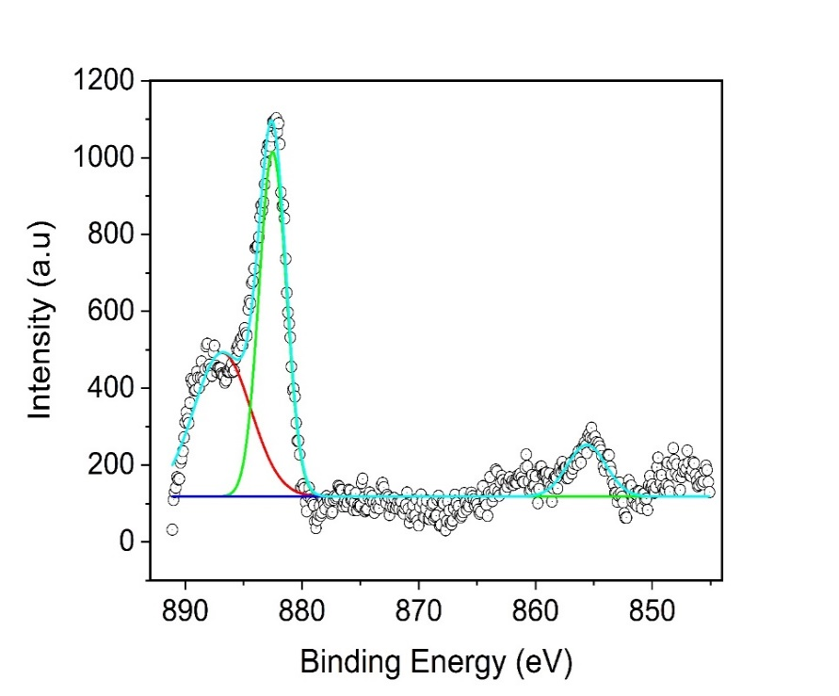
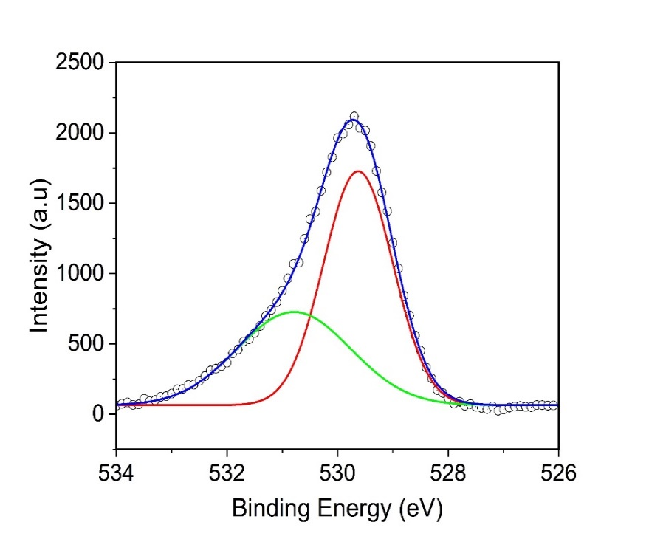
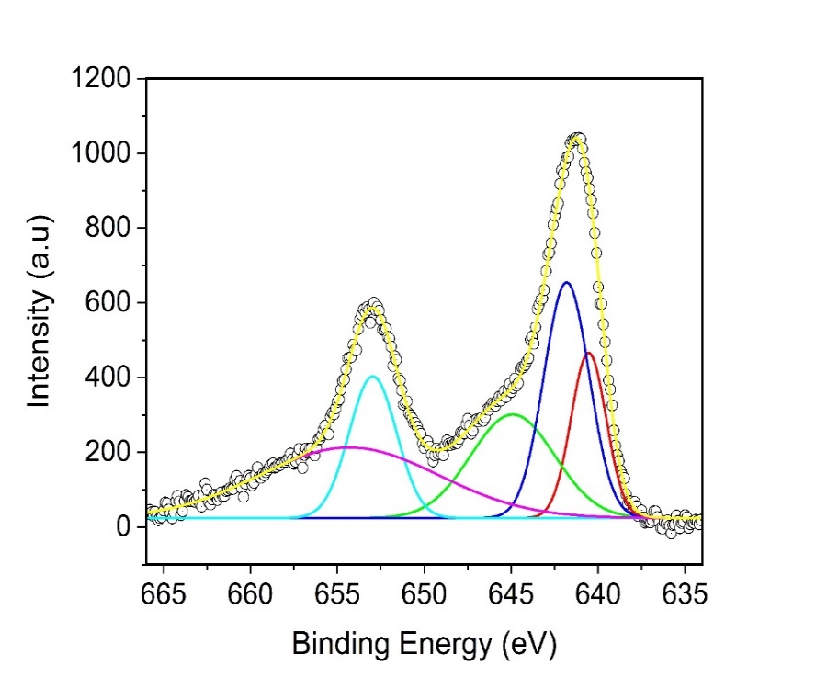
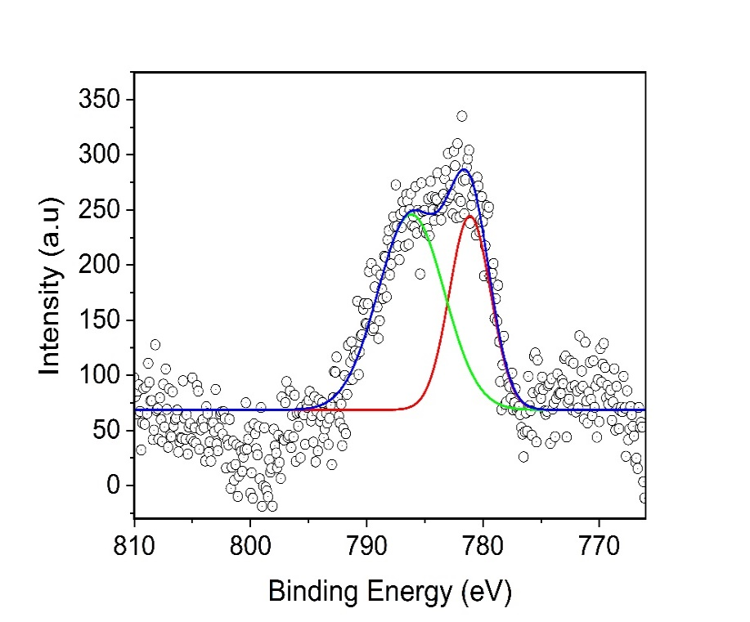
Ce 3d scan
Fe 2p scan
Ni 2p scan
O 1s scan
Mn 2p scan
529.62 eV
530.77 eV
Co 2p scan
Co 2p_{3/2}
B-site Co²⁺
B-site Co²⁺
satellite
Ni 2p_{3/2}
Ni 2p_{1/2}
B-site Fe³⁺
A-site
Fe³⁺
A-site Fe³⁺
satellite
Fe 2p_{1/2}
Fe 2p_{1/2} satellite
Fe 2p_{3/2}
Mn²⁺
Mn³⁺
Mn 2p_{3/2}
Mn 2p_{3/2} satellite
Mn 2p_{1/2}
Mn 2p_{1/2} satellite
v
vʹ
vʹʹ
vʹʹʹ vʹʹʹʹ

u
vʹʹʹʹ
ʹ
(a)
(b)
(c)
(d)
(e)
(f)

Figure S6. XPS spectra of Co_{1-2x}Ni_{x}Mn_{x}Fe_{2-y}Ce_{y}O₄ sample for which x = y = 0.3: (a) Co 2p scan, (b) Ni 2p scan, (c) Mn 2p scan (d) Ce 3d scan, (e) Fe 2p scan, and (f) O 1s scan

Table S1: Fitting peaks in Figures S5(d) and S6(d) and the responsible cations
Peak | cation
V | Ce⁴⁺
V’ | Ce⁴⁺
V’’ | Ce⁴⁺
V’’’ | Ce⁴⁺
V’’’’ | Ce⁴⁺
U | Ce3⁺

Corresponding author. Department of Physics, University of Limpopo, Private Bag X1106, Sovenga, ZA0727, South Africa. E-mail address: steven.solethu.nkosi@gmail.com (S.S. Nkosi)

