Full Title: A comprehensive genetic study of Microtubule-associated genes clusters for male infertility in a Taiwanese cohort
Short Title: Microtubule-associated genes clusters for male infertility
Chying-Chyuan Chan^{1,2}, Te-Hsin Yen², Hao-Chen Tseng³, Brang Mai³, Pin Kuan Ho⁴, Jian-Liang Chou^{1,5}, Gwo-Jang Wu^{1,6*} and Yu Chuan Huang^{1,3,5*}
SUPPLEMENTARY TABLES
Table S1 The primers of SNPs on ESR1, CFTR, SPATA16, STPG2, KIF6 and SIMC1 were used to validate the targeted NGS and WES (upper table). The PCR reaction protocol is shown in the lower table and generally run for 34 cycles.
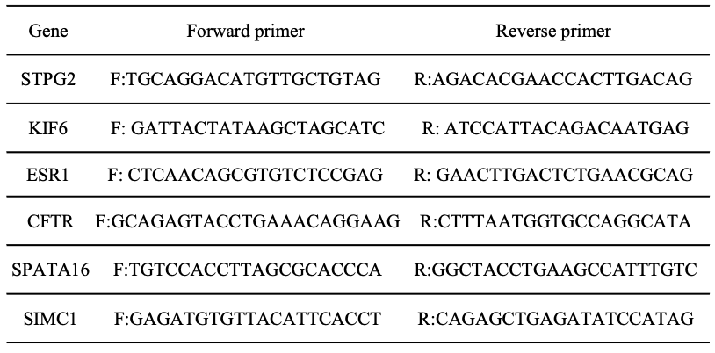
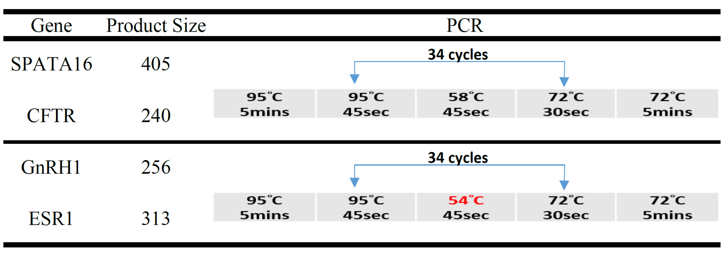
Table S2 Screening of Y chromosome microdeletion was used for testing samples for the presence of AZF-STS based on polymerase chain reaction. The map contains STSs in different AZF (Promega).
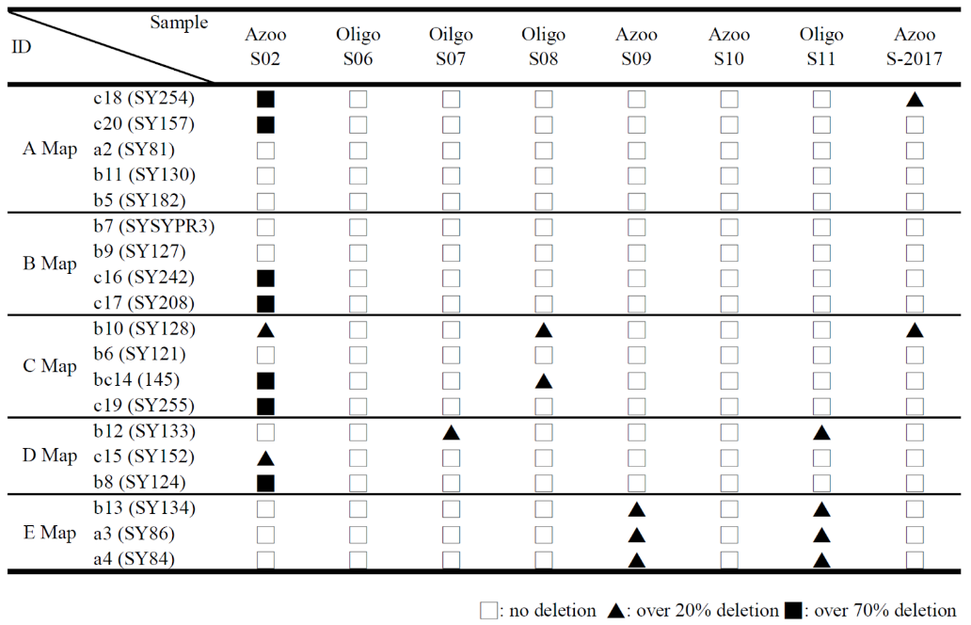

Table S3. Variants identified and in silico evaluation of pathogenicity of nucleotide changes in exons of CFTR and SPATA16 was performed using CADD, SIFT, Polyphen. MAF were checked in the GenomAD and Taiwan Biobank
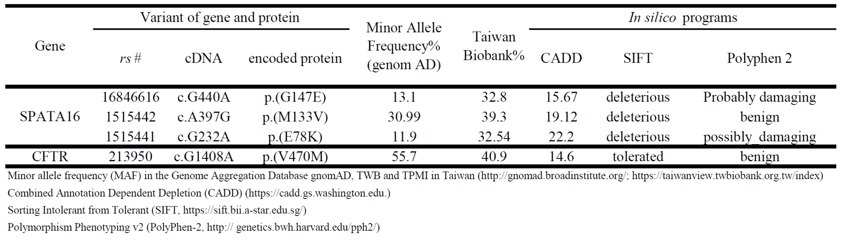

Table S4. Variants identified and in silico evaluation of pathogenicity of nucleotide changes in exons of 15 candidate SNPs were performed using CADD, SIFT, Polyphen. MAF and MAF_eas were checked in the CLC module. The mutation frequencies in cases are compared to those in controls and are also provided in the list.
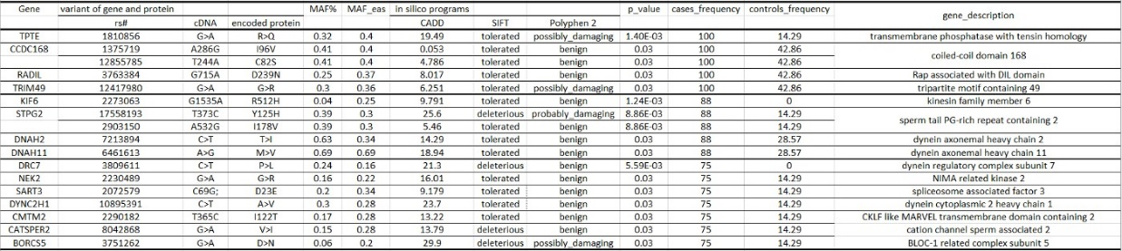

SUPPLEMENTARY FIGURES
Figure S1 AZF-STS based multiplex polymerase chain reaction (PCR) is routinely used to detect YCMD by tracing sequence-tagged sites (STSs) marks in the AZF (azoospermia factor region) at the long arm of Y chromosome (Yp) (Promega).

Figure S2A The designed amplicons (green) covered the Refseq (blue) of FSHB, AURKC, LHB, and PICK1 regions of a 15-gene targeted NGS panel.

Figure S2B The designed amplicons (green) covered the Refseq (blue) of DAZL, ESR1, GNRH1, NR5A1, and KAL2(FGFH1) regions of a 15-gene targeted NGS panel.

Figure S2C The designed amplicons (green) covered the Refseq (blue) of AR, TEX11, USP26 and KAL1(ANOS1) regions of a 15-gene targeted NGS panel.

Figure S3 Screening of Y chromosome microdeletion (Promega) was used for testing samples for the presence of AZF-STS based on polymerase chain reaction. (red-labeled ones are represented azoospermia; black-labeled ones are represented oligozoospermia.

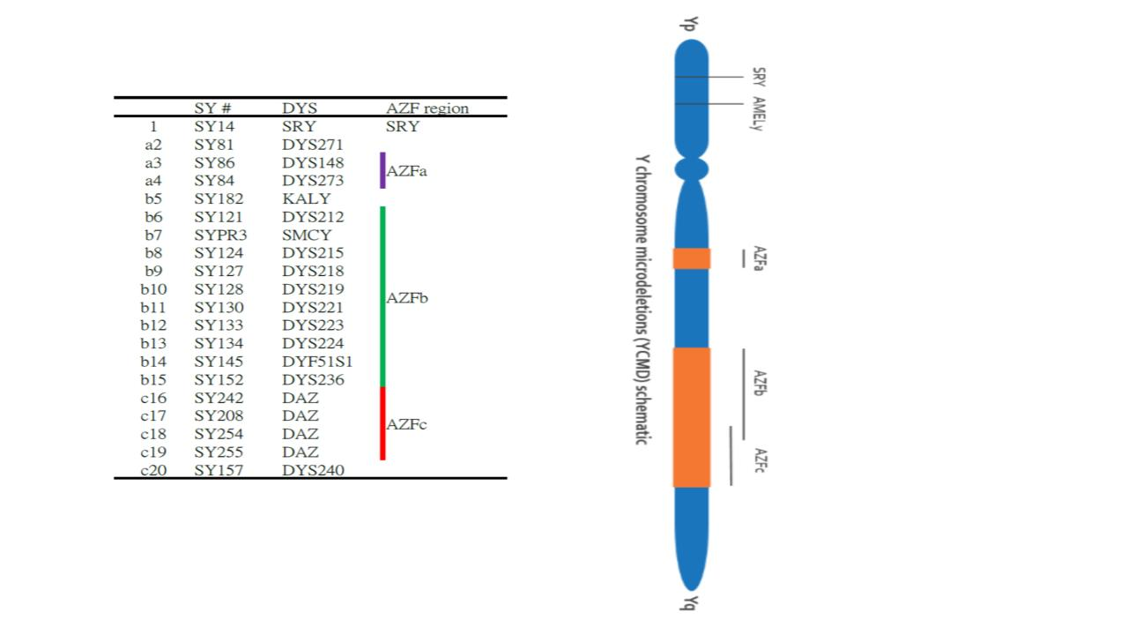
Figure S1
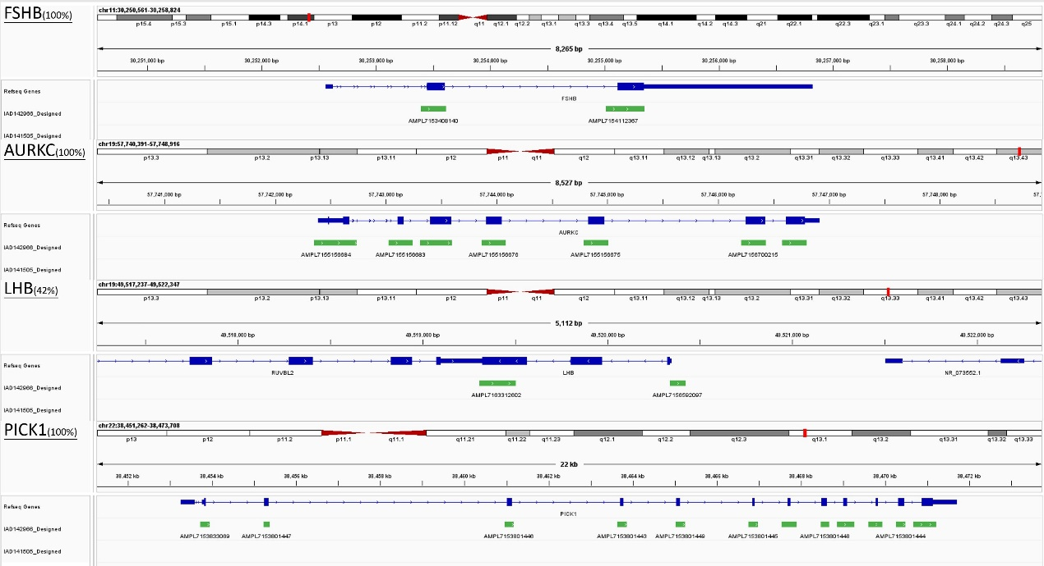
Figure S2A
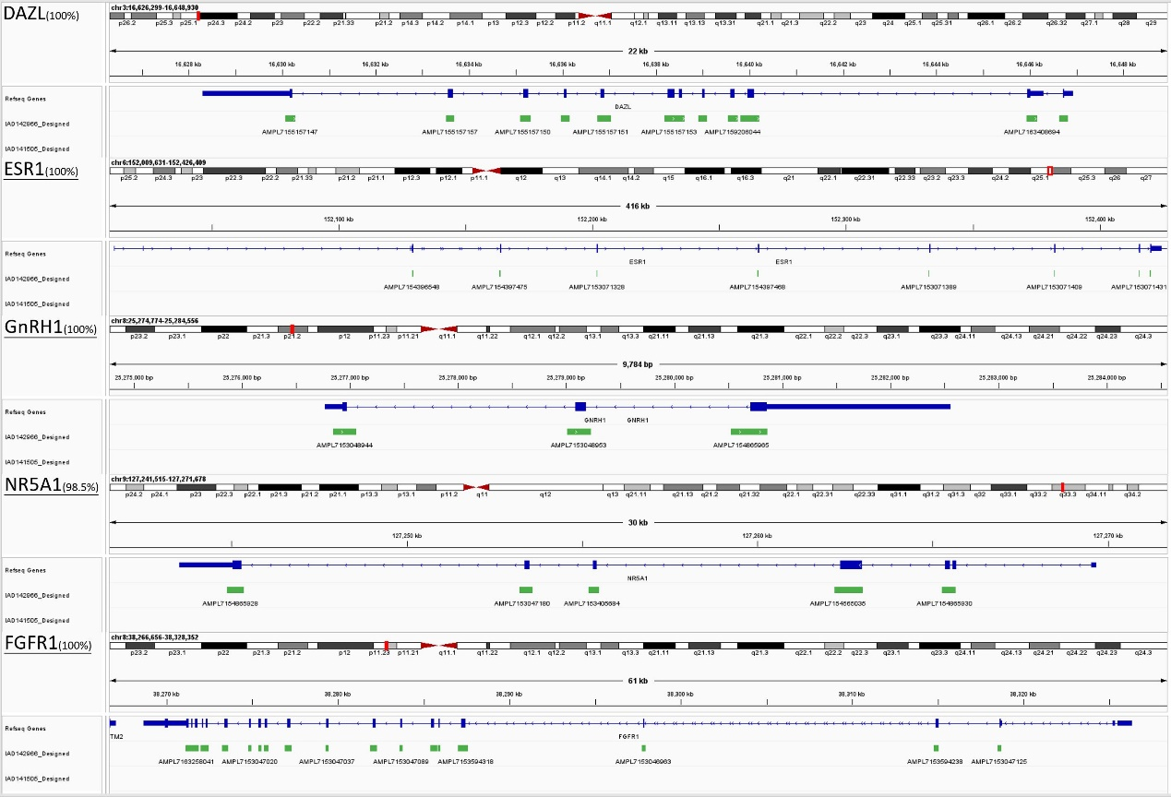
Figure S2B
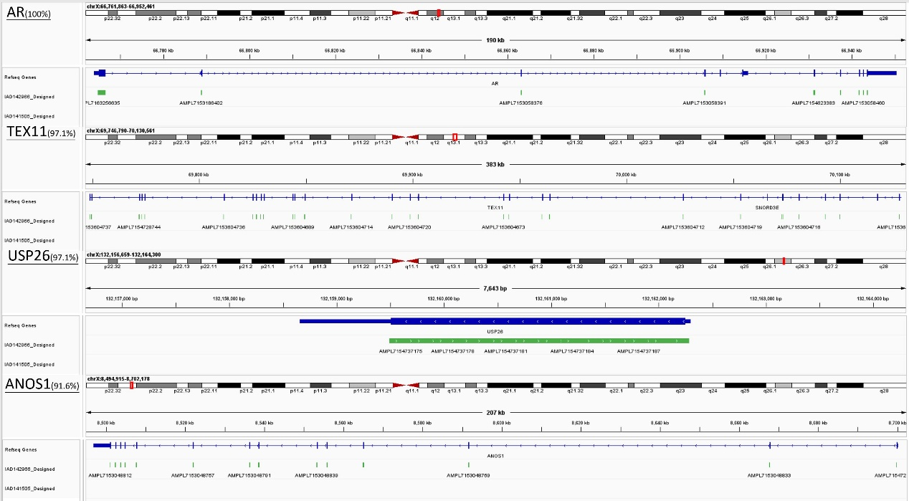
Figure S2C

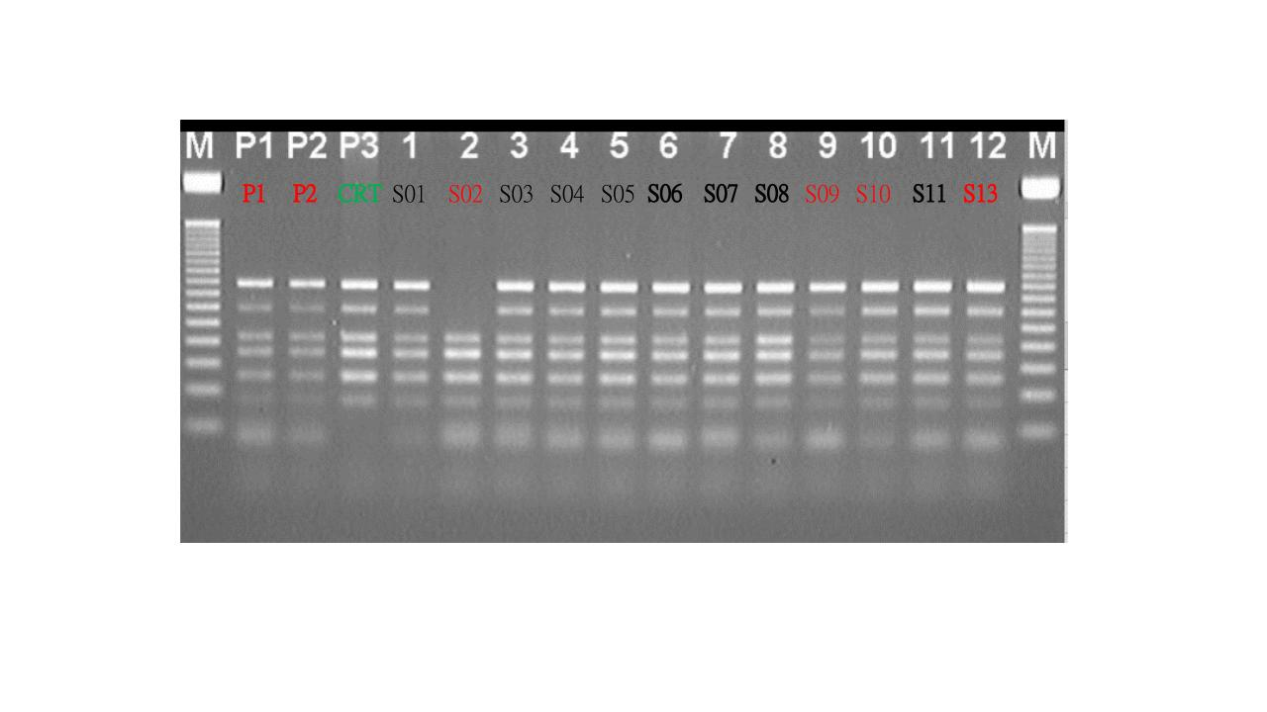
Figure S3
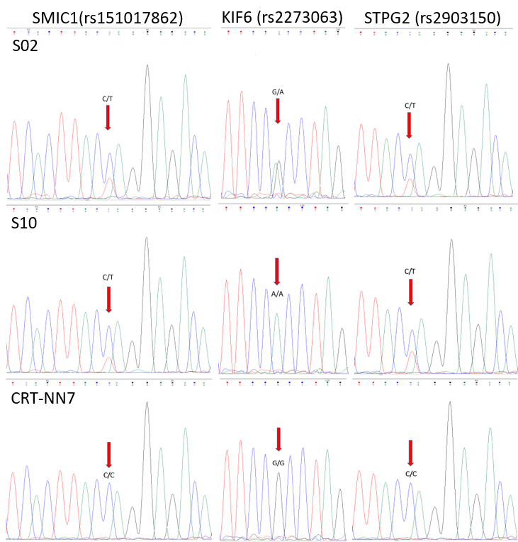
Figure S4

