Methods
CMR Scan acquisition
The following 2D balanced steady state free precession (2D b-SSFP) cine parameters were used: TR/TE 3.1/1.5ms; acquisition matrix 288-320 × 288-320; flip angle 60°; interslice gap 0 mm; slice thickness 6-7 mm; 30 phases per cardiac cycle. 4D flow Data sets were acquired with retrospective electrocardiographic (ECG)-gating during free-breathing. Full volumetric coverage of functional single ventricle was set up in transverse plane. 4D Flow sequence parameters were as follows: TR/TE 2.1 /4.3 ms; ﬂip angle 8–12°; voxel size, 1.6 to 2.2×1.6 to 2.2×1.6 to 2.2 mm³; temporal resolution, 34.4-55 ms; velocity sensitivity, 120-150 cm/s; parallel imaging with reduction factor, R=2.
4D flow CMR pre-processing
Data was reconstructed using research software (MASS Version 30mar2020; Leiden University Medical Center, Leiden, The Netherlands) to correct for eddy currents and concomitant field gradients. Aliasing artifacts was visually checked in 4D flow data (all three velocity components) and unwrapped using a sliding velocity scaling to correct artifacts. Remaining background errors were corrected by the (LPC, local phase correction) filter on the 4D Flow image. LPC used surrounding tissue (muscle) to determine “static” areas.
Segmented endocardial contours at end systole (ES) and end diastole (ED) from volume quantification were used to generate pathlines from each segmented voxel: (1) direct flow: blood that enters and exits the ventricular in the analyzed cardiac cycle; (2) retained inflow: enters the ventricular but does not exit during the analyzed cycle; (3) delayed ejection flow: starts and resides within the ventricular and exits during the analyzed cycle; and (4) residual volume: blood that remains in the ventricular for at least 2 cardiac cycles .
Table S1. Characteristics of the repaired Fontan patients
Diagnosis | n | Type of Fontan
Left ventricular morphology | 9
Tricuspid atresia |  | Extracardiac
Tricuspid atresia |  | Extracardiac
Tricuspid atresia |  | Extracardiac
Tricuspid atresia |  | Extracardiac
Tricuspid atresia |  | Extracardiac
Tricuspid atresia |  | Extracardiac
Pulmonary atresia |  | Extracardiac
Pulmonary atresia |  | Extracardiac
Pulmonary atresia |  | Extracardiac
Ebstein’s anomaly |  | Extracardiac
Right ventricular morphology | 9
Double outlet right ventricle, ventricular septal defect |  | Extracardiac
Double outlet right ventricle, ventricular septal defect |  | Extracardiac
Double outlet right ventricle, ventricular septal defect |  | Extracardiac
Double outlet right ventricle, ventricular septal defect |  | Extracardiac
Double outlet right ventricle, ventricular septal defect |  | Extracardiac
Single right ventricle |  | Extracardiac
Single right ventricle |  | Extracardiac
Total anomalous pulmonary venous connection, ventricular septal defect |  | Extracardiac
Complete Transposition of the Great Arteries, ventricular septal defect |  | Extracardiac
Biventricular morphology | 7
Double outlet right ventricle |  | Extracardiac
Double outlet right ventricle |  | Extracardiac
Double outlet right ventricle |  | Extracardiac
Pulmonary stenosis |  | Extracardiac
Transposition of the Great Arteries, ventricular septal defect |  | Extracardiac
Transposition of the Great Arteries, ventricular septal defect |  | Extracardiac
Pulmonary atresia |  | Extracardiac

Table S2. Blood flow components and kinetic energy parameters were performed to assess impaired LV diastolic function.
Parameters | AUC | P | Cut-off | sensitivity | specificity
Direct flow | 0.760 | 0.011 | <=34.43 | 86.67 | 70
Systolic KEi_{EDV} | 0.680 | 0.140 | >3.9 | 100 | 40
Peak systolic KEi_{EDV} | 0.673 | 0.159 | >11.7 | 66.67 | 80
Residual volume | 0.653 | 0.174 | >35.32 | 33.33 | 100
Global KEi_{EDV} | 0.600 | 0.427 | >3.9 | 100 | 30
EF | 0.500 | 1.000 | >60.5 | 46.67 | 70

Table S3. Intra and inter-observer variability for blood flow components and kinetic energy parameters
 | Intra-observer |  | Inter-observer
 | ICC (%) | COV | ICC (%) | COV
Direct flow, % | 85.3 | 5.76 | 93.4 | 4.69
Retained inflow, % | 87.7 | 5.81 | 85.4 | 6.62
Delayed ejection flow, % | 94.6 | 2.43 | 93.7 | 3.65
Residual volume, % | 84.3 | 6.58 | 82.9 | 7.33
Average KEi_{EDV}, µJ/ml | 99.6 | 1.62 | 98.1 | 3.29
Peak systolic KEi_{EDV}, µJ/ml | 99.6 | 2.04 | 90.1 | 10.63
Systolic KEi_{EDV}, µJ/ml | 98.3 | 3.62 | 82.5 | 11.24
Diastolic KEi_{EDV}, µJ/ml | 96.4 | 3.11 | 89.4 | 7.54
Peak E-wave KEi_{EDV}, µJ/ml | 94.7 | 2.94 | 82.1 | 8.63
Peak A-wave KEi_{EDV}, µJ/ml | 97.3 | 2.71 | 83.2 | 7.61
ICC = intraclass correlation coefficient; COV = coefficient of variation; EDV = end-diastolic volume.

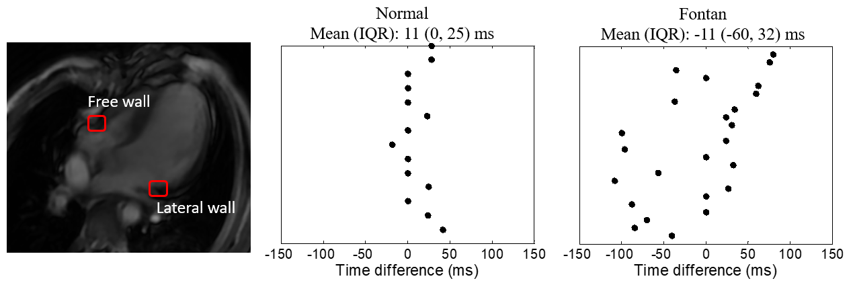
Figure S1. Difference in time to maximal displacement (T-Dmax) between free wall and lateral wall (Time difference = T-Dmax of free wall - T-Dmax of lateral wall) at Fontan group and control.

Figure S2. KE evaluation within one heart beat cycle. (A). KE color maps on short axis view; (B). Time-resolved KE curves within one heartbeat in a normal control.

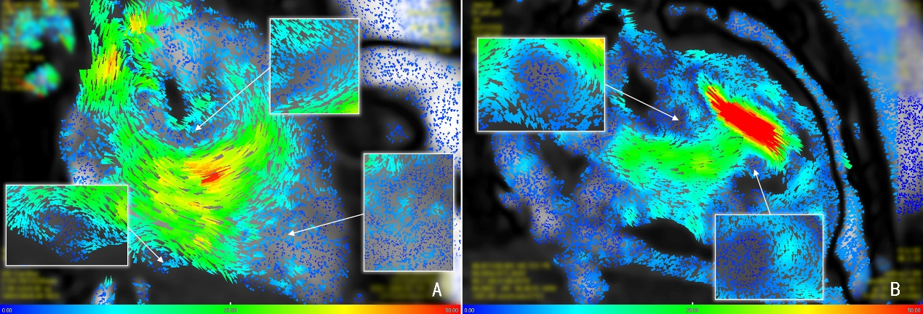
Figure S3. Comparison of RV velocity map during peak systole in a normal control (A) and rFontan patient (B). A. Vortex ring makes the blood flow effectively into the right ventricular outflow tract in normal RV. B. Disruption of RV flow patterns effect outflow from the right ventricular, due to the abnormal intracardiac anatomy in Fontan patients.

