Leveraging the Fragment Molecular Orbital Method to Explore the PLK1 Kinase Binding Site and Polo-Box Domain for Potent Small-Molecule Drug Design
Jongwan Kim^{1,3,*}, Haiyan Jin^{2*}, and Kyoung Tai No^{1,2,3.}
¹ Department of Biotechnology, Yonsei University, Seoul, Republic of Korea
² The Interdisciplinary Graduate Program in Integrative Biotechnology & Translational Medicine, Yonsei University, Incheon, Republic of Korea
³ Bioinformatics and Molecular Design Research Center (BMDRC), Incheon, Republic of Korea
* Co-first authors
* Correspondence: Kyoung Tai No (ktno@yonsei.ac.kr)

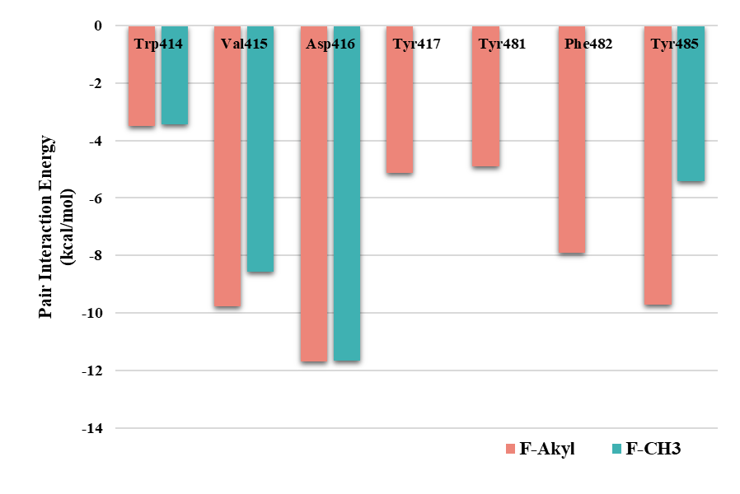
Figure S1. Comparison of F-Akyl with F-CH3 using pair interaction energy (PIE).

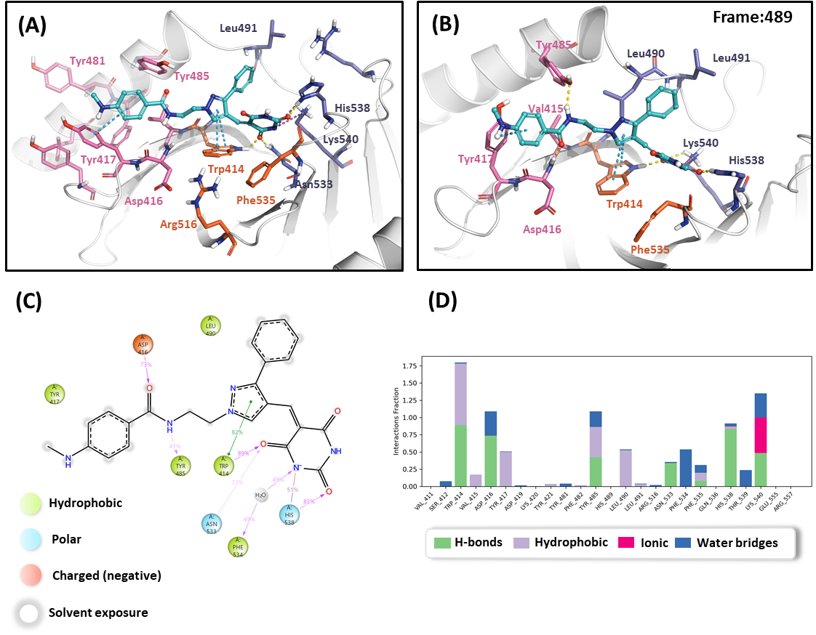
Figure S2. Molecular dynamic (MD) simulation analysis of KBJK557. (A) Docking structure of KBJK557 with the polo-box domain (PBD). (B) Structure of Frame 489 chosen from the MD simulation. (C) Protein-ligand contacts of the two-dimensional (2D) chemical structure and 2D summary reveal that interactions occur more than 30% of the simulation time. (D) Histogram of the protein-ligand interaction fraction.

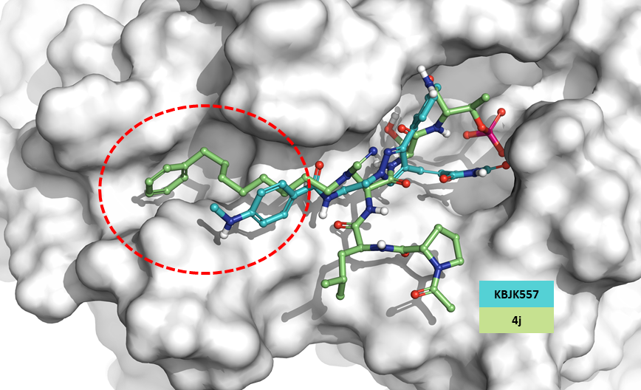
Figure S3. Superposition of 4a and KBJK557. Overlay representation of KBJK557 with 4j, where KBJK557 is light blue, 4j is light green, and the protein is presented with a white surface.

Table S1. PIEDA of ATP and PLK1 complex. All energies are in kcal/mol. The calculation was conducted at the FMO2/DFTB3/PCM level.
Residue | ΔE^{int} | ΔE^{es} | ΔE^{ex} | ΔE^{ct+mix} | ΔE^{di} | ΔG_{sol}
Lys82 | -141.385 | -250.496 | 0.216 | -0.555 | -3.033 | 112.484
Leu197 | -46.510 | -12.336 | 0.271 | -0.429 | -2.375 | -31.640
Gly196 | -43.174 | -43.062 | 0.018 | -0.182 | -0.735 | 0.788
Gly62 | -34.317 | -28.590 | 0.312 | -0.380 | -1.764 | -3.896
Arg136 | -26.851 | -91.29 | 0 | 0 | -0.895 | 65.333
Arg134 | -17.438 | -52.034 | 0.008 | -0.001 | -0.935 | 35.524
Ala65 | -14.211 | -21.054 | -0.006 | -0.008 | -0.945 | 7.803
Cys133 | -10.425 | -5.720 | -0.370 | -0.148 | -2.375 | -1.813
Leu59 | -9.960 | -5.822 | -0.060 | -0.012 | -1.960 | -2.106
Val114 | -7.320 | -7.105 | -0.016 | 0 | -0.977 | 0.779
Phe183 | -6.702 | -1.999 | -0.084 | 0.016 | -5.790 | 1.155
Cys67 | -6.390 | -7.198 | -0.182 | -0.045 | -3.571 | 4.606
Ala80 | -6.080 | -7.014 | 0.038 | -0.003 | -2.004 | 2.903
Leu130 | -4.936 | -4.423 | -0.002 | 0 | -1.087 | 0.576

Table S2. PIEDA of BI2536 and PLK1 complex. All energies are in kcal/mol. The calculation was conducted at the FMO-MP2/6-31G**/PCM level.
Residue | ΔE^{int} | ΔE^{es} | ΔE^{ex} | ΔE^{ct+mix} | ΔE^{di} | ΔG_{sol}
Cys133 | -14.382 | -15.497 | 12.292 | -3.133 | -7.068 | -0.976
Gly60 | -14.095 | -13.257 | 5.720 | -2.618 | -5.916 | 1.976
Leu132 | -12.557 | -7.003 | 4.455 | -2.848 | -6.951 | -0.21
Arg136 | -11.995 | -7.929 | 4.386 | -2.637 | -9.238 | 3.423
Leu59 | -8.796 | -1.082 | 7.484 | -2.854 | -12.121 | -0.223
Phe183 | -8.170 | -1.082 | 3.851 | -1.380 | -8.944 | -0.615
Arg57 | -4.443 | -4.717 | 1.939 | -1.406 | -3.641 | 3.382
Glu69 | -4.255 | -4.070 | 0.643 | -0.980 | -1.501 | 1.653
Cys67 | -3.632 | -3.406 | 7.750 | -1.659 | -6.159 | -0.158
Gly62 | -3.215 | -2.520 | 1.025 | -0.841 | -2.058 | 1.179

Table S3. PIEDA of Onvansertib and PLK1 complex. All energies are in kcal/mol. The calculation was conducted at the FMO-MP2/6-31G**/PCM level.
Residue | ΔE^{int} | ΔE^{es} | ΔE^{ex} | ΔE^{ct+mix} | ΔE^{di} | ΔG_{sol}
Glu140 | -49.684 | -103.375 | 6.591 | -5.569 | -7.408 | 60.077
Lys82 | -15.799 | 10.706 | 4.323 | -2.501 | -5.047 | -23.280
Phe183 | -12.410 | -5.963 | 5.979 | -2.432 | -12.102 | 2.108
Arg134 | -11.929 | 7.329 | 5.507 | -2.883 | -5.345 | -16.537
Leu132 | -10.461 | -8.495 | 3.117 | -2.183 | -5.025 | 2.125
Cys133 | -9.000 | -5.721 | 8.138 | -2.091 | -6.214 | -3.112
Gly60 | -7.029 | -12.922 | 2.082 | -1.577 | -3.544 | 8.932
Asn181 | -6.527 | -16.009 | 1.011 | -0.727 | -2.013 | 11.211
Leu59 | -6.407 | 0.597 | 3.488 | -1.644 | -8.014 | -0.834
Asp194 | -5.387 | -39.078 | 3.136 | -2.553 | -4.270 | 37.378
Arg136 | -5.031 | 40.183 | 6.361 | -3.800 | -8.770 | -39.005
Ser137 | -4.245 | -0.214 | 1.983 | -0.862 | -4.377 | -0.775
Cys67 | -3.444 | -2.285 | 13.220 | -3.305 | -8.658 | -2.416
Arg57 | -3.129 | 23.939 | 0.892 | -1.095 | -1.710 | -25.155

Table S4. PIEDA of GSK461364 and PLK1 complex. All energies are in kcal/mol. The calculation was conducted at the FMO-MP2/6-31G**/PCM level.
Residue | ΔE^{int} | ΔE^{es} | ΔE^{ex} | ΔE^{ct+mix} | ΔE^{di} | ΔG_{sol}
Glu140 | -56.329 | -120.777 | 13.802 | -6.773 | -8.460 | 65.879
Lys082 | -12.529 | 0.356 | 10.821 | -2.931 | -6.761 | -14.014
Phe183 | -10.389 | -8.297 | 6.331 | -1.926 | -10.167 | 3.670
Cys133 | -10.248 | -3.916 | 1.592 | -0.251 | -3.187 | -4.486
Asp194 | -9.998 | -38.054 | 5.523 | -3.781 | -5.619 | 31.933
Asn181 | -5.220 | -12.858 | 0.545 | -0.737 | -2.068 | 9.898
Leu059 | -4.066 | 0.449 | 2.725 | -1.095 | -5.254 | -0.891
Gly060 | -3.419 | -12.033 | 0.704 | -0.310 | -2.527 | 10.747

Table S5. PIEDA of KBJK557 and PLK1 complex. All energies are in kcal/mol. The calculation was conducted at the FMO-MP2/6-31G**/PCM level.
Residue | ΔE^{int} | ΔE^{es} | ΔE^{ex} | ΔE^{ct+mix} | ΔE^{di} | ΔG_{sol}
His538 | -25.291 | -83.443 | 8.239 | -4.695 | -5.607 | 54.608
Lys540 | -23.556 | -94.849 | 3.000 | -3.492 | -4.191 | 71.785
Trp414 | -21.232 | -28.843 | 14.597 | -5.024 | -10.169 | -1.962
Asp416 | -10.779 | 14.983 | 6.886 | -1.928 | -4.024 | -30.720
Tyr485 | -8.698 | -5.375 | 4.851 | -1.775 | -5.641 | -6.399
Tyr417 | -7.744 | -2.724 | 4.970 | -2.397 | -8.491 | -7.593
Leu490 | -7.455 | -2.355 | 6.972 | -2.204 | -9.725 | -9.868
Val415 | -6.996 | -1.849 | 3.192 | -2.662 | -4.504 | -5.677
Leu491 | -5.033 | -7.018 | 1.092 | -0.442 | -3.068 | 1.335
Phe535 | -3.763 | 2.863 | 5.310 | -2.895 | -5.023 | -9.041

Table S6. PIEDA of KBJK-4a and PLK1 complex. All energies are in kcal/mol. The calculation was conducted at the FMO-MP2/6-31G**/PCM level.
Residue | ΔE^{int} | ΔE^{es} | ΔE^{ex} | ΔE^{ct+mix} | ΔE^{di} | ΔG_{sol}
His538 | -34.010 | -110.056 | 21.855 | -7.675 | -6.445 | 68.311
Trp414 | -16.658 | -21.122 | 13.368 | -4.167 | -11.114 | 6.377
Lys540 | -10.549 | -59.446 | 2.091 | -2.631 | -2.826 | 52.263
Leu490 | -7.450 | -3.407 | 7.553 | -2.552 | -10.104 | 1.060
Phe535 | -4.603 | -0.517 | 1.522 | -2.381 | -3.560 | 0.333
Asp416 | -4.029 | 19.404 | 5.679 | -2.193 | -3.998 | -22.921
Thr539 | -3.637 | -4.309 | 0.006 | 0.143 | -0.185 | 0.708
Val415 | -3.564 | 2.558 | 1.164 | -1.512 | -3.257 | -2.517
Tyr485 | -3.540 | -0.696 | 2.877 | -0.921 | -3.650 | -1.150
Leu491 | -3.347 | -6.077 | 0.665 | 0.669 | -2.375 | 3.771

Table S7. List of PDB IDs of protein structures used in this paper.
Entry | PDB ID | PLK1 domain | Ligands | Resolution (Å)
1 | 2OU7 | KD | ATP | 2.4
2 | 3FC2 | KD | Volasertib | 2.45
3 | 2RKU | KD | BI2536 | 1.95
4 | 4J52 | KD | TAK-18 | 2.3
5 | 4J53 | KD | TAK-960 | 2.5
6 | 5TA6 | KD | Compound 15 | 2.5
7 | 5TA8 | KD | Compound 11 | 2.6
8 | 2YAC | KD | Onvansertib | 2.2
9 | 3KB7 | KD | Compound 49 | 2.5
10 | 3THB | KD | MLN0905 | 2.5
11 | 4A4O | KD | Compound 13 | 2.7
12 | 4A4L | KD | Compound 25 | 2.35
13 | 3P37 | PBD | FDPPLHSpTA | 2.38
14 | 3RQ7 | PBD | 4j | 1.55

KD: kinase domain
PBD: polo-box domain

