Supplementary material

In this section we design a procedure based on the use of visible radiation (wavelength λ₂ = 0. 633 μm), to simulate the longitudinal focusing performances of the axicon at 1THz frequency (wavelength λ₁ =300 μm). Referring to the scheme of Fig. A1 , the axicon produced with a heating power of 270 mW (swelling : 164 μm) , focuses virtually the radiation at 1 THz frequency with a maximum intensity I_{max} at a distance z_{max}= 3.4 mm from the surface, with a focus FWHM_{x} = 0.92 mm.
Let’s consider a segment of length 2δz centered at z_{max}, at the ends of which the relative intensity reduction is ΔI/I_{max} . As explained in the Theoretical modeling section, by properly reducing the heating power we can generate an axicon that yields at a wavelength λ₂ the same spatial field distribution produced at the wavelength λ₁. Indeed, the field at coordinates z_{max}±δz is reproduced at unchanged transversal coordinates, but at expanded z-coordinates, namely M (z_{max}±δz) = M·z_{max}± δζ, where δζ = M·δz =142.8 mm and M=λ₁/λ₂= 476. The maximum intensity is transferred at the point P_{F} whose z-coordinate is z_{F} = z_{max}M and here the FWHM_{x} remains unchanged while its distance from L is p_{F} = d_{L}+ z_{F} = 2218 mm and the overall D_{ax} is enlarged to 7520 mm. This expanded virtual focal region at λ₂ is imaged and demagnified in the real space by the positive lens L (Fig.A1).
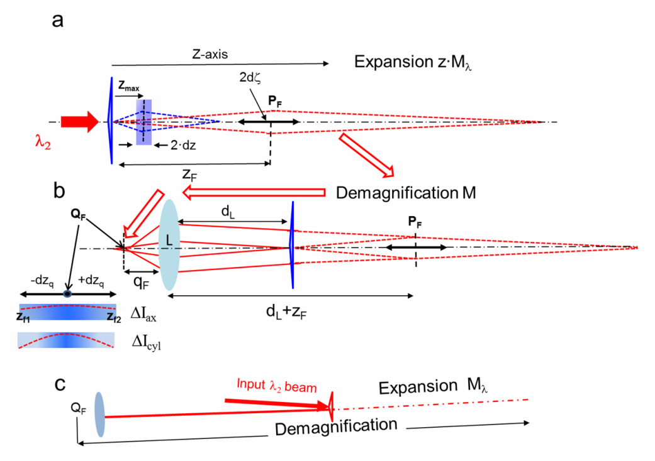
Fig.A1. (a) Schematic representation of the simulation at the wavelength    m of the focus region produced by the axicon at 1 THz frequency (flattened blue triangle). The length dz (= 0.30 mm) is an arbitrarily small width of the longitudinal region around the point of maximum intensity, placed at z_{max}= 3.4 mm (blue dashed quadrilateral). The virtual expanded simulation region is represented by the red dashed quadrilateral . (b) Transfer and demagnification in the real space by the lens L (focal length =100 mm) of the expanded virtual focal region. The variation I_{ax} at the endpoints of the focal region is compared with that one, I_{cyl}, calculated when the axicon is changed with a cylindrical mirror with the same focal length.
(c) In order to simplify the optical set-up, in the experimental layout the two sections (a) and (b) are collinear and tilted by a small angle with respect to the input light probe at wavelength λ₂ . For the detailed description see the text of Appendix.

However , aiming to consider the imaging of the whole focus region, one should take into account that the demagnification suffers a strong change along the axis, and as a consequence the light intensity distribution downline of L would have strong distortions with respect that one in the axicon focus of 1 THz radiation. In order to avoid this complication and simplify the calculations, we will select δζ<< p_{F} by choosing an arbitrarily low value of δz =0.3 mm << z_{max} in our case. By applying the law of conjugate points, P_{F} is imaged in the point Q_{F} at a distance q_{F}= p_{F}/M=104.72 mm from L, with a transversal de-magnification M =22.2 . As it can be easily verified, M is uniform within ±3.5 % with respect to its average value (M_{av} =21.8) in the segment centered on P_{F},  whose length is 2dζ . As δz/p_{F}= 0.064<<1, the length δz_{q}, longitudinal image of dζ, can be simply found by applying the approximate relationship of geometrical optics δz_{q}~ δζ/M² = 0.29 mm. The z-coordinates of the endpoints of the focal region, centered at distance q_{F}, are thus z_{f1}= (q_{F}+δζ)/M² , z_{f2} =(q_{F}-δζ)/M². As M is almost constant, the virtual field in the expanded focal region is transferred in the real focus with almost uniform M-scaling in the transversal coordinates and M² -scaling in the axial coordinate. As a consequence, indicating with I_{max} the maximum intensity in the focus Q_{F}, the ratios of the intensities at its endpoints, I(z_{f1})/I_{max} and I(z_{f2})/I_{max}, reply with good approximation the ratios of the intensities at the virtual endpoints of the expanded focal line at λ₂ and, for the scaling property of Eq.5, at the endpoints of the simulated focal line at 1 THz. To summarize, the axial intensity distribution generated by the axicon at 1 THz frequency can be reproduced with good fidelity by using the visible probe beam at λ₂ , provided that only a small region around the focus is considered. It is transformed in a region close to the focus of the lens L that is demagnified M=22.2 in the cross section and M²=492 in the axial direction. The intensity fall at the endpoints ΔI_{ax} is ΔI_{ax} ~0.2% I_{max}, so the intensity is almost uniform in the considered width around the focal point. Even if we limited ourselves to examine the intensity variations in a small region around the focus, this is still enough to evaluate the long focusing performances if we compare this result to that one achieved if a conventional focusing optics would be used.
To demonstrate this statement, we replace the axicon with a fictitious convex cylindrical mirror that focuses virtually at the coordinate z_{max} the same Gaussian beam used as input for the axicon (beam waist w₀= 1 mm) . The focal distance f_{THz} of the mirror is thus f_{THz}= z_{max} . The beam waist at focus is w₁= λ₁f_{ΤΗζ}/πw₀ = 0.32 mm. Then, as for the axicon, we change the wavelength λ₁ with the simulation wavelength λ₂. The focused field is calculated with Eq.5 by simply substituting the phase factor corresponding to the axicon (Eq.3) with that one introduced by the fictitious optics, that is Φ(x)=πx²P₁/λ₁, where P₁ =1/f_{THz} is the dioptric power of the mirror. This expression of Φ(x) has a form analogous to that one of Eq.3 that describes the phase variation introduced by the axicon, namely a constant multiplied for a function of x. Thus, the replication at λ₂ of the field distribution produced at λ₁ , is possible by expanding the z-coordinate to zM_{λ} and changing the power of the mirror to P₂=P₁/M_{λ}. The focal length is enlarged to f₂ = M_{λ}f_{THz} = z_{F} , while the virtual focus waist w₁ is simply translated to z_{F} . The lens L provides to transfer this focus in the real space. The well known formulas of Gaussian optics permit to calculate the beam waist of the focused beam and its distance from L, that result w_{f}= 0.0148 mm and 104.50 mm respectively. The corresponding Rayleigh range is z_{f}= πw_{f}²/λ₂ = 0.98 mm. The relative intensity fall with respect to the maximum I_{max} expected at coordinates ±dz_{q} from w_{f} , namely ΔI_{cyl}/I_{max}, can be approximately calculated by the formula ΔI_{cyl}/I_{max} ~1-(1+ (dz_{q}/z_{f} )² )⁻¹ = 9%, to be compared with the observed constant trend of the axial intensity vs. distance.

