|  |  |  |
| --- | --- | --- |
| **Supplement Table 1. Real-time PCR gene-specific primer pairs** | | |
| **Gene** | Forward | Reverse |
| ***Gsdmd*** | TCATGTGTCAACCTGTCAATCAAGGACAT | CATCGACGACATCAGAGACTTTGAAGGA |
| ***Casp1*** | CTGACAAGATCCTGAGGGCA | AAAGATTTGGCTTGCCTGGG |
| ***Casp3*** | AAGGAGCAGCTTTGTGTGTGT | AAGAGTTTCGGCTTTCCAGTC |
| ***Casp8*** | CTCCGAAAAATGAAGGACAGA | CGTGGGATAGGATACAGCAGA |
| ***Aim2*** | AAGTGCGAGGAAGGAGACAA | TTCAAGGAGCAGCATCAGGA |
| ***Nlrp1*** | ATAGAGGAGCAGGCAGGTCT | CGTGCTCCTGGAAAGGTTCT |
| ***Nlrp3*** | GCTCCAACCATTCTCTGACC | AAGTAAGGCCGGAATTCACC |
| ***Gfap*** | GGTTGAATCGCTGGAGGAG | CTGTGAGGTCTGGCTTGG |
| ***Aif1/Iba1*** | AGAGAGGTGTCCAGTGGC | CCCCACCGTGTGACCTCC |
| ***Il1b*** | GACCTTCCAGGATGAGGACA | AGGCCACAGGTATTTTGTCG |
| ***Tnfa*** | CAAAATTCGAGTGACAAGCCTG | GAGATCCATGCCGTTGGC |

**Supplement Figures**



**Supplemental figure S1.** Change in PERG latency 3 weeks following spike and steady OHT stress events. Non-significant changes at 1 and 2 weeks. Latency significantly increased at 3 weeks following spike. Mean ± SE, *P <0.05, n = 10-15.

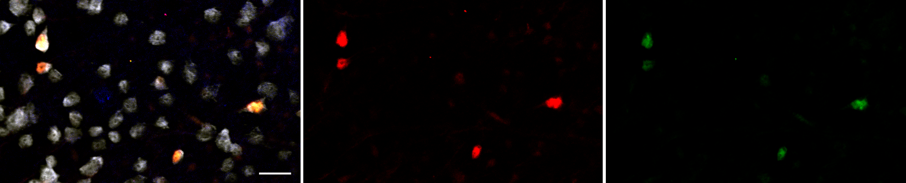

**RBPMS+merge Casp1 Casp-8**

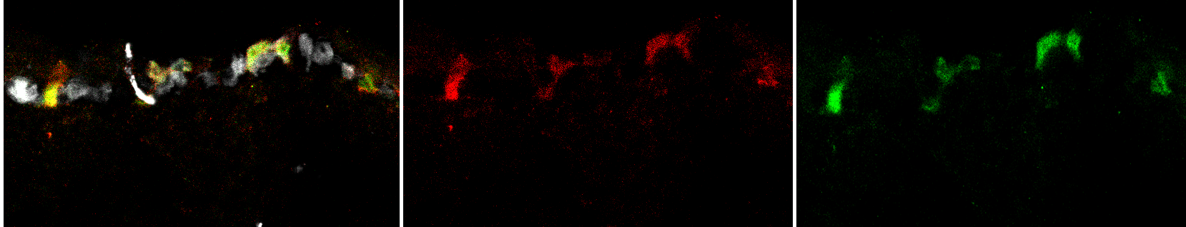

A

B

40μm

30μm

**Supplement Figure S2.** Co-activation of Casp1 and Casp8 in RGCs. Representative micrographs from retinal wholemounts (top) and cross sections (bottom) showing active caspase-1 (red) and caspase-8 (green) labeling assayed with FLICA-conjugated substrates. RGCs were labelled with RBPMS marker protein (white)

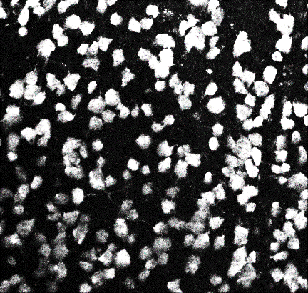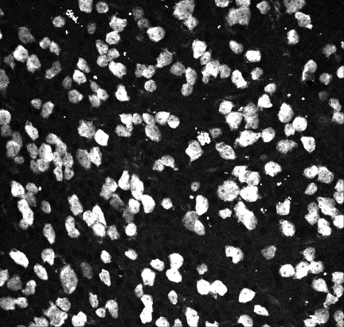

Naïve WT

spOHT WT

stOHT WT

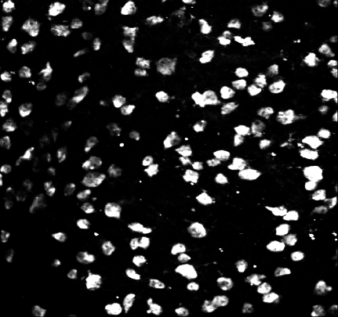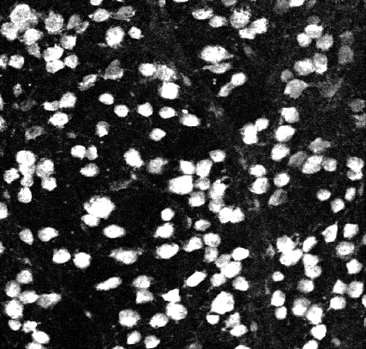

spOHT NLRP1KO

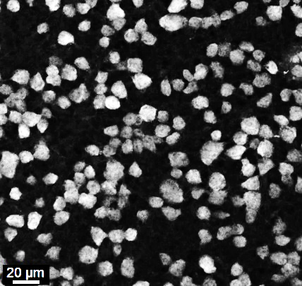

spOHT Csp1KO

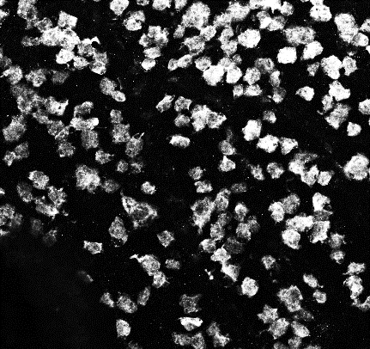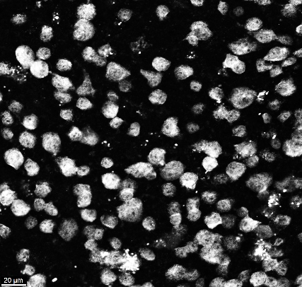

spOHT +DEVD

spOHT GSDMDKO

**Supplement Figure S3.** Representative micrographs of wholemount retinas stained for RBPMS marker to assess RGC density at 7dpi in the mid-retina exposed to either spOHT or stdyOHT challenges

B

A



**Supplement Figure S4.** **A**. Diagram depicting experimental setup for a PERG recording experiment. **B**. PERG amplitude changes vs baseline at 1,2and 3 weeks after the challenge by a single episode of spOHT (7x1).

**Supplement Figure S5 (**full version of Fig. 9**). Monocyte/macrophages infiltration into the inner retina and optic nerves after spOHT challenge. A,B.** Representative micrographs for cells expressing CD45 (red) and CD11b (green) markers in rounded monocyte/macrophage cells that were abundant at the inner retinal surface, in the GCL, INL and in the optic nerves of the spOHT-challenged eyes. Co-staining with GFAP (light grey, top panels) identified astrocytes. **C,D**. Control immunostaining in stOHT-challenged optic nerves showed no CD45+ monocytes in both retina and optic nerves. Small punctate CD45+CD11b+ cells are ramified microglia. Bright green puncta represent citrin-labelled ASC-specks of mature inflammasomes that are abundant in the optic nerve astrocytes and in infiltrating cells (yellow arrows). **E,F.** Control immunostaining in sham-operated controls showed only weakly labelled CD45+CD11b+ microglial cells in the IPL of the retina.

**Supplement Figure S6.** **A**. Meta-analysis of publicly available murine transcriptomic data (GEO GD51728), revealed evidence of inflammasome gene activation in aging DBA2J mice with glaucoma vs young pre-disease animals. **B.** Meta-analysis of murine scRNAseq dataset (https://www.ncbi.nlm.nih.gov/geo/query/acc.cgi?acc = GSE115404) showing differential activation of several upstream inflammasome regulator genes panx1, panx2, p2rx4; danger sensor genes NLRP10 and aim2, pore protein gene gsdmD reveal significant variability in these gene expression levels among different RGC subtypes.

a

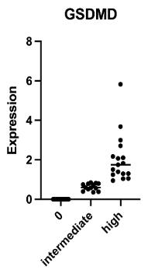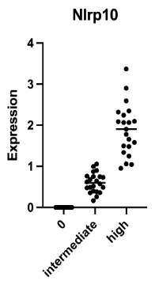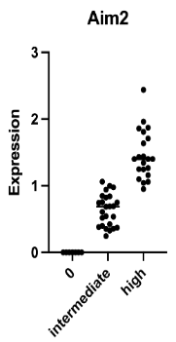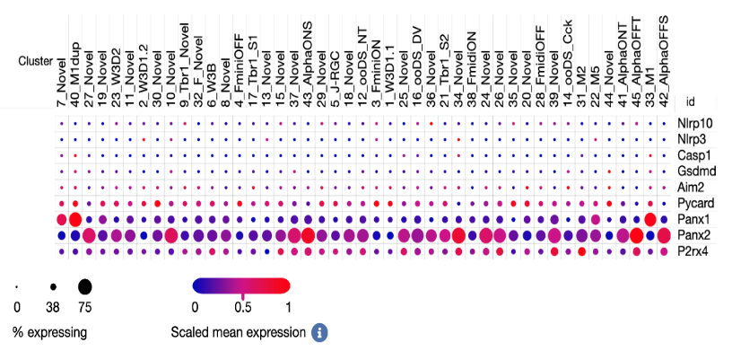

b

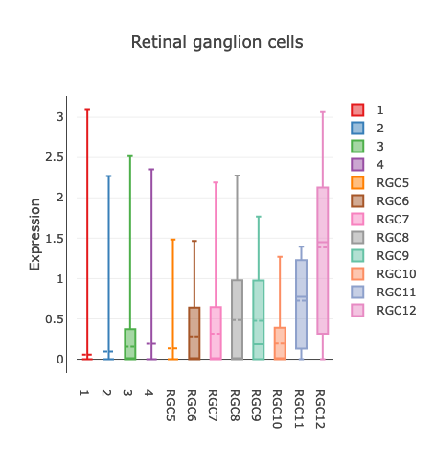

c

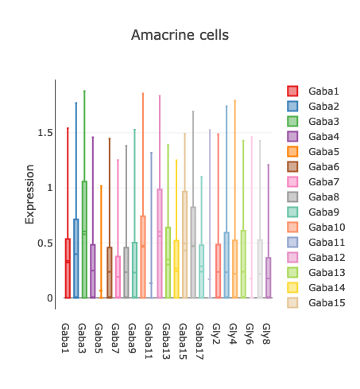

e

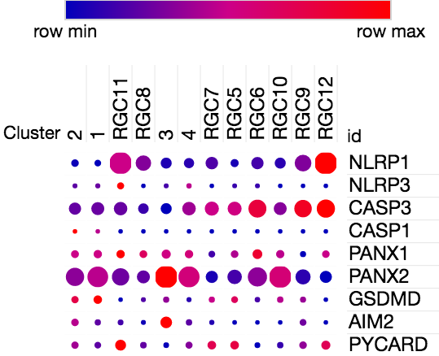

d

***

***

***

**inflammasome genes**

**NLRP1 NLRP1**

**Supplement Figure S6.** **Meta-analysis of RGC subtype-specific scRGAseq data for inflammasome gene expression from human retina. A**. Scatter plots for *NLRP10, AIM2* and *GSDMD* expression in averaged low- and high-expressing RGC subtypes. **B** Relative expression of the inflammasome pathway genes among different RGC subtypes in the murine retina. **C-D** Relative expression of the NLRP1 gene among the most abundant RGC subtypes in human fovea (Data source: https://singlecell.broadinstitute.org/ study #SCP839). **E**. Dot plot of the key inflammasome pathway genes among the most abundant RGC subtypes in human fovea.

**Supplement Figure S7. Meta-analysis of scRGAseq data from human photoreceptors, bipolar horizontal and non-neuronal cells for inflammasome gene expression** (Data source: https://singlecell.broadinstitute.org/ study #SCP839).