Appendix A: Supplementary material for “Effects of land use characteristics, physiochemical variables and river connectivity on fish assemblages in a lowland basin”
List of Authors
Zhiming Zhang ^{1,} *,Junfeng Gao ², Yongjiu Cai ²
1 The Key Laboratory of Earth Surface Processes and Regional Response in the Yangtze Huaihe River Basin, School of Geography and Tourism, Anhui Normal University, Wuhu, 241002, China
2 Key Laboratory of Watershed Geographic Sciences, Nanjing Institute of Geography and Limnology, Chinese Academy of Sciences, Nanjing 210008, China
Corresponding author: zmzhang2013@126.com
Table A1 Connectivity variables for the four connectivity groups in the Lake Chaohu Basin. The Kruskal-Wallis tests were conducted to detect differences of variables among groups. Values are averages (ranges).
Physicochemical variables | River-connectivity group |  |  |  | p value
 | Group 1 (n=9) | Group 2 (n=8) | Group 3 (n=19) | Group 4 (n=21)
ROrder | 4.67(2-5) | 4.13(4-5) | 2.89(1-4) | 2.43(1-3) | <0.001***
Link | 250.22(156-567) | 52(32-82) | 12.89(1-37) | 7.38(1-21) | <0.001***
BLink_Lf | 279.56(108-970) | 60.38(5-119) | 13.68(0-45) | 4.95(0-16) | <0.001***
BLink_R | 353.22(215-537) | 49.38(26-84) | 10.21(0-33) | 5.81(0-18) | <0.001***
BLink | 632.78(394-1423) | 109.75(70-199) | 23.89(0-59) | 10.76(0-28) | <0.001***
CLink | 18(2-39) | 25.88(1-78) | 21.05(4-68) | 53.05(32-85) | <0.001***
DLink | 239.11(161-499) | 60(26-94) | 14.05(5-29) | 8.1(1-22) | <0.001***
Down_L (km) | 1290.5(13.02-3911) | 1700.35(63.37-6957) | 874.07(10.9-7329) | 2016(11.8-16500) | 0.420
Up_L (km) | 1227.53(131.1-5231) | 1504.04(29.43-3930) | 997.75(11.48-4852) | 1414.17(13.11-4840) | 0.826
LSS | 0.51(0.05-0.99) | 0.55(0.01-0.94) | 0.56(0.04-0.98) | 0.46(0.01-0.99) | 0.909
***Correlation is significant at the 0.001 level.
ROrder, stream order; Link, stream-link magnitude; BLink_Lf, number of branches along a path to the left; BLink_R, number of branches along a path to the right; BLink, branch link; CLink, confluence link; DLink, downstream link; Down_L, downstream segment length; Up_L, upstream segment length; and LSS , the location of sampling site.
Table A2 Physicochemical variables for the four connectivity groups in the Lake Chaohu Basin. The Kruskal-Wallis tests were conducted to detect differences of variables among groups. Values are averages (ranges).
Physicochemical variables | River-connectivity group |  |  |  | p value
 | Group 1 (n=9) | Group 2 (n=8) | Group 3 (n=19) | Group 4 (n=21)
pH | 8.39(7.4-9.87) | 8.22(6.93-9.87) | 8.25(7.5-10.16) | 8.06(7.23-9.19) | 0.619
DO(mg/L) | 10.72(6.14-18.22) | 9.82(3.22-18.22) | 8.86(0.85-13.45) | 9.86(1.46-16.94) | 0.896
EC(μs/cm) | 158.56(69-221) | 185.75(41-323) | 201.74(33-576) | 191.9(41-616) | 0.939
TDS(mg/L) | 0.12(0.05-0.17) | 0.14(0.03-0.26) | 0.15(0.03-0.4) | 0.14(0.04-0.29) | 0.952
Alka(mg/L) | 35.18(0-59.36) | 40.99(14.13-62.19) | 60.7(19.79-115.89) | 44.82(8.48-132.85) | 0.088
Turb(NTU) | 14.22(0.9-30.9) | 8.6(0.9-20.4) | 21.78(0.1-116.1) | 10.75(0.3-34.8) | 0.414
TN(mg/L) | 0.63(0.09-2.11) | 0.52(0.08-2.11) | 2.64(0.17-15.85) | 0.60(0.09-4.99) | 0.595
NH₄⁺-N(mg/L) | 0.49(0.13-1.8) | 0.76(0.06-2.74) | 0.14(0.04-0.73) | 0.21(0.04-1.04) | 0.082
NO₃⁻-N(mg/L) | 1.72(0.66-2.7) | 1.94(0.45-4.97) | 3.77(0.57-17.87) | 1.70(0.48-5.55) | 0.006**
TP(mg/L) | 0.06(0.02-0.26) | 0.05(0.01-0.24) | 0.20(0.01-1.05) | 0.03(0-0.06) | 0.013*
PO₄³⁺_P(mg/L) | 0.11(0.04-0.34) | 0.08(0.02-0.34) | 0.41(0.02-2.66) | 0.05(0.01-0.11) | 0.020*
DOC(mg/L) | 4.55(3.03-7.59) | 5.13(3.18-7.21) | 7.17(2.34-16.81) | 4.72(1.45-8.03) | 0.041*
Elevation(m) | 22(12-33) | 50.25(18-123) | 57.63(8-387) | 63.24(7-159) | 0.023*
Temp(ºC) | 18.77(15.99-25.25) | 17.83(13.32-25.25) | 18.76(10.96-25.89) | 17.85(12.3-25.23) | 0.495
Width(m) | 149.22(40-320) | 61.38(10-108) | 48.16(4-240) | 20.67(3-150) | <0.001***
Depth(m) | 4.12(0.9-7) | 2.21(0.8-4) | 1.98(0.3-4) | 0.99(0.3-5) | <0.001***
Flow(m/s) | 0.10(0-0.2) | 0.19(0-0.61) | 0.09(0-0.51) | 0.18(0-0.81) | 0.349
Chl-a(ug/cm²) | 0.25(0.03-0.71) | 0.17(0.05-0.33) | 0.40(0.05-1.79) | 0.31(0.02-1.27) | 0.899
Note: * p<0.05, ** p<0.01, *** p<0.001
Table A3 Land use and land cover for the four connectivity groups in the Lake Chaohu Basin. The Kruskal-Wallis tests were conducted to detect differences of variables among groups. Values are averages (ranges).
Land use and land cover | River-connectivity group |  |  |  | p value
 | Group 1 (n=9) | Group 2 (n=8) | Group 3 (n=19) | Group 4 (n=21)
U_Grass | 0(0-0) | 1.25(0-9.98) | 1.49(0-28.33) | 12.72(0-86.32) | 0.018*
U_Built | 9.18(0-21.46) | 9.5(0-13.93) | 21.56(0-84.98) | 7.57(0-54.3) | 0.080
U_Crop | 78.21(63.45-97.14) | 66.68(27.34-90.72) | 62.83(0-98.76) | 49.64(0-97.25) | 0.127
U_Wood | 1.39(0-12.47) | 15.25(0-61.85) | 10.83(0-100) | 27.52(0-100) | 0.002**
U_Water | 11.22(0-31.16) | 7.32(0-23.31) | 3.29(0-39.3) | 2.54(0-13.58) | 0.032*
D_Grass | 0(0-0) | 1.16(0-6.84) | 1.31(0-24.96) | 10.09(0-57.22) | 0.094
D_Built | 8.02(0-28.55) | 9.76(0-19.88) | 19.03(0-99.24) | 8.15(0-42.62) | 0.255
D_Crop | 81.04(62.05-94.97) | 66.53(28.8-93.2) | 65.81(0-98.6) | 53.95(0-96.4) | 0.081
D_Wood | 0(0-0) | 12.98(0-56.08) | 10.39(0-100) | 24.87(0-100) | 0.002**
D_Water | 10.95(0-33.17) | 9.56(0-35.79) | 3.31(0-41.23) | 2.94(0-13.15) | 0.031*
T_Grass | 0(0-0) | 1.29(0-8.33) | 1.41(0-26.81) | 10.16(0-53.22) | 0.023*
T_Built | 8.44(0-22.94) | 9.78(0-18.71) | 19.89(0-89.66) | 8.07(0-44.31) | 0.179
T_Crop | 79.72(64.61-95.73) | 66.37(27.91-92.15) | 64.58(0-98.68) | 52.92(0-96.73) | 0.098
T_Wood | 1.1(0-9.87) | 14.44(0-59.59) | 10.7(0-100) | 26.07(0-100) | 0.001***
T_Water | 10.75(0-32.06) | 8.12(0-27.88) | 3.37(0-40.12) | 2.78(0-12.98) | 0.045*
Note: * p<0.05, ** p<0.01, *** p<0.001
U_Grass, U_Built, U_Crop, U_Wood, and U_Water represent the grassland, built-up land, cropland, woodland, and water body in the 1 km buffer along the upstream segment where sampling site located, respectively.
D_Grass, D_Built, D_Crop, D_Wood, and D_Water represent the grassland, built-up land, cropland, woodland, and water body in the 1 km buffer along the downstream segment, respectively.
T_Grass, T_Built, T_Crop, T_Wood, and T_Water represent the grassland, built-up land, cropland, woodland, and water body in the 1 km buffer along the total segment, respectively.
Table A4 Fish taxa richness and diversity indices in the four connectivity groups in the Lake Chaohu Basin. The Kruskal-Wallis tests were conducted to detect differences of variables among groups. Values are averages (ranges).
Fish taxa richness and  diversity indices | River-connectivity group |  |  |  | p value
 | Group 1 (n=9) | Group 2 (n=8) | Group 3 (n=19) | Group 4 (n=21)
Taxa richness | 6.89(3-13) | 6.13(4-11) | 7.53(1-14) | 5.48(1-12) | 0.119
Total number of fish captured | 53.67(12-142) | 46.25(10-110) | 89.11(1-455) | 44(1-122) | 0.114
Simpson | 1.31(0.68-1.78) | 1.38(0.85-2.01) | 1.27(0-1.88) | 1.13(0-2.22) | 0.513
Shannon-Wiener | 0.63(0.25-0.92) | 0.7(0.47-0.9) | 0.57(0.33-1) | 0.68(0.32-1) | 0.099
Buzas and Gibson's evenness | 1.11(0.6-1.59) | 1.16(0.67-1.77) | 1.14(0-1.71) | 0.95(0-1.9) | 0.482
Margalef | 0.72(0.42-0.95) | 0.78(0.53-0.92) | 0.66(0.29-0.82) | 0.72(0.17-0.96) | 0.159
Fisher's alpha | 2.46(0.89-3.98) | 2.36(1.2-3.86) | 2.16(0-3.12) | 2.17(0-5.71) | 0.733
Berger-Parker | 0.54(0.29-0.83) | 0.46(0.32-0.77) | 0.55(0.29-1) | 0.56(0.19-1) | 0.625

Table A5 Fish taxa richness and diversity indices in the river order groups in the Lake Chaohu Basin. Kruskal-Wallis tests were conducted to detect differences of variables among groups. Values are averages (ranges).
Fish taxa richness and  diversity indices | River-order group |  |  |  |  | p value
 | 1st-order (n=3) | 2nd-order (n=14) | 3rd-order (n=19) | 4th-order (n=12) | 5th-order (n=9)
Taxa richness | 4.67(3-6) | 7(1-13) | 5.89(1-10) | 7.58(4-14) | 6(3-10) | 0.492
Total number of fish captured | 30.67(5-55) | 46.5(1-142) | 63.58(1-122) | 96.08(10-455) | 40.67(12-92) | 0.236
Simpson | 1.24(1.06-1.38) | 1.3(0-2.22) | 1.05(0-1.88) | 1.39(0.85-2.01) | 1.34(0.68-1.78) | 0.477
Shannon-Wiener | 0.78(0.66-0.96) | 0.68(0.25-1) | 0.58(0.32-1) | 0.59(0.33-0.9) | 0.7(0.39-0.92) | 0.149
Buzas and Gibson's evenness | 1.01(0.68-1.24) | 1.11(0-1.9) | 0.93(0-1.71) | 1.22(0.67-1.77) | 1.13(0.6-1.59) | 0.649
Margalef | 0.84(0.77-0.96) | 0.74(0.46-0.93) | 0.62(0.17-0.87) | 0.72(0.53-0.92) | 0.77(0.42-0.95) | 0.089
Fisher's alpha | 2.18(1.66-3.17) | 2.72(0-5.71) | 1.74(0-3.15) | 2.46(1.1-3.86) | 2.28(0.89-3.98) | 0.232
Berger-Parker | 0.44(0.4-0.5) | 0.52(0.19-1) | 0.62(0.29-1) | 0.5(0.33-0.77) | 0.5(0.29-0.83) | 0.415

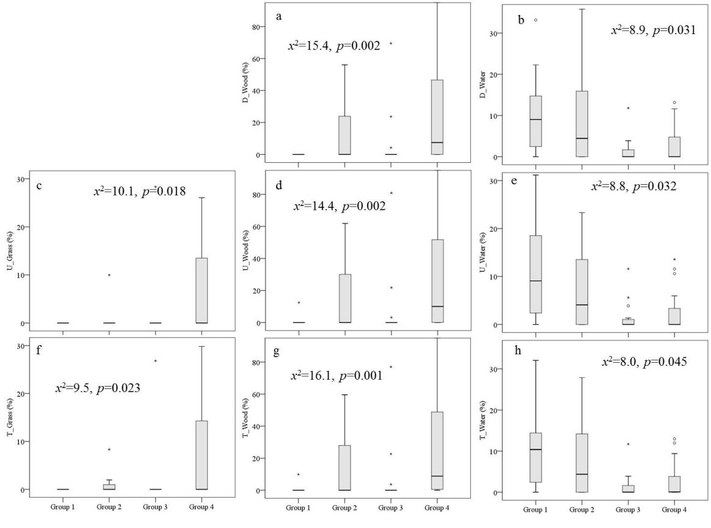
Figure A1. Box plots of selected Land cover variables in the four connectivity groups. Kruskal-Wallis test of the variables among the four groups indicated significant differences between the groups (p<0.05). U_Grass, U_Wood, and U_Water represent the grassland, woodland, and water body in the 1 km buffer around the upstream segment; D_Wood and D_Water represent the woodland and water body in the 1 km buffer around the downstream segment; T_Grass, T_Wood, and T_Water represent the grassland, woodland, and water body in the 1 km buffer around the total segment where sampling site located.

