Supplementary Material: Epigenetic profiling of PTPN11 mutant JMML hematopoietic stem and progenitor cells reveals an aberrant histone landscape.
Table 1. Clinical and genetic characteristics of JMML patients cohort.
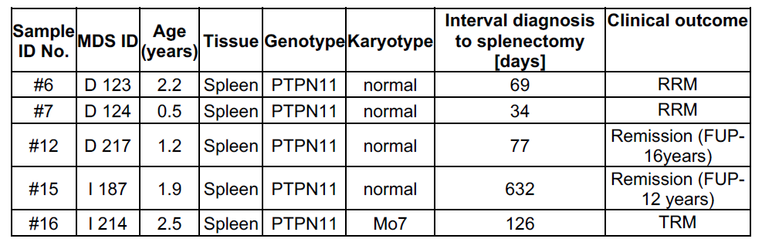
FUP: follow up; TRM: Transplant related mortality; RRM: Relapse-related mortality.
Note: Splenectomies were performed prior to hematopoietic stem cell transplantation in all 5 cases. Leukemia burden was high in all 5 patients at the time of splenectomy.
Table 2. Phenotype of hematopoietic stem and progenitor subsets identified in UCBs and. JMML patients samples.
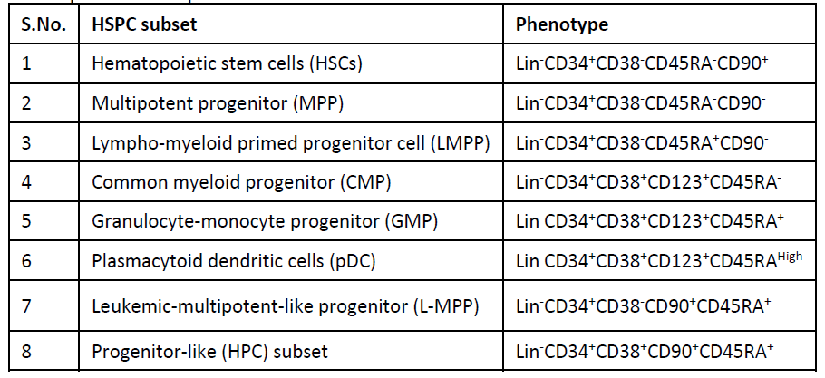
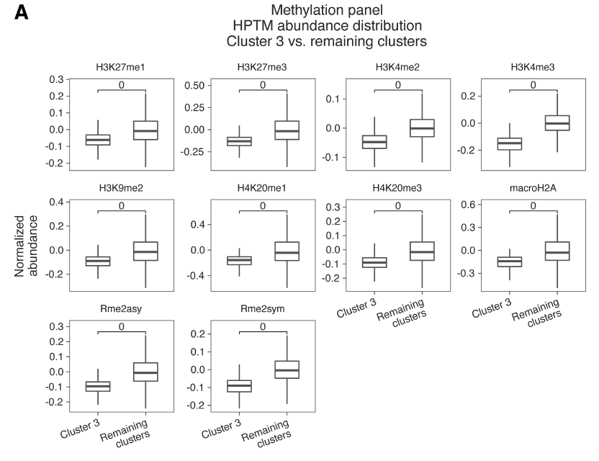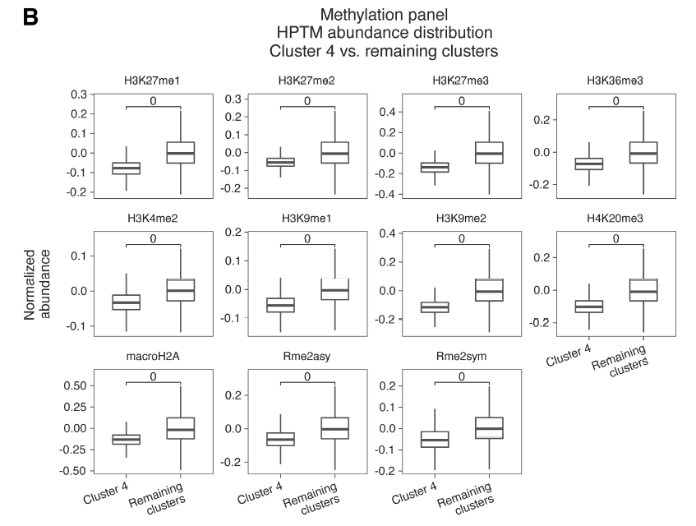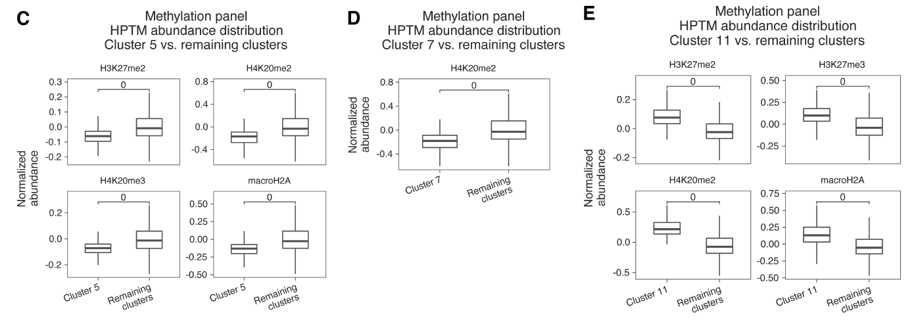
Figure S1: Key histone methylation marks that defined clusters with significantly distinct JMML vs UCB HSPC proportions: Dimensionality reduction analysis was performed on normalized datasets using uniform manifold approximation and projection (UMAP) based on histone methylation post translational modification (PTM) marks. Thereafter, clustering was done using PhenoGraph which revealed 13 distinct clusters of which clusters A) 3, B) 4, C) 5, D) 7 and E) 11 showed significantly distinct distribution of JMML vs UCB HSPCs. We examined median abundance of HPTMs in each of these individual clusters against all the other clusters to identify the HPTM marks that were significantly distinct (higher or lower) abundant in each cluster. Statistical significance was calculated using t-tests and p values in all cases shown here are <0.0005.
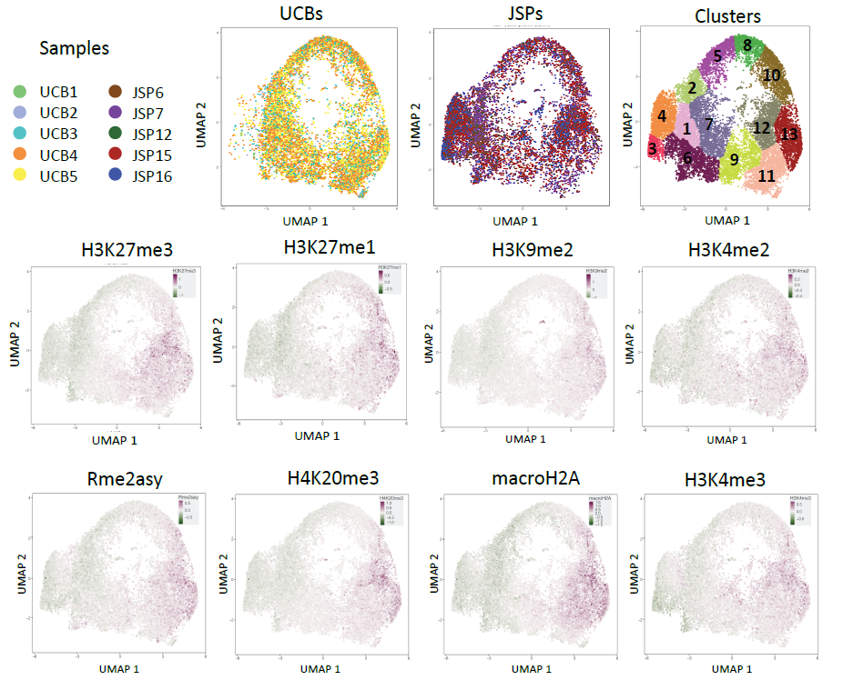
Figure S2: Distinct histone methylation signatures in JMML versus UCB HSPCs using UMAP clustering. Dimensionality reduction analysis was performed on normalized datasets using uniform manifold approximation and projection (UMAP) based on histone methylation post translational modification (PTM) marks in Fig.1A-Table. Individual contour UMAP plots of all UCBs or all JMML spleens are also shown alongside the clustering map wherein 13 distinct clusters were identified with varied distribution of JMML spleens (n=5) and UCBs (n=5) cells within each cluster. Significant loss of H3K27me3, H3K27me1, H3K9me2, H3K4me2, Rme2asy, H4K20me3, macroH2A and H3K4me3 was observed in JMML SP HSPCs when compared to UCBs. Color represents median histone PTM expression as indicated from minimum (green) to maximum (magenta) in each UMAP plot. HSPC: hematopoietic stem or progenitor cells; UCB: umbilical cord blood; SP: Spleen; UMAP: uniform manifold approximation and projection.
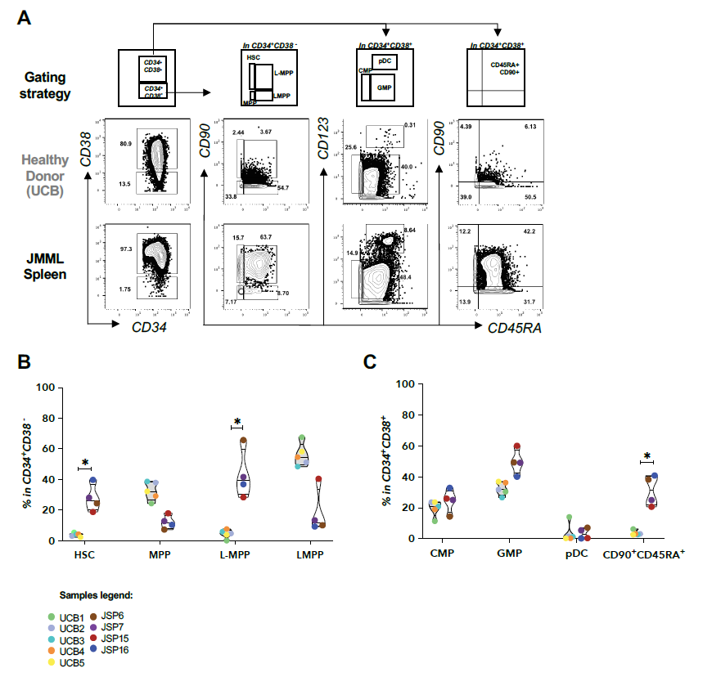
Figure S3: HSPCs identified in JMML samples compared to healthy donor controls. HSPCs distribution in healthy donor controls (UCB n=5) and JMML patient samples at diagnosis (SP n=4) using EpiTOF are shown. A) Gating strategy implemented for distinct HSPC subsets in control and JMML groups. Quantifications of the classical and novel HSPCs identified include B) HSC, MPP, leukemic MPP (L-MPP), LMPP, C) GMP, CMP, pDC and CD34+CD38+CD90+CD45RA+, shown in violin-jitter plots as Mean+SD. Sample legends of HD UCBs and JMML spleens are color coded consistent with figures 1 and 2. Multiple t-tests were performed for statistical analysis (* : p<0.05, ** :p<0.01, *** : p<0.001). EpiTOF: Epigenetic landscape profiling using cytometry by Time-Of-Flight; HSPC: Hematopoietic stem or progenitor cells; UCB: umbilical cord blood; SP: Spleen; BM: Bone marrow; HSC: Hematopoietic stem cells; MPP: multipotent progenitor; LMPP: Lymphoid-myeloid primed progenitor; L-MPP: Leukemia-multipotent-like progenitor; pDC: Plasmacytoid dendritic cells; GMP: Granulocyte-macrophage progenitor; CMP: Common myeloid progenitor.
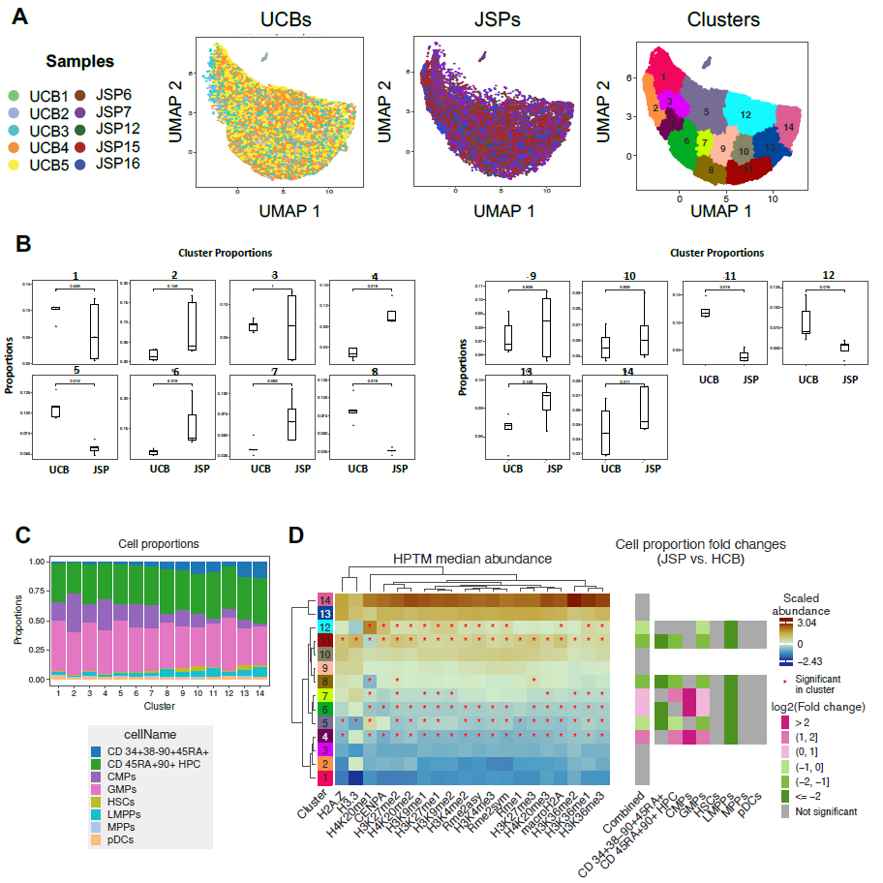
Figure S4: Reduction in histone methylation marks in splenic JMML HSPC subsets. A) Dimensionality reduction analysis was performed on normalized datasets of isolated individual HSPC subsets (Table-2) from each JMML patient spleen samples and control UCBs using uniform manifold approximation and projection (UMAP) based on histone methylation post translational modification (PTM) marks in Fig.1A-Table. Single-cell level UMAP of HSPCs from UCBs (n=5) or JMML SPs (n=5) are generated with each dot representing a single HSPC cell, and each sample is color coded as per the legend. Clustering map is also shown displaying the 14 distinct clusters that were identified with varied distribution of JMML spleens (n=5) and UCBs (n=5) HSPC subsets within each cluster. B) Clusters 4,6 and 7 have significantly higher proportion of HSPCs from JMML samples. Clusters 5, 8, 11 and 12 have significantly higher proportion of UCB HSPCs. Each dot represents a single sample, and each patient sample is color coded as per the sample legend. C) Each of the 14 clusters had heterogenous distribution of UCB and JMML HSPCs as shown in the stacked bar plots with the legend denoted below the graph. D) Heatmaps were generated for visualization of median abundance of histone methylation marks per UMAP-cluster based on unsupervised hierarchical clustering. Significant abundance or loss of the histone PTM marks that define each cluster distinctly from all the other clusters are marked by an *. The fold change in JMML vs UCB cell proportion per cluster is also highlighted, with JMML-abundant clusters (4, 6 and 7) being marked magenta and UCBabundant clusters (5,8, 11 and 12) marked green. Each cluster is defined by distinct histone PTMs signature. Overall differences in histones PTM marks profiles between clusters as well as between individual histone PTMs, are denoted with dendrograms.
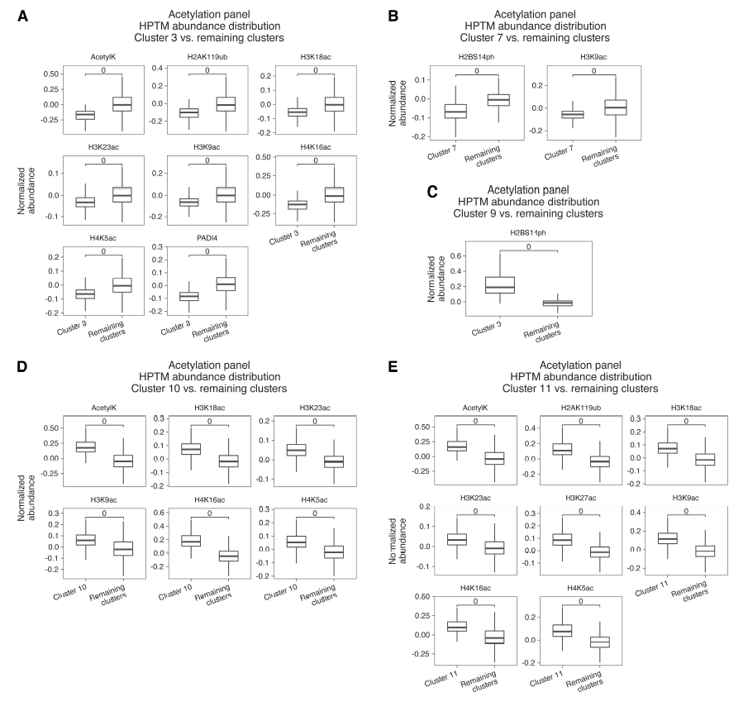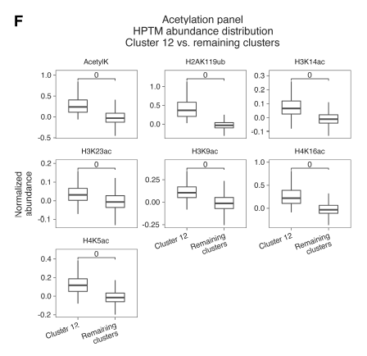
Figure S5: Key histone acetylation, phosphorylation, and ubiquitination marks that defined clusters with significantly distinct JMML vs UCB HSPC proportions: Dimensionality reduction analysis was performed on normalized datasets using uniform manifold approximation and projection (UMAP) based on histone acetylation, phosphorylation, and ubiquitination post translational modification (PTM) marks. Thereafter, clustering was done using PhenoGraph which revealed 12 distinct clusters of which clusters A) 3, 5, B) 7, C) 9, D) 10, E) 11 and F) 12 showed significantly distinct distribution of JMML vs UCB HSPCs. We examined median abundance of HPTMs in each of these individual clusters against all the other clusters to identify the HPTM marks that were significantly distinct (higher or lower) abundant in each cluster. Statistical significance was calculated using t-tests and p values in all cases shown here are <0.0005.
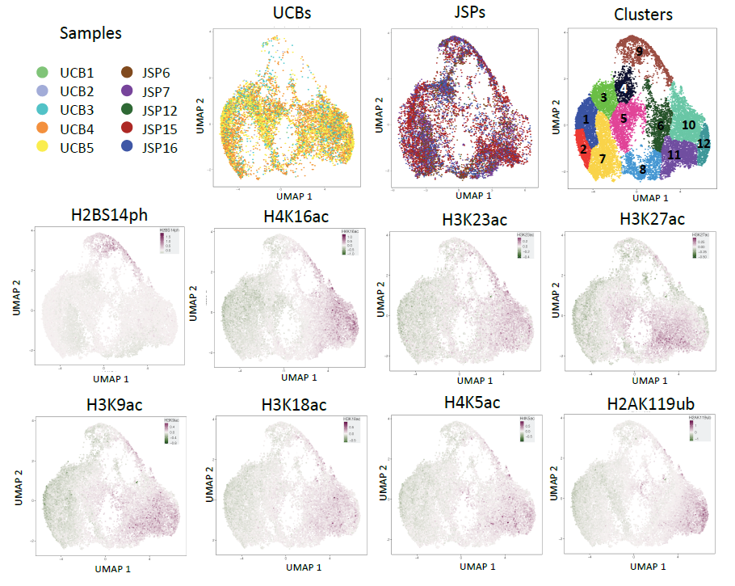
Figure S6: Distinct histone acetylation, phosphorylation, and ubiquitination signatures in JMML versus UCB HSPCs using UMAP clustering. Dimensionality reduction analysis was performed on normalized datasets using uniform manifold approximation and projection (UMAP) based on histone acetylation, phosphorylation, and ubiquitination post translational modification (PTM) marks in Fig.1A-Table. Individual contour UMAP plots of all UCBs or all JMML spleens are also shown alongside the clustering map wherein 12 distinct clusters that were identified with varied distribution of JMML spleens (n=5) and UCBs (n=5) cells within each cluster. Overall trend of reduced H3K9ac, H4K16ac, H3K23ac, H3K27ac, H4K5ac, and H2AK119ub was observed in JMML SP HSPCs when compared to UCBs. Varied expression of H2BS14ph mark was observed within JMML-abundant clusters 7 and 9. Color represents histone marker expression as indicated from minimum (green) to maximum (magenta) in each UMAP plot. HSPC: hematopoietic stem or progenitor cells; UCB: umbilical cord blood; SP: Spleen; UMAP: uniform manifold approximation and projection.
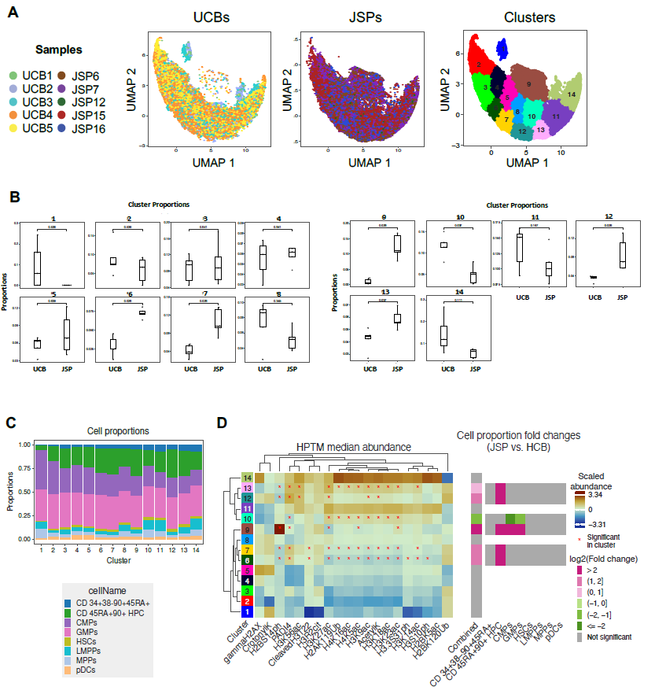
Figure S7: Heterogenous histone acetylation, ubiquitination and phosphorylation markers in primary JMML splenic-HSPC subsets. A) Dimensionality reduction analysis was performed on normalized datasets of isolated individual HSPC subsets (Table-2) from each JMML patient spleen samples and control UCBs using uniform manifold approximation and projection (UMAP) based on histone acetylation, ubiquitination and phosphorylation post translational modification (PTM) marks in Fig.1A-Table. Single-cell level UMAP of HSPCs from UCBs (n=5) or JMML SPs (n=5) are generated with each dot representing a single HSPC cell, and each sample is color coded as per the legend. Clustering map is also shown displaying the 14 distinct clusters that were identified with varied distribution of JMML spleens (n=5) and UCBs (n=5) HSPC subsets within each cluster. B) Clusters 6, 7, 9, 12 and 13 have significantly higher proportion of HSPCs from JMML samples. While only cluster 10 has significantly higher proportion of UCB HSPCs. Each dot represents a single sample, and each patient sample is color coded as per the sample legend. C) Each of the 14 clusters had heterogenous distribution of UCB and JMML HSPCs as shown in the stacked bar plots with the legend denoted below the graph. D) Heatmaps were generated for visualization of median abundance of histone methylation marks per UMAP-cluster based on unsupervised hierarchical clustering. Significant abundance or loss of the histone PTM marks that define each cluster distinctly from all the other clusters are marked by an *. The fold change in JMML vs UCB cell proportion per cluster is also highlighted, with JMML-abundant clusters (6, 7, 9, 12 and 13) being marked magenta and UCBabundant cluster 10 marked green. Each cluster is defined by distinct histone PTMs signature. Overall differences in histones PTM marks profiles between clusters as well as between individual histone PTMs, are denoted with dendrograms.

