**Supporting Information**

Extension of Shelf Life and Postharvest Quality of Bell pepper (*Capsicum annuum* L. cv Nagano) with Forced-air Precooling and Modified Atmosphere Packaging

**Samuel Yeboah1,2, Sae-Jin Hong2*, Yeri Park2, Jeong Hee Choi3, Hyang-Lan Eum2,4\***

1 Smart Farm Research Center, Korea Institute of Science and Technology (KIST), Gangneung 25451, Korea; iamsamyeboah@gmail.com (SY)

2 Department of Plant Science, College of Life Sciences, Gangneung-Wonju National University, Gangneung 25457, Korea; iamsamyeboah@gmail.com (SY); hongsj@gwnu.ac.kr (SJH); dyfl6854@hanmail.net (YP); eumhl76@korea.kr; (HLE)

3 Research Group of Consumer safety, Korea Food Research Institute, 245, Nongsaengmyeong-ro, Wanju-gun, Jeollabuk-do 55365, Korea; choijh@kfri.re.kr (JHC)

4 Postharvest Technology Division, National Institute of Horticultural and Herbal Science, Rural Development Administration, 100, Nongsaengmyeong-ro, Wanju-gun, Jeollabuk-do 55365,

Korea

**\*** Correspondence: hongsj@gwnu.ac.kr (SJH); eumhl76@korea.kr; (HLE)

Table S1. Soluble sugars (sucrose, glucose, and fructose) of bell pepper cv. Nagano during storage at 11oC 95% RH. FOLO, forced-air precooling + 30 μm PE liner; FOLX, forced-air precooling; FXLO, 30 μm PE liner; FXLX, control. zMean separation within columns by Duncan’s multiple range test (DMRT) at *p* < 0.05. **ns, **,** not significant or significant at, *p* < 0.001, respectively. DW (dry weight), (n = 6).



**A B**

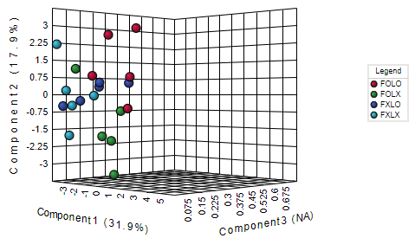 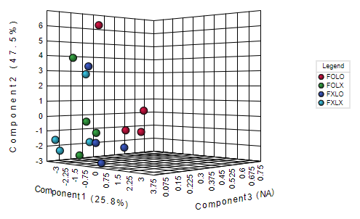

Figure S1. Three-dimensional (3D) sparse partial least squares-discriminant analysis (sPLSDA) scores plot representing treatments of observed parameters of bell pepper cv. Nagano harvested in 90% coloring (A) and 50% coloring (B), stored at 11oC 95% RH for 15 and 16 days respectively. FOLO, forced-air precooling + 30 μm PE liner; FOLX, forced-air precooling; FXLO, 30 μm PE liner; FXLX, control.