Supporting information

Oxidized Alginate and Nano-Hydroxyapatite as Biodegradable Tanning Agent and Non-Toxic Flame Retardant for cleaner leather tanning and post-tanning processes

Ilaria Quaratesi1, Maria Cristina Micu1, Erica Rebba2, Cristina CarŞote3, Noemi Proietti4, Valeria Di Tullio4, Rita Porcaru5 and Elena Badea1,6*

1. National Research and Development Institute for Textile and Leather - Research Institute for Leather and Footwear (INCDTP-ICPI), Ion Minulescu Str. 93, 031215 Bucharest, Romania; [i.quaratesi@gmail.com](mailto:i.quaratesi@gmail.com); [711mariacristina@gmail.com](mailto:711mariacristina@gmail.com)
2. Department of Chemistry, NIS Interdepartmental and INSTM Reference Centre, University of Turin, Via Pietro Giuria 7, 10125, Torino, Italy; [erica.rebba@unito.it](mailto:erica.rebba@unito.it)
3. National Museum of Romanian History, Calea Victoriei Str. 12, 030026 Bucharest, Romania; [criscarsote@yahoo.com](mailto:criscarsote@yahoo.com).
4. Istituto di Scienze del Patrimonio Culturale (ISPC) CNR, Area della Ricerca di Roma 1, 00015 Monterotondo, Roma, Italy; [noemi.proietti@cnr.it](mailto:noemi.proietti@cnr.it); valeria.ditullio@cnr.it
5. KEMIA TAU SRL, Via Torino 56/64, 10040-La Cassa (Torino), Italy. rita.porcaro@kemiatau.com
6. Department of Chemistry, Faculty of Sciences, University of Craiova, Calea Bucuresti Str. 107 I, 200512 Craiova, Romania.

**\*** Correspondence: elena.badea@edu.ucv.ro; Tel.: +40734138920

**Preparation method of nano-HAp at industrial level**

The preparation method of nano-HAp at lab level was scaled up in Kemia Tau. Batches of 5 kg and 100 kg were prepared sequentially. The first step was the selection of the suitable reagents for industrial manufacturing. Since the use of ultrapure/pure reagents is possible only at laboratory scale, industrial alternatives were selected from Kemia Tau (Table S1).

**Table S1.** Reagents used for the preparation of nano-HAp at lab scale and at industrial scale (5 kg and 100 kg).

|  |  |
| --- | --- |
| **Lab procedure**  **(0.5 Kg)** | **Industrial scale up (5Kg/100Kg)** |
| Calcium hydroxide [Ca(OH)2] 96% | Hydrated lime |
| Phosphoric acid [H3PO4] 85% | Phosphoric acid 85% |
| Ammonium hydroxide 5N (NH4OH) | NH3 solution 33% |
| Distilled water | Mains water |

For the 5 kg nano-HAp production, a big beaker and a propeller stirrer was used, in order to reproduce as close as possible the factory process (Figure S1a). For the scale up of 100 kg, the production was moved to the processing department, and cylindrical tanks equipped with propeller stirrers were employed. The final yield was more than 99%, with only a 0,73% of non-reacted hydrated lime (Figure S1b).



**Figure S1.** nano-HAp production: A) 5 kg of nano-HAp produced using a big beaker and a propeller stirrer. B)100 kg of nano-HAp produced in the factory, using a cylindrical tank and a propeller stirrer. Both batches (5kg and 100kg) were analysed with the same characterization techniques used for the lab-scale samples, in order to assess the formation of HAp and its nano-dimensional size.

As the market require a shelf life of the products ≥12 M, different storage tests were performed to determine this parameter. The nano-HAp produced at industrial scale were stored in suspension and, after a few days, precipitation of nanoparticles was observed. This could be a problem for the potential formation of agglomerates and, most of all, for the applicative step. The use in leather processes of a not well-dispersed product requires a preliminary complex mixing phase that could affect the entire leather treatment.

In order to avoid the precipitation of nano-HAp particles, the viscosity of the suspension was increased adding different types of thickening agents (polymeric and/or inorganic agents). In order to find the best type and amount of thickening agents, a number of stability tests were performed. The products were subjected to accelerated aging tests, thermal stresses, and sunlight exposure tests.

The selected thickening agents gave a thixotropic effect to the formulation: under stationary conditions, the product has a viscosity such as to avoid separation; in dynamic conditions, the viscosity decreases making it easier to use.

The best results in accelerated aging tests was achieved with ACRYSOL TT -615 as thickening agent (12.4%), with a shelf life > 12M.

**Figure S2.** The selected thickening agents (ROHAGIT SD 15, ACRYSOL TT -615, THICKENER PUL, and RHEOLATE 278) added to the formulation.

**Analysis on the nano-HAp: from laboratory to pilot-scale level**

In Figure S3A, FTIR-ATR spectra of the produced nano-HAp in Kemia Tau are shown (blue and green spectra), compared to the spectrum of produced nano-HAp at lab scale (black spectrum). In all cases typical signals of carbonates (1500-1400 cm-1) and bulk phosphate groups are present (1090-960 cm-1), showing only slight differences in the bands relative intensities.

Moreover, in Figure S3B, XRD patterns of the same samples are reported, showing the typical peaks of HAp single phase in all cases. The high specific surface area (SSA) values confirm the nano-dimensional size of HAp produced even at industrial scale.

**Figure S3.** (A) FTIR-ATR spectra of nano-HAp at lab scale (black curve), nano-HpA scale up 5 kg (blue curve), and nano-HAp scale up 100 kg (green curve). (B): XRD patterns of nano-HAp at lab scale (black curve), nano-HAp scale up 5kg (blue curve), and nano-HAp scale up 100 kg (green curve). The specific surface area (SSA) values are reported above each curve.

**Laboratory tanning process using OSA and nano-HAp**

A solution of OSA at molar ratio 0.8:1 was used by varying only the quantity of salt used. 10 g of un-pickled pelt was added, respectively, to a solution of 6% or 12% sodium chloride (calculated respect the weight of the hide) and 200 g of OSA solution and stirred for 2 hours at 25 °C at a pH between 5-6. Basification of the sample was realized by adding sodium bicarbonate, until the pH reached value 8. The samples were left to rest in the float for 18 hours before they were drained, rinsed and dried.

**Table S2.** Tanning process with OSA at laboratory level

|  |  |  |
| --- | --- | --- |
| Operation: Laboratory tanning process on calf leathera,b | | |
| Products | % w/w |  |
| Hide | 100 | *T* = 25 °C, pH= 5-6 |
| NaCl | 6 or 12 |  |
| OSA | 2000 | Rotate 2 hours |
| NaHCO3 | - | Rotate 30 min, pH = 8.0 ± 0.5 at 25°C |
| Leave in the tanning float 18 hours then drain, rinse and dry. | | |
| a Prior to the tanning step, the calf hide was prepared following the classic preliminary physical-mechanical steps to obtain an un-pickled pelt to be used directly in the tanning process.  b The percentage of added products is calculated based on the hide weight. That is, for 100 g hide, 100 g of water is added. | | |

The samples treaed with nano-HAp are obtained as follow: into 50 mL of solutions of 1, 1.5 and 3% nano-HAp in water, were added 5 g of leather tanned with OSA and stirred for 2 hours at 25 °C. Final pH value of the solution was around 9.3. The finals leathers were dried at room temperature.

**NMR-mouse analysis on laboratory scale samples**

|  |  |  |
| --- | --- | --- |
|  |  |  |
| **Figure S4.** Longitudinal relaxation time (T1) from CPMG signals of S-GA1, S-OSA2 and S-OSA3. | | |

**Industrial scale-up of the tanning process using OSA and nano-HAp**

**Table 3S.** Tanning process with OSA at pilot-scale level

|  |  |  |
| --- | --- | --- |
| Operation: Pilot-scale tanning process on calf leathera,b | | |
| Products | % w/w |  |
| Hide | 100 | *T* = 25 °C, pH= 4.5-6.5 |
| NaCl | 6 |  |
| Stirring the hide with the NaCl for 20 minutes | | |
| OSA | 2000 | Rotate 6-8 hours |
| Leave in the tanning float overnight |  |  |
| NaHCO3 | - | Rotate 4-6 hours, pH = 8.0 ± 0.5 at 25°C |
| Leave in the tanning float 18 hours then drain, rinse and dry. | | |
| a Prior to the tanning step, the calf hide was prepared following the classic preliminary physical-mechanical steps to obtain an un-pickled pelt to be used directly in the tanning process.  b The percentage of added products is calculated based on the hide weight. That is, for 100 g hide, 100 g of water is added. | | |

**NMR-mouse analysis on industrial scale samples**

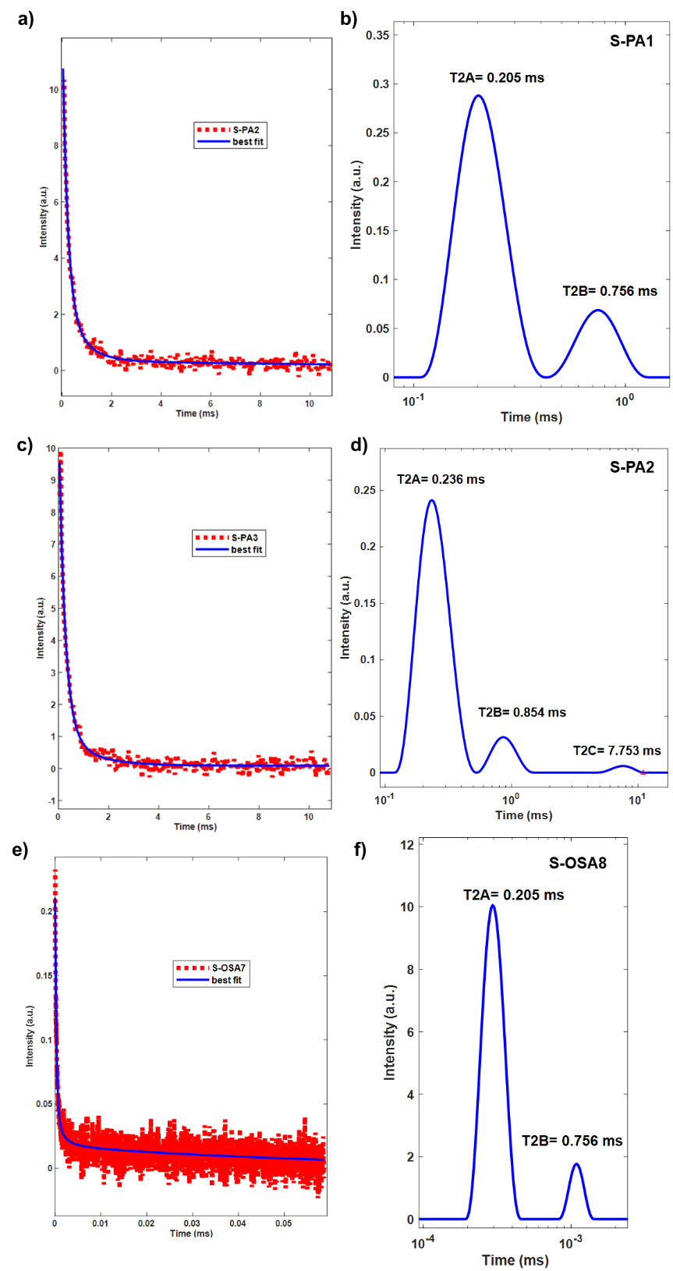

**Figure S5.** Longitudinal relaxation time (T1) from CPMG signals of (a) S-PA1, (c) S-PA2, (e) S-OSA7 and transverse relaxation time (T2) distribution for the CPMG signals calculated with inverse Laplace of (b) S-PA1, (d) S-PA2, (f) S-OSA7.

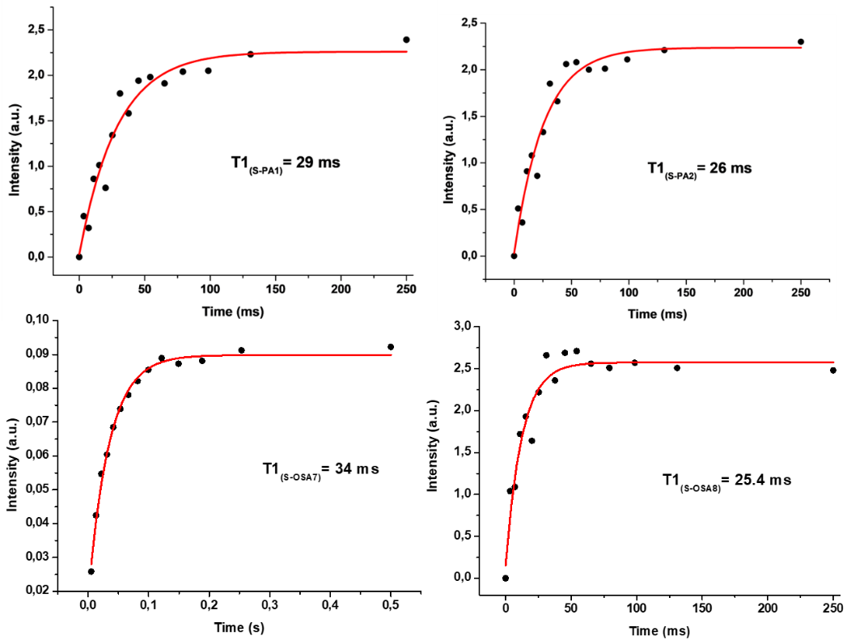

**Figure S6.** Longitudinal relaxation time (T1) from CPMG signals of S-PA1,S-PA2 S-OSA7 and S-OSA8.