Supplementary Materials:
THE SECOND DERIVATIVE OF FULLERENE C₆₀ (SD-C₆₀) AND BIOMOLECULAR MACHINERY OF HYDROGEN BONDS: WATER-BASED NANOMEDICINE

¹Matija, L∗., ¹Stanković,I., ¹Purić,M., ^{1,4}Miličić, M, ²Maksimovic-Ivanić,D., ²Mijatović,S., ²Krajnović, T, ²Gordić , V., ^{1,3}Koruga,D∗.
¹Nano Lab, Department of Biomedical Engineering; Faculty of Mechanical Engineering, University of Belgrade, 11220 Belgrade, Serbia
²Institute for Biological Research Siniša Stanković – National Institute of the Republic of Serbia, University of Belgrade, 11000 Belgrade, Serbia
³Biomedical Photonic Lab, NanoWorld, 11043 Belgrade, Serbia
⁴TFT Nano Center, 11050 Belgrade, Serbia

∗ Corresponding authors: Lidija Matija, matijalidija@gmail.com , lm@mas.bg.ac.rs phone +38162295236 (Viber and WhatsApp), Djuro Koruga, djuro.koruga@gmail.com, dk@mas.bg.ac.rs , phone +38163287353 (Viber and WhatsApp)
Hydrogen bonds
- Let us observe the interaction between two isolated water molecules via non-covalent hydrogen bonds as displayed in Figure 1. The length of covalent hydrogen bond is 0.0984±0.0025 nm, and this will be declared in our model as unity („1“), a point of reference with respect to the noncovalent hydrogen bond. In other words, we shall observe a change of the non-covalent hydrogen bond „x“(as the larger part of the system „x+1“) with respect to „1“(as the smaller part in the system „x+1“). Since the water molecules spontaneously organize and deconstruct themselves, i.e., they have the property of self-organization (harmonization), based on a stable covalent hydrogen bond „1“, the ratio „x“ to „x+1“ should be as „1“ to „x“ (the larger part with respect to the whole is related as the smaller part to the larger part). Based on the regular ratio of parts to the whole and the ratio between parts, the proportion is obtained x : (x+1) = 1: x, giving x² = x + 1, namely x² - x -1 = 0. Solutions of this quadratic equation are x₁ = 1.61803, which is Φ, and x₂= -0.61803, which is -φ. Therefore, we observe that, for two molecules to organize themselves spontaneously into a dimer, the non-covalent hydrogen bond should be 1.61803±0.025 greater than the covalent hydrogen bond. Thus, the oscillation process occurs within limits 1.59303 and 1.64303 of the value of the covalent hydrogen bond. This is in agreement with neutron experimental data [(Jeffrey, G.A. and Saenger,W., Hydrogen Bonding in biological Structures, Springer-Verlag, Berlin, 1991 and Heyrovska, R., Dependence of the length of the hydrogen bond on the covalent and cationic radii of hydrogen, and additivity of bonding distances. Chemical Physics Letters, 432: pp. 348-351, 2006)].

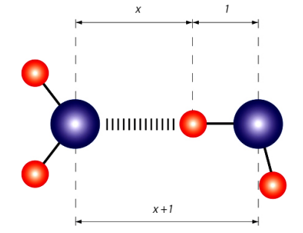
Supplement Figure 1: The interaction between two isolated water molecules via non-covalent hydrogen bonds, where „1“ denotes the value of the covalent hydrogen bond (reference size), „x“ is the variable distance between hydrogen atoms of one molecule and the oxygen atom of the other water molecule. The expression „x+1“represents the distance between centers of oxygen of two water molecule.
However, when we observe the organization of water molecules into a chain, as shown in Figure 2, then the notation for a water molecule is 1, for two molecules 1+1/1, for three molecules 1+ 1/(1+1), etc. We observe the system is getting more complex, and the displayed simplified organization of water molecules is only a possible variant. When we calculate the fractions from Figure 5.29, we obtain values 1, 2, 3/2, 5/3, 8/5 and 13/8. Thus, if we observe the water dimer, in case when two water molecules are at 13/8 Hyperpolarized Light the double value of the covalent hydrogen bond, they engage in a hydrogen noncovalent bond. It is known that the convergence point of this sequence is Φ (1.61803….)
A diagram representing values of water molecules organization into chains is displayed in Suppl. Figure 2, indicating that the establishing noncovalent hydrogen bond is the longest in a water dimer, equal to two lengths of the covalent hydrogen bond. When the bond is established and stabilized, the non-covalent hydrogen bond oscillates between values 1.615 and 1.625 and converged to Φ =1.61803….
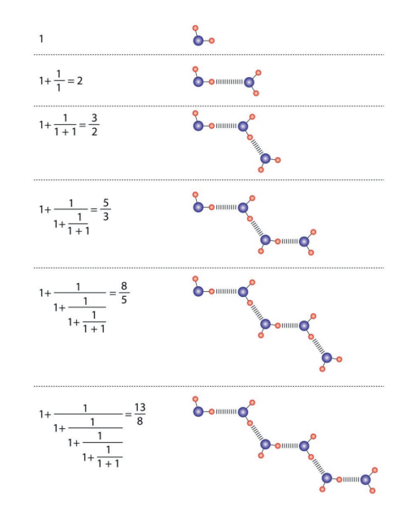
Supplement Figure 2: The Fibonacci fractions values for chains of water molecules are: 1,2,3/2, 5/3 ,8/5 and 13/8, respectively. These values are set of Fibonacci sequence of Φ. The question is what is the chain length of stable water molecules? The system of Fibonacci determinants provides the answer. The number of molecules where the determinant of non-covalent hydrogen bonds is equal to zero gives a stable chain. (Suppl. Figure 6). A chain of 3, 4, 5...8 water molecules would not be stable, it would be created and destroyed within a few ps. However, for a chain of nine water molecules (not beginning with a monomer or dimer water molecule, but with a trimer) the determinant of such a system is equal zero and chain is stable. Same case is with Fibonacci chain of 16 water molecules (Suppl. Figure 6).

Supplement Table 1: Icosahedral symmetry group that determines the energy states (T_{1g}, T_{2g}, T_{1u} and T_{2u}) of structures and processes. Fibonacci numbers Φ, -Φ, φ, -φ are subset of icosahedral symmetry group ( ± ½(1+$\sqrt{5}$and ± ½(1-$\sqrt{5}$)) (Adapt from Kettle, S.F.A., Symmetry and structure, John Willey and Sons, Chichester, 1995).
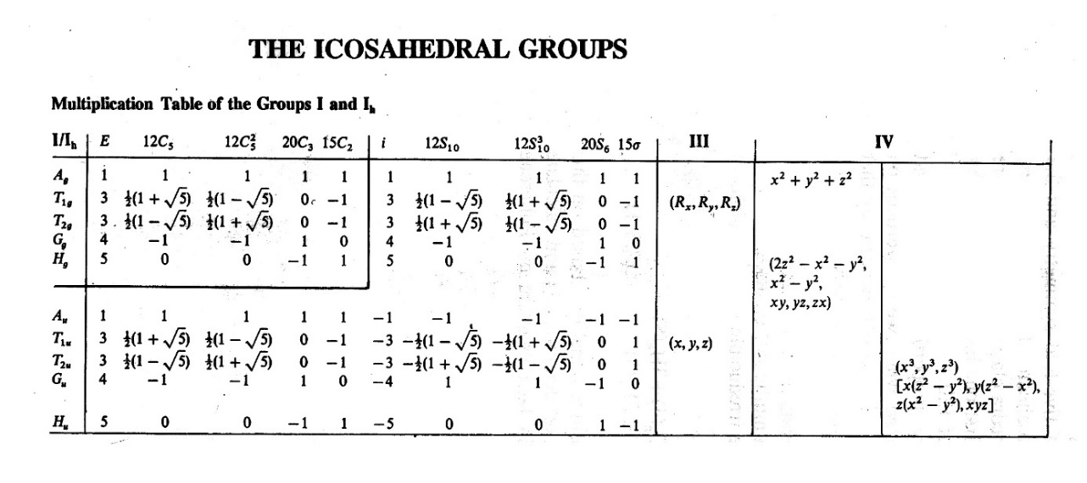

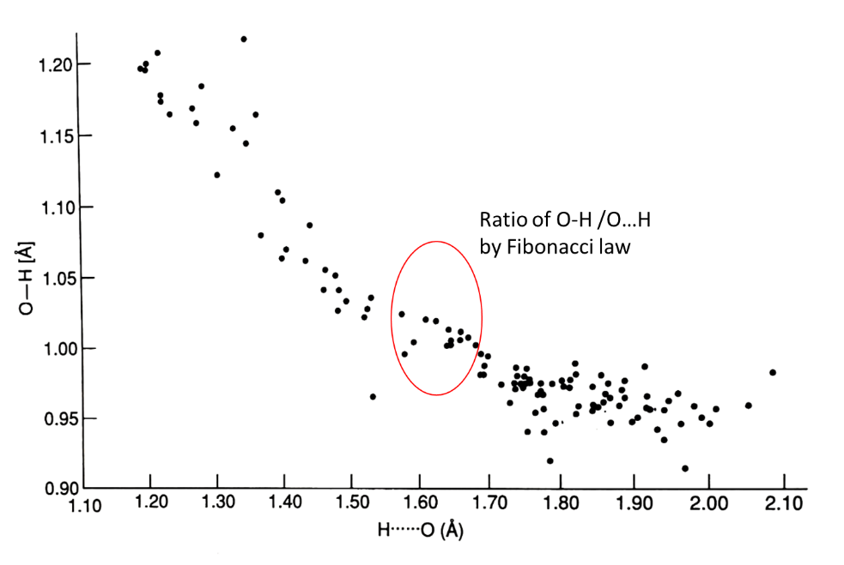
Supplement Figure 3: Plot of covalent (O-H) hydrogen bonds and non-covalent (O…H) hydrogen bonds based on neutron diffraction data (Jeffrey, G.A. and Saenger,W., Hydrogen Bonding in biological Structures, Springer-Verlag, Berlin, 1991.)

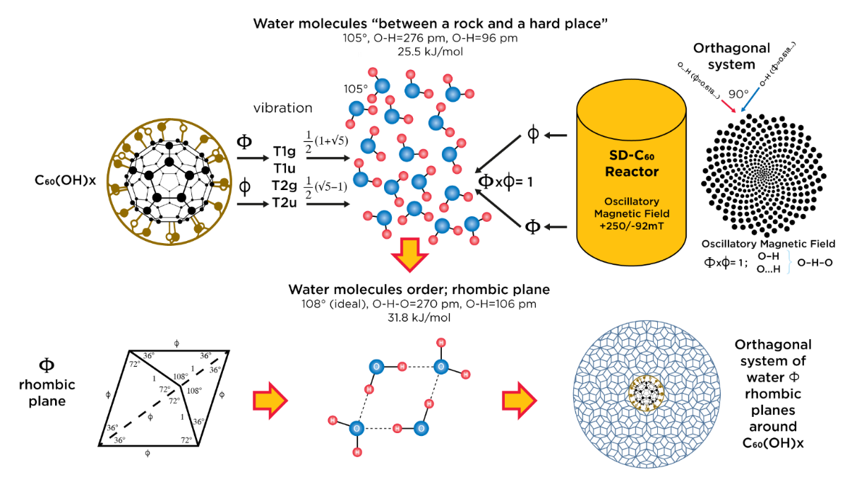
Supplement Figure 4: Schematic representation of the formation of an elastic soft-matter structure (SD-C₆₀), composed of water molecules that are elastic (deformable) and that form 3-dimensional icosahedral water shells (layers, onions) as a soft material.

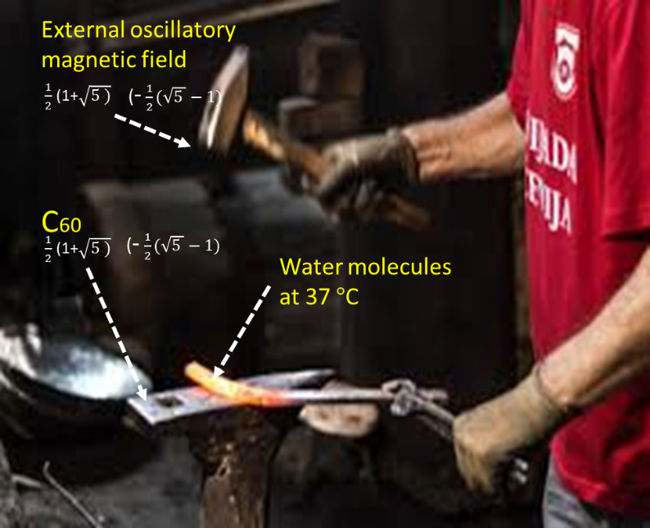
Supplement Figure 5: The principle "between a hammer and an anvil" in process water tiles and shells (onion) formation according to action of C₆₀ vibrations and external oscillatory magnetic field by icosahedron symmetry

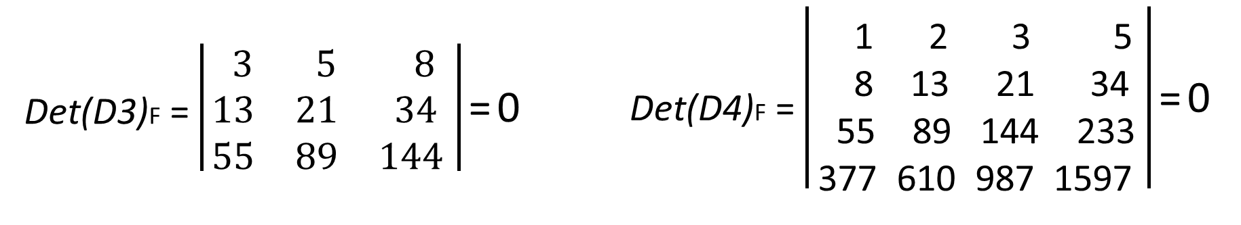
Supplement Figure 6: Two Fibonacci determinants detF(3) and detF(4) (set of {9,16}_{Φ} ) by which the oscillatory magnetic field is programmed to stimulate rhombic tiles formation . Since the determinant column is a linear combination of the remaining columns of that determinant, then the determinant is equal to zero (this follows from the law of the sequence: u_{n-1} + u_{n} = u_{n+1}) than the Φ-rhombic tiles of {9,16}_{Φ} set are stable.

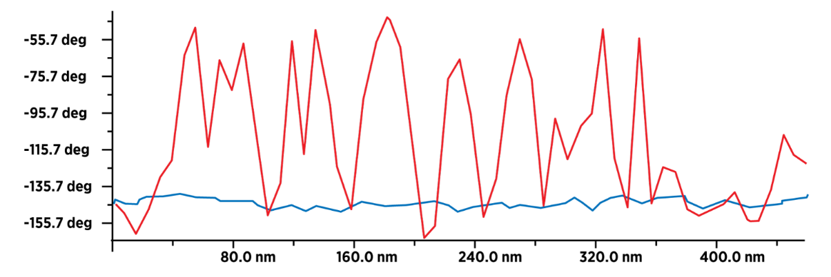
Supplement Figure 7: Presence water molecules in FD-C₆₀ and SD-C₆₀. Comparative diagrams (from Figure 16 and 17, range 0-400 nm) of intensity values of dipole-dipole interactions between MFM magnetic tip and substrate (FD-C₆₀ - blue line and SD-C₆₀ - red line). FD-C₆₀ has a low intensity of dipole-dipole interaction due to humidity, while SD-C60 has a high intensity of dipole-dipole interaction because, in addition to humidity, it contains water molecules packed in rhombic plates (3DPT).
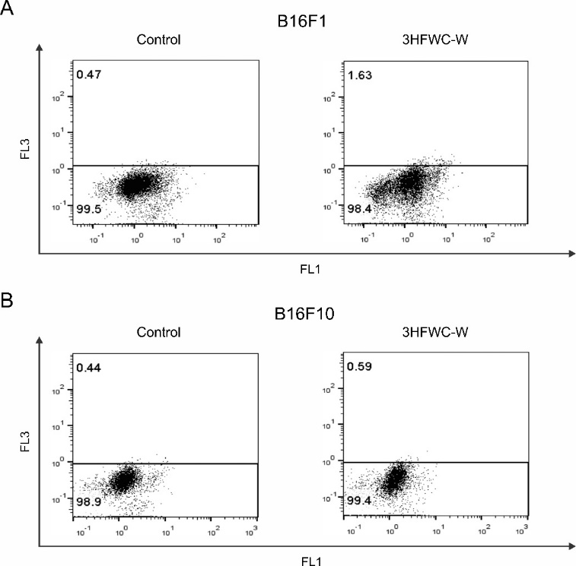
Supplement Figure 8. The effect of 3HFWC-W on induction of autophagy in melanoma cells. The percentage of cells in autophagy in B16F1 (A) and B16F10 (B) cell cultures treated with the IC₅₀ value of 3HFWC-W (SD-C₆₀) for 24 h was determined by AO staining and subsequent flow cytometry. Representative dot plots of one out of three independently performed experiments are shown.

